Exams
Success in exams can be reduced to one thing, answering the question. That sounds simple, but in reality it takes effort and preparation to do that well. When students who don’t do as well they wish in exams this is the reason. The ways students don’t answer an exam question vary, but the result is the same a lower mark than expected.

Revision
Revision for exams should start several weeks before the exams are due and if this is during term time it is best to try and make some time to do so. The longer you work with revision material the more chance you have of going beyond remembering and start writing, because you know and understand.

The two elements involved
When approaching exam revision it is useful to remember that there are two distinct elements that you should work on. The first is the one, that everyone tends to concentrate on, is memorising the knowledge that you will require for the exam. Fewer students recognise the second element which is just as important if not more so. That element is, manipulating that memorised knowledge to answer a specific question. It is very important to have what you have learned, to hand, so you can answer any given question. However, constructing the answer to an exam question is a skill, which if not developed, means your exams will not truly reflect what you have learned.

What to revise
In choosing what to revise there are three things that can help inform what you revise, one are the learning outcomes for your module, the second is the lecture schedule and the third is past exam papers (if there are any). All of these give you an indication of might be in the exam.

Learning outcomes
Learning outcomes are generally at the start of the module handbook and state in four or more sentences or bullet points what the module is trying to teach you. For example, the following is a learning outcome from a politics module.

Provide students with an understanding of the conceptual and theoretical debates surrounding political institutions and political behaviour;

It can be argued that the module leader will be looking for what they taught to come back through your exam answers. So be aware of learning outcomes and what they mean. In the case of the learning outcome above an exam would have questions that will ask students to review what understanding they have and put it down on paper to answer that question. For example, what are the theoretical debates and to which institutions do they apply?

Lecture and seminar schedules
You exam questions will reflect the distinct areas taught in the modules and these areas will probably be seen in the lecture and seminar timetable. If you can establish what these areas are that will be helpful for your revision.

Past exam papers
In terms of revising previous exam papers indicate the types of questions to be asked and you can use this in two ways. Firstly, it helps identify the areas covered in the exam and secondly, they allow you to practise understanding what is being asked in a question and structuring an answer.
Between all of the above you should be able to establish the scope of the exam and from that the things you should study. It is important to revise an area rather than practising exam questions, because exam questions only represent part of an area

Remembering
One method of recalling information in the exam can be achieved by reducing or ‘packing up’ information until it is an amount that is memorable and succinct to take into the exam. Then once in the exam this information can be unpacked and restored to a larger form that is enough to use to answer a given question.

Packing up
An example of packing up information would be taking three pages of notes and then reducing those three pages to three paragraphs keeping the essential points made, but reducing the detail. Then taking those three paragraphs and reducing them to a bullet point or sentence with three parts. If you repeat this process four or five times you end up with a revision card with five bullet points which represents twelve to fifteen pages of notes and twelve to fifteen paragraphs that could form the answer to an exam question.
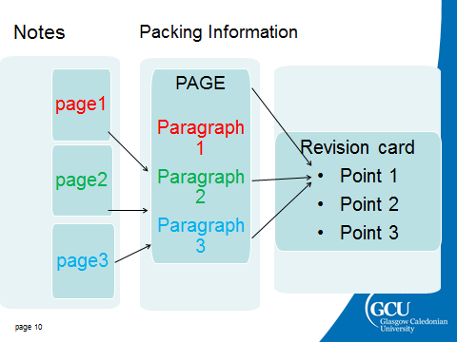
Figure 1 ‘packing’ exam information
In terms of memorising, this means for one area of your module you memorise one card to prompt access to the information to answer an exam question.

Unpacking
It is important to acknowledge that when you are in the exam this will not be your first attempt to unpack the information from five bullet points and into the form that to answer the question. You must practise unpacking what you need to answer the question. Unpacking involves constructing the paragraphs from the information the bullets points represent.
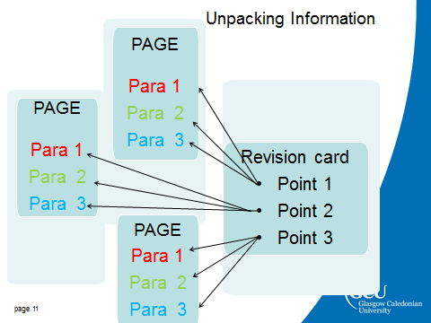
Figure 2 'unpacking' exam information
The more this is done the easier it will become to build text that will answer any given question and build your ability to manipulate the knowledge you have to do that. In addition, there are other benefits to this activity. If you work at constructing text, which is actively engaging with what you have learned, you are going through a learning process. As a result you will increase your depth of understanding of the subject. The more your understanding increases the exam becomes less about memorising and more about showing the examiner that you understand. All of this is more productive than passive reading which students often do, in preparation for an exam.

Using the knowledge
This section discusses how you can rehearse using the knowledge you have acquired to answer the exam question

Previous exam papers
One way to practise manipulating knowledge before an exam is to answer exam questions or parts of exam questions. This does not mean preparing an answer to take into an exam; in the hope the question asked is close enough to your prepared answer. Answering previous exam questions is all about the following:
Understanding the question/supplying the information needed
Structuring your answering
All of these will be explained, so you are aware of the importance of each to producing and exam answer worthy of your learning.

Understanding the question
At university, the ability to understand what you are being asked to do should not be underestimated and it is essential to take time to break down a question. As you will know questions can be complex and any misinterpretation can lead to an answer that is incomplete or has the wrong emphasis. Writing something that is not part of the expected answer will attract few marks, if any at all. Knowing what the question is asking is the foundation to a comprehensive exam answer. If you are asked to make someone a sandwich, but fail to acknowledge they are a vegetarian, even the most delicious bacon and sausage snack will not be appropriate. Likewise, if you do not understand what the examiner has asked for, you may inadvertently give an unsuitable answer.Once you understand what the question is asking you can quickly work out what is required for an answer.
Structuring your answer
There is an expectation for a structure to all answers, so make sure you give your answers a logical flow. Giving some thought to the structure of any answer will avoid a rambling disjointed response, which may lose you marks, because it lacks clarity.

Exam preparation
There are several things you can do before an exam.
The obvious one is to be sure of when and where the exams are. Very occasionally, students do not do this and the consequences of missing an exam can be far reaching. Missing an exam resit can mean repeating a module.
Are you familiar with the exam structure? What is involved? Is it all essay questions or is a mix of essay questions and short answer questions or even multiple choice questions? How long is the exam, 2 hours, 3 hours? You should be aware of all of these elements and prepare for your exam with them in mind.
For example, work out how much time you have to write each answer (allowing time to plan and check your answer), then sit down and see how much you can write in that time. Just write anything at a steady pace for the time you have. Then you will know if you are a six page person, a two page person or a four page person. In other words, you know how many pages you have to make your answer. This in turn will influence how much detail you unpack in the exam to construct your answer. You should be far less likely to write excessively for your first answer, leaving insufficient time for you other answers.

