Getting Started with
Online Submission, Digital Marking and Feedback
_________________________________________________________

1. Introduction
This guide provides an introduction to some of the commonly used processes and practices around online submission, digital marking and feedback at GCU. School Learning Technologists and the Academic Development team in Academic Quality and Development can also provide further support and development opportunities for programme and module teams.

The GCU Digital Assessment Policy (pdf) states that,

‘All suitable coursework assignments, both formative and summative, will normally be submitted online. Where student work is submitted online, digital forms of marking and feedback are also the expected norms.’(section 4.1, GCU Digital Assessment Policy)

As outlined in the Policy, the well-managed use of technology for submission, marking and feedback has advantages for students, staff and the University, including:

For Students: | submitting work online and receiving timely feedback on their performance; automatic proof of receipt; easy access to digital feedback; convenience of not having to travel to submit assessments; reduces paper use and addresses environmental concerns.
For Staff: | improving student learning by providing feedback in efficient and timely ways; the convenience of not having to collect and carry large quantities of paper; being able to reuse common feedback comments; allows easy access to external examiners.
For Schools, central departments and the University: | ease of access to accurate, up-to-date assessment data which can inform quality enhancement and assurance, marketing, course information for prospective students and long-term curriculum planning; potential increase in student satisfaction.

2. Online Submission
The main method for the submission of student assignments and coursework is through Turnitin Feedback Studio which is integrated within GCULearn. More detailed information on the expectations of online submission and the practicalities of using Turnitin Feedback Studio can be found in the the GCU Online Similarity Checking Policy (PDF) and guides.
In summary:

- Turnitin Feedback Studio, accessed via GCULearn, is the main application for the online submission of student coursework and assignments.

- It is used for similarity checking, providing feedback and creating marking schemes (e.g. using Rubrics).

- Turnitin Feedback Studio does not replace academic judgement. It enables a lecturer to compare where there are similarities between the student‘s own work and what has already been submitted to the Turnitin repository. The percentage score is an indicator to help identify issues which need to be addressed, and the academic will have to make the judgement on what has been copied and poorly referenced.

- Current practice varies across modules, programmes and Schools e.g.

  - Formative: students are encouraged to upload up their work to check their similarity score one or more times before final submission. The students’ assignments are only added to the Turnitin repository after the final submission. This allows students to learn from the similarity feedback to improve their academic writing skills and referencing. As noted in the Online Similarity Policy, this formative approach is strongly encouraged.

  - Summative: students are required to submit assignments via Turnitin and the similarity score is withheld. This may be for example, because they are postgraduates and should not be plagiarising. Such an approach should however be the exception rather than the norm.

- Students can access support from their School Learning Development Centre (LDC) for help with avoiding plagiarism, academic writing skills and referencing (with support also from the Library). GCU subscribes to PLATO, a short online course on what plagiarism is and how to avoid it in academic writing, available via GCULearn,

- For content which is not suitable for online similarity checking (e.g. graphics, computer coding, mathematical symbols and other non-textual presentation), student work can still be submitted online through the GCULearn Assignment tool.

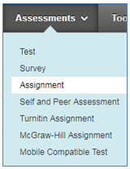

- Inevitably there will be exceptions for some assessments, e.g. the production of an artefact, which may not lend themselves to online submission.

- In all cases, GCU Assessment Regulations and Code of Student Conduct should be adhered to for submissions.

3. Digital Marking
Digital forms of marking can bring benefits to staff and save time, for example by enabling the reuse of common feedback comments, facilitating second marking and reducing the administrative burden. Students can access their marks and the marking criteria quickly and easily.

Where marking responsibilities are shared, it is important to agree across the team how the marking will be done to ensure a consistent experience for the students.

Approaches may include using Turnitin Feedback Studio to :

- Create Rubrics detailing clearly defined marking criteria

- Use QuickMarks to create sets of commonly used feedback comments which can be accessed speedily while marking and reviewing student assignments
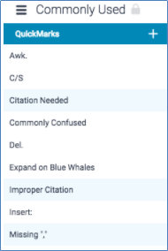

- Using Grade Centre in GCULearn to:

  - download submissions, and enter marks and feedback

  - view MCQ test and quiz results

  - monitor marking progress where there are teams of markers

  - hide or reveal student marks at an appropriate time

  - create customisable reports for modules, groups of students, defined categories or marking periods.

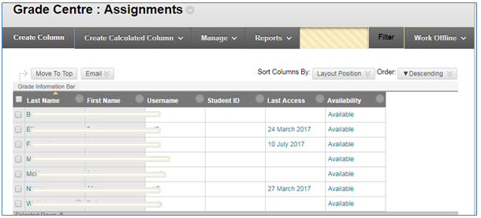

Further guidance on how to use the different features of Grade Centre can be found under the Staff Help Tab in GCULearn and in the Blackboard videos for instructors.

4. Digital Feedback
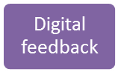

Providing feedback in digital form can be very helpful for students as they can take time to read, watch or listen to it when it suits them, and return to it later for revision purposes. When managed effectively, it can potentially save time for staff. Feedback to students should also reflect the Student Performance Feedback Policy (pdf).

Approaches can include:

- marks and feedback forms made available to students through GCULearn Grade Centre
- a discussion board, announcement or blog post for generic feedback highlighting key points to all students in a cohort on GCU Learn
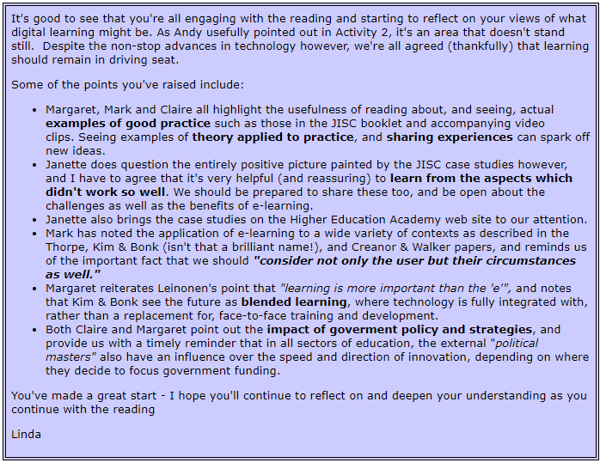
- ‘in-line’ feedback on Word documents to individual students via email
- ‘in-line’ feedback via Turnitin Feedback Studio commenting tools where assignments have been submitted online through Turnitin Feedback Studio (accessed via GCULearn)
- Rubrics with criteria for grades, most commonly via Turnitin Feedback Studio Rubrics
- re-usable feedback comments added to documents, e.g. through using Turnitin Feedback Studio’s Quickmarks feature.
- audio feedback (up to 3 minute) comments via Feedback Studio’s commenting tools (section 2.1)
- similarity ratings generated through TurnitIn
- personal response systems (clickers, if available) or mobile polling apps (e.g. Poll Everywhere, Socrative, Mentimeter) in lectures and seminars, with collated student responses used to gauge understanding and provide formative feedback.
- Padlet or Trello for shared feedback, comments and suggestions
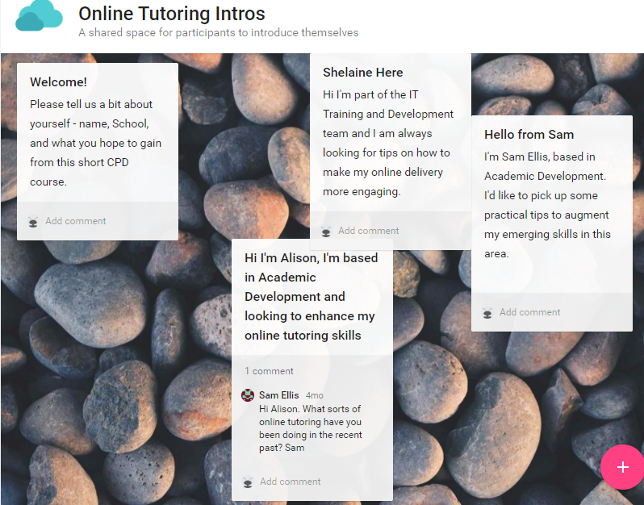

- Peer assessment through specialist applications such as WebPA
- Short tutor videos explaining key feedback points to a class or group uploaded to Edshare or Youtube and embedded in GCULearn
For support and guidance with any of these approaches, please contact your School Learning Technologists.

‘Getting Started with Online Submission, Digital Marking and Feedback’ by Prof LInda Creanor, Glasgow Caledonian University, is licensed under a Creative Commons Attribution-Non-Commercial-ShareAlike 4.0 International Licence

http://www.jisc.ac.uk/guides/electronic-assessment-management
http://www.gcu.ac.uk/gaq/regulationsandpolicies/

