Learning Analytics Readiness Project
Glasgow Caledonian University

Prepared by
Andy Ramsden, and Steve Bailey, Blackboard Strategic Services
20th November, 2015

EXECUTIVE SUMMARY

As part of the Jisc’s Learning Analytics initiative, Jisc have commissioned a series of Readiness Assessments from Blackboard Consulting. The Glasgow Caledonian University engagement took place between September and October 2015. The engagement included a pre-visit questionnaire, a document review, an online kick off meeting, and a three-day onsite discovery schedule (forum meeting, interviews and workshops). The primary deliverable was to assess the extent to which the institution is ready to progress with Learning Analytics. This is classified as either; ready, ready with recommendations, not ready with recommendations. The decision was informed by four pillars of readiness; culture, people, processes and technology infrastructure.

The working definition of Learning Analytics for this engagement was “the application of analytic techniques to analyze educational data, including data about learner and teacher activities, to identify patterns of behavior and provide actionable information to improve learning and learning related activities” [Davenport et al, (2010)].

Glasgow Caledonian University proposed the learning analytic theme was “to explore the area of student engagement and intervention strategies, with particular interest in informing the effective use of blended and fully online delivery of learning and teaching”.

Based upon the information shared by the University through the document review, pre-visit questionnaire and the onsite discovery sessions, Blackboard Consulting’s assessment is Glasgow Caledonian University is ready with recommendations for Learning Analytics, and is encouraged to move towards a pilot phase.

Figure 1 illustrates the findings by the four categories. The area of greatest concern is the IT Infrastructure.

Figure 1: Readiness for Learning Analytics: Breakdown by Category
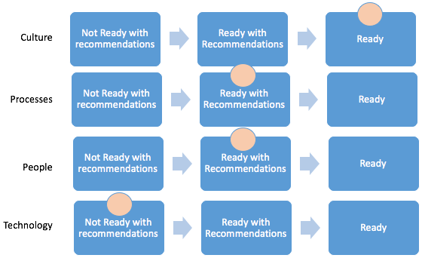

The following recommendations will enable Glasgow Caledonian University to improve its readiness for Learning Analytics through building up understanding and capabilities in preparation to scaling up as a service.

The key recommendation is

- Implement a pilot project using the LMS as the key data source to enable Glasgow Caledonian University to enhance it’s institutional understanding, capacity, and capabilities of enhanced reporting and intervention strategies.

The recommendations are subdivided into the four pillars of readiness.

Culture

- Embed Learning Analytics and data driven decision making within the culture, values and beliefs of Glasgow Caledonian University. This should to include; approving a working definition of Learning Analytics to be used across the institution, dissemination of a series of white papers on use cases for Learning Analytics with specific context of student support and curriculum design.

People

- Undertake a skills audit within the pilot studies to ensure the different stakeholder groups have the required skills to access, interpret and take effective actions based on the learning analytics data being surfaced

- Undertake a wider review of the likely required staffing levels and capabilities for a Business Intelligence Unit.

Processes

- Create a cross institution coordinating group to promote Learning Analytics with Glasgow Caledonian, and own the institutional pilots.

- Ensure all teaching focused software procurement processes consider data transfer into a proposed University Data Haven

- Undertake a number of development activities to generate intervention work streams which clarify, who does what? what are the data triggers? when do they do it? how it will be monitored and enhanced? and what skills sets are required?

- Review the curriculum design and development process across the Schools to ensure programs generate timely, meaningful data to trigger intervention strategies. Particular focus should be on technology enhanced assessment and feedback processes.

Technology infrastructure

- Undertake a wider review the likely IT infrastructure to inform requirements for a Learning Analytics Service and work streams.

- Identify and pilot software services for the data haven and linked reporting technologies which are robust, resilient and can accommodate changing use cases.

Acknowledgements

The authors would like to express their gratitude to Sheila MacNeill at Glasgow Caledonian University for the organization and support which enabled the online meetings and onsite engagement to progress smoothly.

REPORT

Section 1: Background Context

Institutions are increasingly aware the data generated by learners can provide important insights into identifying, quantifying and solving key institutional issues. Institutions have expressed particular interest in exploring this data in the context of driving student retention and progression or understanding academic adoption and effective curriculum design (Bichsel (2012), Sclater (2014) and Nussbaumer et al., (2015)). In seeking to develop a well-defined vision for the use of data regarding student engagement, performance and retention, institutions aim to collect, analyze and create actionable knowledge and share this knowledge across a broad range of stakeholders.

The strategic importance of Learning Analytics from a JISC perspective is evident from Martyn Harrow (JISC, 2015), who proposed over “the next three to five years could see UK universities develop next-generation learning technology that will use analytics to deliver rich, individually-tailored learning anywhere in the world”

On behalf of Jisc, Blackboard Consulting is providing a Learning Analytics Discovery Service which aimed to discover, analyse and report on institutional readiness for adoption of learning analytics tools. Assessment of institutional readiness will encompass strategy readiness, technical readiness and cultural readiness, including policy, processes, systems and people. The engagement explored the institutions data-decisions requirements, its existing policies and processes and its internal capacity and capabilities to make effective use of learning analytics tools.

A number of key considerations explored within the engagement included:

- what are the requirements regarding policies, processes, systems and people to support effective adoption of learning analytics?
- what is the institution’s current institutional readiness (maturity) to address those requirements and where is the gap, and how can it be closed?
- what opinions are available regarding tracking and monitoring performance over time?

Section 2: Methodology

The consultancy is divided into three phases, with a number of data collection points (see Table 1). The three phases are; pre-onsite, onsite and analysis and reporting. The onsite is a three-day event facilitated by two Blackboard Consultants, with strategic and analytics expertise.

Following the onsite, the Blackboard consultants analyse the data and information collected throughout the engagement. The findings are reviewed, interpreted and documented against a subset of Blackboard’s proprietary set of 100+ rubrics spanning Effective Practices Areas (EPA) in; strategic change, effective use of educational technology and digital learning in higher education. This engagement would focus on the ‘Data-driven Decision Making Effective Practice Areas’ and ‘Supporting Student Retention/Throughput Effective Practice Areas’ rubrics. This is an established and rigorous evidence-based maturity methodology. The Blackboard’s rubric-based EPA approach is similar to a capability maturity model as it is designed to capture convergence toward effective practice. Distinctively though, it takes into account the diverse organisational cultures and operational goals and objectives of education institutions.

The analysis is informed by Blackboard’s six key characteristics required to drive technological adoption (http://bbbb.blackboard.com/technology_adoption_series)

- Leadership from the top
- Institutional commitment and investment
- Robust and reliable infrastructure
- Effective and available support for academic staff
- Ability to demonstrate the benefits to the student and staff experience
- Evidence-based decision-making and a continuous cycle of improvement

Table 1: Overview of data points

Pre-Visit | Onsite
Pre-visit questionnaire is intended to identify the Learning Analytics theme to be explored in the engagement, and an initial readiness assessment.  The document review is undertaken before the onsite event, with the intention of clarifying policies, procedures, vision, goal statements and planning documents. | The open forum develops a collective understanding of what the term Learning Analytics means to the institution and how they define student engagement. The session design includes a number of questions on perceptions of institutional readiness.  There are a number of interviews (n=9) with senior managers within the institution. These are designed to identify the institutions readiness (maturity) for learning analytics regarding policies, processes, systems and people (see Appendix for list of interviewees)  The workshops are arranged into stakeholder groups (academics, students and professional services / data managers). The workshops are designed to encourage creative ideas around the use of Learning Analytics, outside of the theme suggested in the pre-visit questionnaire. They are intended to highlight, (i) what are the institution’s short term learning data needs and longer term data aspirations to provide key insights regarding the student experience, (ii) how might the institution convert learning data into actionable knowledge?

Section 3: Glasgow Caledonian University defined vision and strategic themes

Representatives from Glasgow Caledonian University proposed their broad theme for the engagement was;

To explore the area of student engagement and intervention strategies, with particular interest in informing the effective use of blended and fully online delivery of learning and teaching.

During the onsite engagement this divided into the two distinct themes for the application of Learning Analytics, for the identification of

- an individual or cohort of learners to enable a positive intervention support
- current LMS usage to enhance curriculum design of online and blended course design and learning activities

The interview with the Executive Sponsor, identified the success for this engagement would be to give a clearer sense of how learning analytics could be used to improve the student experience and outcomes.

Section 4: Assessment of the institutions readiness against key maturity metrics

The assessment is organized into the four pillars of readiness, and will discuss current good practice, and areas requiring improvement. Finally, the evidence is mapped to a number of Learning Analytics readiness statements, aggregated from the EPA Rubrics.

Culture
This pillar focusses on the current practice around the creation and dissemination of institutional goals, outcomes and vision, and the degree of support from the institution’s Executive Leadership for Learning Analytics.

The engagement identified existing good practices, including;

- A culture of consultation for the development of strategy, and goal setting (Strategy 2020, and Strategy for Learning)
- A desire by all parties at all levels of the institution to take responsibility for developing, analyzing and acting on data and evidence to improve performance
- A high degree of support from Executive Leadership and Service Managers for Learning Analytics and Data Driven Decision Making.

The engagement identified a number of areas requiring improvement and further exploration to improve readiness for Learning Analytics.

Table 2 summarises the responses to the three discovery questions within the Forum. It demonstrates the need to address the negative perceptions of learning analytics held by staff at Glasgow Caledonian. These perceptions need to be challenged to promote an institutional culture which embraces Learning Analytics.

Table 2: Readiness for Learning Analytics: Forum Responses: Discovery Questions

Question | Positive Responses | Negative Responses
When you hear the term “learning analytics” what comes to mind? | - Various elements used to identify at risk students – retention  - Highlight student feedback be able to address earlier  - Quality enhancement  - Data which will inform curriculum design  - Bringing together datasets from across the institution  - Bring together data from all systems in the student lifecycle to support students; data availability in a dashboard, ie attendance swipes, assessment data etc., | - Extra work - you can pull the numbers out, but how do we make sense of it?  - the relevant software costs  - Problem of quantifying essential qualitative stuff  - Analytics doesn’t do everything, not everything is quantifiable
What are some of the positive things you associate with learning analytics? | - A better experience for the students. With interventions at earlier stage when individuals are struggling  - Assess effectiveness of a module or programme  - Assess effectiveness of teaching techniques  - Real time feedback to academics  - Improve future decision making  - Drive change and improvements  - Data driven decision making which is based on actual live data  - Overview of student (learner) progress
What are some of the negative things you associate with learning analytics? |  | - Analysis paralysis and information overload.  - Manipulation of data to influence a specific strategy or policy  - Data interpretation must be constant across analyst / system determination  - Can develop a tick box culture. The number of views doesn’t equal amount of understanding.  - Quantitative data is only part of a much bigger and deeper overview  - Rear view mirror, ie., not real time  - Privacy of data  - Fear of monitoring, “big brother”. Staff might feel exposed
During the Forum a number of closed questions were asked as indicators of institutional culture. The responses identified the participants believed Glasgow Caledonian was ready for Learning Analytics. The question with the strongest agreement was the belief the Executive Leadership encouraged a culture of inquiry and evidence based decision making that lead to a continuous improvement. The question which created the most uncertainty was the existence of a clear vision guided the overall educational practice and technology portfolio within the institution.

The interviews identified inconsistencies in practice, which needs to be addressed. There appeared to be inconsistencies in effectively embedding a culture of continuous improvement. For instance, there a number of references to the situation where the information from the Strategy and Planning Team did not meet requirements and needed to be re-analysed at the local level. When asked, has this been fed back? The answer was “yes, frequently, but nothing has changed”.

There appeared to be inconsistencies in working practices around cross team collaboration. It is acknowledged there are examples of effective networks (ADLTQs, Directors of Learning Development Centres and School based Learning Technologists). However, many responses indicate inconsistencies in actual practice between these groups and the GCU Lead Team when designing and developing the current online programme.

People

This pillar focusses on the current practice around the capacity and capabilities of people within the institution for the successful implementation of a Learning Analytics service.

The engagement identified existing good practices, including;

- The Strategy and Planning Team provide a business intelligence function, including managing requests, data analysis and reporting
- Existing current practice around enhanced reporting and manual intervention strategies within Maths Tutor Support, which feeds into improvements in the curriculum design and student outcomes.

The engagement identified a number of areas requiring improvement.

There are reported shortages of capacity and capability shortages within the IT Infrastructure Team and Data Analysts. Concerns where raised around the limited number of DBAs within IT Services, and Statistical Analysts in the Strategy and Planning Team.

The interviews identified capability shortages when deploying appropriate technology enhanced learning activities within GCU Learn, and other learning systems. There was a strong message around a lack of instructional / TEL curriculum designers within the Schools.

There was limited reference to ethical and data management considerations of managing large data sets on student activities. At the institutional level progress is evident from emerging work of the Information Classification Policy, however, this did not appear asa priority for individuals.

Processes

This pillar focusses on the governance processes, how policies and procedures are developed, implemented, monitored and reviewed, and the degree of transparency.

The engagement identified existing good practices, including;

- People Passport and Disability Awareness where identified of successful institutional wide cultural change programmes.
- The existing process and procedure to generate goals and key performance indicators with School and Department Plans, based on institution strategy and vision.

The closed questions within the Forum identified inconsistencies in policy and procedures from respondents. When asked if they are aware of process documents and implementation plans by which the institutional vision and goals will be achieved / realized, it generated the widest spread of responses, from strongly agree to strongly disagree. In contrast, the majority agreed if they were concerned about an individual student they would know who to ask within the institution for information, and were confident they’d be able to provide accurate information quickly.

The engagement identified a number of areas requiring improvement.

The interviews identified inconsistencies in the way technology enhanced curriculum was designed and implemented within the Schools. This was particularly evident with the development of the online curriculum.

There were inconsistencies in the execution and monitoring of policies. For instance, it was often reported a policy maybe known, however, due to technical barriers an individual would use a workaround which conflicted with the institutional policy. An often quoted example was having to email large data sets containing personal information to colleagues.

There are also concerns around a number of IT Infrastructure processes. There did not seem to be a transparent, robust procedure for the governance and prioritization of IT work packages. While the piloting and purchase of learning software within and across Schools does not appear coordinated by a central body. Within this context the decentralized model is not the issue, however, it may result in software not being future proofed for a GCU data warehouses.

Technology Infrastructure

This pillar focusses on how robust is the existing technology infrastructure, and is it sophisticated enough for learning analytics?

The engagement identified existing good practices, including;

- the positive perception from staff and students about the value of the LMS, its reliability and available support routes.
- the recent changes in governance of IT Services, with the creation of IT Systems Board, and linked Committees & Groups.

The engagement identified a number of areas requiring improvement.

A clear message from the onsite was user confidence in IT Software and Service was low. It was also reported morale within IT Team was low.

A number of institutional software systems are near end of life, including SIS, Human Resources System, while other systems are likely to be reviewed (Library). The procurement of replacements will focus existing resources onto these projects. The IT Infrastructure is over complex and with functionality being duplicated in multiple systems. For instance, they have four portals. Interviewees reported none were fit for purpose.

The onsite engagements identified Glasgow Caledonian do not have the technical infrastructure for Learning Analytics (see Figure 1), or the capacity and capabilities in the short terms to implement the required technology.

Figure 1: Stylised visualisation of IT Infrastructure for Learning Analytics
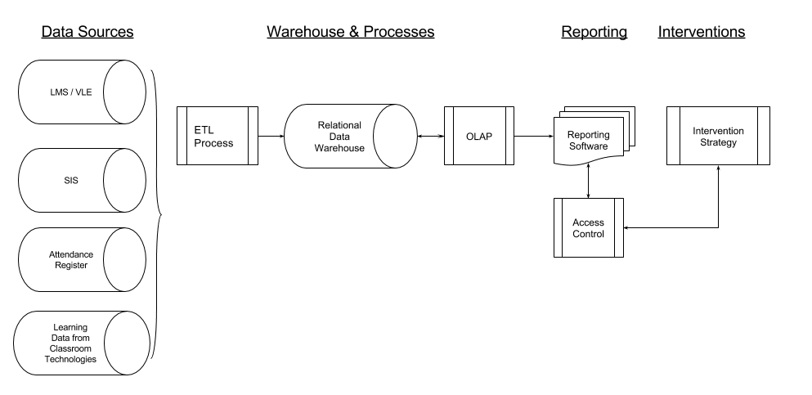
Table 3 represents the analysis from the perspective of the characteristics needed for an institution to be ready for Learning Analytics. The institution would be ready would be if all the statements are in the Yes column, or at least there are no statements in the No column. With respect to Glasgow Caledonian University it is evident the primary set of concerns are around capacity and expertise in statistical and data analysis, and the reliability and sophistication of current infrastructure. This triangulates when asked what is the main barrier for a learning analytics service at Glasgow Caledonian. The main themes included; technical capacity and capabilities, cultural change (both academics and support), and concerns around the collective ability to collect and translate data into actionable information.

Table 3: Evidence statements for Culture, Process, People and Technology Infrastructure for Learning Analytics: Glasgow Caledonian

Yes | Unclear | No
Executive leadership actively supports and promotes the use of technology in teaching and learning | Responsible parties at all levels across the institution take responsibility for developing, analyzing and acting on data and evidence to improve performance of their units | Capacity and expertise in statistical and data analysis
Executive leadership actively encourages a culture of inquiry with data informed decision making with the aim of leading to improvements | Capacity and expertise in pedagogical and curriculum design | The current infrastructure is reliable
A clear vision guides the overall educational practice and technology portfolio | A coordinating body which comprises of high level stakeholders who regularly convene to monitor efforts, infrastructure and evidence for effective data decision making within the institution | The current infrastructure is sophisticated enough for learning analytics
Goal statements support the vision in clear terms that communicate desired end states | Responsibilities are clearly defined and result in an effective process for supporting the education and teaching
Process statements identify the strategies and operational means by which the vision and goals will be achieved.

Section 5: Recommendations

The following recommendations support Glasgow Caledonian University implementing a number of pilot projects around Learning Analytics with the primary aim of enhancing institutional capacity, awareness, and capabilities to ensure readiness.

It was identified through interviews at Glasgow Caledonian, Learning Analytics is a new concept for staff, so they need to understand what it is, and how it might help students and them. There is a need to move this topic into people’s consciousness and discussion. Until this happens, it will remain abstract, which will act as a major barrier to adoption.

The recommendations have not been assigned to owners or undergone prioritization. This needs to be undertaken by the appropriate members of Glasgow Caledonian.

The key recommendation is

- Implement a pilot project using the LMS as the key data source to enable Glasgow Caledonian to enhance institutional understanding, capacity, and capabilities of enhanced reporting and intervention strategies.

The recommendations are subdivided into the four pillars of readiness.

Culture

- Embed Learning Analytics and data driven decision making within the culture, values and beliefs of Glasgow Caledonian University. This should include; approving a working definition of Learning Analytics to be used across the institution, dissemination of a series of white papers on use cases for Learning Analytics with specific context of student support and curriculum design.

People

- Undertake a skills audit within the pilot studies to ensure the different stakeholder groups have the required skills to access, interpret and take effective actions based on the learning analytics data being surfaced

- Undertake a wider review of the likely required staffing levels and capabilities for a Business Intelligence Unit.

Processes

- Create a cross institution coordinating group to promote Learning Analytics with Glasgow Caledonian, and own the institutional pilots.

- Ensure all teaching focused software procurement processes consider data transfer into a proposed University Data Haven

- Undertake a number of development activities to generate intervention work streams which clarify who does what? what are the data triggers? when do they do it? how it will be monitored and enhanced? and what skills sets are required?

- Review the curriculum design and development process across the Schools to ensure programs generate timely, meaningful data to trigger intervention strategies. Particular focus should be on technology enhanced assessment and feedback processes.

Technology infrastructure

- Undertake a wider review the likely IT infrastructure to inform requirements for a Learning Analytics Service and work streams.

- Identify and pilot software services for the data haven and linked reporting technologies which are robust, resilient and can accommodate changing use cases.

Section 6: Glasgow Caledonian University’s Indicative Feature Set & Data Improvement Cycle

Section 6.1: Indicative Feature Set
The Forum captured a range of opinions around the characteristics of an engaged student. There was debate about does engagement with resources represent student understanding. The following represents the main focus on measuring student engagement and should be represented within the indicative feature set; Attendance at taught classes, library use, GCU learn engagement (how often, how long), level of engagement in group activities, exam attendance (performance), coursework, engagement in online discussion groups and engagement with feedback

Given the concerns with the current IT Infrastructure, especially around replacing the SIS. The proposal would be focus the pilot on the LMS and the Lecture Attendance Monitoring Software.

The following are suggested proxies for the level of student engagement;

- the completion a number of formative (online) assessments within the LMS
- login data to specific modules within the LMS
- lecture attendance monitoring data
- satisfactorily completion of summative assessments based on data points within LMS Grade Centre (unratified results).

The onsite engagement identified the consistent view of academics was this initiative should facilitate conversations between them and the student and not simply a student facing dashboard with links to relevant support material. Therefore, the discovery phase does not include the development of a student facing dashboard. Initially the reporting will focus on early alerts for staff (academic teams, personal tutors, learning development tutors and appropriate people in student services). The broad aims are to enable the institution to develop capabilities, capacity and experience of learning analytics before committing resource to more robust, scaleable solution.

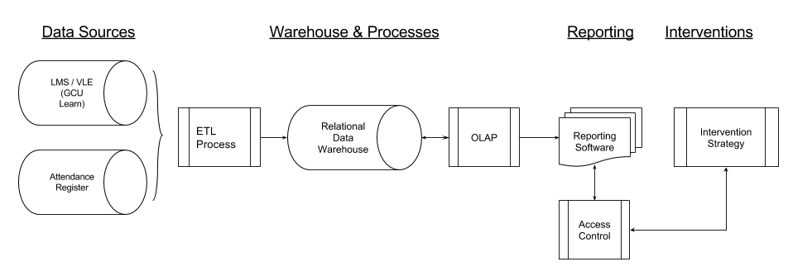
Data Source(s)

- VLE (ELE/Moodle)
- Attendance Monitoring Database (in house development)

Warehouse & Processes

- ETL process to ingest data from multiple sources on a regular basis, e.g. nightly.
  - Querying source systems “live” would have impact on load, and would require all source systems to be available at the point the query is made.
- Relational data warehouse – recommended to support list-based or parametrised reports.
- OLAP layer to data warehouse – recommended to support ad-hoc data analysis and generation of reports in different formats.

Reporting

- A reporting interface and/or notification system to deliver actionable information to key stakeholders in a timely manner and appropriate format, such as dashboards, reports, emails etc.
- Access management to limit access to the data to appropriate members of the institution.

Section 6.2: Data Improvement Cycle
The following outlines a process of developing a data improvement cycle within the context of the strategic theme to identify an individual or cohort of learners to enable a positive support intervention by academic teams and/or learning development centres. The pilot will provide answers to the following questions which were raised during the onsite at Glasgow Caledonian;

- What is Learning Analytics within a GCU context?
- What specific questions do we need Learning Analytics to answer?
- What are the data points and indicators?
- Where does the data reside? How does it need to be stored?
- Who is to access the data? What is the reporting process?
- What are the most appropriate intervention strategies and work flows?
- What are the ethical considerations around using Learning Analytics?
- What changes do we need to make in GUC Policy and Procedures to use Learning Analytics?
- What is the required evaluation framework and enhancement cycle for Learning Analytics at GCU?

The following discovery project is designed build on the requirements and deliver a number of the key recommendations outlined in Section 5.

Table 4: Data Improvement Cycle: Discovery project

Step | Description | Stakeholders
1 | Agree and document what are the appropriate indicators (variables) to represent student engagement. For each of the indicators discuss how they would be represented and likely trigger points for interventions. | Personal Tutors, Student Support Services & LDC Team, Academics (1st Year Programmes), widening participation team, GCU LEAD Team, student representation, DBA/Analyst, Policy & Planning
2 | For 1st year courses / modules, coordinate the design, development and timing of learning activities within LMS which will create the frequent, accurate data at the program level. A suggested timeframe, and tool use would be; online formative objective quiz in week 2 and 3, and the completion of a written task in week 5. | Academics (1st Year Programmes), GCU LEAD Team, LDC Team, Academic Enhancement Team,
3 | Creating the schema for the Data Haven with the required data from LMS (access activity, gradebook data), other required sources (attendance data). This includes a workflow of how to populate the data haven from the data sources, and identify any missing data sources. | IT Services, System Owners (SIS, LMS, Other), DBA/Analysts, Analytics Service Manager, Policy & Planning
4 | Documenting the proposed report creation processes, and workflows of the likely intervention strategies, including ethical considerations, and the evaluation framework. | IT Services, DBA/Analysts, Personal Tutors, Student Support Services, Academics (1st Year Programmes), student representatives, Policy & Planning
5 | Dissemination of outcomes and next steps (Phase 2: Developing Prototype) to key stakeholder groups, and the wider University. | Analytics Service Manager, Internal Comms Team, Analytics Sponsor, Policy & Planning, Personal Tutors, Academics (1st Year Programmes)

Appendices

Appendix: Attendance at Onsite Engagement

Forum | 24 people
Workshop: Student | 1 person
Workshop: Academics | 9 people
Workshop: Professional Services | 12 people

The following people were interviewed:

Name | Title / Role
Bernadette Kelly | CIO
Michael Stephenson | President, GCU Students Association
Mark Johnston | Director of IT
Shirley Rate | ADLTQ GSBS
Iain Stewart & Morag Stewart | ADLTQ SEBE, and Assistant Head SfL and Digital Futures
Prof James Miller | Deputy Principal
Nicola McLarnon | ADLTQ SHLS
Prof Linda Creanor | Head of Blended Learning
Kirsty Rodin | Deputy Director, Policy and Planning

Appendix: Further Reading

A new dawn for learning analytics in UK HE (no date) Available at: http://edtechnology.co.uk/Article/a-new-dawn-for-learning-analytics-in-uk-he (Accessed: 26 August 2015).

Baker, R. and Siemens, G. (2014) ‘Educational Data Mining and Learning Analytics’, The Cambridge Handbook of the Learning Sciences, pp. 253–272.

Barber, R. and Sharkey, M. (2012) ‘Course correction: Using Analytics to Predict Course Success’, Proceedings of the 2nd International Conference on Learning Analytics and Knowledge - LAK ’12, .

Bichsel, J. (2012) 2012 ECAR Study of Analytics in Higher Education. Available at: http://www.educause.edu/library/resources/2012-ecar-study-analytics-higher-education (Accessed: 13 August 2015).

Cooper, A. (2012) CETIS Analytics Series Volume 1, No 5: What is Analytics? Definition and Essential Characteristics. Available at: http://citeseerx.ist.psu.edu/viewdoc/download?doi=10.1.1.269.7294&rep=rep1&type=pdf (Accessed: 14 August 2015).

Griffiths, D. and Cetis (2012) CETIS Analytics Series: The impact of analytics in Higher Education on academic practice. Available at: http://publications.cetis.org.uk/2012/532 (Accessed: 9 September 2015).

Johnson, L., Adams Becker, S., Estrada, V. and Freeman, A. (2015)NMC Horizon Report: 2015 Higher Education Edition. Available at: https://net.educause.edu/ir/library/pdf/HR2015.pdf (Accessed: 13 August 2015).

Koedinger, K. R., Corbett, A. T. and Perfetti, C. (2012) ‘The Knowledge-Learning-Instruction Framework: Bridging the Science-Practice Chasm to Enhance Robust Student Learning’, Cognitive Science, 36(5), pp. 757–798.

Lets Talk Learning Analytics and Student Retention (2014) Available at: http://www.letstalklearninganalytics.edu.au/wp-content/uploads/2015/06/Discussion-Questions-Final-26-May-2015.pdf (Accessed: 9 September 2015).

Morison, S. R., Davenport, T. H. and Harris, J. G. (2010) Analytics at Work: Smarter Decisions, Better Results. Boston, MA: Harvard Business Review Press.

Sclater, N. (2014) Learning analytics The current state of play in UK higher and further education. Available at: http://repository.jisc.ac.uk/5657/1/Learning_analytics_report.pdf (Accessed: 13 August 2015).

Whitmore, J., Schiorring, E., James, P. and Miley, S. (2015) ‘How Students Engage with a Remedial English Writing MOOC BRIEF A Case Study in Learning Analytics with Big Data’, Educase Learning Initiative: Brief,

