Guide to adding publications to Pure

- Log on to Pure using your domain user name and password.

Choose an appropriate template

- Click the + Add content button at the top right hand side of the screen and choose the template that fits the publication type for example article or conference proceeding.

- The Submission guide section displays the most common template types.

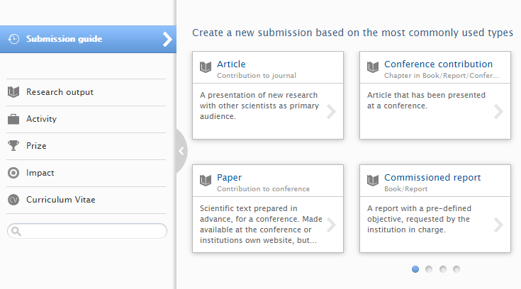

- To view the complete range of templates available, select the Research output section from the left hand side menu. Clicking on each section will display the range of template options for example Contribution to journal.

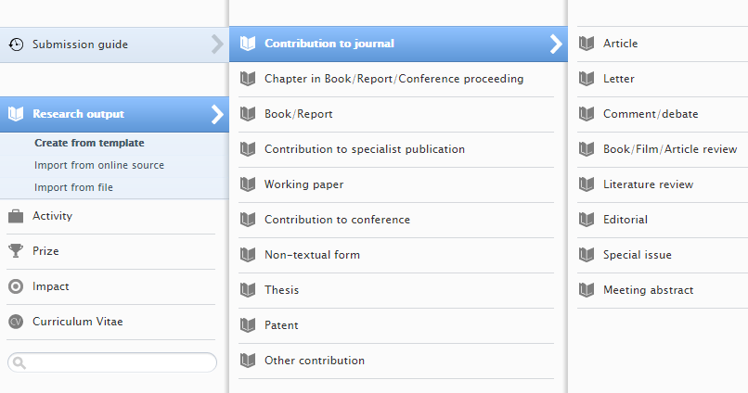

Add metadata for your output

- Add the available publication data to the record including the DOI or alternative link if available. Fields marked with an asterisk are the mandatory fields to be completed.

- To add the early online date for an article, select the Epub ahead of print option from the Publication status field drop-down and complete the date.

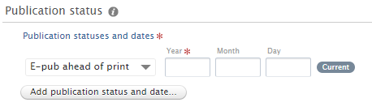

- If the article or conference proceeding is at the acceptance stage and not yet published select the Accepted/In press option instead and complete the date.

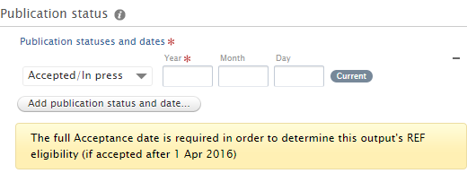

- To add co-authors select the Add person option from the Contributors field.

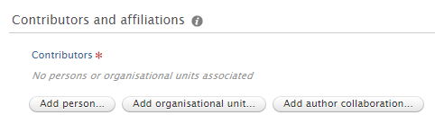

- Use the search box to find internal GCU authors. The author surname should appear in the search results to complete the entry and add to the record.

- External authors can be searched for in the same way. For external authors not found in the search results select Create external person.

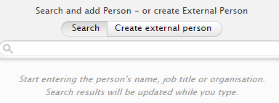

- Add the author name and select the Country from the drop-down list. Choose the relevant external affiliation for the author by clicking on the Add organisational unit.

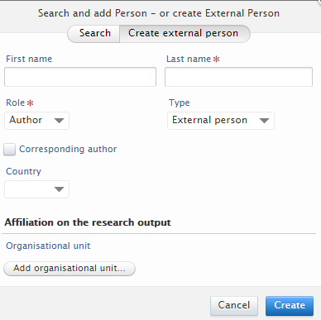

- Use the search box to find existing external organisations. If no results are found choose Create external organisation for a new entry. Complete the Name and the Country fields within the popup window.

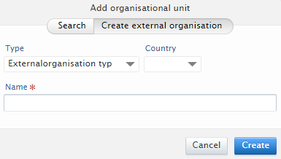

- To add a DOI click on the Add electronic version (file, DOI or link) button

- Select Add DOI of an electronic version to enter the DOI code and update the field.

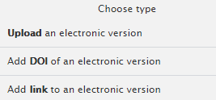

- To add an alternative link such as a publisher or conference event website, select the Add other link button to open the field and insert the web address.

Upload a file

- To upload a file choose the Add electronic version (file, DOI or link) and select Upload an electronic version.

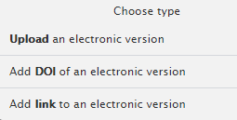

- If uploading an accepted author manuscript Word files are the preferred format for Pure.

- Within the popup window use the browse option to select the file from your computer.

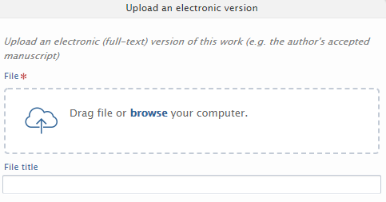
- Once the file is uploaded select the file version from the Document version drop-down for example Accepted author manuscript.

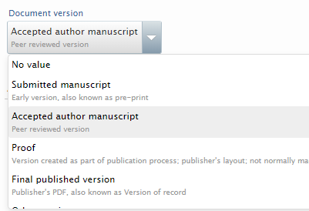

- Leave the Public access to file field set to Open. This is the default option and all files will be checked by Library staff for publisher permissions.

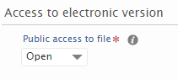

- Select Create to complete the document upload and then select Accept licences on the Pure storage licence pop-up window. This will take you back to the publication record which should now show the attached file.

Submit your output for validation

- Once the metadata is complete and any files uploaded, check the record status is set to For validation and click the Save button at the end of the form.
- Your publication record will now enter the validation queue with the library. The library will check, review and edit the record before it can be validated. If key information is missing library staff will contact you.

- The publication metadata will be displayed on the research portal upon validation.

- Publication files added to Pure will be made available for open access download according to publisher policies and may be placed under a temporary embargo in line with publisher repository permissions.

- If your publication metadata has already been validated by the Library, the record will be locked for further editing. Authors can request changes to records by contacting libraryresearch@gcu.ac.uk and the library will confirm when the record has been updated.

For any questions on this process please contact the library repository team at: libraryresearch@gcu.ac.uk.

