Steps to access and update your researcher profile in Pure

- Log on to PURE using your domain user name and password.
- Click the Personal overview tab and then click Edit profile

- Once the Edit profile area has been accessed, there are a number of areas in your Research Profile that can be updated. Areas include:

Personal identification
- Nationality
- Name variant
- Title (including Academic degree titles)
- ID (identification numbers, including Scopus Author ID)
- Profile photos (both portrait photos and a photo gallery, see section 4 below)
- Links (including social media profiles)
- Dates as an independent researcher
- Retirement date

Curriculum and research description > Profile information (see section 5 below)
- Research interests
- External grants

Positions outside of the institution
- External positions

Education/Qualifications

Sustainable Development Goals

Portal details
- Willingness to take PhD students
- PhD research projects available

Personal expertise
- Area of expertise
- Willingness to talk to media

Visibility
- Ensure Visibility is set to “Public – No restrictions” under the Visibility section

- To upload a photograph click on the Add file button under the Profile photos section.
- Upload your photograph using the “drag file of browse your computer” option.
- The Type option should be left as Portrait.
- Click Create once your file has been uploaded.
- It is recommended to crop any photograph to a 1:1 or square aspect ratio before uploading.

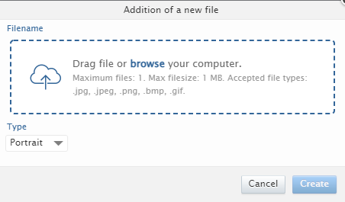

You can also add images to an image gallery within Pure. Images added using this feature are visible on the Research Profile on ResearchOnline.

To add an image to the image gallery within Pure:
- Follow the above outlined process, however set the Type option to Gallery
- Click Create

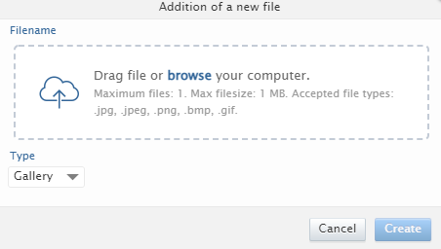

- To update your research interest and personal description click on the Add profile information button under the Curriculum and research description section.
- Click Create once you have added the text for your research interest and personal description.

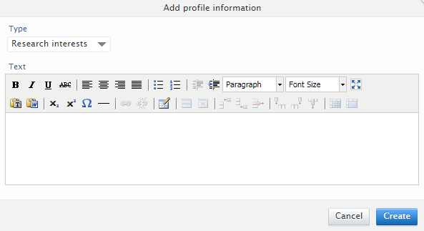

- Click Save in your research profile to save any updates you have made.

