A guide to developing fully online modules in GCULearn

GCU LEAD Digital Learning Team
Glasgow Caledonian University
October 2015

Contents
1. Introduction 5
2. Preparing to teach online 6
3. Your students 6
4. Structuring an online module 7
4.1. The module menu 7
4.2 Welcome and introductions 8
4.3 Contact Details 9
4.4 Module Overview 9
4.5 Guidance on Learning Online 11
4.6 Announcements 11
4.7 Organising Module Activities and Content 12
4.8. Reading list 14
4.9 Assessment and Feedback 14
4.10 Blogs, wikis, e-portfolios 16
4.11 Student area 17
5. Communicating Online 17
6. Checklist 18
Appendix 1 20

Developing fully online modules in GCULearn
_____________________________________________

1. Introduction
This guide aims to support the development of high quality online modules in GCULearn. The virtual environment is central to the online student’s learning experience and their perception of GCU, so offering engaging learning activities within a carefully structured and well-organised framework is vitally important. Before beginning the development work, we recommend that you undertake a curriculum design process with colleagues on the module team to develop a plan for your online module. Support for this can be found in the ‘Guide to Curriculum Design for online modules’ (available under the Staff Help tab in GCULearn).
Online development is informed by the principles of the GCU Online Learning Experience, namely that it should be: student-centred; well-organised; challenging; inclusive; interactive; and socially engaged.
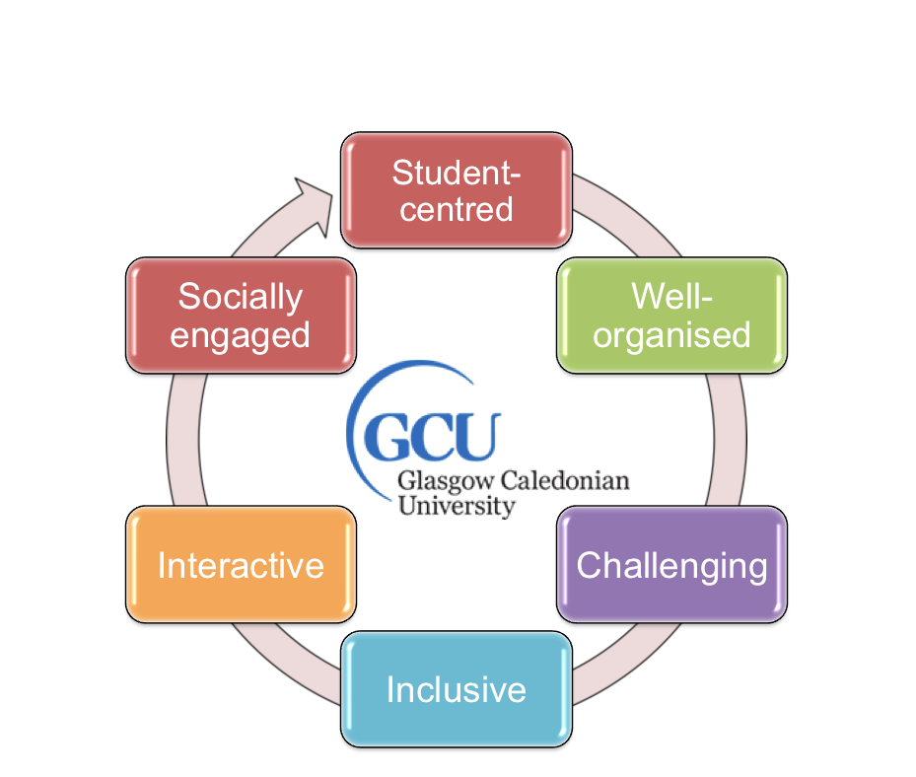
Figure 1: GCU Online Learning Principles

Online modules will differ in structure and format depending on the learning outcomes of the module, the preferred learning and teaching approach of the module team and the subject studied. There are however a number of common elements that should be included to support students and encourage engagement. Before starting the development work it is important to consider the implications of teaching online.

2. Preparing to teach online
Most academics are already experienced in creating digital resources and online activities for their students in GCULearn, so why should developing modules for fully online delivery be any different?
One answer to this is that students studying online and at a distance do not have the same opportunities as campus-based students to meet tutors and peers, ask questions, seek support or experience the social aspects of life on campus. For those reasons, online students need to be highly motivated as well as confident, independent learners. Retention and progression can become a problem if students do not find the experience of learning online stimulating and engaging. Some of the factors to consider are listed below:
- Students studying online and at a distance need explicit, detailed information on all aspects of their study, including studying online, timescales, learning activities and assessments.
- Creative thinking and careful planning are required to ensure online students remain motivated and engaged throughout the module.
- An activity-based approach is more likely to encourage online collaboration, peer support and effective learning.
- A more student-centred approach implies a change in role for the tutor as a facilitator of learning.
- Online communication relies primarily on text-based rather than verbal communication and therefore requires a different style.
- Developing an online presence and a digital identity needs to be considered, especially if social media is involved.
- Resources may need to be adapted and transformed into a variety of new digital formats.
- Establishing an online learning community and managing group work will be a new experience for those more used to supporting students in face-to-face groups.
- Time management, for tutors and online students, is a key issue.
- For programmes with international students, cultural differences can often become more obvious in the online environment and need to be taken fully into account when planning resources and activities.
- And finally, consider the kind of pedagogical and technological support you might need to become an effective online tutor and where you will access it.

3. Your students
The first stage in a student-centred approach is to consider who your students are by asking yourself the following questions:
- Are they undergraduate or postgraduate?
- Are they new to HE?
- Do they have previous experience of learning online?
- How much academic support are they likely to need?
- Will they need access to technical support?
- What kind of internet access and broadband capacity will they have?
- How will they access module content?
- Will mobile devices be used?
- What kind of induction will they need and how will this be managed online?
- Are there likely to be cultural or language issues to take into account?
- How will accessibility issues be addressed?
Answers to these questions will help to determine the learning and teaching approach, the types of resources needed and the style and frequency of communication.

4. Structuring an online module
The next stage is to start building the module structure within GCULearn. For help in using the various tools within GCULearn, please contact your School Learning Technologists. You can also access support resources from the Staff Help Tab within GCULearn.
The following sections highlight the main features that should be included in all online modules to enhance quality and consistency.

4.1. The module menu
The first thing students will see when they log on to a module is the menu and the headings within it. The menu guides students to different parts of the module and the resources they need to study successfully so the menu items should be clearly labelled and logically structured. A programme team may decide to create a standard menu structure across all modules, or, as is more likely, there may be variations in menus across modules depending on the learning and teaching approach and the nature of the subject. For example, module activities may be divided into weeks, topics or units, and may include frequent, short learning activities, a mix of individual and group activities, or fewer, more in-depth assignments. Most modules will include a combination of these.
All modules should include standard information about the module, including: tutor contact details; learning outcomes; reading lists; assignments; and timescales., A few sample menus from GCU modules are shown in Figure 2.
The overall design, colour schemes and any additional graphics to enhance the appearance of the online modules should be agreed in collaboration with School Learning Technologists who will be able to advise how the basic menu structure in GCULearn can be adapted. Short guides on how this can be done can also be found at -
https://www.youtube.com/watch?v=14NsBGUyKSs https://www.youtube.com/watch?v=WEkaunZISIg
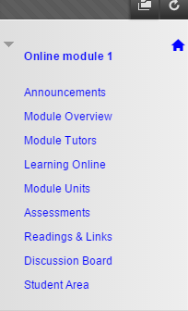 | 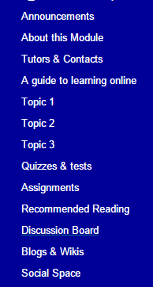

Figure 2: sample menu structures

Decisions will also need to be made about how much information and content is to be made available to students at the beginning of their module. To encourage students to log on regularly, it can be useful to introduce new activities, information and resources on a regular basis to maintain interest and enhance motivation. Students may find it daunting if there is too much to take in the first time they log on, therefore some careful advance planning is required. The adaptive release feature in GCULearn can be used to manage the availability of menu items, content and learning activities. Enabling statistics tracking can also be used to monitor student access to various aspects of the module which may help to identify levels of engagement with different resources and online activities as the module progresses.

4.2 Welcome and introductions
First impressions are important so the landing page for the module should be welcoming and informative. You may decide to make the Announcements page the landing page and post a welcome message there as in the example below, or you may decide to design a separate introductory section with its own link from the main menu.

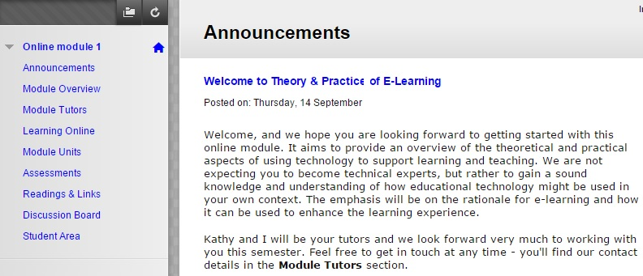
Figure 3: sample welcome announcement

It is important for online students to have a sense of tutor presence and for this a friendly tone is important. You may decide to include a short introductory video or podcast to introduce the module team and what the students might expect from a particular module.

4.3 Contact Details
Tutor contact details, including availability and preferred communication mode (e.g. email, phone, skype etc) should always be included. For online students, seeing a photograph of each tutor helps to create a sense of presence and engagement. You may also wish to add details of social media sites you use for professional purposes such as LinkedIn, Twitter or Slideshare.
Contact details for the Programme Administrator should also be included, and information about any technical or academic support they may access, e.g. IT HelpDesk and Learning Development Centre.

4.4 Module Overview
Each module should include clear information about the module learning outcomes, its overall structure and the assessment calendar. The module handbook should be available to download, but the important sections should also be easily accessible so you can be sure they have been drawn to the attention of students. Fig 4 provides examples of how this could be structured.

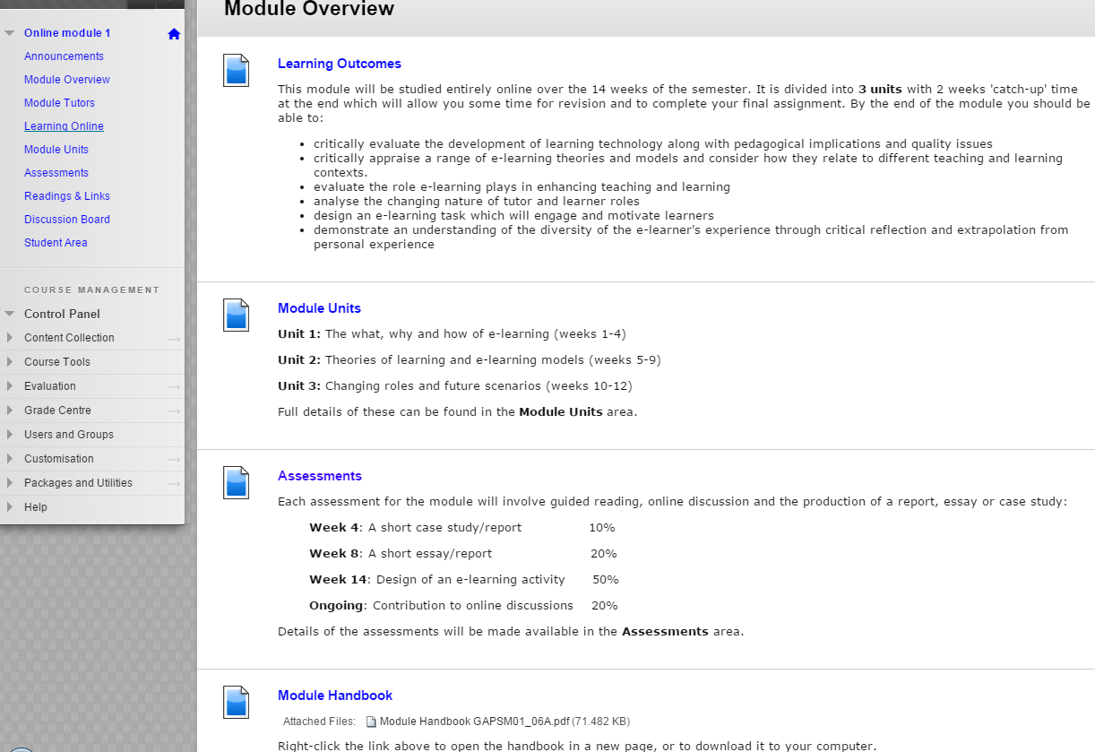
Figure 4: Module overview 1

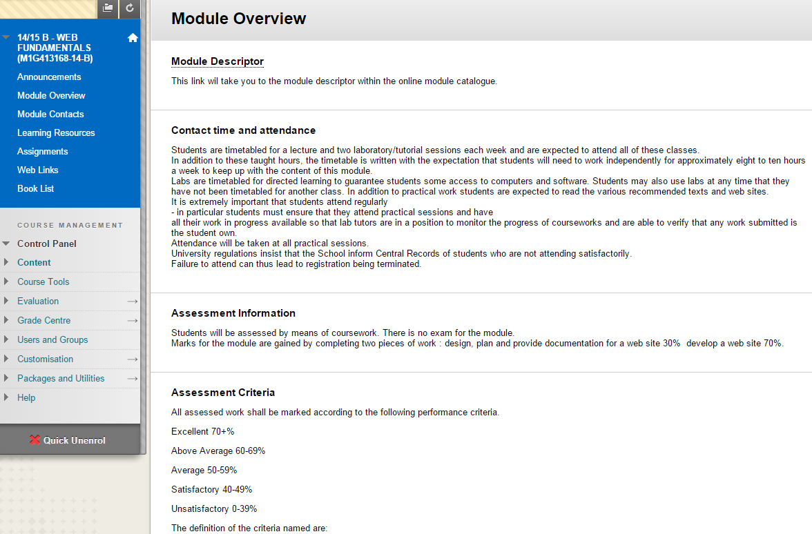
Figure 5: Module Overview 2

4.5 Guidance on Learning Online
Your module handbook will have information on the learning and teaching approach, but it is still important to draw the students’ attention to the differences involved in learning online and what kind of support they can expect. The example below makes explicit what these expectations might be. Students will also want to know how and where they can access technical support when required, and also academic support.
Making it clear to students what they can expect from tutors is important too, as this helps to manage time and expectations. For example, providing a timeframe within which you will respond to email or discussion posts helps to avoid frustration when you are not in a position to reply right away.
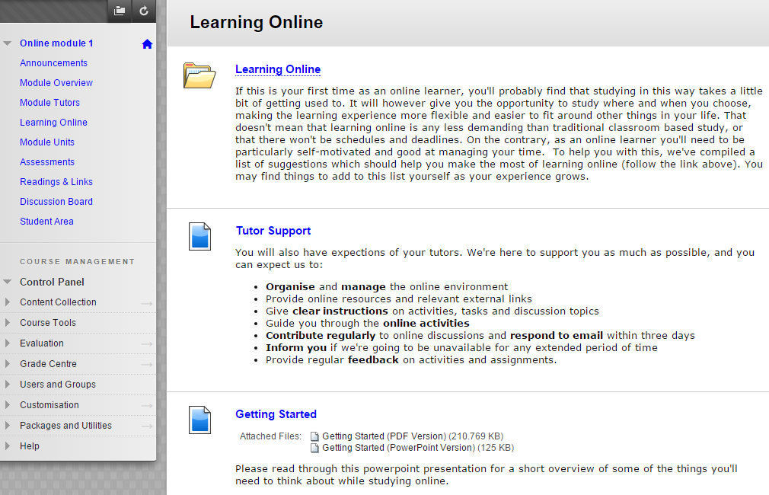
Figure 6: Guidance on learning online

4.6 Announcements
As an online tutor you will be communicating with students in different ways either as a cohort, in groups or individually. As the online module progresses, the tutor’s presence should be felt through regular messages of encouragement, signposting of activities and reminders of next steps. This will normally be done via the Announcements page so that it is visible to all students when they log on.
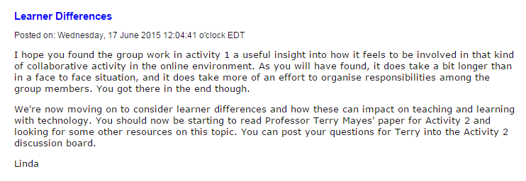
Figure 7: sample announcement

4.7 Organising Module Activities and Content
As noted in section 3, module content and associated activities will be structured differently according to the nature of the subject, the learning outcomes and the pedagogical approach. There is no single recommended way to do this, but whichever approach is chosen, students should be able to find the all their learning resources and activities quickly and easily. Some examples are provided below (Fig 8).
It is worth remembering that there is plenty of scope for variety in the online environment and that it is not simply a case of transferring existing activities from a campus based course. Importantly, the lecture is no longer the primary focus for learning online. Some example activities and associated resources are listed in Appendix 1.
Accessibility issues should also be considered. Where formats other than text are being used, it is important to provide alternatives where possible, such as transcripts for video or audio resources. Jisc provides useful advice on this and GCU’s disability team can also help students with advice on assistive technologies
www.jisc.ac.uk/guides/using-assistive-and-accessible-technology-in-teaching-and-learning www.gcu.ac.uk/student/disability/assistivetechnology/
Copyright issues are also important when creating or re-using digital resources in the online environment. Open educational resources with creative commons licences can be especially useful for online learning. Guidance on these is available from the Library at www.gcu.ac.uk/library/usingthelibrary/copyright/
The Library provides edShare@GCU, a repository which accepts permanent learning and teaching resources created by GCU staff. For help and advice on this please contact edShare@gcu.ac.uk
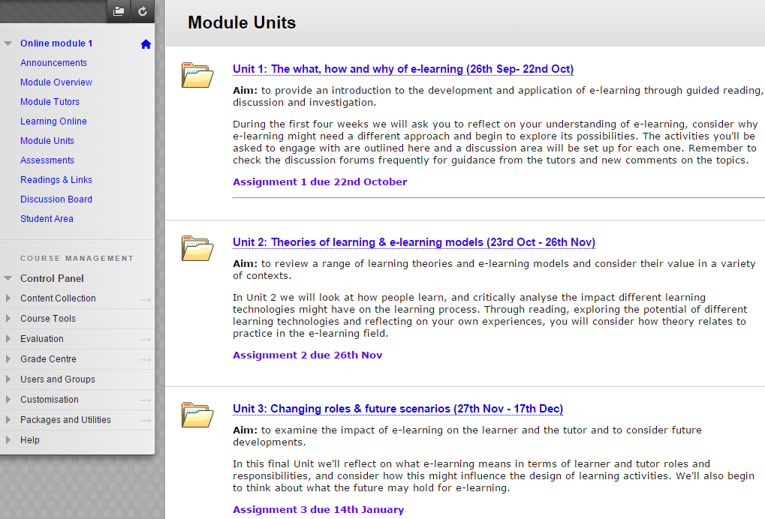
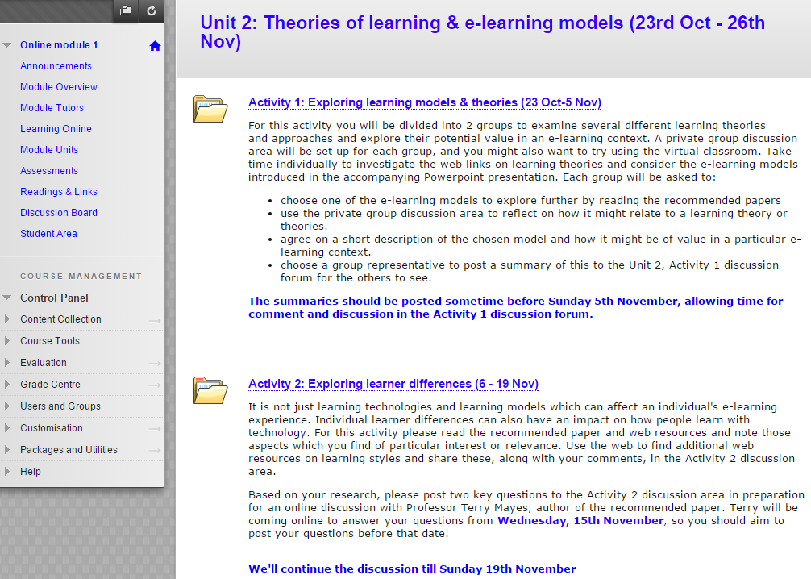
Figure 8: two examples of module content structure

4.8. Reading list
There should be a direct link from the module menu to the reading list for the module. For online students it is particularly helpful if most of the recommended texts are available in digital format.
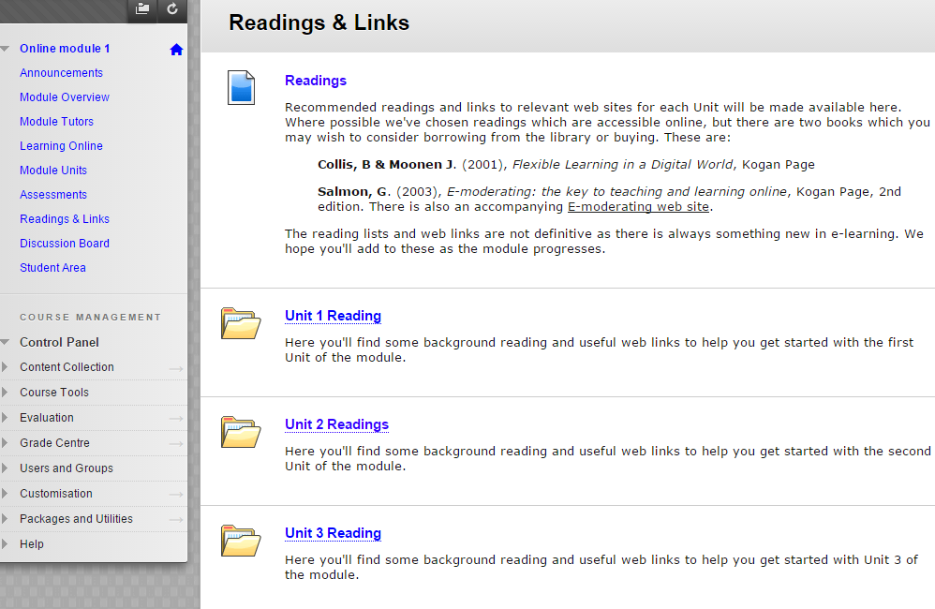
Figure 9: Sample Reading list structure

Importantly, remember to email reading lists to the library as soon as they are ready so that required readings can be made available for students. Guidance on how to do this is available from the library web site at http://www.gcu.ac.uk/library/servicesforstaff/readinglists/
It is also recommended that you add a link to the library guides on information literacy, search skills and plagiarism, which include the online guides for undergraduate students SMILE and its mobile version SMIRK. PILOT is aimed at postgraduates. Further information is available at http://www.gcu.ac.uk/library/subjecthelp/communicationandsearchskills/

4.9 Assessment and Feedback
There should also be a direct link from the main menu to the Assessment schedule for the module. This should provide clear details of the assessments, including deadlines and submission guidelines.

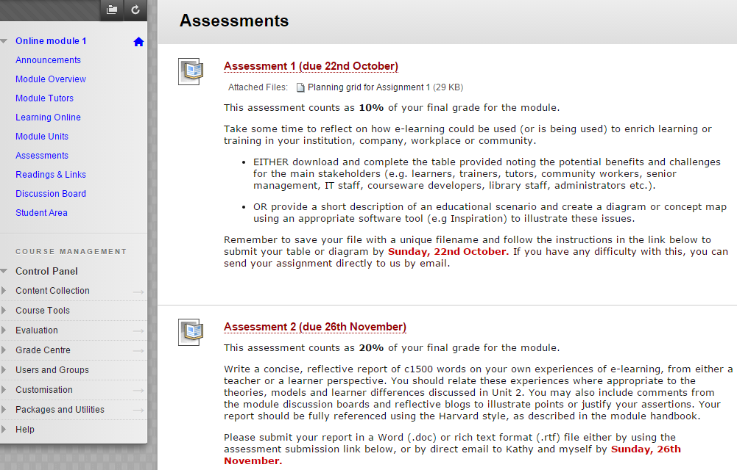
Figure 10: sample assessment information structure

Grading criteria for each assignment should also be available. An increasing number of modules are using Grademark and the Rubrics feature within it to provide these within GCULearn. If you are unsure about using these, your School Learning Technologists will be able to help.
If online contributions to discussion forums, blogs, wikis or social media sites are being assessed in some way, the criteria for assessing online participation should be clearly described before the activities begin.
Students should also be informed of how and when they will receive feedback, and made aware of different types of feedback they will experience and how they can act on it. This may include formative as well as summative, and self, peer and tutor feedback. Some modules have introduced a Feedback link from the main menu which takes students directly to generic tutor feedback on assignments which is relevant for all students on a module. Students should also be directed to the GCU Feedback Principles and the associated resources for students at http://www.gcu.ac.uk/futurelearning/studentinformation/
There should also be a statement about plagiarism and a link to PLATO, the online plagiarism tutorial, embedded within the appropriate section of the module(available at http://plato.gcal.ac.uk/plagiarism/index.html).
Guidance on the use of Turnitin for similarity checking and online submission should also be included. Learning Technologists have made guidance available within Schools, and there is also a Quick Guide to Turnitin for staff under the Staff Help Tab in GCULearn.

4.10 Blogs, wikis, e-portfolios
Reflective blogs, collaborative wikis and e-portfolios are used in many modules to support a range of learning activities. Again a direct link from the menu makes it easier for students to access them.
When social media applications outwith GCUlearn are used, you should make yourself familiar with the Social Media Guidelines for Learning and Teaching which are available from the Staff Tab in GCULearn.
Several social media and file-sharing applications such as YouTube, Slideshare and Twitter can be embedded directly within GCULearn as additional resources. School Learning Technologists will be able to provide guidance on how to do this. An active Twitter feed within a page in GCULearn can provide regular new information and comments, and transform a static page into a frequently updated one.
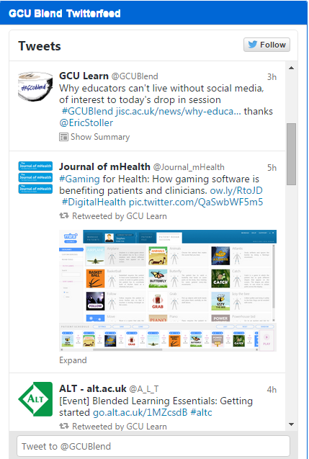
Figure 11: Example of an embedded Twitter feed

4.11 Student area
Where students are studying online and at distance, they can sometimes feel isolated and unsure about communicating with their fellow students in a more informal way. Setting up areas which students can access to share experiences and support each other can help to create a sense of group identity and belonging, which in turn can impact positively on motivation and retention. This may be done though creating a separate ‘social space’ as in the example below, linking to a discussion forum or shared wiki where students can interact without the tutor being present.
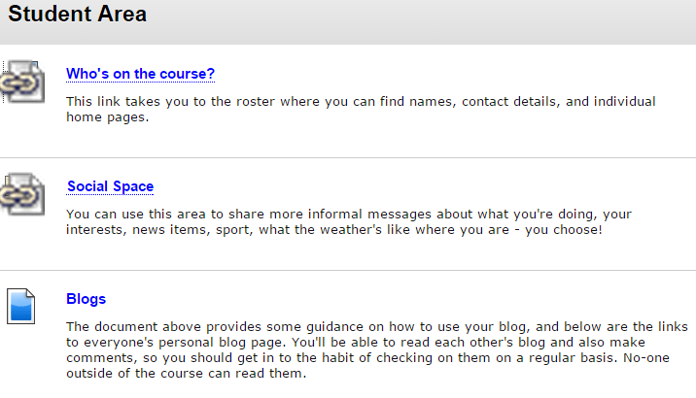
Alternatively, online students may be encouraged to set up their own areas using social media sites such as Facebook where they can get to know each other in a more informal way. Tutors may or may not be invited to join the group, but before agreeing, tutors will need to consider the implications for their professional identity in this type of forum.

5. Communicating Online
Once teaching starts, it is important to maintain regular communication with the online cohort in order to encourage and motivate them as they engage with the course content, the learning activities and each other. Creating an inclusive and supportive online learning community will aid retention and help to increase student satisfaction and success.
As noted earlier, as an online tutor you will need to develop an online presence and establish your identity with the students. While you may occasionally use videoconferencing, the majority of online communication is likely to be text based. Without the cues of body language and facial expression, the focus is entirely on the words used therefore more attention needs to be paid to the manner in which we express ourselves online, whether it is through email, GCULearn announcements, or facilitating online discussion forums. This is particularly important at the start of a module when students will be looking for reassurance and encouragement.
Setting the tone is a key aspect of the online tutor’s role. If they are new to online learning, students may find it difficult to judge whether to adopt a formal or informal tone, or what an acceptable length might be for contributions to an online discussion, wiki or blog. By modelling the style and tone which suits your learning and teaching context, and providing clear guidelines on expectations for discussions and coursework, you can help students to adjust quickly to communicating in the online environment. Some simple steps can help:

- Ensure the title of email messages or discussion posts are meaningful.
- Keep messages reasonably short and concise, and structured in short paragraphs rather than unbroken lengths of text
- Highlight key points in bold text
- Personalise responses with phrases such as ‘I agree…’; ‘I’m confused..’;’ I’m finding this very interesting…’.
- Use encouraging phrases such as ‘Good idea’ or ‘Thanks for the suggestion’.
- Use humour sparingly, especially if you have students of different nationalities
- Encourage courteous and considerate behaviour online, and deal quickly with any inappropriate comments or contributions

6. Checklist
Finally, it is worth spending some time reviewing and checking over what you have done, ideally with feedback from an experienced critical friend. A check list like the one below, which has been agreed with all the members of your module team, can be a useful way to do this.

Topic | Notes
Have you considered the needs of your students?

Can students find what they need quickly and easily via the module menu?

Is there a friendly and welcoming announcement, video, podcast or web page?

Is there guidance for students on learning online?

Are contact details available for all tutors, programme administrator(s) and academic advisor(s)?

Do the students know how to access academic support? IT support?

Is there a clear and comprehensive module overview?

Is the module handbook available to download?

Is there guidance for students on learning online?

Have you outlined what the students can expect from online tutors?

Have you planned for ongoing announcements to encourage students, send reminders and signpost upcoming activities?

Are the module resources in an appropriate digital format?

Have you considered sourcing or creating open resources with a creative commons licence?

Have you created a logical structure for module content?

Is there a clear reading list with links to relevant resources and has a copy been sent to the Library?

Is there a link from the menu to an assessment section, with detailed information on assignments, grading criteria, deadlines, and submission guidelines?

If using social media, have you provided guidance in line with the GCU Social Media guidelines for Learning & Teaching?

Is there an online social area for students within GCULearn or elsewhere?

Has the style and frequency of communication been discussed among the module team?

Have the learning resources been copyright checked and are they all accessible?

Appendix 1
Examples of suggested online learning activities – to be added to by module teams
Online Activity | Purpose | Digital Resources and tools
Web search | - To find new information and evaluate sources | Search engines;  Library databases;  Google Scholar;  Collaborative wiki to share & critique findings;  social bookmarking tools (e.g Diigo; Delicious; Scoop.it)  Discussion forum
Case study | - To support problem-based learning  - To provide basis for discussion and debate | Relevant digital resources including documents, web sites, video & audio clips.  File sharing sites such as Slideshare, YouTube, Flickr;  Reflective blogs.  Discussion forum including Q&A with invited expert.
Create a report | - To clarify knowledge and understanding  - To inform decision making processes | Relevant digital documents;  web sites;  online newspaper/journal articles;  recordings of TV & radio reports (e.g Box of Broadcasts);  interviews with stakeholders;  stats, graphs and financial reports;  Excel spreadsheets;  shared file space (e.g. Dropbox)
Role play | - To enhance understanding of the perspectives of stakeholders affected by a particular event, legislation or medical situation. | Documentation in a variety of formats for background information;  discussion forums;  videoconferencing;  synchronous chat;  collaborative wiki to share views and progress;  Individual reflective blogs.
Group presentations | - To acquire and share knowledge and understanding  - To develop presentation skills  - To encourage collaboration and team working | Group discussion areas in GCULearn;  shared whiteboard;  real time chat;  videoconferencing;  documents and web sources to inform development work;  PowerPoint;  Prezi;  Sway;  Blendspace;  Camtasia;  Slideshare
Quizzes and tests | - To test knowledge and understanding  - To create basis for discussion  - To encourage self-regulated learning  - Module evaluation | Test and survey tools in GCULearn  Question banks for randomisation and future use  Discussion forum to share results and clarify points
Discussion and debate | - To stimulate online interaction  - To deepen understanding and encourage critical thinking | Group discussion areas;  Twitter  YouTube videos  Box of Broadcasts (BoB)  Videoconferencing  Expert invited to present online  Recorded lecture  Online seminars (e.g. Google Hangouts, Skype; Adobe Connect, Collaborate, WebEx)
Simulations, virtual labs, virtual field trips | - To encourage experimentation with different scenarios | Interactive scenarios created with a simulation or animation tool, (e.g. Flash)  Immersive worlds (e.g Second Life)  Lab simulations online
Additional suggestions & notes

The GCU Guide to Developing Fully Online Modules by the GCU LEAD Digital Learning Team is licensed under a Creative Commons Attribution-Non-Commercial-ShareAlike 4.0 International Licence

