Using My Bookshelf on BrowZine
You can choose to personalise BrowZine using the My Bookshelf function. To begin with you will need to create an account with BrowZine.
Connect to BrowZine [link: https://gcu.idm.oclc.org/login?url=http://browzine.com/libraries/1263] and click on My Bookshelf.
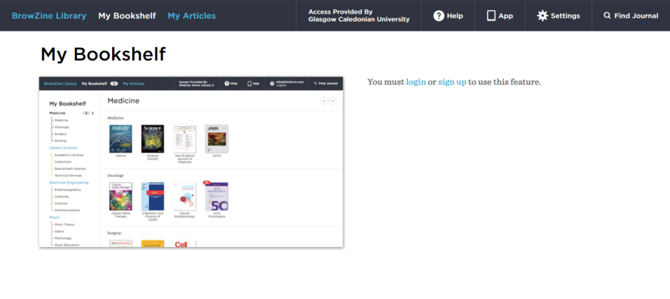Click sign up and then follow the on screen instructions to create your account. You can sign up to BrowZine with an email address and password of your choice.
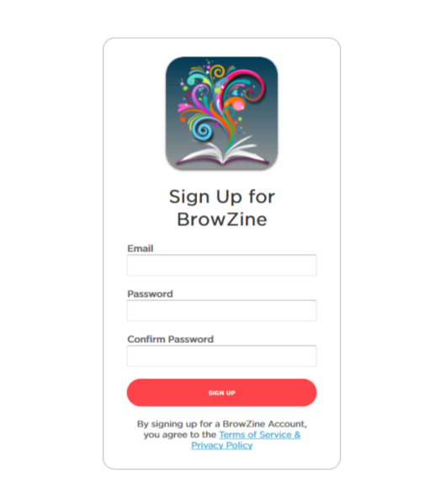
You will then be sent a confirmation email. Click confirm my email and you will be redirected to your My Bookshelf area in BrowZine.

You can easily customise your bookshelves by adding labels
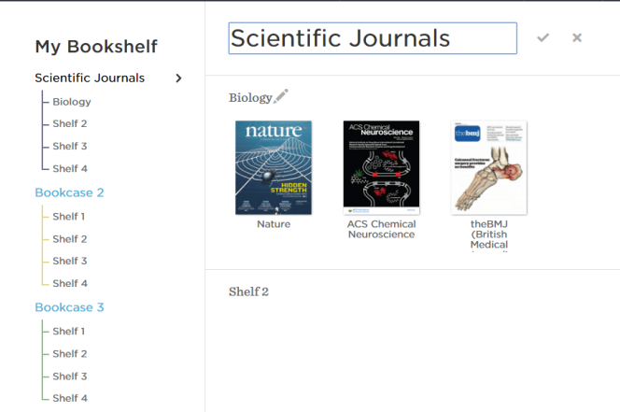

To add titles to your bookshelf, use the search box to find the title you are after. Once you are on the journal page, you can click the add to my bookshelf link.
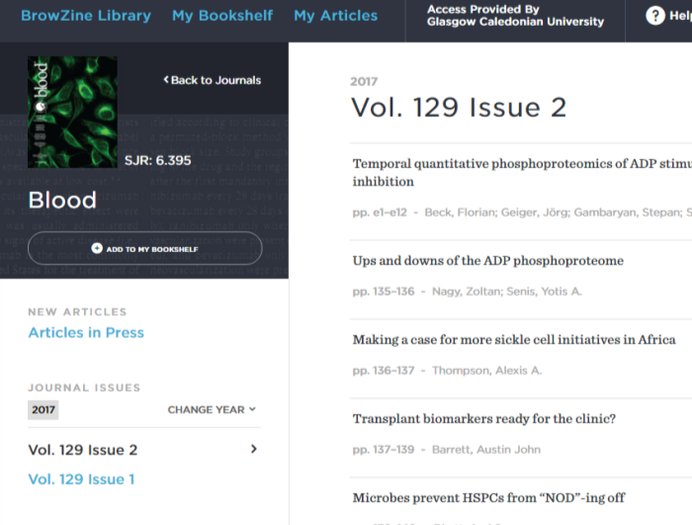

This will automatically add the title to your bookshelf.
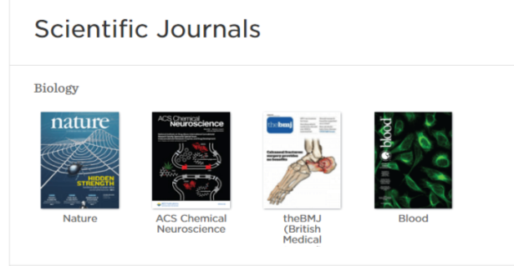
You can move or delete items at any time by hovering over the journal cover and clicking on the menu icon.
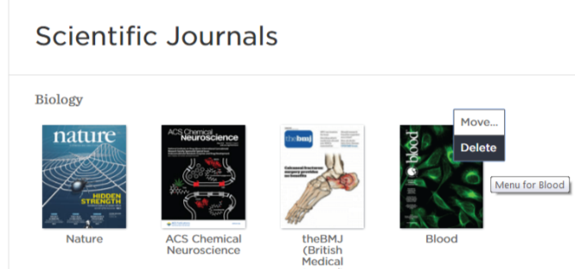

Unfortunately, it is not possible to add titles from certain publishers to your bookshelf. These titles will be marked with a grey journal icon. You can still view the journal content, but you will be redirected to the publisher’s website.
