Using the BrowZine App

Logging into the app
When you open the app for the first time you will be prompted to choose your library from an alphabetical list. Scroll down until you see Glasgow Caledonian University, or use the search bar, and select by tapping the name.
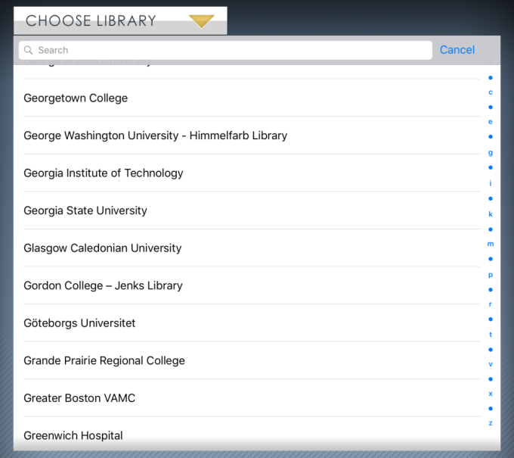
You will then be prompted to log in with your University Domain username and password.
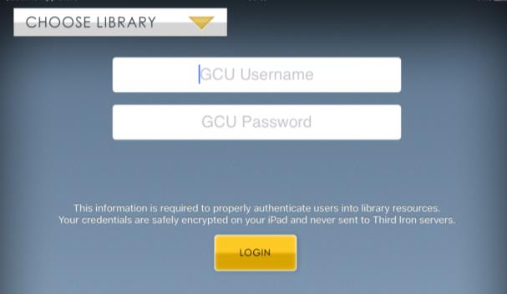
You will then be directed to the BrowZine app homepage.

Browsing journal titles
There are several ways you can browse our journal collections in BrowZine. You can use the Subjects tab to search different subject areas.
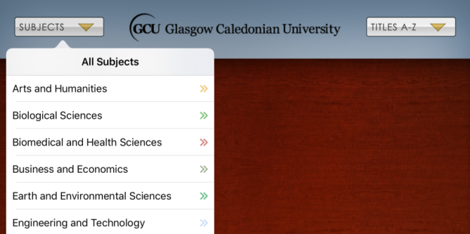
Alternatively you can use the search box to find your specific area of interest.
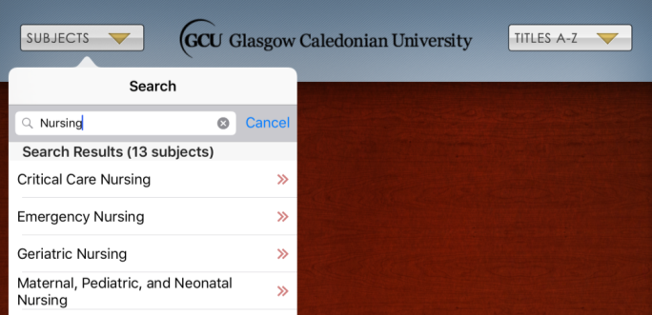
Once you select your area of interest you will be shown the associated journal titles. You can browse the different titles by dragging the icons from right to left.
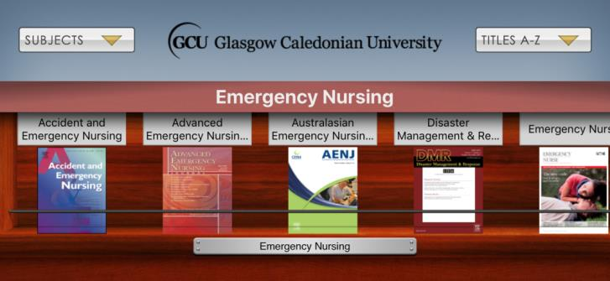

You can also use the Title A-Z to browse all the titles in our collection or the search box if you are looking for a specific title.
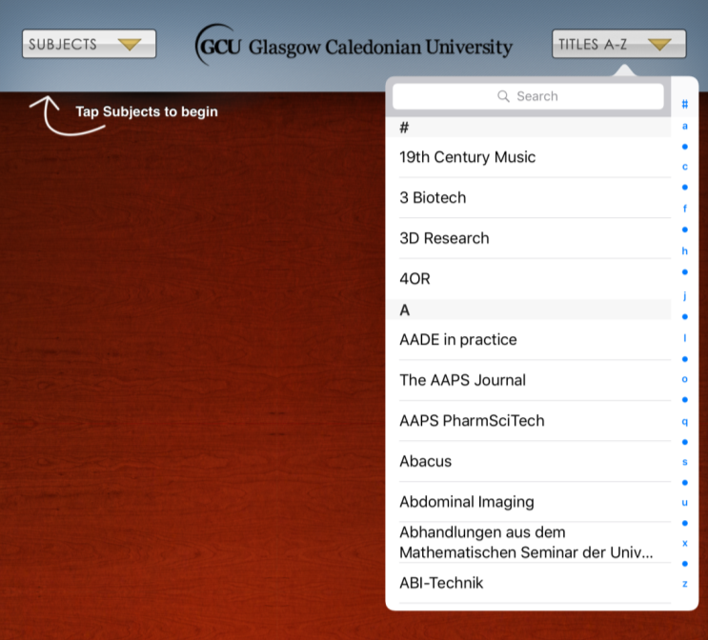

Adding titles to My Bookshelf
You can track journal titles you are interested in by adding them to My Bookshelf. You will receive notifications when new issues are added. To add a title to My Bookshelf, tap the yellow Add to My Bookshelf icon on the journal homepage.
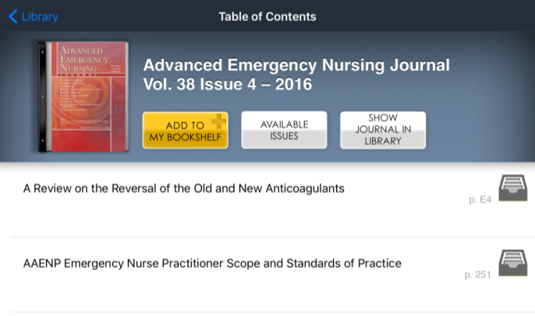

You will then be taken to your bookshelf, where you can drag and drop the journal icon onto your shelves.
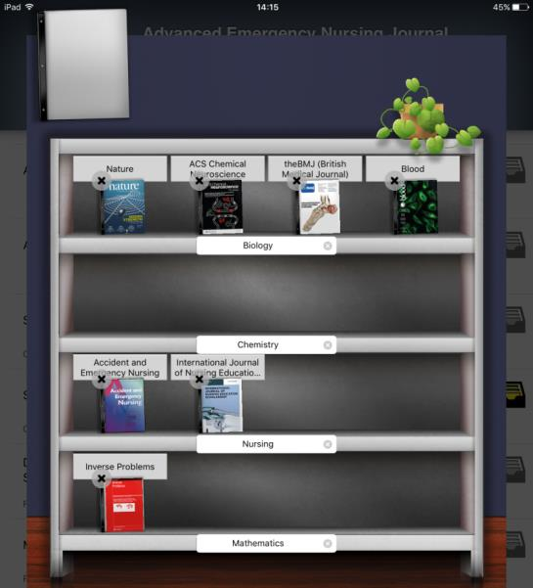
You can visit My Bookshelf at any time by using the menu at the bottom of the screen. Each user has four bookcases and you can customise these by adding different labels to the bookcases and shelves. Tap Edit at the top right hand side of the screen to edit the labels in the My Bookshelf area.
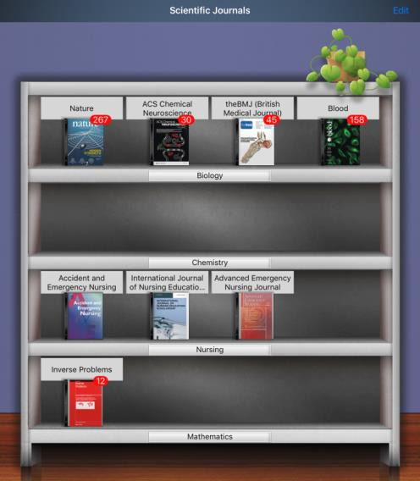

Using My Articles
You can save any articles you are interested in to the My Articles section of BrowZine. To do this, tap on the grey folder icon next to the article title. This will then turn yellow and your chosen article will be saved.
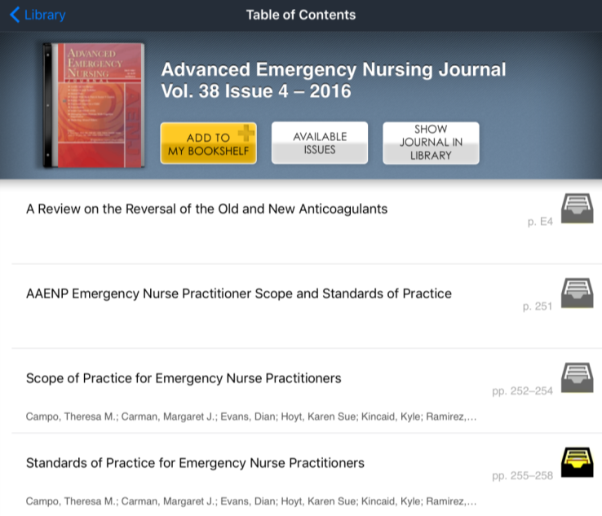
You can access your saved articles by using the menu at the bottom of the screen. You can also customise any labels in this section by tapping Edit in the top right hand side of the screen.
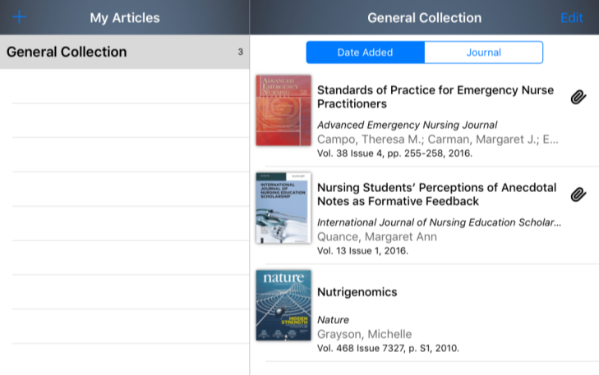

Exporting citations to RefWorks
You can export the citations of journal articles you read in BrowZine directly to your Refworks account. To do this, tap the Share icon in the top right hand corner of the screen. You will then see the RefWorks icon under the heading Bibliographic Management.
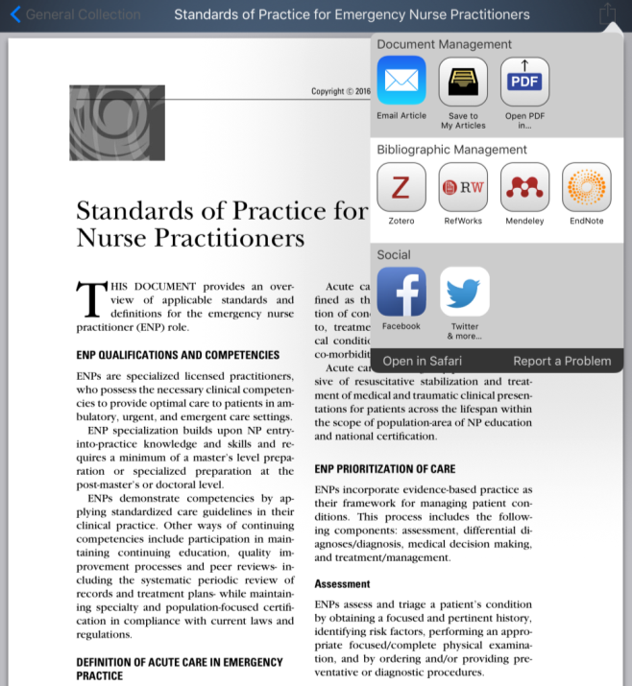

Tap the RefWorks icon and the citation will be automatically sent to your RefWorks account.
Please note: if you have not already signed into RefWorks on your device, you may have to complete the sign in process first and then export the citation to RefWorks again.

