1. Copyright exceptions for education
Copyright is a territorial right, and UK copyright law does not apply to courses delivered in Singapore and Tanzania. However, similar to UK law, the laws of these countries allow the use of short excerpts of any publications, broadcasting, sound or visual recordings of works for the purpose of teaching subject to the following -
- The copying is used to illustrate a point about the subject being taught
- The purpose of the use is non-commercial (courses offered abroad are considered as non-commercial)
- The use of the material is fair
- Where practical, there should be sufficient acknowledgement of authorship of the work
There is no legal definition of what is fair or unfair but a useful definition is “minor uses, such as displaying a few lines of poetry on an interactive whiteboard, will be permitted, but uses which would undermine sales of teaching materials will still need a licence”.
For “Sufficient acknowledgement” the library suggests using a standard citation system for academic works (for example, Harvard). For other resources (such as images taken from the internet) use the basic citation format “Type of content: Title by Author. Link.” providing as much information as possible.
Some examples of fair use of excerpts used under the terms of these copyright exceptions with sufficient acknowledgement are:
- Photograph
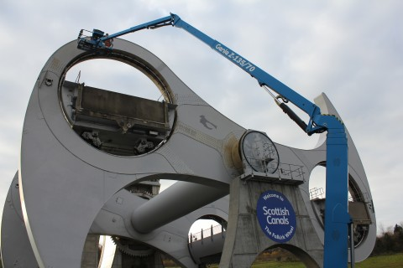
Image: The Falkirk wheel gets an MOT by Angela Finlay. https://www.scottishcanals.co.uk/media-centre/galleries/the-falkirk-wheel-gets-an-mot.

- Diagram

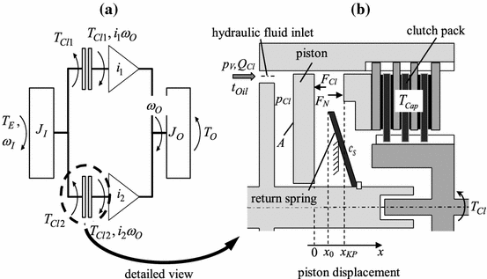
Image: Schematic diagram of a double clutch (a) and detailed cylinder model. In: WURM, A., BESTLE, D. 2015. Robust design optimization for improving automotive shift quality. Optimization and Engineering [online]. [viewed 13 April 2016]. Available from: http://dx.doi.org/10.1007/s11081-015-9290-1.

- Quote
“Environmental assessment is the process of assessing, or measuring, the change or consequence to environmental factors when making plans, such as those for an engineering construction project, or decisions, such as deciding whether to go forward with a new, tax-funded project.”
Text: JAIN, R. et al. 2012. Handbook of Environmental Engineering Assessment [online]. Boston: Butterworth-Heinemann. [viewed 13 April 2016]. Available from: http://dx.doi.org/ B978-0-12-388444-2.00001-4.
2. Copying and using extracts of published material, broadcasts, and newspapers

Provided the above requirements are met, any content may be made available to students via GCULearn. For content not covered by these copyright exceptions, the University holds a number of other licences.
2.1 Copying and using larger extracts of published material

GCU holds a Copyright Licencing Agency (CLA) licence with an extension covering overseas-campus based students which allows the library to make copies of book chapters and journal articles for distribution to students via GCULearn. These copies must be made by the library on behalf of lecturers.

GCU’s CLA licence also allows the use of a tool called the Second Extract Permissions Service, which offers the option to buy permission to copy and use an additional extract from a published work. This allows copying of another chapter from a book, another article from a journal issue, or an additional 10% of the total work whichever is greater.

To request a scan please visit the library scanning service web page.

2.2 Copying and using longer broadcasting, sound or visual recordings

The Educational Recording Agency (ERA) Licence allows staff and students access to broadcast sound or visual recordings content from the Box of Broadcasts (BOB) National service. However, this service is only available in the UK and content from BOB National is not available to ALC students.

2.3 Copying and using extracts of newspapers

The library subscribes to the Newsstand database that provides full text online access to over 1300 news publications. When preparing newspaper content for ALC students, staff are advised to use this database.

3. Using Open Educational Resources (OERs)

Open Educational Resources (OERs) are digital educational materials such as images, audio, video, animations, content modules, and other digital resources. These materials are not subject to the same copyright restrictions described above and can be freely and openly used or re-purposed for teaching, learning and research. For further information on how to find, use and cite (or acknowledge) OERs visit the library copyright pages.

