This guide shows how to add a reading list to your module so that it is highlighted in the left hand content menu.
- Log in to GCULearn
- Go in to your module and navigate to the required section (for example learning resources)
- Go to the grey + symbol at the top of the blue content menu on the left of the screen

- Click Tool link
- Choose Resource List from the drop down type list, and type in the name of your reading list then click Submit

To view your list, select it on the blue content menu. It will appear with the title you assigned to it on setup.
This will pull in your list for that module. Return to GCULearn using the back link, then the back button on your browser.
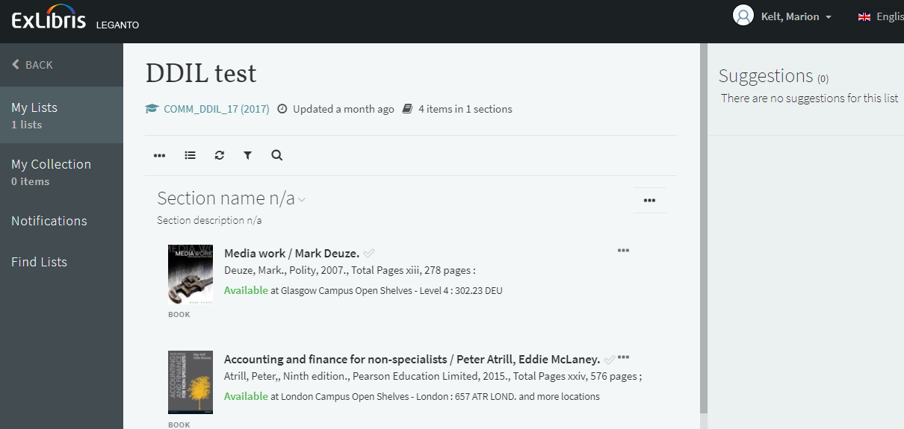
If the window stays blank, or a message stating that no reading lists have been associated with that module appears, contact us on readinglists@gcu.ac.uk

