Getting Started With Collaborate Ultra: Setting up a Collaborate Ultra Session in GCULearn

About
The Collaborate Ultra web conferencing system is now integrated into GCULearn. This means that you can set up a web conference quickly and easily and it will be embedded directly into your module.

You can also get a web link (url) to join sessions. So, for example if you wanted to invite a guest speaker to a session, you would send them a guest link. Clicking on that link allows them to join the session directly, without the need to get a guest login to access GCULearn.

Video Overview
To get a quick overview of the system, Blackboard have created a short video introduction that you can watch here.

Quick Start Checklist

Audio and Video | Do you have a working webcam, microphone/headset?  You will need these to successfully participate in any session. Make sure your students do too!
Web Browser | Collaborate Ultra works best with the Chrome and Firefox browsers.  Before you start any session, make sure you have an up to date version of either of these browsers.  Not using these browsers will impact on the user experience.

Finding Collaborate Ultra in GCULearn

Collaborate Ultra is now part of the integrated tool set in GCULearn. To access it go to
Tools, then scroll down and click on More Tools, you’ll see Blackboard Collaborate Ultra in the extended list of tools. (Figure 1).

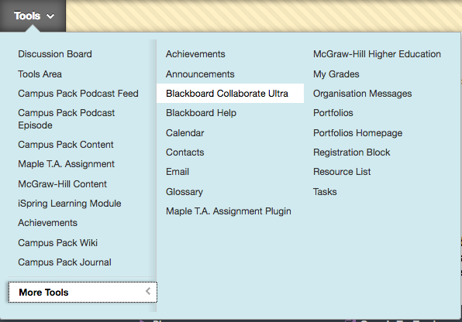
Figure 1

Setting Up A Collaborate Session

When you select the Collaborate Ultra option from the Tools list you will be taken to a set up screen. You will be guide to create an item area for your session just in the same way you would add any content to GCULearn. Give your session a name and add any other information you want your students to see about the session. (Figure 2).

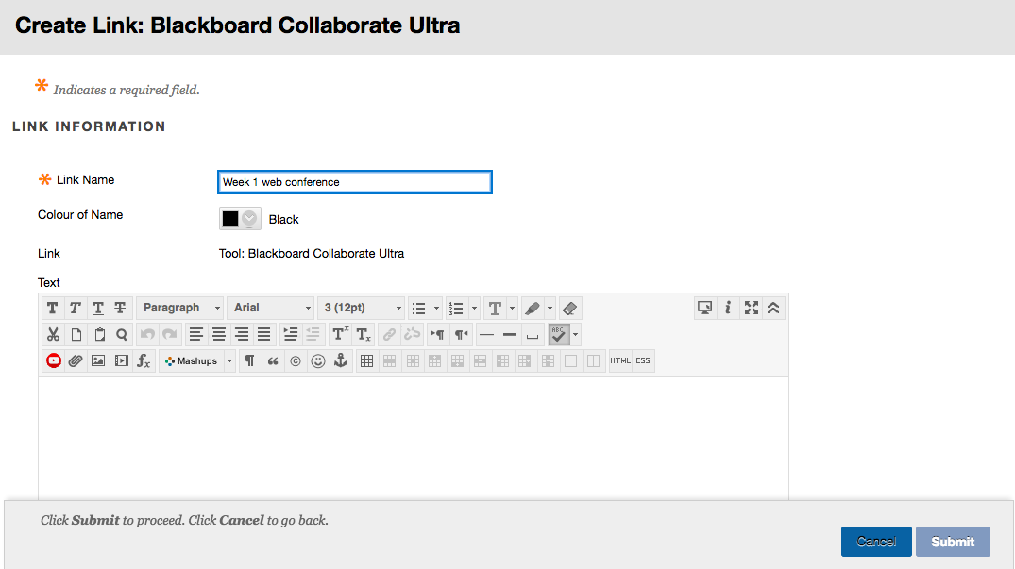
Figure 2

When you click on Submit, a link to your collaborate session will appear in your module. (Figure 3).

Figure 3

When you click on the link (remember you need to be in Edit mode) you will be taken to a control panel where you can access and edit session information. (Figure 4).

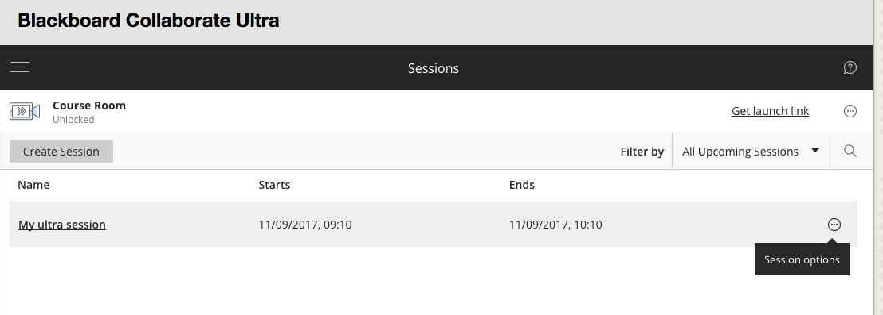
Figure 4

Clicking on the session options button allows you to edit the options for your session. (Figure 5).

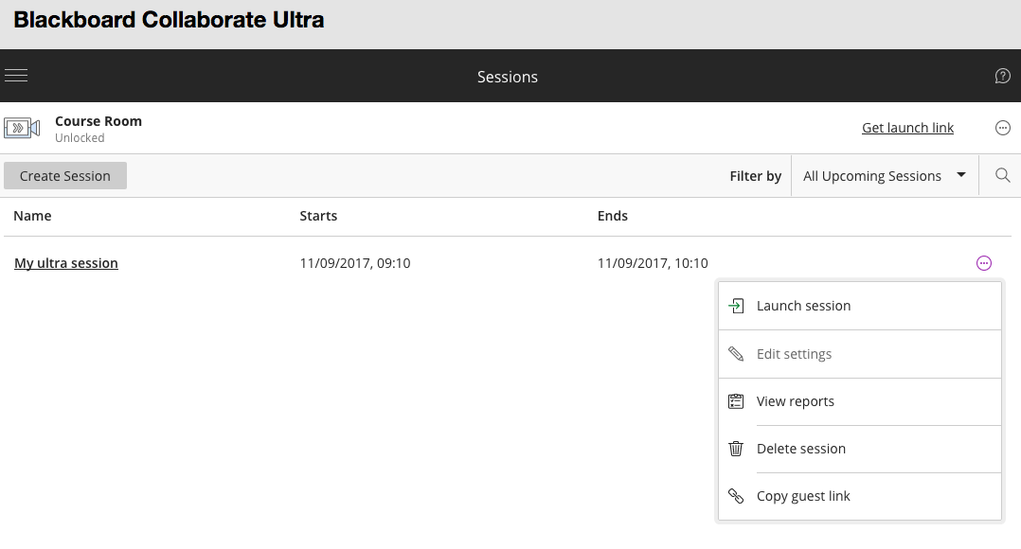
Figure 5

Launch Session | This will take you directly into the session
Edit Session | Allows you to change information and settings
View reports | Gives you information on all your sessions
Delete Session | Only do this if you are really sure you want to delete the session. Once it’s gone, it’s gone
Copy Guest Link | Use this option to copy and send a link to the session with external participants.

Customising Your Sessions
The Edit Session option allows you to customise your session, change dates/times etc. (Figure 6).

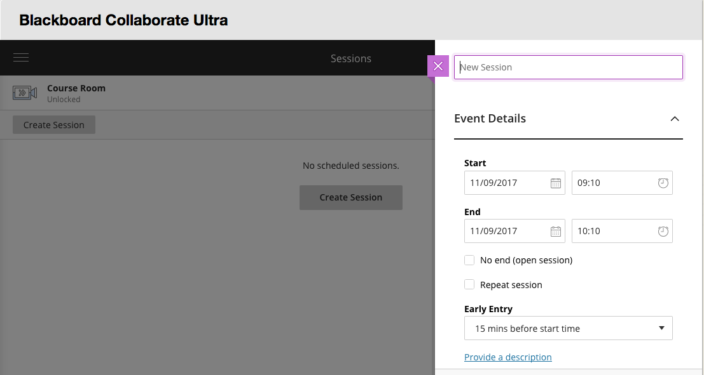
Figure 6

If you want to have guests (non GCU staff/students) join your session, select that option. You can then decide if what role you want that guest to have. (Figure 7).

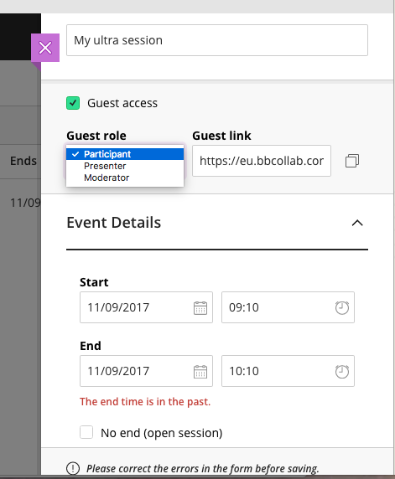
Figure 7

Roles
Moderator: has full control over all content being shared. It is the default role for lecturers attached to modules. Moderators set the session settings; including deciding what participants can and can't do. They can make any participant a presenter or a moderator. Moderators see hand raise notifications and can lower hands. They can remove participants from a session, but they cannot remove other moderators.

Participant: (default student role). Participants can enable and disable their own notifications, such as when they enter and leave a session or when someone has posted something to the chat. Moderators decide if participants share audio and video, chat, and draw on the whiteboard or shared files.

Presenter: designed to allow students to present without giving them full moderator privileges. Presenters can upload, share, edit, and stop sharing content.

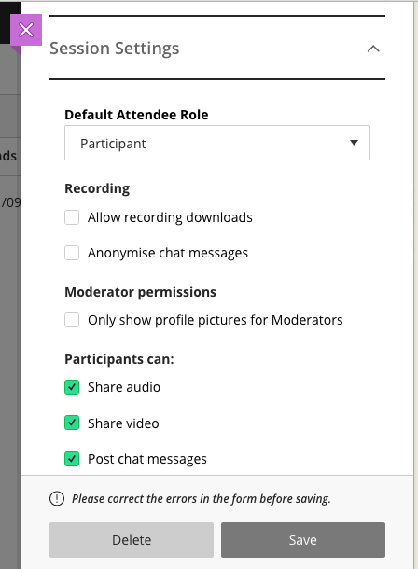
Figure 8

One you have edited and saved your sessions, then you are ready to go. Your students can access your session directly from your module. (Figure 8). Remember if you want to record your session you must tick the Allow recording downloads options.

More information and guidance is available here.

If you need any further help or guidance, contact your school Learning Technologists.

https://youtu.be/SQH-SkjMGOU
https://help.blackboard.com/Collaborate/Ultra/Moderator This work is licenced under a Creative Commons Attribution Non Commercial Share Alike 4.0 Licence

