Introduction to Assessing Digitally
_________________________________________________________________________

CC0 Public Domain image from https://pixabay.com/en/assess-measure-evaluation-business-2372181/

1. Introduction

As blended and online practices become more central to learning and teaching, it follows that digital forms of assessment are also increasingly popular. This short guide introduces some of the techniques that can be used to create innovative and engaging digital assessments to enhance the student learning experience. It should be read in conjunction with the guide Getting Started with Online Submission, Digital Marking and Feedback

As with all types of testing, digital assessments should have a clear purpose and align to the module learning outcomes. The Module Design Guide provides more details on constructive alignment and designing a module effectively. Students should be provided with details of the assessments, including the format used, deadlines and submission guidelines. In the case of digital assessments, they should also know where to get help if they need support in using specific technologies or applications.

As described in GCU’s Guide to Developing Online Modules, grading criteria for each assignment should also be available. An increasing number of modules are using Turnitin Feedback Studio and the Rubrics feature within it to provide these within GCULearn. If you are unsure about using these, your School Learning Technologists will be able to help.

If online contributions to discussion forums, blogs, wikis or social media sites are being assessed in some way, the criteria for assessing online participation should be clearly described before the activities begin.

Students should also be informed of how and when they will receive feedback, and made aware of different types of feedback they will experience and how they can act on it. This may include formative as well as summative, and self, peer and tutor feedback. Some modules have introduced a Feedback link from the main menu which takes students directly to generic tutor feedback on assignments which is relevant for all students on a module. Students can also be directed to the feedback guidance for students.

Guidance for students on the use of Turnitin Feedback Studio for similarity checking and online submission is included in the appendices of the GCU Online Similarity Checking Policy. School Learning Technologists and the Learning Development Centres can also provide support with this.

2. Online quizzes and tests

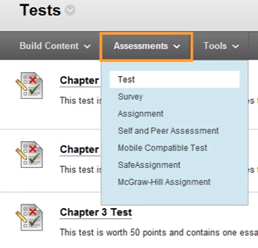
Online multiple choice tests (MCQs) are a popular choice and are commonly used for both formative and summative assessments. They are often used to test knowledge, but they can also be constructed to assess understanding and the application of knowledge. An advantage for students is that they receive immediate feedback on their performance.

The most commonly used MCQ application in GCU is the GCULearn quiz tool. For regular use, banks of questions can be developed and presented to students in a randomised fashion. Question types range from a basic true/false option to multiple choice, hotspots, fill in the blanks and essay questions. For support in setting up a test in GCULearn, please contact your School Learning Technologists. You can also access Blackboard training videos on YouTube.

For STEM subjects, other tools, such as Maple TA , are also in use in some parts of the University.

If a test is being used for a summative assessment, it is particularly important to make sure that:

● The test has been piloted successfully
● Students are familiar with the technology
● Appropriate alternatives are available for students who need them
● Opportunities for plagiarism are minimised
● For high stakes online tests, appropriate procedures are in place for invigilation in labs or off-campus, in line with the Academic Registry requirements.
● Where large numbers of students (>100) will be undertaking an online MCQ test simultaneously on GCULearn, Information Services and Blackboard have been informed in advance to allow them to provide increased bandwidth/server capacity if necessary.
● Contingency plans are in place in the unlikely scenario of technology or internet failure.

3. Assessed discussion boards, blogs, wikis, journals and e-portfolios

GCULearn discussion boards and e-portfolios, and Campus Pack blogs, wikis, and journals are often used for reflective assignments, reports and collaborative group work. These applications are supported by the University.

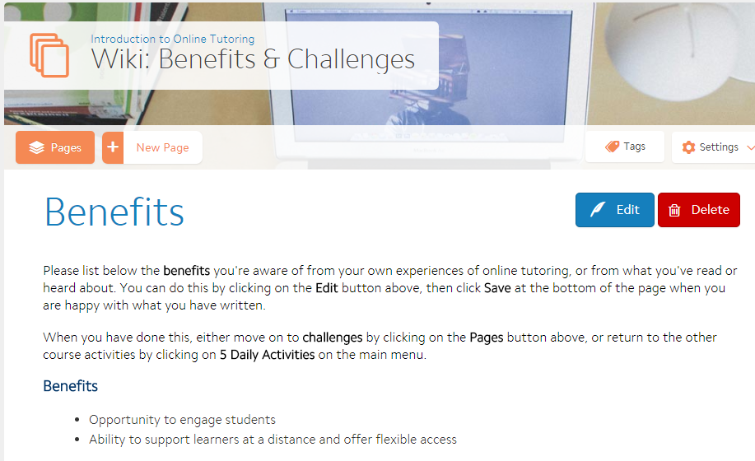

Again, it is important to ensure that:

● Students are familiar with the technology
● Clear instructions have been provided for the assignment
● Grading criteria have been made available in advance
● Collaborative group work is carefully managed and that grading is transparent and fair to all participants.
● Where alternative, social media applications are used (e.g. Google Docs, WordPress, YouTube) -

○ refer to the GCU Social Media Guidelines for Learning and Teaching (pdf) which are available on GCULearn
○ create backup plans for submission and storage of student assignments as social media applications are not centrally supported by GCU

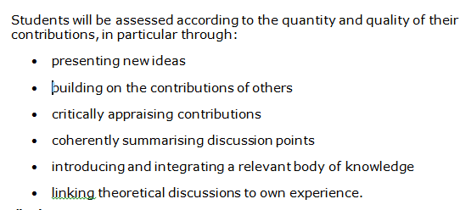
Example criteria for assessing a discussion forum

4. Assessed student work using PowerPoint, Prezi, audio or video

Students can also be encouraged to use technology in creative ways for assessed presentations, reports and critical reviews with a variety of visual, video and audio applications. When considering the use of a new application to assess students, points to consider include:

- the discussion of options with the School Learning Technologists
- storage arrangements for large audio or video files
- students’ and module tutors’ understanding of the relevance and benefits of different technologies in the context of the set assignment.
- availability of alternatives to ensure accessibility for all students
- access to training and support for the technologies used
- access to necessary equipment such as cameras, webcams and mics

An example from the University of Southampton explains how they have used mobile phones for video for the assessment of clinical skills (link to YouTube) in a nursing programme.

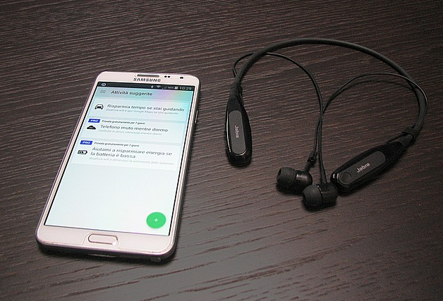
CC0 Public Domain Image from https://pixabay.com/en/smartphone-bluetooth-headset-1119314/

5. Summary

Integrating digital forms of assessment into modules, both formative and summative, should be considered at the programme development stage and on an ongoing basis as programmes and modules are updated and re-approved. This approach not only enriches the learning experience for students, but also helps to develop their digital capabilities and confidence. Jisc has defined this as,

"the capabilities which fit someone for living, learning and working in a digital society".

The Jic Digital Capabilities Framework identifies 6 key elements, all of which can be addressed through the creative use of technology for assessment.
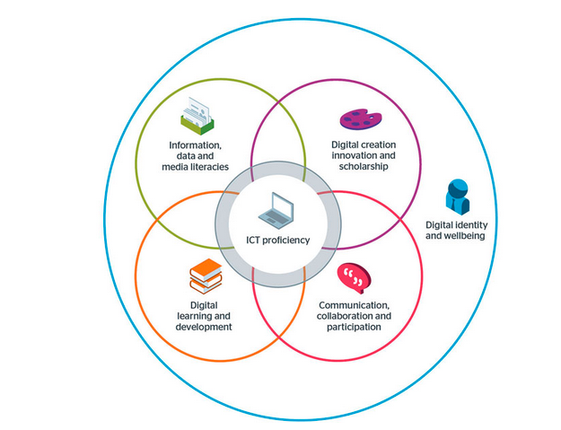
Image: Jisc CC BY-NC-ND

6. Further Reading

Jisc Electronic management of Assessment (EMA) guidance
Jisc Digital Capabilities Framework update (blog post)

‘Introduction to Assessing Digitally’ by Prof LInda Creanor, Glasgow Caledonian University, is licensed under a Creative Commons Attribution-Non-Commercial-ShareAlike 4.0 International Licence

