- Log on to PURE using your domain user name and password.
- Click the Edit profile button on the Personal overview tab.

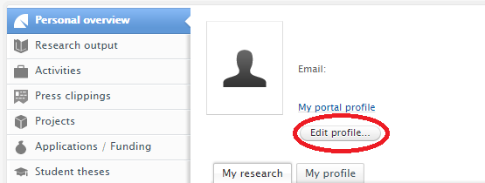

- Three areas in your Research Profile can be updated at this time, (1) Profile photo, (2) Research interests, and (3) Visibility of profile.
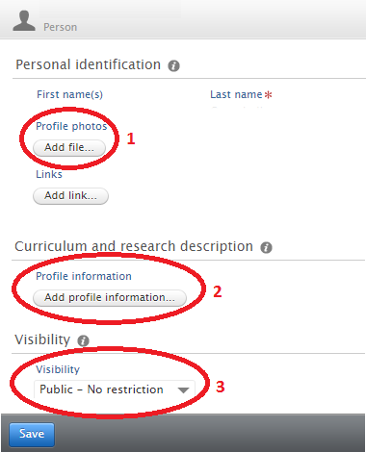

- To upload a photograph click on the Add file button under the Profile photos section.
- Upload your photograph using the “drag file of browse your computer” option.
- The Type option should be left as portrait.
- Click Create once your file has been uploaded.
- It is recommended to crop any photograph to a 1:1 or square aspect ratio before uploading.

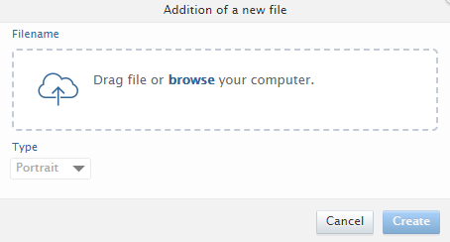

- To update your research interest and personal description click on the Add profile information button under the Curriculum and research description section.
- Click Create once you have added the text for your research interest and personal description.

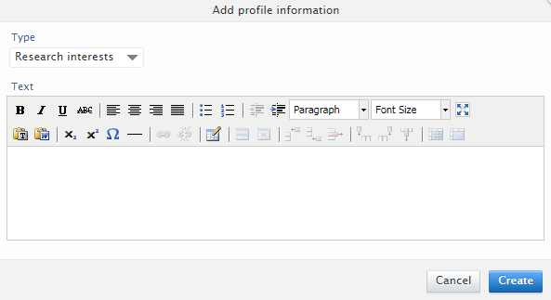

- Ensure Visibility is set to “Public – No restrictions” under the Visibility section.
- Click Save in your research profile to save all of these updates.

