What is the difference between versioning and using a record as a template?
When a system or procedure changes, you need to update your resources to reflect this. The best way to do this is to create a new version of your resource using edShare. Versioning is a useful tool as it always points the user to the newest version of the resource. It also allows you to create an audit trail of previous versions which can be useful for items like annual reports.
The new version will automatically display in the results of any edShare searches and the old one will be hidden and won’t display in the search results.

How to do it:
First log in to edShare, you won’t be able to edit the resource if you are not logged in. Go to the resource you want to version. You can do this from your own content manager page or by searching from the home page.
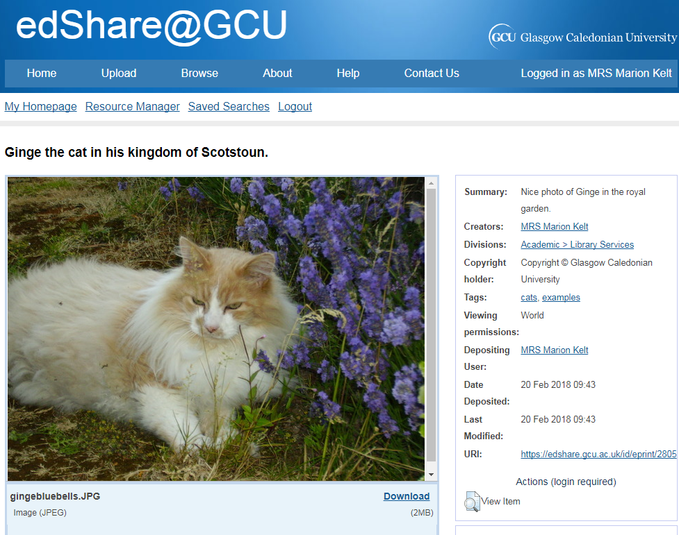
Click View Item.

On the next screen, click the Actions tab, then the blue New Version button.
edShare will now display the new version for you to edit.
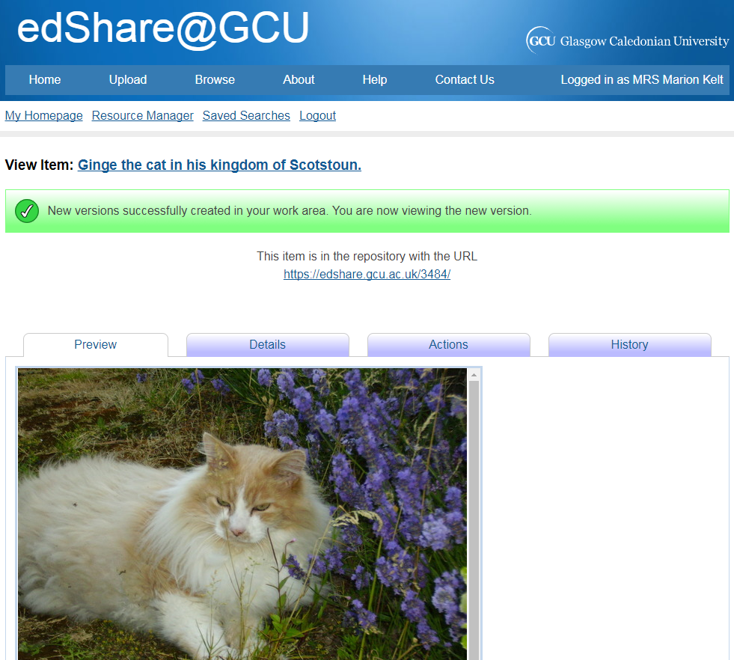
Move to the foot of the screen and click Edit item in the Toolbox section.
Now Delete the old item, edit the record to show that this is a new version, and upload the new version as usual. Click the blue Deposit button.
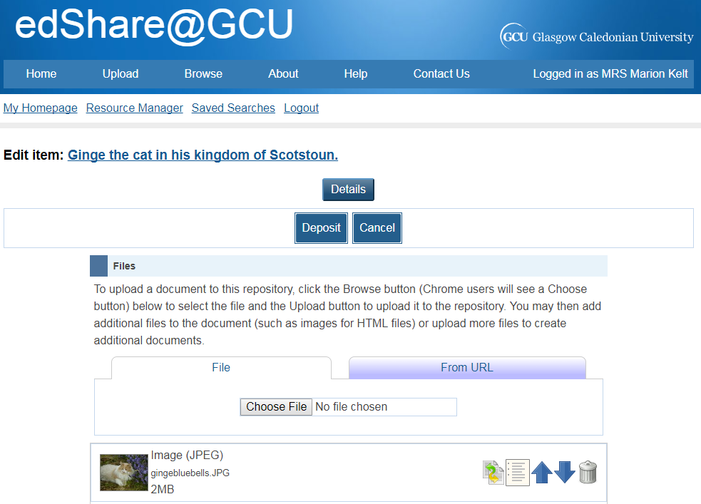
edShare will link the two records, but will hide the old version from search results. Remember to update any links on your web pages or handouts.
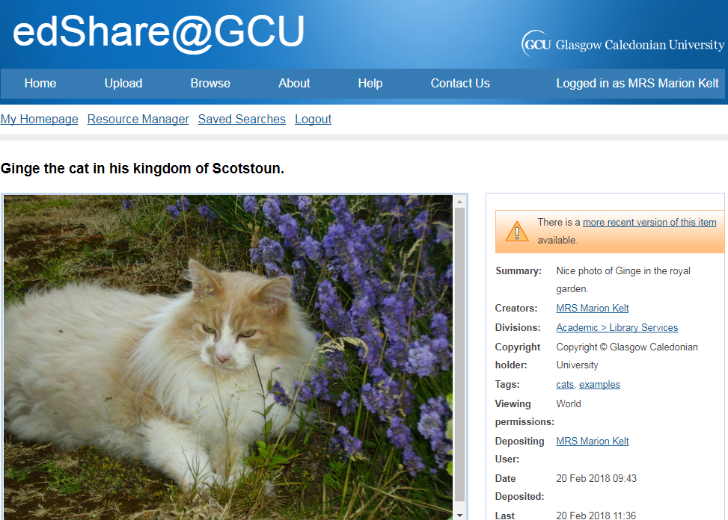
The old version showing a link to the newer version.
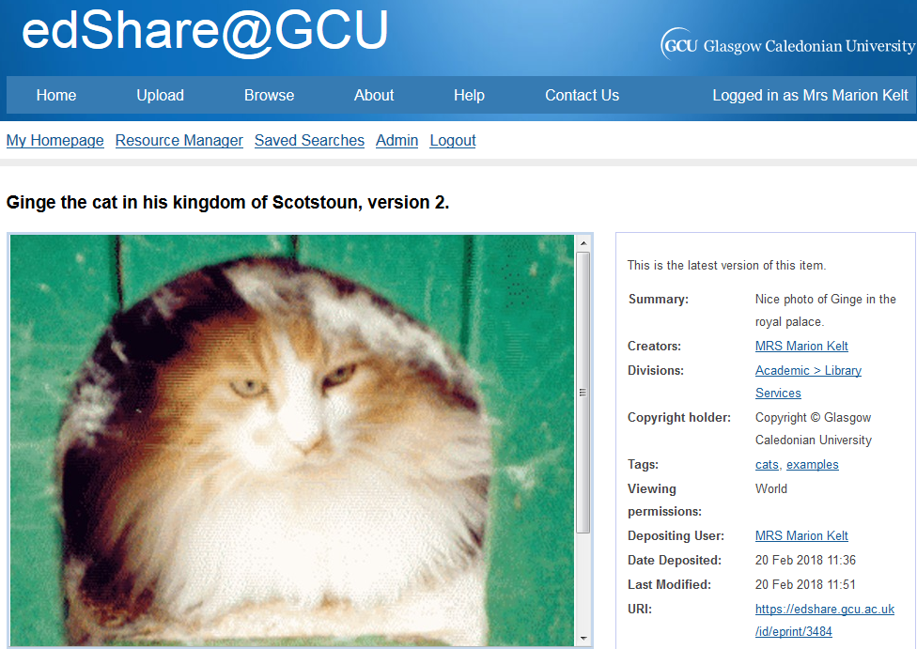
The new version showing the message saying so.

