These instructions explain how to build your player and how to embed your player in GCULearn.

To download one of the HTML files from edShare (<https://edshare.gcu.ac.uk/id/eprint/1197>) right click the View link, select Save Link As, and save the file to your computer. You can edit HTML files using a standard text editor such as TextPad or Notepad.

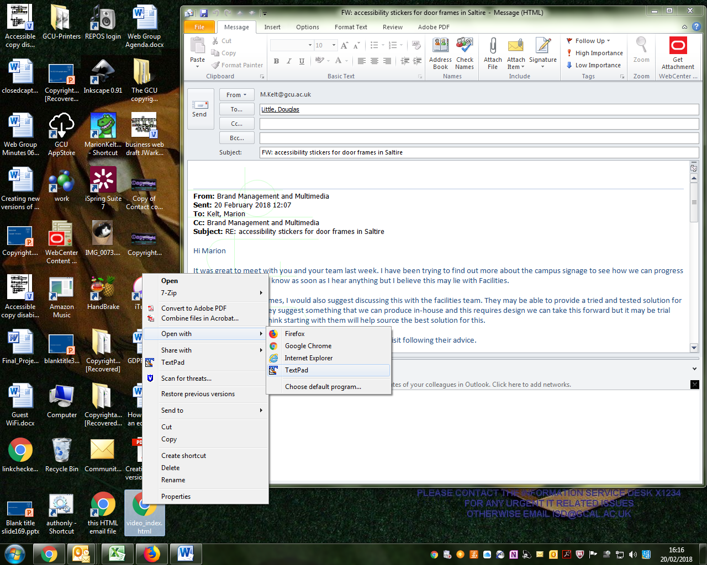

The file looks like this:

<!DOCTYPE html>  
<html>  
<body>

<video width="350" controls>  
<source src="https://edshare.gcu.ac.uk/1038/1.hasvideo_mp4ThumbnailVersion/" type="video/mp4">

<source src="https://edshare.gcu.ac.uk/1038/1.hasvideo_webmThumbnailVersion/" type="video/webm">

<source src="https://edshare.gcu.ac.uk/1038/1.hasvideo_oggThumbnailVersion/" type="video/ogg">

Your browser does not support HTML5 video.

</video>  
</body>  
</html>

If you have any queries or need help building a player please contact the edShare team ([edshare@gcu.ac.uk](mailto:edshare@gcu.ac.uk)).

Once you have created an HTML5 player for your audio or video resource there are a number of additional features you can apply to your resource. These include:

* Autoplay - specifies that the resource will start playing as soon as it is ready
* Controls - specifies that controls should be displayed (such as a play/pause button)
* Loop - specifies that the resource will start over again, every time it is finished
* Muted - specifies that the audio output of the resource should be muted

These attributes are disabled by default; adding them to the audio/video tag will enable them. Full lists of HTML5 attributes are available via the following links:

* Audio attributes - <http://www.w3schools.com/tags/tag_audio.asp>
* Video attributes - <http://www.w3schools.com/tags/tag_video.asp>
* Global attributes - <http://www.w3schools.com/tags/ref_standardattributes.asp>

For assistance using any of these attributes please contact the edShare team.

Creating an HTML5 player also allows you to add subtitles or closed captions to a video. To add closed captions you must create a Web Video Text Tracks (WebVTT) file which contains the text track for your video and associated timings. You can then reference this file in your HTML5 player using a track tag. This is the best method of captioning your videos as it is accessible to screen reading software.

* Create your WebVTT file. You can either convert an existing transcript to WebVTT format or create a new file and manually add captions. The following site provides tools which can make this process quick and easy: <http://www.vttcaptions.com/the-caption-generator.html>  
  It should look like this:

WEBVTT

00:00:19.901 --> 00:00:24.500

See that our senses sometimes deceive us,

00:00:24.700 --> 00:00:28.876

I was willing to suppose that nothing existed.

00:00:40.076 --> 00:00:45.247

Some men err in reasoning even on the simplest matters of geometry,

00:00:45.447 --> 00:00:50.522

although I was convinced that I was as open to error as any other.

00:00:56.981 --> 00:01:01.710

All thoughts that had ever entered into my mind when awake,

00:01:01.910 --> 00:01:07.075

had in them no more truth than the illusions of my dreams.

00:01:20.790 --> 00:01:25.020

As I observed this truth, I think, therefore I am.

00:01:25.763 --> 00:01:29.495

I concluded that I might accept it as the first principle

00:01:29.505 --> 00:01:33.218

of the philosophy of which I was in search.

* Ensure you save your WebVTT file with UTF-8 character encoding

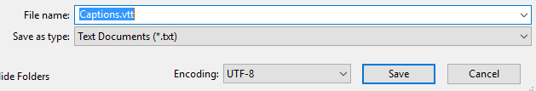

* Upload your WebVTT file alongside your video in edShare. We recommend giving your file a simple name like Video.vtt

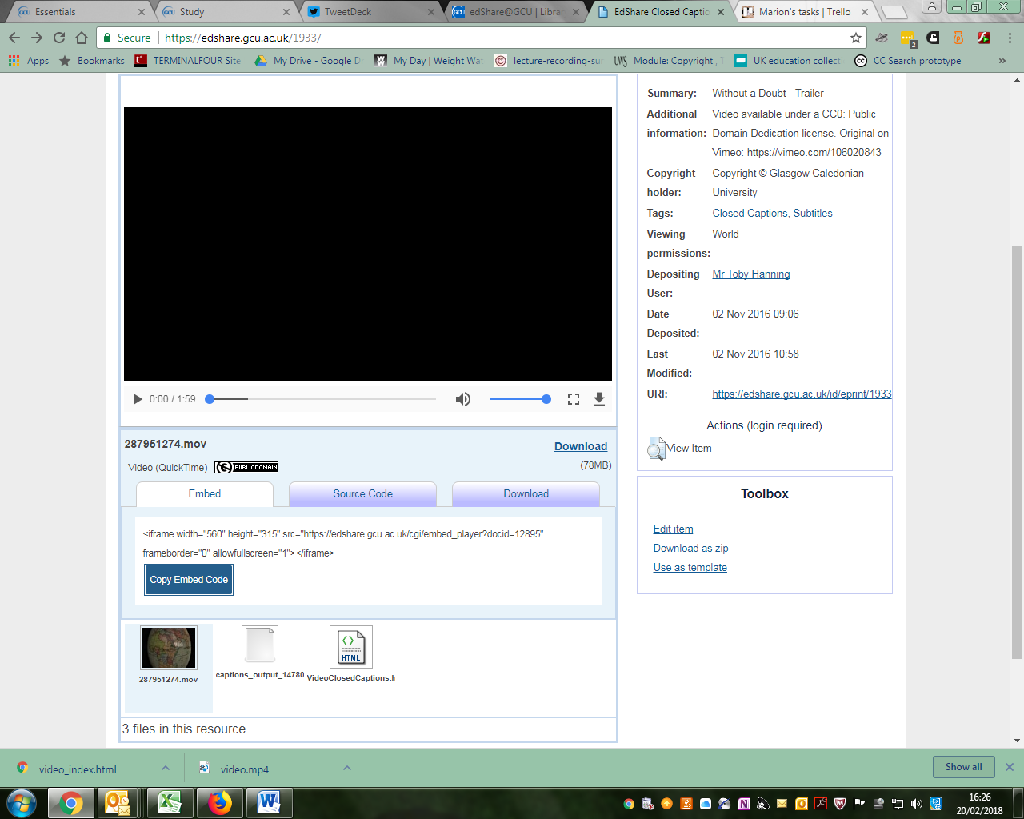

* Obtain the document URL for your WebVTT file in edShare. This is the link you will reference in your HTML5 player. To obtain this link select the WebVTT file, right click the Download button and select Copy Link Address. The link will usually take the form: <https://edshare.gcu.ac.uk/id/document/xxxx>
* Add a track tag to your HTML5 player. The track tag is contained within the video tag and takes the form: <track kind="captions" src="" label="English"></track>   
  Add the document URL for your WebVTT file to the src attribute of the track tag e.g.
* <track kind="captions" src=<http://edshare.gcu.ac.uk/id/document/5332>” label="English"></track>
* Your player should now look like this:

<!DOCTYPE html>

<html>

<body>

<video width="350" controls>

<source src="https://edshare.gcu.ac.uk/1038/1.hasvideo_mp4ThumbnailVersion/" type="video/mp4">

<source src="https://edshare.gcu.ac.uk/1038/1.hasvideo_webmThumbnailVersion/" type="video/webm">

<source src="https://edshare.gcu.ac.uk/1038/1.hasvideo_oggThumbnailVersion/" type="video/ogg">

<track kind="captions" src="https://edshare.gcu.ac.uk/id/document/5332" label="English"></track>

Your browser does not support HTML5 video.

</video>

</body>

</html>

* You can find full details of additional HTML5 attributes available for the track tag here: <http://www.w3schools.com/tags/tag_track.asp>
* Upload your HTML5 player alongside your video and WebVTT file in edShare. When viewing the player you will now see a button which can be used to switch your closed captions on and off . Note this icon appears in Firefox, when viewing in Chrome, use the menu with three dots in the control bar of the video.