W201 – Quick Start Guide
Broadcast Mode
To begin login to the PC and then press anywhere on the touch screen.
Step 1 – Select Mode
You will now see the Mode Select Screen below. There are four options to choose from.
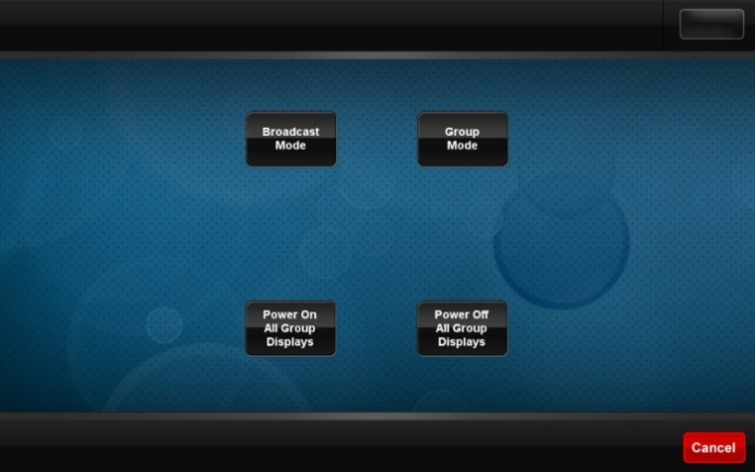
Broadcast Mode – Select this to enter Broadcast Mode.
Group Mode - See the Quick Start Guide for Group Mode.
Power On All Group Displays – Turns on all the Desk Monitors.
Power Off All Group Displays – Turns off all the Desk Monitors. Remember to select this before you leave the room.
Step 2 - Broadcast Mode
Selecting Broadcast Mode takes you to the screen below.
Broadcast Mode allows you to control what is projected on the walls and also the 8 screens at the Group Tables.
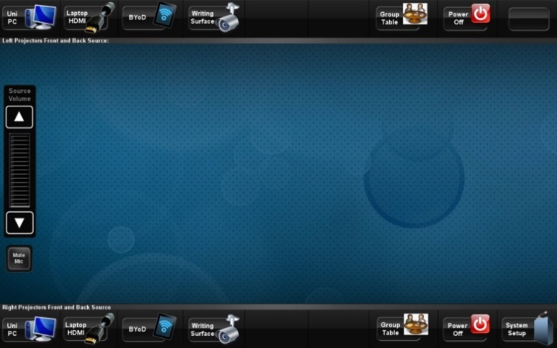
Step 3 – Display Options
The top row of options allows you to select what appears on the left projection.
The bottom row of options allows you to select what appears on the right projection.
Uni PC – Displays the Desktop PC.
Laptop HDMI – Displays the screen of a laptop if connected via a HDMI cable.
BYoD – Displays a device connected via the Wireless Network.
Writing Surface – Displays the Writing Surface - Explained in Step 4 – Writing Surface.
Group Table – Displays a Group Table Screen - Explained in the Quick Start Guide for Group Mode.
System Setup - Returns to the Step 1 – Select Mode. Select this option to return to the beginning.
Power On/Power Off – Switches the projector on or off. Remember to do this to both projectors before you leave the room.
Step 4 – Writing Surface
You can write with a whiteboard marker pen and also put objects on the Writing Surface that is to the left of the lectern. There is a camera above the Writing Surface which captures what is on the glass surface. The camera has a zoom, focus and the option to record video or still images. The settings can be adjusted to meet your needs.
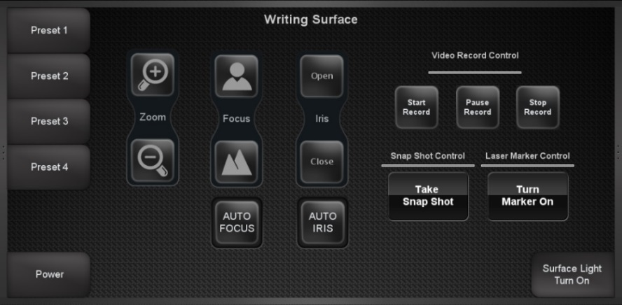
Important Settings and Features
AUTO FOCUS – This is the recommended setting and will focus the camera on whatever is placed on the surface.
Surface Light Turn On – This option allows you to switch the light beneath the Writing Surface on or off. Adjust the light depending what is on the surface in order to make it appear more clearly.
Remember to Power Off the projectors and Power Off All Group Displays before you leave the room.
W201 – Quick Start Guide
Group Mode
To begin login to the PC and then press anywhere on the touch screen.
Step 1 – Select Mode
You will now see the Mode Select Screen below. There are four options to choose from.
Broadcast Mode - See the Quick Start Guide for Broadcast Mode.
Group Mode - Select this to enter Group Mode.
Power On All Group Displays – Turns on all the Desk Monitors. This must be selected for students to view the screen at their desks.
Power Off All Group Displays – Turns off all the Desk Monitors. Remember to select this before you leave the room.
Step 2 – Group Mode
Each desk in W201 has a screen for group working. Group Mode allows you to project a selected Group Table screen on the walls.
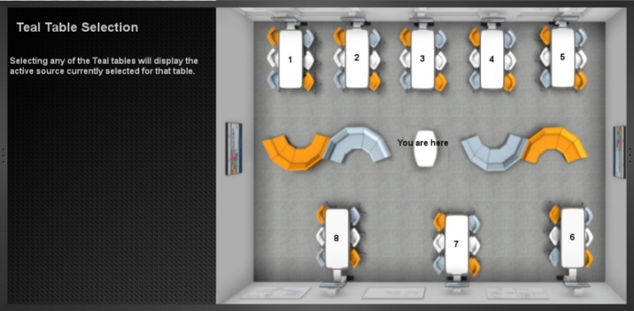
There are 8 Group Tables, each with a screen labelled 1 -8. To project one of the Group Table monitors select that Group Table number from the selection screen above.

Step 3 - Group Table Panel
At each desk and below the screen there is a panel. This Panel has 4 options. Students can select the options by pressing one of the buttons.
DESK 1
Power On – Switches the screen on.
Power Off – Switches the screen off.
BYOD – Allows a device to be connected via the Wireless Network.
SHOW ME – Projects the Group Table Monitor onto the wall. This function will only work if Group Mode is selected.
POWER
ON
POWER
OFF
BYOD

SHOW ME

Remember to Power Off the projectors and Power Off All Group Displays before you leave the room.

