Reflecting and Analysing to Develop Text

What?
So what?
Then what?
(Rolfe et al. 2011, 44)

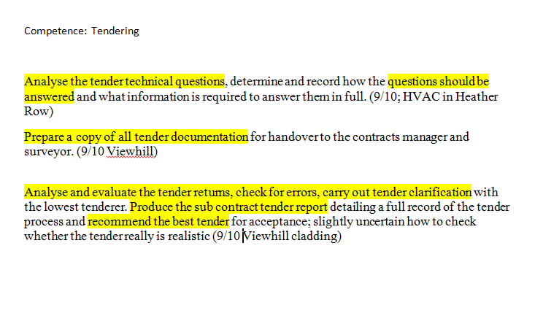
Example 1

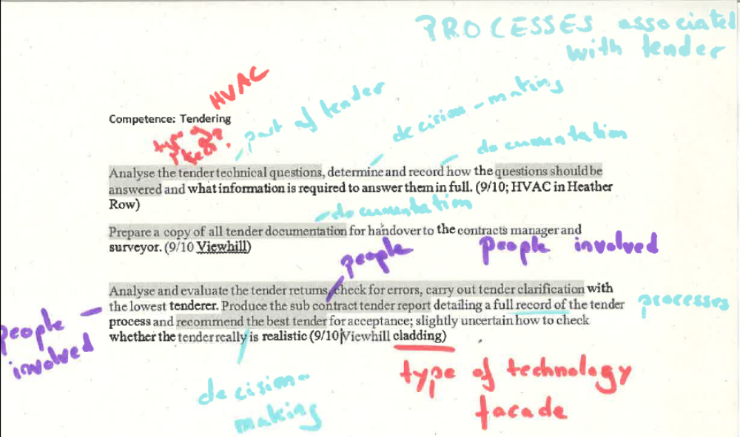

Example 2

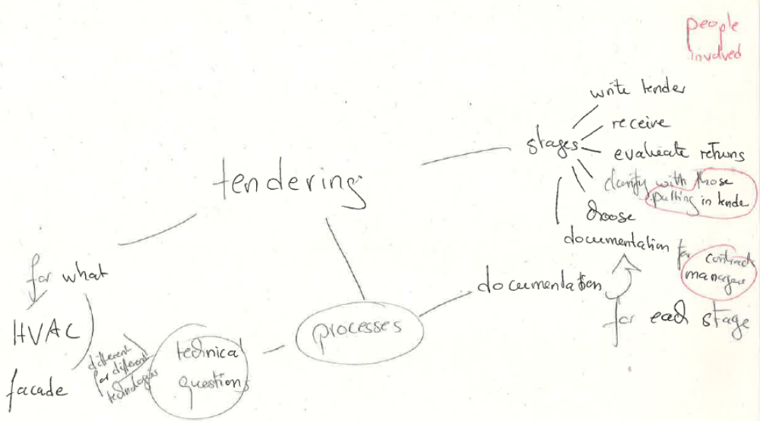

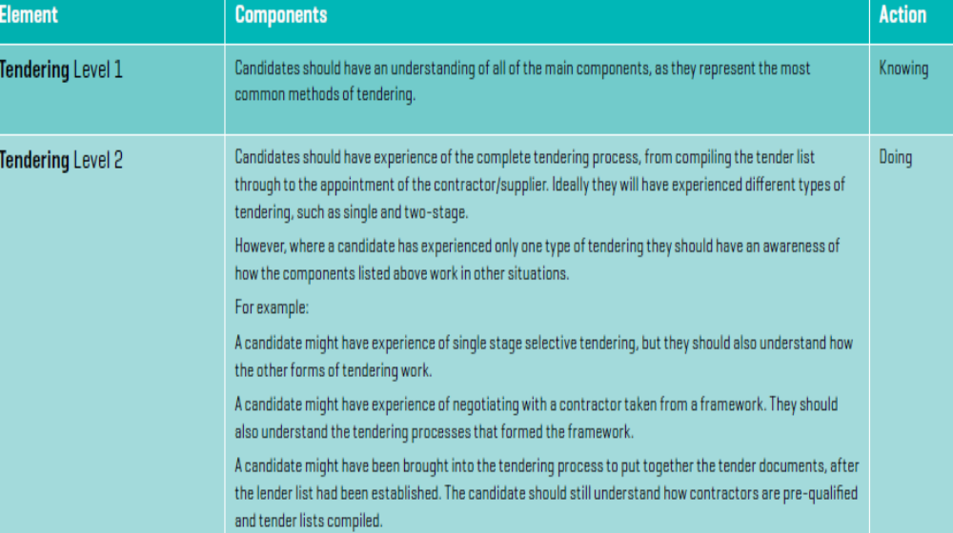
Tendering Level 1 and 2 (RICS 2015, 40)

Example 3

Main Body

Competence: Tendering
Process of tendering:
Saw all stages of 1-stage tender:
Writing (see diary 11.10)
Technical questions (see diary 12.10)
Clarifying submissions with those who put in tender (see )
Choosing tender; only observed, but that was really helpful to see the factors that were taken into account in the decision-making process;
Preparing documentation for hand over (see diary …)

Area in which tenders took place
Noticed differences in tendering for façade and HVAC, as 2nd involved smaller, more local companies; this meant (think about the differences!) which made me realised….

(RICS. 2015. Assessment of Professional Competence. Quantity Surveying and Construction. London: RICS HQ)

Rolfe, Gary, Jasper, Helen and Freshwater, Dawn. 2011². Critical Reflection in Practice. Generating Knowledge for Care. Houndsmill and New York: Palgrave Macmillan

