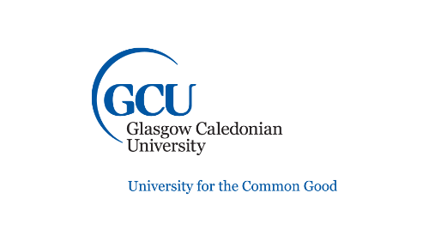**Did you know that you have a big friendly library right on your doorstep?**

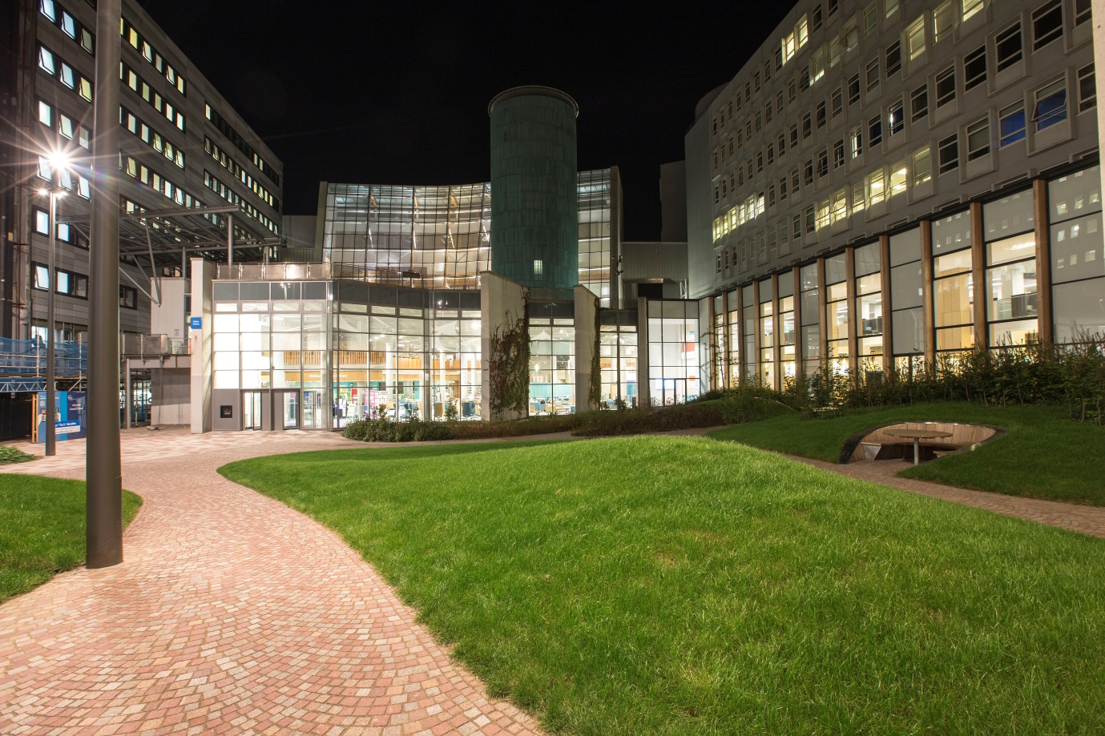

Glasgow Caledonian University Library offers free community membership to the public.

You can:

* sign up for free wi-fi access
* borrow a laptop computer from the Library Desk to use in the library building for three hours
* borrow three long loan books from our collections in the compact shelves
* use any of our paper books or journals for reference
* just come in for a quiet place to read or study

To help you get started, our friendly staff will help you connect to our wi-fi and can offer you advice on a range of basic computer skills.

You can join online using our form at <https://www.gcu.ac.uk/library/usingthelibrary/membership/communityusersform/>

Don’t worry if you haven’t got internet access, you can pop in to the library and use our smart tables to complete the form. To get your library card you need to show us two forms of ID, one should be photo ID and one should have your name and address on it.

Here’s how to find us:

Dobbie’s loan



We are here!

Cowcaddens Road facing bus station

If you would like to chat to someone about a community membership, you can drop us an email at [library@gcu.ac.uk](mailto:library@gcu.ac.uk) or call us on 0141 273 1000.

We look forward to meeting you!

