An ORCID (Open Researcher and Contributor ID) is a persistent digital identifier that distinguishes you from every other researcher. It helps provide links between you and your professional activities ensuring that your work is recognised. If you don’t have an ORCID, you can register for one here. To ensure the highest level of visibility for your research outputs, it is recommended that you set your ORCID visibility settings to ‘Everyone’.

Add your ORCID to your Pure profile
To add your ORCID to your Pure profile please follow these steps:
- Go to Caledonian Connected webpages
  - Click Services
  - Click E
  - Click Employee Self Service
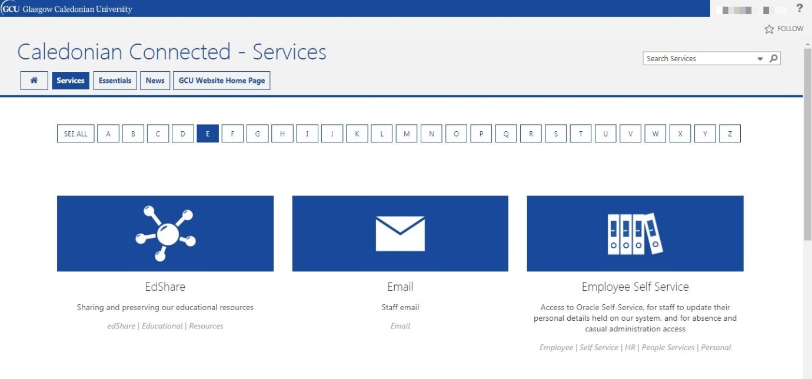
- Sign in to Employee Self Service
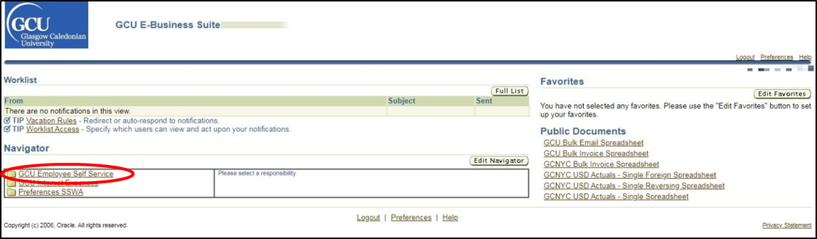
- Click GCU Employee Self Service
- Click HESA
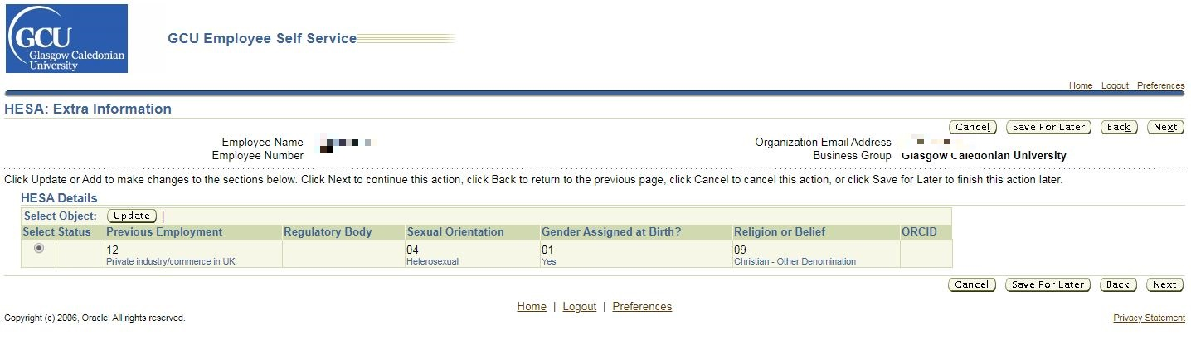
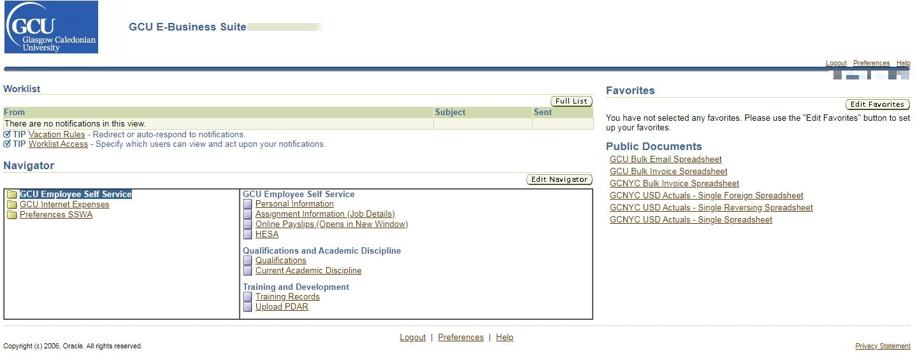
- Click update

- Enter the ORCID including dashes (16 digits), for example: 0001-0002-0003-0004. Enter only the number part of the identifier and dashes.
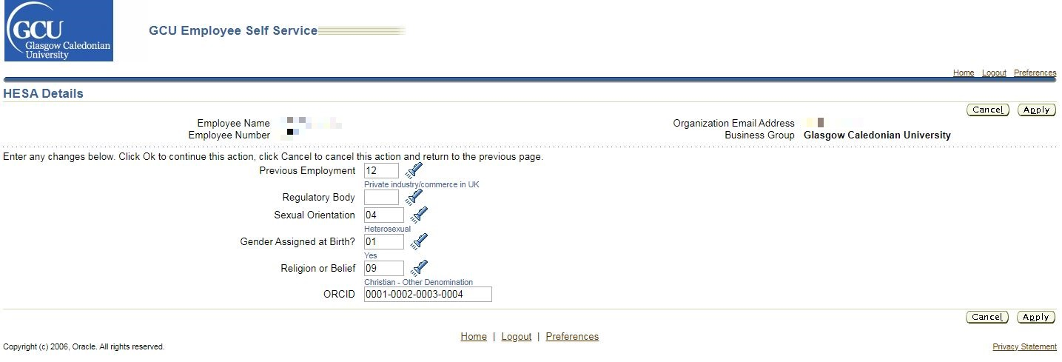
  - Click apply
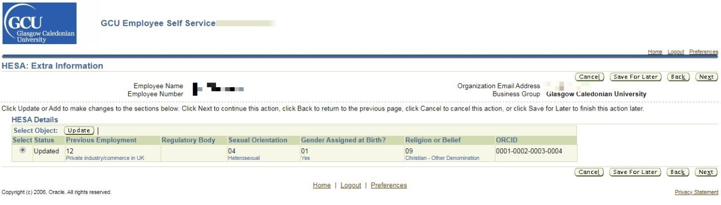
- The ORCID will then be present within the HESA Details section of GCU Employee Self Service

- An automated process will then pass the ORCID from the GCU Employee Self Service system (ORACLE) to Pure and complete a series of validation checks. If the proposed ORCID passes validation checks it will be visible on your Pure profile within 24hrs. If the proposed ORCID fails the validation checks, it will take longer for it to appear on your Pure profile.

Getting help
If you are unable to log in to Employee Self Service please contact workforcesystems@gcu.ac.uk.
If you have successfully added your ORCID to Employee Self Service but it does not appear on your Pure profile after a week, please contact librarysystems@gcu.ac.uk.

