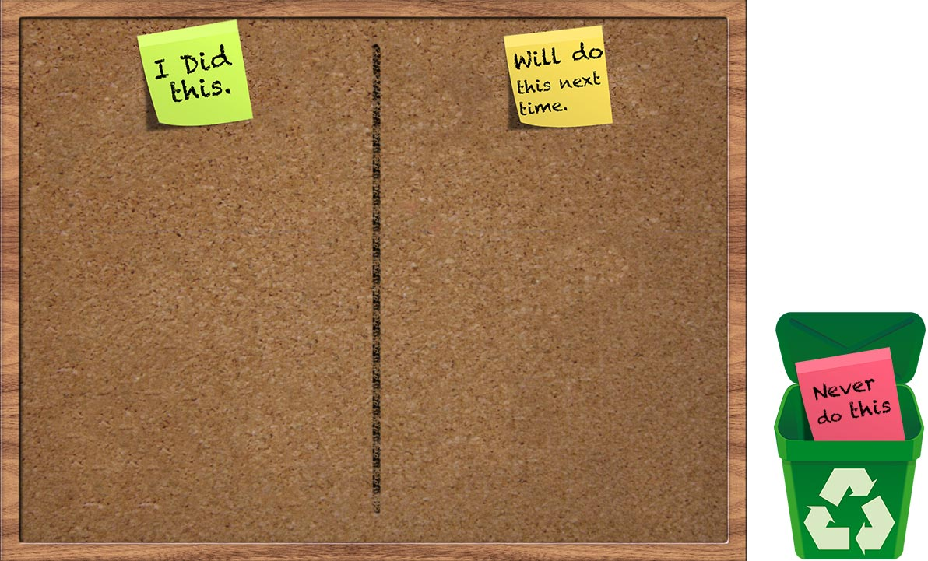

Before you begin, zoom out so you can see both pages of this document

Choose each of the post it notes in turn and drag them onto the notice board or put them into the bin below. Once you have finished, review and act on what you have said you will do next time before you go to your next lecture.

**Reflecting on my lecture**

I brought at least 2 pens or pencils to the lecture

I made notes during the lecture or highlighted my printed notes

I identified in my notes things that I did not immediately understand

I made my lecture notes inside a book or added them to a folder

Within 24 hours of the lecture I read through my notes

I summarised my notes to identify the most important points

I compared my notes with or discussed the lecture with another student

I tested myself on the lecture notes to see how much I can remember

I arrived at the lecture on time

I brought notes that I had printed or blank paper to make notes