W099 & W123 Annual International Conference
​Changes and innovations for improved wellbeing in construction
8th - 10th September 2021 (Glasgow)

Name(s) | Edward Nana-Addy¹ and Innocent Musonda²
Authors of  (title) |  | 1 Rev.  2 Prof.
authorise the W099 W123 Organising Committee to display this work in perpetuity on the edShare@GCU educational resource repository.

I confirm that no third party content is included in my work or, where third party content is included, it is openly licensed or I have obtained permission to use said content in this work. I retain copyright for this work. The work is licensed under a CC BY 4.0 License. Individuals and/or organisations who wish to use my work are free to share (to copy and redistribute the material in any medium or format) and adapt (remix, transform, and build upon the material) for any purpose, even commercially. Individuals and/or organisations who wish to share or adapt my work can do so under the following terms:

Attribution — You must give appropriate credit, provide a link to the license, and indicate if changes were made. You may do so in any reasonable manner, but not in any way that suggests the licensor endorses you or your use.

I agree to this presentation remaining on the W099 W123 Website & the edShare@GCU resource indefinitely.

Signature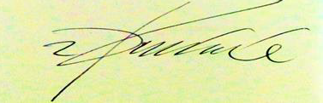

Date 19 August 2021

Please return this form via email to : W099&W123@gcu.ac.uk

