Task Words in Essays and Exams

Further information:

Learning Development Centre
School of Engineering and Built Environment Glasgow Caledonian University
askldc@gcu.ac.uk
+44 (0)141 273 1230
https://www.gcu.ac.uk/ebe/ldc/

Glasgow Caledonian University is a registered Scottish charity, number SC021474. Designed and printed by Print Design Services, Glasgow Caledonian University. © Glasgow Caledonian University 2016. PDS_?????_01/2016.

Categories of Task Words

Task words are the ‘do’ verbs in your question. They fall in different categories best represented in the pyramid below:

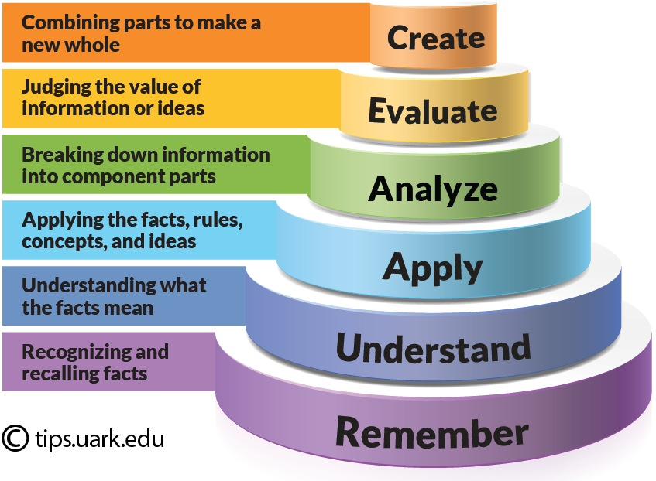
(Accessed from The University of Arkansas, 2013)

Each category represents a set of skills you need to demonstrate in your assignment. The higher up the hierarchy you go, the more complexity you need to add to your answer. For example, if you are asked to identify a list of policies issued on sustainable waste management in Scotland since 2015, you are being asked to recall facts.

However, if you are asked to compare and contrast two different policies (the original and a revised version) and analyse their effectiveness in Scotland since 2015, then the answer merits a more complex analysis. You will need to demonstrate to your tutor that you:
- understand what the policies say in contrast to each other
- and how these have affected everyday waste management practice in Scotland. This last step requires you to analyse and evaluate the effectiveness of these policies.

Commonly Used Task Phrases in Essays and Exams

Word | Meaning
Demonstrate you can create (something new)
Construct | Build a practical project; create an action plan...
Design | Sketch the plan for work to be executed (e.g design a video game)
Write | Write a dissertation: incorporate many of the tasks listed below
Demonstrate you can evaluate
Assess | Decide the value of ... be specific about the basis for your evaluation
Criticise | Give a judgment about the value of something and support that judgement with evidence
Evaluate | Attempt to form a judgement about, be specific about the basis for this judgement
Argue | Present a case for and/or against something
Demonstrate you can analyse
Analyse | Examine closely, look at underlying structures, identify patterns…
Correlate | Show the relationship between A and B…
Examine | Inspect something in detail and investigate the implications
Select | Make a choice based on an informed decision…
Demonstrate you can apply (or use the information)
Apply | Make use of relevant theories, formulae, etc.
Develop | Build on something, add to knowledge…
Choose | Determine the best option (and state why)…
Solve | Find the answer to…
Demonstrate you understand (what the information says)
Compare | Discuss two things in terms of their similarities and differences
Contrast | Discuss two things emphasising their differences
Describe | Present a detailed account of ...
Discuss | Consider and offer some interpretation or evaluation of…  Present and give a judgement on the value of the arguments for and against an issue.  Show you comprehend what you read.
Explain | Make clear the details of ...  Show the reason for, or underlying cause of, or the means by which something occurs…
Interpret | Make clear the meaning of something and its implications;  be explicit about the framework in which you do this
Summarise | Describe something concisely
Demonstrate you remember (what the information is)
Identify | Find and state relevant information…
Define | Make clear what is meant by ... use a definition or definitions to explore the concept of ...
Enumerate | Give an item-by-item account of ...

References

The University of Arkansas, 2013. Using Bloom’s Taxonomy to Write Effective Learning Objectives [Picture]. [viewed 10 January 2018]. Available from: https://tips.uark.edu/using-blooms-taxonomy/

