- Log on to PURE using your domain user name and password.
- Click the Add new button at the top right hand side of the screen and choose the template that fits the publication type, such as article, conference proceeding and so on.

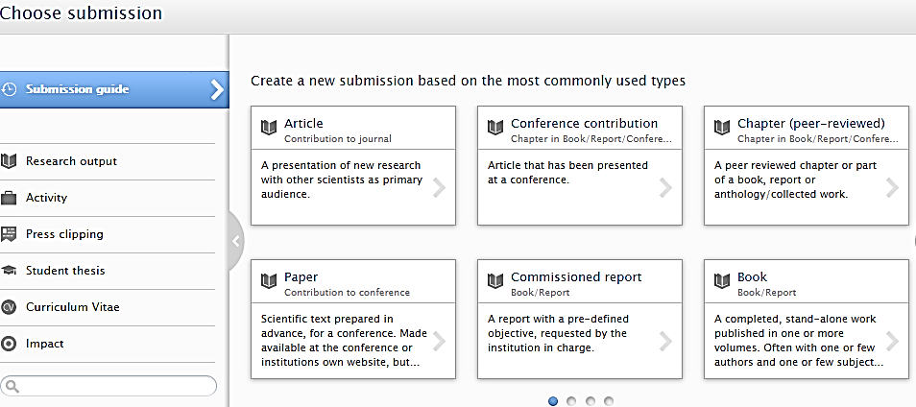

- The author accepted manuscript (the version that has been through peer-review and has been accepted for publication) should be uploaded to PURE as required by the open access policy for the next REF. To upload your accepted author manuscript file:
- Click the Add electronic version (file, DOI or link) button and select Upload an electronic version.
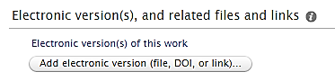
- Use the browse function to select the relevant file from your computer.
  - Select the Accepted author manuscript option from the Document version drop-down.
  - Select the Closed option from the Public access to file menu (this is the default option and will be checked by Library staff).
  - Select Create to finalise the document upload and then Accept licences on the PURE storage licence pop-up window. This will take you back to the publication record which should now show the attached file.

- Add the publication reference information to the record, including the DOI or alternative link if available.
- To add the early online date for an article, select the Epub ahead of print option.
- If the article or conference proceeding has not yet been published and is at the acceptance stage, select the Accepted/In press option.
- To record the DOI click on the Add electronic version (file, DOI or link) button and select Add DOI of an electronic version to complete the information.
- To add an alternative link such as a publisher url, click the Add other link button to complete the information.

Once the document is loaded and the relevant reference information completed, check the record status is set For validation and click the Save button at the end of the form.
- Your publication record will now be added to the validation queue for the library staff. The library will check, review and edit the record before it can be validated. If information is missing, the library will contact the author. The publication metadata will be displayed in ResearchOnline@GCU upon validation. Documents added to PURE will be made available for open access full text download according to publisher and funder requirements, and may be placed under a temporary embargo.
- If your research output metadata has already been validated by the Library, the record will be locked and you will not be able to upload a publication using the process above. In such cases please send the document to repository@gcu.ac.uk and the Library will attach the file.

