Getting Started with GCULearn

What is GCULearn?
GCU Learn is the University’s virtual learning environment (VLE). GCULearn is our customized version of the Blackboard VLE.

How do I access GCULearn?
The easiest way to find GCULearn is from the staff portal. You access that from the university home page (www.gcu.ac.uk)/ . Click on “staff” at the top of the page to access the staff portal. GCULearn can be accessed via the icons on the right hand side of the page

Where do I get my user name and password?
As with all university systems, you use your university username and password to log into GCULearn. You will be given this by IS automatically when you become a member of staff.

Where do I find my modules and students?
When you log into GCULearn, you will be taken to your “My GCULearn” homepage. This will give you an overview of all the modules you are attached to.

NB: in GCULearn, modules are called Courses (it’s default setting we can’t change).

You should be attached to modules you are teaching on, but if you can’t see them in the
My Courses box; speak to the Module Leader who will be able to add you.

Staff Help Resources
The Staff Help tab contains lots of resources to support digital learning and teaching and the effective use of GCULearn.

Finding your way around a module in GCULearn

In your module area you can add a variety of activities, content and assessments. You can control student access to activities, content and assessment. The image below provides an overview of a default module structure.

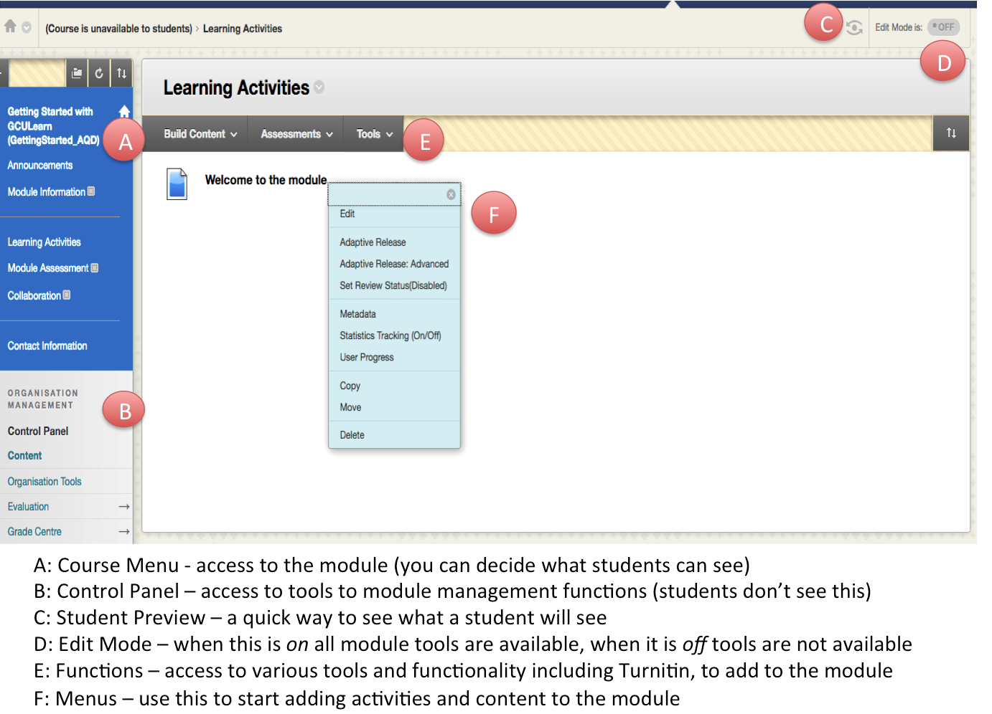

The default module structure

The default menu structure has three main sections. More information about this is available here.

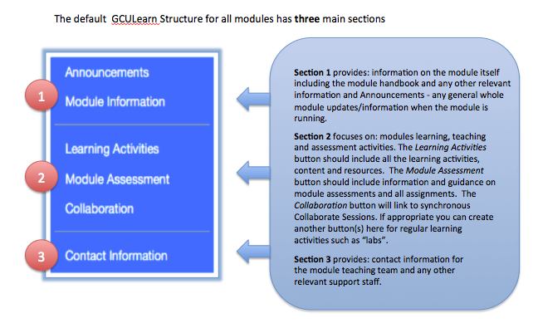
You can customize these headings as the example below shows.

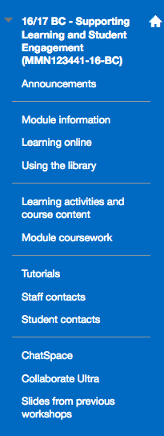

More information on getting started with Blackboard is available here. The Learning Technologists in your school are also an invaluable source of information and support in using GCULearn.

