Writing Learning Outcomes Activity

A Quick Review

Finding and using the right active verb is the key to writing meaningful learning outcomes. Remember a learning outcome needs to be much more specific than a module aim.

Although it has been with us for a considerable time Bloom’s Taxonomy (1956) is a useful starting point when considering the active verb i.e. what level of knowledge or skills are expected to ‘do’.
What you design for students to ‘do’ should align to the appropriate SCQF level. Asking students to ‘describe’ may be appropriate at SCQF level 7 but it might not be appropriate at SCQF level 9 where the challenging (or active) verb should be more aligned to the higher levels of Bloom’s taxonomy.

The original taxonomy was updated in 2001 (illustrated in the diagram below). It can be a useful point of reference when thinking about active verbs.
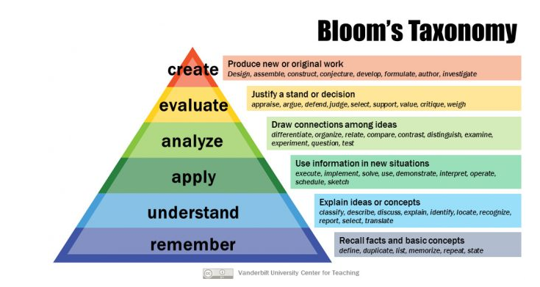

This interactive version of the taxonomy illustrates some more exemplars of it being used. For some more verb inspiration you can also explore the Blooms Digital Taxonomy Verbs list.

Remember, learning outcomes should be short, unambiguous and to the point so that everyone (staff and students) has a shared understanding. You should try to avoid terms such as “appreciate”, “demonstrate”, “be familiar with” as they are unclear and difficult to measure.

Activities
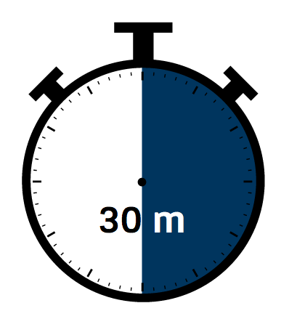

Suggested time: 45 - 60 minutes
NB you may find it useful to have access/copies of some of the examples provided in the links provided in the useful links and resources provided in the review section and at the end of the worksheet.

Activity 1 - Starting with the end in mind (10 minutes)
Before you start writing learning outcomes, think carefully about what is you want your students to do and be able to demonstrate on completion of the module.

As students progress through a programme, the level of skills and knowledge should increases in line with the SCQF (Scottish Credit Qualifications Framework).

As a rule of thumb, learning outcomes should consist of 3 parts:

A verb (something the student does) | An object (what the student is working on or with) | A context for the action (activity or assessment)

Using the 3-part rule should help you to write meaningful learning outcomes. You should try to avoid terms such as “appreciate”, “demonstrate”, “be familiar with” as they are unclear and difficult to measure.

Example

Aim: To support students to develop an in-depth understanding of divergent theoretical perspectives and key concepts to make evidence informed decisions

Learning Outcome: (Students should be able to) Critically analyse conflicting perspectives to produce an evidence informed solution to a work based challenge

A verb (something the student does) | An object (what the student is working on or with) | A context for the action (activity or assessment)
(critically) analyse | produce an evidence informed solution | Work based challenge

Try it yourself

A verb (something the student does) | An object (what the student is working on or with) | A context for the action (activity or assessment)

Activity 2 (30 - 40 minutes)
Using the GCU Module Descriptor Template, and the 3-part rule (re)write the learning outcomes for your module. Ideally you should write about 4 to 6 learning outcomes for a module. If you find that you are writing many more then it might be that you are trying to capture the entire syllabus. Remember that learning outcomes must be demonstrable and measurable. Before you start, remind yourself of what SCQF level is the module aligned to.

Title of Module:

SCQF Level:

Module Aim:

Learning Outcomes
On successful completion of this module the student should be able to: -
*

Activity 3 - Review (10 - 20 minutes)

- Using the checklist below, review your learning outcomes.
- Plan your next steps for constructively aligning your learning outcomes, activities and assessment tasks.

*Suggestion - if using this as a team activity, why not get team members to write learning outcomes individually then review as a team.

Checklist | Yes | No | Suggestions
- Are there an appropriate number of LOs? Do the learning outcomes contain any ambiguous terminology or jargon?
- Can you identify an action verb for each and is the level appropriate?
- Can you determine the context of the learning for each LO?
- Do the learning outcomes make it clear to the student what they will be able to do on completion of the module?
- Are they measurable?
- Do the learning outcomes map to the GCU Common Good Curriculum?

Useful Links and Resources;

- Chapter 5, Moon, J. & Dawsonera 2002, The module & programme development handbook: a practical guide to linking levels, learning outcomes & assessment, Routledge. (available online from the library)
- Subject Level Benchmark Statements
- Writing Learning Outcomes
- Examples of Learning Outcomes
- Good vs Bad Learning Objectives
- GCU Constructive Alignment Resources

This activity has been developed by Academic Quality and Development, GCU and is licensed under a Creative Commons Attribution Non-Commercial ShareAlike 4.0 International Licence.

http://www.celt.iastate.edu/teaching/effective-teaching-practices/revised-blooms-taxonomy/revised-blooms-taxonomy-flash-version
https://globaldigitalcitizen.org/blooms-digital-taxonomy-verbs

