Constructive Alignment Activity

You can undertake this activity by yourself for your own reflection, however we would recommend that it works best as a group activity, ideally with a module team.

What you need:
- copy (ies) of your current module descriptor (and a copy of your writing learning outcomes checklist if you are in the development stage).
- Copies of the constructive alignment matrix

Using the three steps below, as a guide, complete the module alignment matrix. (NB you may want to divide larger teams into small groups of 2-3 people for this first stage)

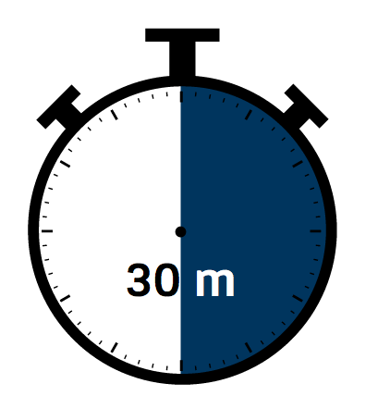

Suggested Timings:
Steps 1- 3: 30 - 40 minutes; step 4: 20 - 30 minutes.

Step 1: - Learning outcomes and Assessment Tasks
Look at your module learning outcomes. Is the active verb being assessed in each one?

You need to make sure that the active verb in your learning outcome is actually what will be assessed. This should ensure that the assessment task will ask students to demonstrate the expected knowledge and/or skills necessary to achieve one or more of the set module learning outcomes.

(If you are having any issues identifying or agreeing on appropriate active verbs you may find it useful to look at our Writing Learning Outcomes Activity).

Step 2: Learning & Teaching Activities and Assessment Tasks
Thinking about the learning and teaching activities (LTAs) you have planned for the module, are they designed to support students to meet the assessment tasks?

For example, if an assignment task asks students to make a presentation and when you look at the the TLAs for the module there are activities which focus on developing effective presentation skills, then the module is aligned. If, on the other hand, there aren’t any activities that support developing presentation skills, then the module is not aligned.

( You might find it useful to look at/use our Quick Planning Sheet to help to help you (re)design your LTA).

Step 3: Assessment Tasks
When deciding on the number (and type) of assessments, your learning outcomes should act as the basis of how many skills or knowledge areas should be demonstrated in each assessment task.

Look at your module assessment tasks. Are they actually aligned to different skills and/or knowledge presentation?

If two assessments are measuring the same knowledge/skills/learning outcomes, you need to consider if they are distinct tasks. Are both assessment tasks really necessary? Are they actually a staged assessment?

Step 4: Feedback, reflection and next steps

Share and reflect on the outcomes from each group.

- As a group discuss and agree on what steps you will take to address any mismatches that the activity highlighted.
- Complete a revised version of the matrix.
- Agree a plan on how and when you are going update your learning outcomes, teaching and learning activities and assessment tasks.

This activity has been developed by Academic Quality and Development, GCU and is licensed under a Creative Commons Attribution Non-Commercial ShareAlike 4.0 International Licence.

