Appendix A
E-Submission of Assessments through Turnitin UK:
Good Practice Guidelines for GCU Staff
_________________________________________________________________________________
Electronic submission of summative coursework by students through Turnitin is increasingly used across the University and is actively encouraged. The GCU Online Similarity Checking Policy states that all standard academic summative submissions of coursework will be submitted through Turnitin.
Turnitin is a similarity checking application that is used to help students develop their academic writing and referencing skills and enhance their understanding of plagiarism and collusion. Before using Turnitin, you should read the GCU Online Similarity Checking Policy Guidelines.
To ensure a smooth e-submission process, the following practices are recommended:
- Plan your Submission Timescale
- Ensure your date and time for submission are set for when students can contact someone if they have an issue. In practice this means:
  - avoiding a deadline of midnight on Friday unless you are available to be contacted
  - generally trying to avoid Friday as a submission day.
  - ideally setting your submission time for before 12 noon.

2. Be aware of the limitations of the file submission system
- Turnitin accepts a text file size of up to 40MB (or approximately 400 pages of text).
- Specify a file type so your students know what format to submit, what you want to assess and what the system will accept.
- Screenshot 1 below illustrates the Turnitin details which are shown to students when they are submitting their coursework.

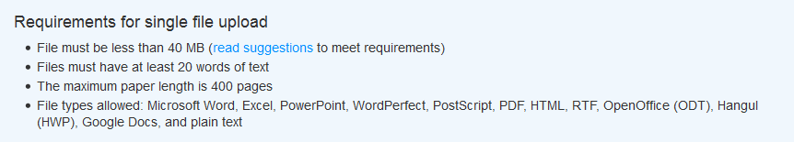
Screenshot 1

3. Complete the assignment submission settings
- Complete the required settings to suit your assignment. Screenshot 2 below shows an example of settings which meet GCU’s three week feedback timescale requirements:

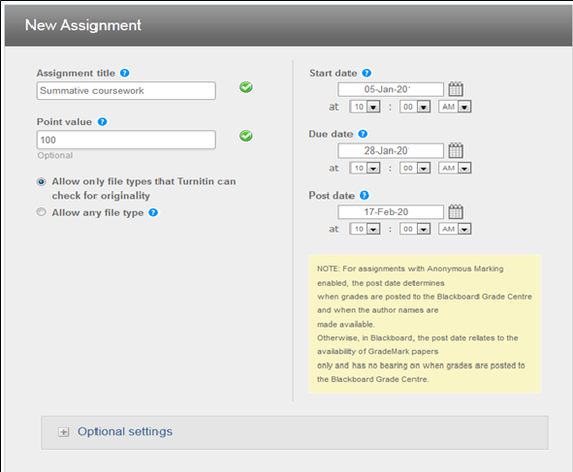
Screenshot 2

- Screenshot 2 shows the top level settings. You should enter a relevant total in the point value cell to enable proper marks entry in Grade Centre. Select “Optional settings” to add some further key information as shown in Screenshot 3 below.

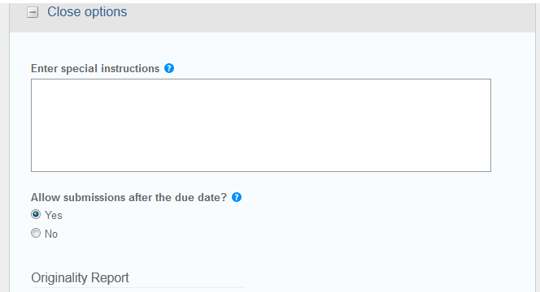
Screenshot 3
- If you are unsure how to proceed in terms of settings for your assessment, then please contact your School Learning Technologists.

4. Further actions to help reduce student submission issues
- The Enter special instructions section is where you can help your students by specifiying what is expected of them and what to do if they have a submission problem.
Enter special instructions
By submitting this piece of coursework via TurnitinUK from your personal GCULearn account, you are confirming that it is all your own, original work and that it has not been submitted elsewhere in fulfilment of the requirement of this or any other award. You also confirm that you are aware of, and have adhered to, the GCU Code of Conduct for Students (available on the GCU website via this shortened link http://bit.ly/1Nz4yni )
The final submission date and time is [28 January 2016 at 10.00am UK time]. Late submissions may/may not be accepted and will be marked based on the module handbook regulations.
Do not leave your submission until the deadline owing to possible congestion on the submission software.
If you do have a problem, then take a screenshot of the error message and send an e-mail to your module tutor with the screenshot attached.

- You should also make this information available to students outside of the Turnitin submission.
- Screenshot 4 shows examples of other actions to be added to suit the requirements for your assignment:

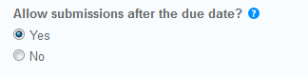
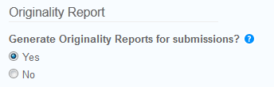
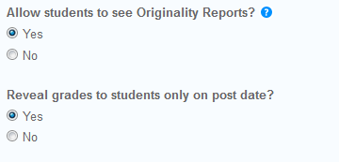
Screenshot 4

Finally, most of these guidelines will have some relevance to other forms of e-submission but will require some adaptation. Your School Learning Technologists, GCU LEAD Blended Learning team and your colleagues can help support you not only with e-submission but also on using the range of assessment tools in GCULearn. Further guidance is available at:

Instructor Quick Start Guide guides.turnitin.com/01_Manuals_and_Guides/Instructor/Instructor_QuickStart_Guide
Interpreting a Similarity Report guides.turnitin.com/01_Manuals_and_Guides/Instructor/Instructor_User_Manual/21_Originality_Check
Turnitin for iPad
guides.turnitin.com/01_Manuals_and_Guides/iPad_User_Manual

The GCU Online Similarity Checking Policy by the Similarity Checking Working Group is licensed under a Creative Commons Attribution-Non-Commercial-ShareAlike 4.0 International Licence

