Appendix C
Turnitin Submissions – A Quick Guide for GCU Students
__________________________________________________________________________________
1. Introduction
Turnitin is a similarity checking application that is used to help students develop academic writing and referencing skills, and enhance understanding of plagiarism and collusion. Turnitin holds a database of all student papers previously submitted worldwide, current and archived internet web sites, periodicals/journals, books and other publications. New submissions are checked against the database and matched on sequences of words.
You may be asked to submit your coursework online by using Turnitin within GCULearn. Your lecturer will provide details of when and what to submit within the module. This short guide leads you through the process of e-submission by outlining what you should know, what to do in the event of getting an error message, and a visual run through.
If would also like more general support to enhance your academic writing and referencing skills, then please contact your School’s Learning Development Centre.
2. What you should know before you start
- You should aim to submit your assignment at least 15 minutes before the deadline to avoid any last minute problems.
- There is a maximum file size of 40MB (approximately 400 pages of text).
- The usual file format to be used is .docx, .doc, .odt. or pdf. The module lecturer will advise the required format in the assignment submission details.
- You can only submit more than once if this feature is enabled by your lecturer.
- Consequently, you can only resubmit once every 24 hours.
- You will get a digital receipt on screen and an e-mail will be sent to your Caledonian e-mail account.
- An originality report normally takes about 10 minutes to generate but can take longer during busy submission periods.
- Only you and your lecturer can see your originality report and feedback.
3. The Dreaded Error Message
If an error message appears on the screen, you will need to capture it by using either the Ctrl, Alt and PrtScn buttons on a PC or the cmd, shift + 3 buttons on a Mac to copy and paste the details into a word document. Attach the saved version of the word document to an e-mail and send it to your module lecturer or programme administrator depending on your submission instructions.
You are responsible for providing evidence of the error message which prevented you from submitting your assignment on time.
4. Submitting your assignment – a run through
Your module e-submission instructions will normally be available via the Assignments menu button within your GCULearn module and in your module handbook, but do check with your lecturer if you are unsure.
These screenshots indicate what to look for but make sure you read the details on the screen during the submission.
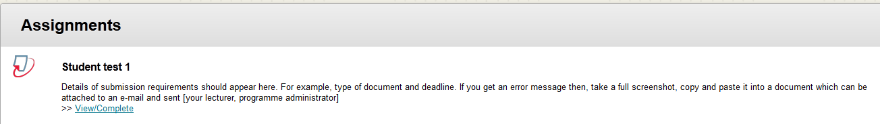
Select View/Complete to get,
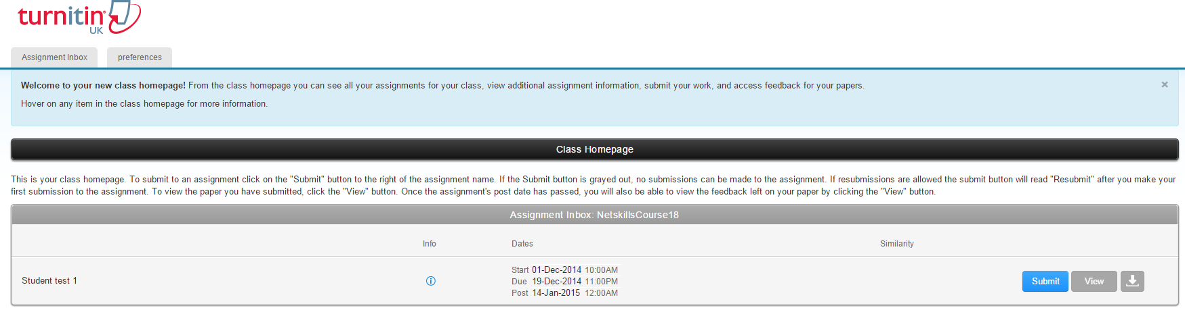
Press Submit to get,
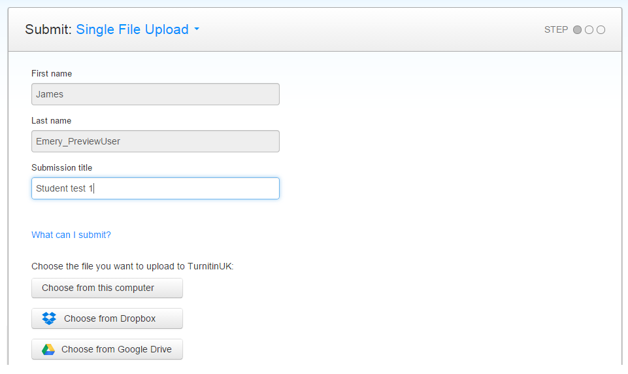
Select Choose from this Computer and browse to where your submission is saved, possibly on a USB/portable drive. You can also try the two other methods but you may get network connectivity issues depending on your location. Select Upload when you have found the file you wish to upload,
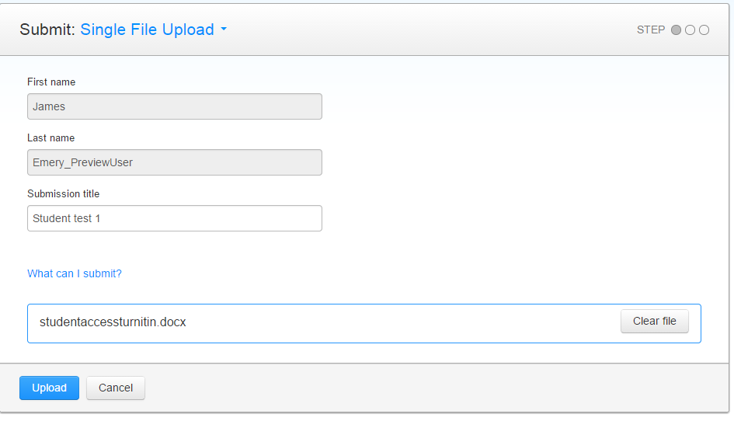
You will now get a preview of your submission for you to check that you have uploaded the correct version, select Confirm,
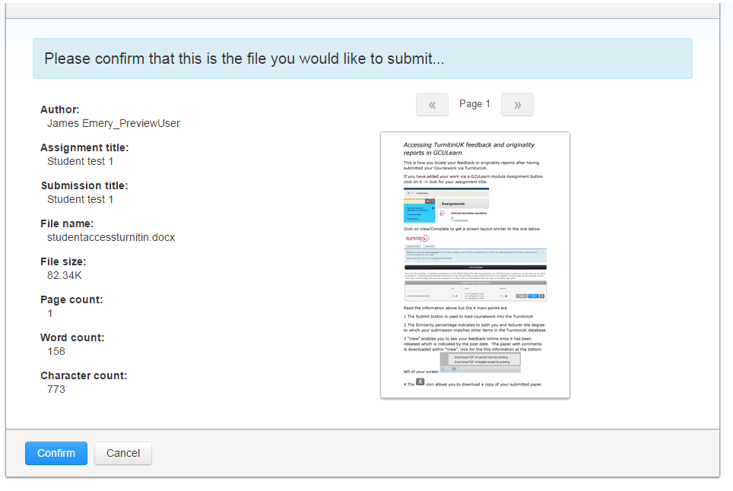
You will now see your digital receipt which you can screen capture or access by clicking on Return to assignment list.
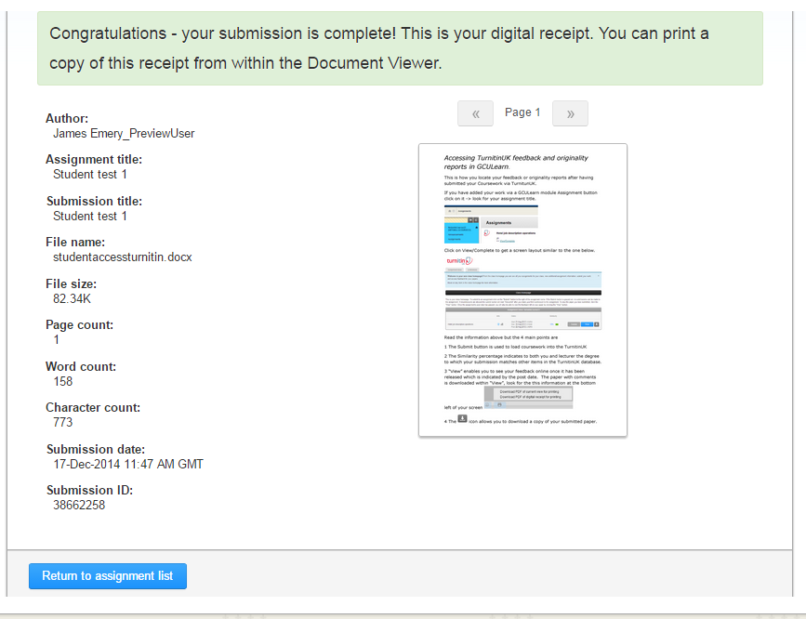
Select download arrow for your digital receipt.
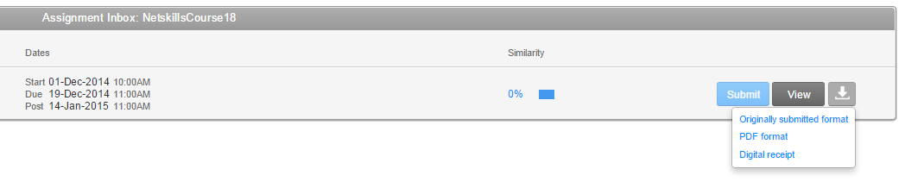
You will also get an e-mail with a message similar to the one below.
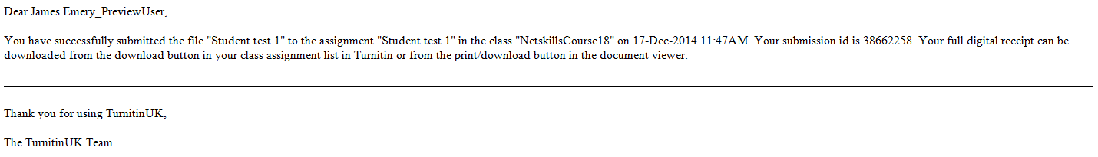

5. Interpreting your Similarity Report

As noted earlier, Turnitin is a similarity checking application which generates a report highlighting areas in your work where it has found similarity with other documents in its database.

- Turnitin gives your piece of coursework a ‘Similarity Score’ (sometimes called an ‘Originality Index’).

- Turnitin does not detect plagiarism by itself. The similarity report it produces needs to be reviewed to determine whether the highlighted areas can be interpreted as plagiarism.

- A high similarity score does not necessarily mean that there is plagiarism (e.g. it might just mean that you’ve used popular quotes that lots of other essays have used).

- Turnitin simply points out areas that may be of concern, and are perhaps worth a second look to double check.

- On some occasions a high score may be ok. A low score may not be.

- So check carefully the areas that are highlighted in your text. Have you –
- Put in quotation marks and references for all your quotes?
- Made sure the reference list and any bibliography are complete?
- Accidentally cut and pasted from a website and forgotten to put in the reference?
- Made sure that you haven’t paraphrased a source rather too closely (although that may still be ok, if you have referenced it correctly)?

The main question is… have you referenced your work carefully, comprehensively and consistently?

If you are not absolutely sure what constitutes plagiarism you should log into GCU Learn where you will find an item called PLATO (Plagiarism Teaching Online). Click on that and follow the instructions. PLATO is a very useful online tutorial that will take you through the basics of plagiarism.

For full details of how to interpret your similarity report, please see the Turnitin guide at:
https://guides.turnitin.com/01_Manuals_and_Guides/Student/Student_User_Manual/17_Originality_Check#Interpreting_the_Similarity_Report

The GCU Online Similarity Checking Policy by the Similarity Checking Working Group is licensed under a Creative Commons Attribution-Non-Commercial-ShareAlike 4.0 International Licence

Section 5 adapted from guidance by Dr Catriona Miller, GSBS

