Appendix B

GCU Staff Guide to interpreting a Turnitin Originality Report

This guide aims to explain some of the terminology used by Turnitin and how to begin to interpret the Originality Report produced by Turnitin when a student submits an assignment. Turnitin does not (and cannot) tell Instructors whether a paper has or has not been plagiarised, but simply provides the tools to help instructors locate potential sources of plagiarism, or incorrectly cited text.

Assignment Inbox

The ‘assignment inbox’ is where all the submissions, settings, originality reports and similarity indices for an assignment can be viewed and accessed. To open the inbox for a particular assignment you should:

- Log into GCULearn and go to the module containing the assignment that you wish to access.
- In the Control Panel click on ‘Course Tools’ to expand and click on ‘Turnitin Assignments’.
- Click on the name of the assignment and you will be taken to the ‘inbox’ for the assignment.

Once you are in the assignment inbox you will be presented with a list of all students and several columns containing information. Each of the column headers can be clicked to ‘sort’ the column and clicked again to reverse the sort.

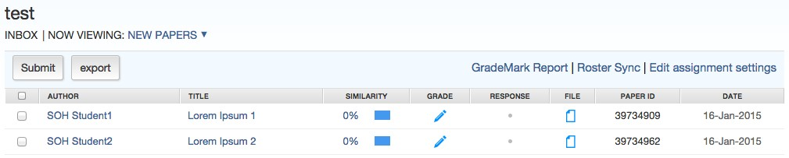

Similarity index

The ‘Similarity Index’ is located in the column titled ‘SIMILARITY’ within the inbox of an assignment. Once a student has made a submission and an Originality Report has been generated (only if ‘Generate Originality Reports for submissions?’ was selected when setting up the assignment), then this column will show a percentage and a coloured flag, based on the submitted work’s similarity to the Turnitin repository and internet sources, including a database of published journals. The coloured flag allows “at a glance” indication of submissions of “potential interest”.

N.B. It is NOT a ‘plagiarism score’ but merely a summative total of the percentages of all matches between the Student paper and other sources. It is very much dependent on the Assignment settings and as such there can be no cutoff point where plagiarism begins and ends.

“Turnitin does not determine whether a paper has or has not been plagiarized. Originality Reports are simply tools to help instructors locate potential sources of plagiarism, or text which may have been incorrectly cited. Therefore, only instructors can deem what is a "good" or "bad" score, as interpretation of the data can only be made by the instructor.”

No matches 1­24% 25­49% 50­74% 75­100%

By clicking on the heading ‘SIMILARITY’ you can sort all the indices in to order to best identify the ones that may require attention.

Originality Report

The Originality Report produced by Turnitin is simply a tool which quantifies similarity between a piece of student submitted work and the Turnitin repository and internet sources, including a database of published journals, and lists those sources as an aid to detecting possible plagiarism.

It is NOT a ‘plagiarism report’.

To access the Originality report, click on the Similarity Index or the coloured flag in the assignment inbox.

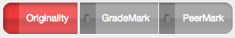
Make sure that the “Originality” button is selected in the top left (image on left).
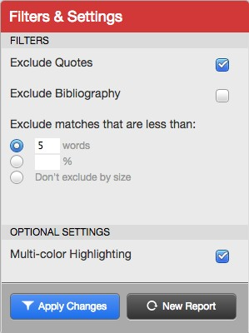
You may need to play around with the filter settings in order to make the best use of the report. You can access it in the bottom right of Turnitin by clicking the button. You’ll be presented with a box resembling that on the right.

For example, sometimes selecting “Exclude Bibliography” can cause more of the paper to be excluded than you actually wish.

Also, setting “Exclude matches that are less than” to 3 or less can cause large similarly due to commonly used phrases or subject specific terminology.

The settings on the right ‘should’ work in the majority of cases though. Press the “Apply Changes” button when you are done.
You can also see a “breakdown” of the total to individual matches by clicking on this icon in the top right.
Hover your mouse over the list and click the arrow 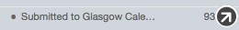 to see the match within the original paper.

Commonly asked Questions and Answers

What percentages are safe?

What is the cut-off percentage?

What is a good or bad score?

There is no hard and fast rule regarding any of these questions. For example a student copying a new or obscure journal article might get a really low index (even 0%) but through writing style or other sources might be deemed to be plagiarising, whereas, a student making a 2nd or 3rd diet submission might get a really high index (100% is possible) when their submission matches a previously submitted one.

N.B. this is not self-plagiarism since their 1st diet submission was a fail and therefore did not contribute to their award.

How can you find submissions that ARE plagiarised?
This is really down to academic judgement by considering ALL the information available including the Similarity Index, the Originality Report, list of matches, student’s work etc. For example if a Similarity Index is high compared to all the others and stands out then it probably warrants a more in depth look at the sources. Similarly if the writing style of a section changes dramatically yet does not match any sources then further investigation may be required. A student needs to have found the source somewhere so Google may be a start to finding a source that has not been identified by Turnitin.

Similarly, a fact that shows up in someone’s work that was used in previous years but not in recent ones MAY indicate resubmission of part of an assignment from a time before Turnitin. Tips to locating these sources include:

- Try copying and pasting the title into Google between double quotes “ ”. This keeps the text as a phrase rather than searching for occurrences of the individual words.

- Similarly, try with a short section of text that is obviously written in a different style.

- Ask your colleagues to read the section of the assignment. If it comes from an article then they might recognise it.

- Ask the student about it. This is probably a last resort as, without evidence, the student will most likely deny any wrongdoing. However they may own up when put in the spotlight.

Here are a few suggestions for how educators and administrators can consider the different types of plagiarism:

INTENT MATTERS
The Plagiarism Spectrum at turnitin.com/assets/en_us/media/plagiarism_spectrum.php emphasizes the range of intent, which when coupled with prevalence and problematic scores, provides educators with guidance in terms of developing appropriate academic responses. For example the ‘Clone’, (submitting another’s work, word for word, as one’s own), with its high problematic and severity scores, warrants a more extreme response, whereas an instance of the ‘Mashup’ (mixing copied material from multiple sources), while fairly prevalent, does not demonstrate the same severity of intent and thus should not be handled in the same way.

GUIDE STUDENTS
There is a range of intent behind student plagiarism, highlighting the range of awareness that students may have about the ways in which plagiarism can take form. Educators would do well to provide students with information and guidance around the types, not only to help curb instances of unintentional plagiarism, but to also let students know that their instructors are wise to the ways in which they might inappropriately include information in their written work.

USE OriginalityCheck®
As instructors work with students on their drafts, they should give them access to view their Originality Reports in Turnitin. This will give students the opportunity to see where they may have improperly paraphrased or inadvertently misused a source. Also, consider asking students to address the Originality Report findings in a “reflection” assignment, i.e. what did the students learn about their papers through the Originality Report, and what steps will they take to address those concerns?

For more information on different types of plagiarism and their levels of severity, please refer to the Plagiarism Spectrum at http://turnitin.com/assets/en_us/media/plagiarism_spectrum.php

The GCU Online Similarity Checking Policy by the Similarity Checking Working Group is licensed under a Creative Commons Attribution-Non-Commercial-ShareAlike 4.0 International Licence

Guidance on interpreting a similarity report developed by SHLS
http://turnitin.force.com/pkb/articles/en_US/Knowledge_Article/Originality­Report­Interpreting­Results­Instructor

