- Log in to GCULearn
- Go in to your module and navigate to the required section (for example learning resources)
- Go to the grey Tools menu near the top of the screen

- Click More tools
- Click Resource List
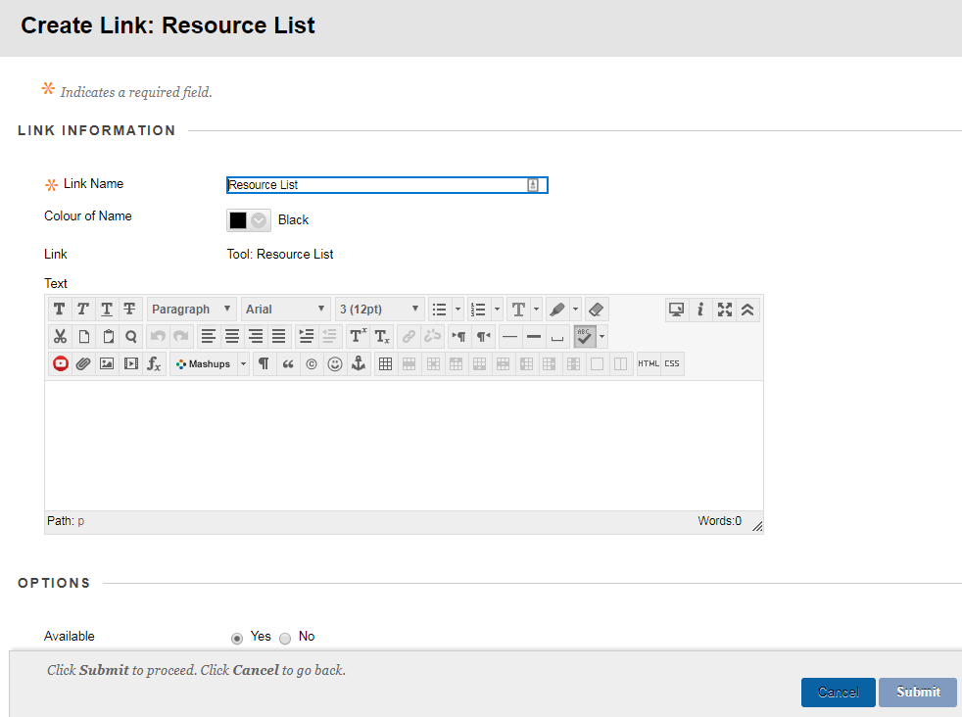
- In the popup window, you can edit the Link name or just leave it as Resource list
- Click the blue Submit button
To view your list, move to the bottom of the page and click the Resource List heading.
This will pull in your list for that module.
If the window stays blank, or a message stating that no reading lists have been associated with that module appears, contact us on ertenq@gcu.ac.uk

