Getting Started With Collaborate Ultra – Part 2: Finding your way around the Ultra interface

The Collaborate Ultra Interface
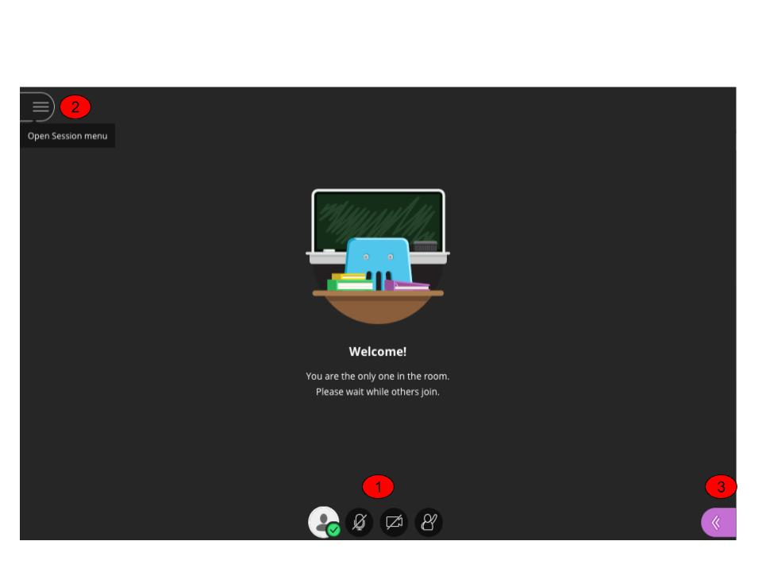
1: Audio/video settings. You can switch on and off your video and audio settings using the icons at the bottom of the screen. Remember you need to either have a (built in) web cam, microphone, headset or speakers to participate in a session. More information is available here.

2: Session Menu. This is where you start a session recording, access official Collaborate Ultra help, and leave a session. More information is available here.

3. Collaborate Panel. This where you manage and moderate a session. You can upload and share content, screen share, use polls, whiteboards and create groups and change use roles. More information is available here.

The Session Menu

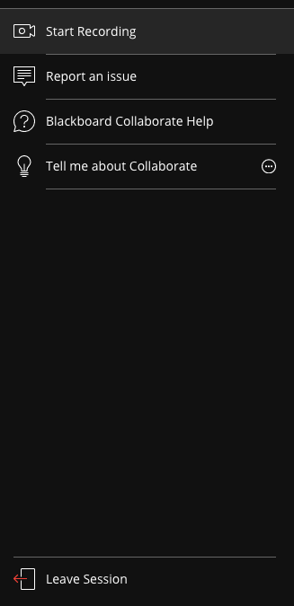
The session menu allows you to start/stop recording a session, access official Blackboard collaborate help and system updates. It’s also where you leave a session.

The Collaborate Menu

Sharing Content 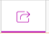

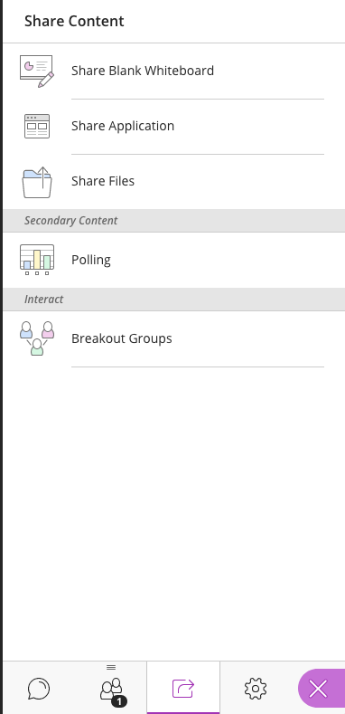

To share content, select Share Files, then drag or upload your files. Your file(s) will then appear. To share them in your session, you need to click the Share now button.

To share an application, select Share Application and follow the on screen instructions.

To set up a poll, select Polling and follow the on screen instructions. NB the polling functionality is limited.

To set up breakup groups, select Breakout Groups, and follow the onscreen instructions.

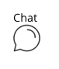 | Select this icon to view and participate in session text chat. Moderators can also set up private chats with selected individuals in the session.
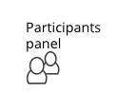 | This is where you can view a list of all the participants in a session and if necessary change their permission e.g. make them a presenter so they can share content.
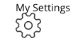 | This is where you can adjust your video/audio settings, and add a profile picture

More detailed information on all the tools is available here.•

• https://help.blackboard.com/Collaborate/Ultra/Moderator/Get_Started

