Use of ActivPAL

SOP Reference: SeniorsUSP/SOP/C04
Version Number: 2 | Previous Version Number: 1  Date: 05.11.14
Author: Dr Elaine Coulter, Dr Philippa Dall
Cohort Approval: PD [05.11.14] SC [05.11.14] SS [05.11.14]
Approved by: Professor Dawn Skelton, PI, Signature:
Effective date: November 2014
Review by: May 2015

ASSOCIATED DOCUMENTS:

ActivPAL3 Program and Download Record
SeniorsUSP/SOP/B06- ActivPAL skin reaction
SeniorsUSP/SOP/E05a- Visual Inspection of WP2 activPAL data- Fieldworkers

SCOPE:
Fieldworkers are required to use the activPAL3 activity monitor to measure physical activity levels and sedentary behaviour of 750 participants from both the Lothian Birth Cohort 1936 (n=300) and West of Scotland Twenty-07 cohorts (n=450).

This Standard Operating Procedure (SOP) describes how to charge, programme and download data from the activPAL3 activity monitor. It also describes how to position the activPAL3 activity monitor on participants’ thighs.

DEFINITIONS:

- LBC1936: Lothian Birth Cohort 1936
- T07: West of Scotland Twenty 07 cohort
- WP2: Work Package 2

PROCEDURE:

- Charging the activPAL3 activity monitor

  - To charge the activPAL3 activity monitor place it in the proprietary docking station, attached to a PC/laptop by a USB cable.
  - Check the orange charging light on the activPAL3 monitor is illuminated to ensure the device is charging. The orange charging light on the front of the activPAL3 will go out when the device is fully charged. The docking station has five charging slots so five devices can be charged simultaneously.

! It is important not to switch off your PC/laptop for the monitors to charge
! The monitors may not charge if your laptop is in sleep mode. Check that the monitors will charge in sleep mode before leaving them to charge this way
! A full charge will take about 3-5 hours
! It is wise to ‘top up’ the charge on the monitor just before programming

- Programming the activPAL3 activity monitor

  - The activPAL3 should be programmed as close to the appointment time as possible.

! The activPAL3 should not be programmed any earlier than 1 day before the research appointment

  - To program the activPAL3 activity monitor place the device in the slot 1-PC interface position of the docking station. Note the device serial number and document this in the ‘ActivPAL3 Program and Download Record’.

! The docking station should be the only device plugged in to USB sockets. The software may not connect if there is more than one item connected via USB

  - Open up the activPAL proprietary software version no. 7.2.32 on the laptop.
  - Click on the ‘connect’ icon.

Trouble shooting
→ if the device does not connect:
→ check that the docking station is the only device connected to the laptop by USB
→ check that the docking station lead is inserted firmly into both the laptop and the docking station.
→ check that the monitor is inserted firmly into the docking station
→ try clicking on the connect button additional times, as this sometimes helps
→ try removing the monitor and replacing in the docking station or closing the software and restoring it
→ if the device continues to fail to connect:
→ program an alternative monitor
→ take a screen shot of the error message (see section 8)
→ report as a fault (see section 7)

  - Check the battery level of the activPAL3 is adequate. Battery levels of 4.15v and over are good. Document this on the activPAL3 ‘Program and Download Record’ Document.

! Only program the activPAL3 monitor if the battery level is more than 4.1v

  - Select the set-up tab
  - From the drop down list start condition select immediately.
  - In the record for section select 14 days.
  - Check the reminder is set to ‘no reminder’. This should be the default option.
  - Click program for the device to begin data collection.

Trouble shooting
→ if you get the battery too low error message:
→check the battery level [remember it should be higher than 4.1v]
→ if it is higher than 4.1v:
→ program an alternative monitor
→ take a screen short of the error message (see section 8)
→ report as a fault (see section 7)
→ if it is lower than 4.1v:
→ charge the monitor for longer to increase battery level and program later
or
→ program an alternative monitor

  - When the message box “activity data stored in the device will be erased” appears, confirm that the data from the monitor has already been downloaded, and then click OK to proceed.

! Programming an activPAL3 monitor deletes any data that is stored in the monitor
! Always download data from the activPAL3 as soon as you get the monitor back from a participant. That way you will know it is OK to overwrite the data on the monitor

  - On successfully programming the monitor you will see the message “activPAL set up complete. Please remove the device from the docking station”.
  - Remove the device from the docking station.
  - The orange light on the activPAL3 blinks rapidly for several minutes while it finishes programming/initiation. The monitor can be removed from the docking station while the orange light is flashing.
  - When the activPAL3 is collecting data, the green light on the monitor illuminates every few seconds. Always check that the green light has started flashing after you have programmed a monitor.

Trouble shooting
→ if the device does not illuminate as expected:
→ take a screen short of the error message (see section 8)
→ report as a fault (see section 7)
→ program an alternative monitor

  - The activPAL3 monitor has now been programmed, and can be prepared for data collection (section 3)

! DO NOT place the monitor back in the docking station once the monitor had been programmed (e.g. to top-up charge), as this will cancel the programming
! If the monitor is placed back in the docking station, then the monitor will need to be re-programmed (from section 2.1)

  - Document the stages of programming in the ‘ActivPAL3 Program and Download Record’

- Preparing the activPAL3 activity monitor for data collection

  - Switch on the heat sealing machine, set at level 2, to heat seal the waterproof plastic tubing, wait until the machine is fully heated before using, this should only take a minute.

! The heat sealing machine should be set to level 2

  - Cut approximately a 10cm section of the FDA approved plastic tubing.
  - Heat seal one side of the plastic tubing. You must use the side of the heat seal machine with the ‘packer’ logo. To do this, position one open end in the middle of the heat seal in line with the two screws (Figure 1). Press and hold the heat sealer down for 2 seconds (Figure 2). Lift it back up again and lift the plastic tubing and check the seal. Trim any excess from the sealed end of the plastic tubing if required (Figure 3).
  - Put the activPAL3 monitor inside the plastic tubing.
  - Heat seal the open side of the plastic tubing with the activPAL monitor inside. Follow the process described in section 3.3. Position the heat seal close to the activPAL enclosed inside (Figure 4).
  - Trim the plastic tubing to remove any excess from the second sealed end (Figure 5).
  - Attach a PALstickie, a double-sided hypoallergenic sticky pad, on the back of the monitor, by removing the clear plastic off the sticky pad (Figure 6).
  - The activPAL3 monitor is now programmed and prepared for use in data collection

! It is advisable to program a spare monitor to take to data collection, in case the prepared monitor develops a fault
- Attaching the activPAL3 monitor

  - The fieldworker will ask the participant to identify their strongest leg or less affected leg to which the activPAL3 will be attached. Otherwise the activPAL3 will be attached to their dominant leg. This will be documented in the ‘Visit 1 Data Collection Sheet’.
  - The fieldworker will note the serial number of the activPAL3 activity monitor, prior to attaching the monitor. The 6-digit serial number is located on the right hand side of the front of the monitor (Figure 7). This will be documented in the ‘Visit 1 Data Collection Sheet’.
  - The activPAL3 should be attached in a private area/room.

LBC1936 cohort specific instructions
→ A room will have been set aside in the hospital as a private area to conduct physical tests.

Twenty 07 cohort specific instructions
→ If the participant has shown you to a room in their house with other family members, advise that a private room should be used for completing the study documentation and for attaching the monitor.

  - The participant will have been asked to wear loose trousers capable of being rolled up over the knee or a skirt. Check whether the participant is wearing suitable clothing. If the participant is not wearing suitable clothing, ask the participant about the following alternatives to find out which they are comfortable with, and proceed using that alternative. If the participant is not comfortable with any of the proposed alternatives, then they will not be able to take part in the study. Please thank them for their time, and explain that they will not be able to take part in the project.

Both cohorts
→ If the participant is wearing a skirt with tights, ask the participant if they are willing to take the tights off. Provide the participant with the privacy to do so.

→ Ask the participant if they have suitable alternative clothing to change into for e.g. shorts. If they do, and are happy to change, provide them with privacy to do so.

LBC1936 cohort specific instructions
→ Ask the participant if they mind covering their lap with a towel and pulling down their trousers to knee height for a short time to attach the monitor. Use a department towel to cover their lap appropriately. Discard for cleaning once used.

Twenty 07 cohort specific instructions
→ Ask the participant if they mind putting on a disposable hospital gown and pulling down their trousers to knee height for a short time to attach the monitor. Use one disposable gown per visit, and dispose of the gown in the home of the participant after use.

  - Prior to attaching the activPAL3, inside the waterproof covering, ensure the device is the correct orientation. When positioned on the thigh the curved edge of the monitor should be on top, and the outline picture of the man should be upright with the head towards the participant’s head (Figure 7).

  - Check to ensure that the green light flashes every few seconds. This indicates that the device is collecting data. If the green light is not flashing, do not attach the monitor, use a different monitor.

! Do not attach a monitor if the green light is not flashing
! It is advisable to program a spare monitor to take to data collection, in case the prepared monitor develops a fault
! If you use the spare monitor, remember to update the monitor serial number on the ‘Visit 1 Data Collection Sheet’

Trouble shooting
→ if a different monitor is used:
→ update the serial number on the ‘Visit 1 Data Collection Sheet’
→ update the ‘ActivPAL3 Program and Download Record’ to reflect the fault when you return from the visit
→ report the fault (see section 7)

  - Remove the paper wings of the double sided sticky pad on the back of the monitor and position halfway up the participant’s mid-thigh (Figure 8).
  - Take a 12cm length of the additional waterproof dressing, these can be cut in advance of the visit. Remove the white paper backing (labeled “1 remove this first”). Be careful at this stage not to remove the transparent plastic backing on the other side of the dressing (Figure 9).
  - Place the dressing loosely over the activPAL3 on the participant’s leg (Figure 10).
  - Remove the transparent plastic cover from the front of the dressing and press the dressing firmly down on the participant’s leg to ensure a waterproof seal (Figure 11 &12).
  - Document the time of attachment of the activPAL in the ‘Visit 1 Data Collection Sheet’.
  - Advise the participant to remain wearing the activPAL3 activity monitor continuously until the second research appointment, including overnight and during water based activities.
  - Inform the participant what to do if they experience a skin reaction, itchiness or discomfort while wearing the monitor (refer to SeniorsUSP/SOP/B06). Advise the participant what to do if the device falls off.
  - Advise the participant to continue with their normal activities and not to let wearing the device change their behaviour.

- Removing the activPAL monitor

  - The device will be removed from the participant’s leg by the fieldworker at the second research appointment. The participant should be wearing loose clothing to aid removal of the device.
  - The activPAL3 should be removed in a private area/room (as detailed above in 4.3).
  - If the participant is not wearing suitable loose clothing follow the same steps as detailed above in 4.4.
  - The fieldworker should ask if the participant experienced any discomfort, itchiness or reaction while wearing the device. This should be documented in the ‘Visit 2 Data Collection Sheet’.
  - The fieldworker should ask if the device was removed during the data collection period and if so, when it was removed and explore the reason why. This should be documented in the ‘Visit 2 Data Collection Sheet’.
  - To remove the waterproof dressing a corner of the dressing should be pulled away from the skin. Do not peel back on the skin, peel the dressing up and forward. With the other hand the participant’s skin should be held taut (Figure 13). Advise the participant there may be some discomfort while removing the waterproof dressing, but using the method described above should minimise any discomfort.
  - Remove the PALstickie by rolling the stickie back (Figure 14). Remove the waterproof plastic tubing using scissors. This can be done after the visit.
  - Check the serial number and write this on the ‘Visit 2 Data Collection Sheet’.
  - Dispose of the dressing, sticky and plastic tubing in a bin if available.

- Data downloading and checking

! Download data from the activPAL3 monitor as soon as possible after retrieving the monitor at Visit 2

  - Open up the activPAL proprietary software version no. 7.2.32 on the laptop.
  - Note the docking station serial number and document on the ‘ActivPAL3 Program and Download Record’
  - Place the activPAL3 monitor in the slot 1-PC interface position of the docking station, attached to the PC/laptop using a USB cable.
  - Click the ‘connect’ icon. If you are downloading from several monitors in a row, you may need to click connect several times for it to work.

Trouble shooting
→ if the device does not connect:
→check that the docking station is the only device connected to the laptop by USB
→check that the docking station lead is inserted firmly into both the laptop and the docking station.
→check that the monitor is inserted firmly into the docking station
→try clicking on the connect button additional times, as this sometimes helps
→try removing the monitor and replacing in the docking station or closing the software and restoring it
→ if the device continues to fail to connect:
→program an alternative monitor
→take a screen shot of the error message (see section 8)
→report as a fault (see section 7)

  - Note the battery level of the monitor in the communication window as soon as possible. Document this on the ‘ActivPAL3 Program and Download Record’. The device will start to charge immediately, so the battery level needs to be noted as soon as possible when it is slotted into the docking station.

! Record the battery level of the monitor as soon as possible
! The activPAL3 monitor will start to charge as soon as it is placed in the docking station

  - Click on ‘Download Stored Data’ and save the data from the monitor. Use the default filename, which is in the format [ActivPAL serial number date/time of programming number of days of data collected].
  - You will be asked to select a folder in which to save the data. The data should be saved into the [Cloud Storage] into a folder labeled with the participant ID. This folder should be already set up in your [Cloud Storage Folder]. Please check that you have selected the folder with the correct participant ID.

! Make sure you check that you are saving the data into the folder with the correct participant ID

  - You should see a window saying “Data transfer successful file size x kb”. Please remove device from station”. Remove the activPAL monitor from the docking station.

Trouble shooting
→ if you receive any error message on downloading data:
→ take a screen short of the error message (see section 8)
→ report as a fault (see section 7)
→ do not use the monitor again until the data is retrieved and the fault is resolved

  - On removing the monitor from the docking station, the software will automatically process the data and open the file.
  - Visually inspect the weekly summary of the downloaded data using the activPAL3 software to ensure that physical activity data is collected for all days of the monitoring period i.e. 7 full days. Refer to SeniorsUSP/SOP/E05a. Document this on ‘ActivPAL3 Program and Download Record’. Report any issues to [Named Person]. Refer to SeniorsUSP/SOP/E05a- Visual Inspection of WP2 activPAL data- Fieldworkers.
  - Check that the activPAL files have been successfully saved to your [Cloud Storage] space. Open your [Cloud Storage] and the right participant folder, check that 6 files are saved in this folder. There should be 3 Excel files, a .datx file , a .def file and a .pal file. Check that the .pal file name matches the serial number of the activPAL3 you have just used for this participant. The .pal file should look like “VP430109 27Aug14 10-11am for 6d 1h 21m.pal” with VP430109 being the serial number. Now please check the date in the file name corresponds to the correct date at which you programmed the activPAL.
  - The activPAL3 monitor can now be charged in preparation of use with another participant. Please do not program the monitor until 24 hours after download, to allow back-up of the data on the cloud to occur.

! Report any difficulty in downloading data or visually inspecting the data immediately as a fault (see section 7)
! Remember DO NOT reprogram the activPAL as this will wipe any data from the device and prevent future attempts to recover the data from the device
! DO NOT attempt to download the data from the activPAL a second time

- Reporting a fault
  - Faults should be reported directly to [Named Person] [contact details].
  - All faults reported should be accompanied by a screen shot of any error message (see section 8), along with a description from the fieldworker as to the nature of the fault.
  - Faults should be reported by e-mail, attaching the screen shot file to [Named person’s email address].
  - If immediate assistance is required (during office hours), then call: [Named person’s phone number].

Twenty 07 cohort specific instructions
! If unable to contact [Named Person], contact:

[Central Cohort Administration phone number]

  - Faults should be reported as soon as possible, and always within 1 day of discovering the fault, to allow rapid response to the problem, and provision of additional monitors if required.

! Never attempt to program an activPAL3 monitor that has failed to download data
! The act of programming a monitor deletes any data held on the monitor
! It is sometimes possible to retrieve data from a monitor, even if the download has failed, but this option is not available if the monitor has been re-programmed

- Taking a screen shot

  - With the error message displayed on the screen, press the print screen button on the keyboard.
  - Open a blank word document.
  - Paste the screen shot into the document. This can be achieved either by pressing Control + V, or by using the paste special function and pasting as an image.
  - Type the date, monitor ID, fieldworker ID/name, and brief description of the type of fault into the word document.
  - Save the word document with an appropriate file name.

Review Acknowledgements
I acknowledge that I have read and reviewed this SOP and that no changes are required.

Name | Job Title | Signature | Date | Next Review due
Figure 1. Middle line of the heat sealer machine to position the plastic tubing.

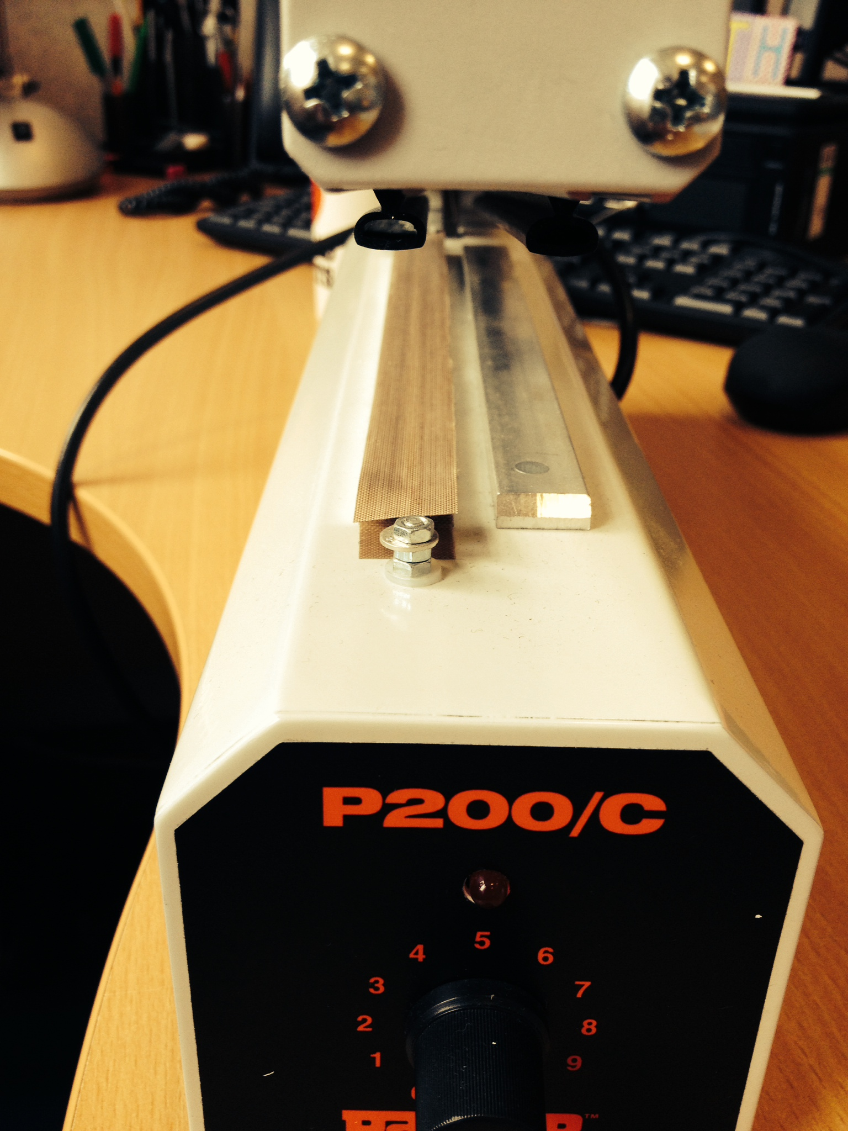
Position the plastic tubing to heat seal along the middle line between the two screws

Figure 2. Heat seal one end of the plastic tubing.

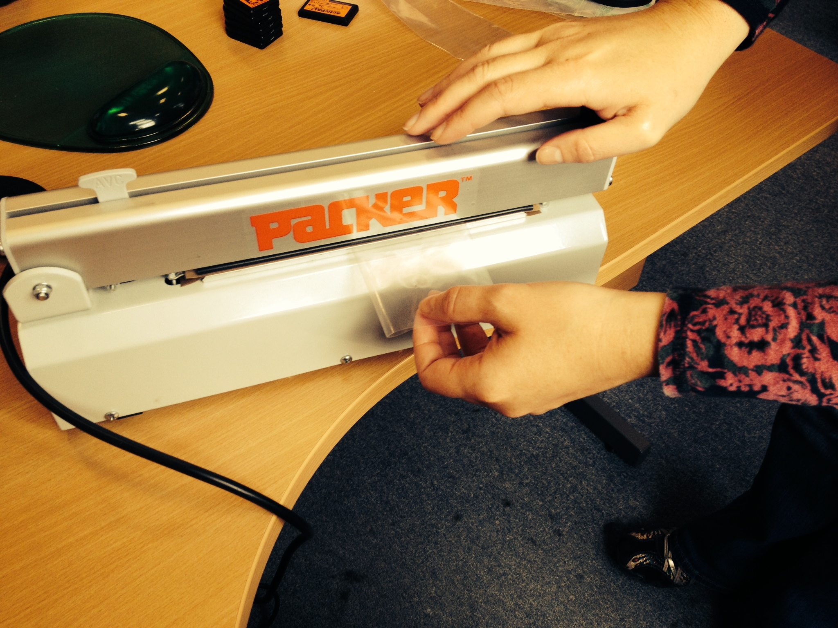

Figure 3. Plastic tubing with heat seal on one end, trim any excess as required.

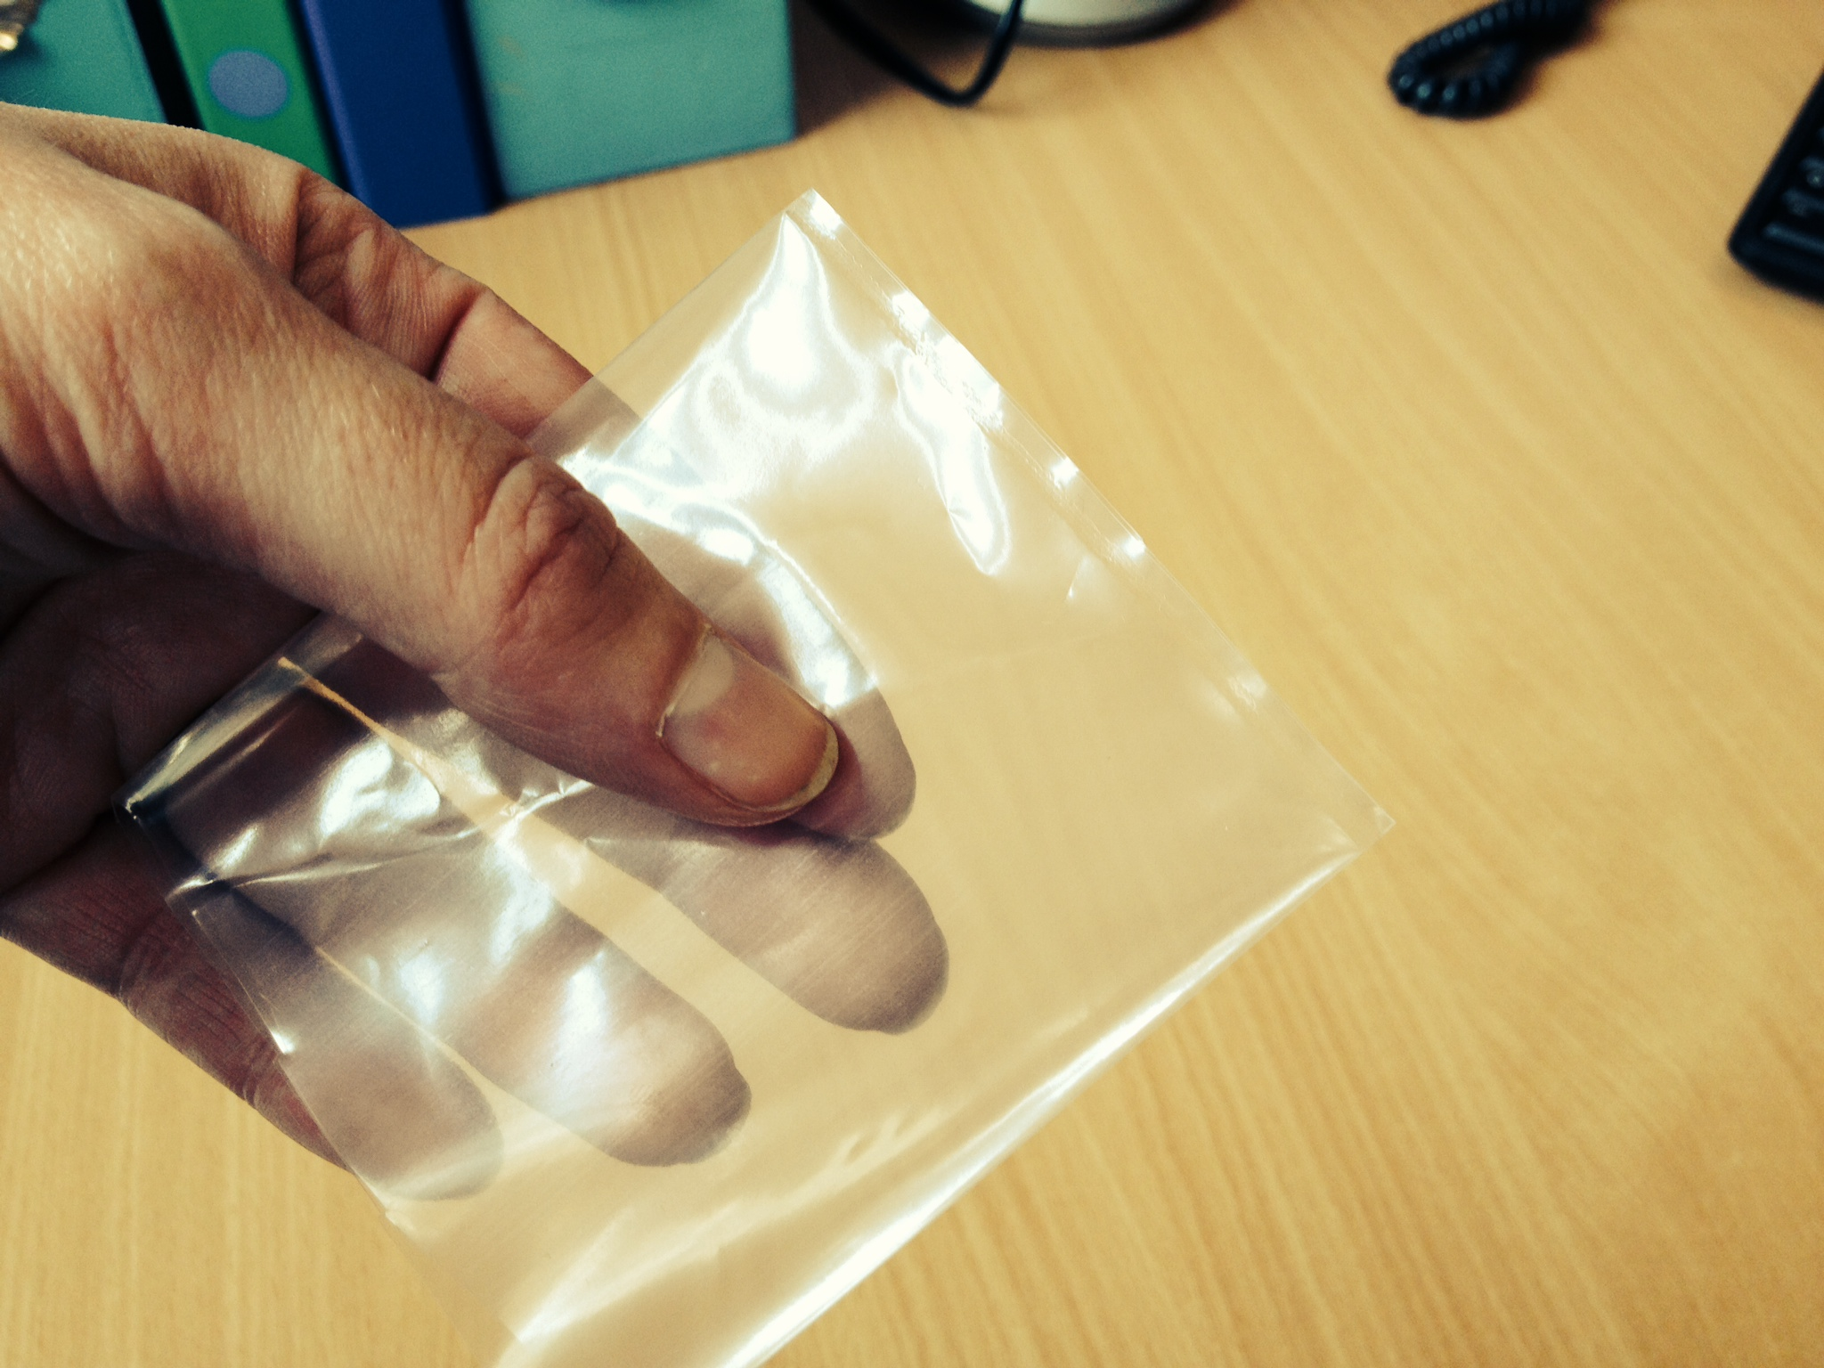

Figure 4. Heat seal the open end of the plastic tubing with the activPAL3 enclosed inside.

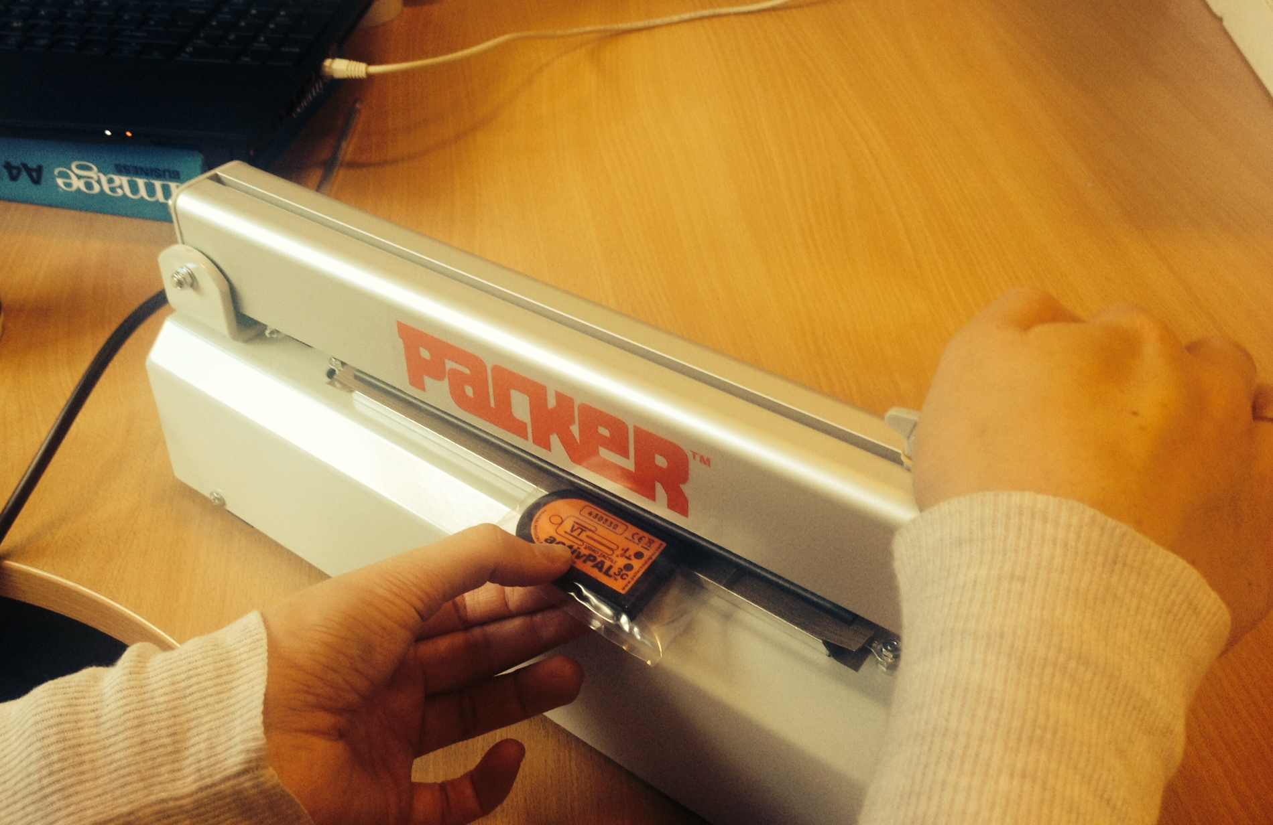

Figure 5. Trim excess plastic tubing from the second sealed end with the activPAL enclosed.
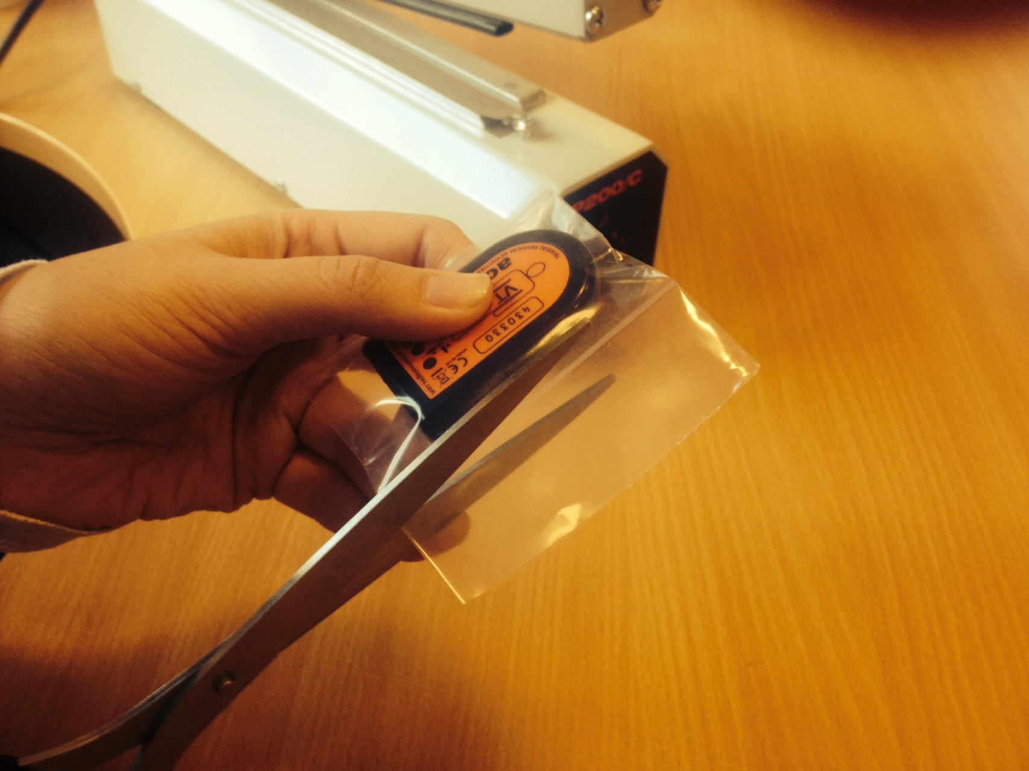
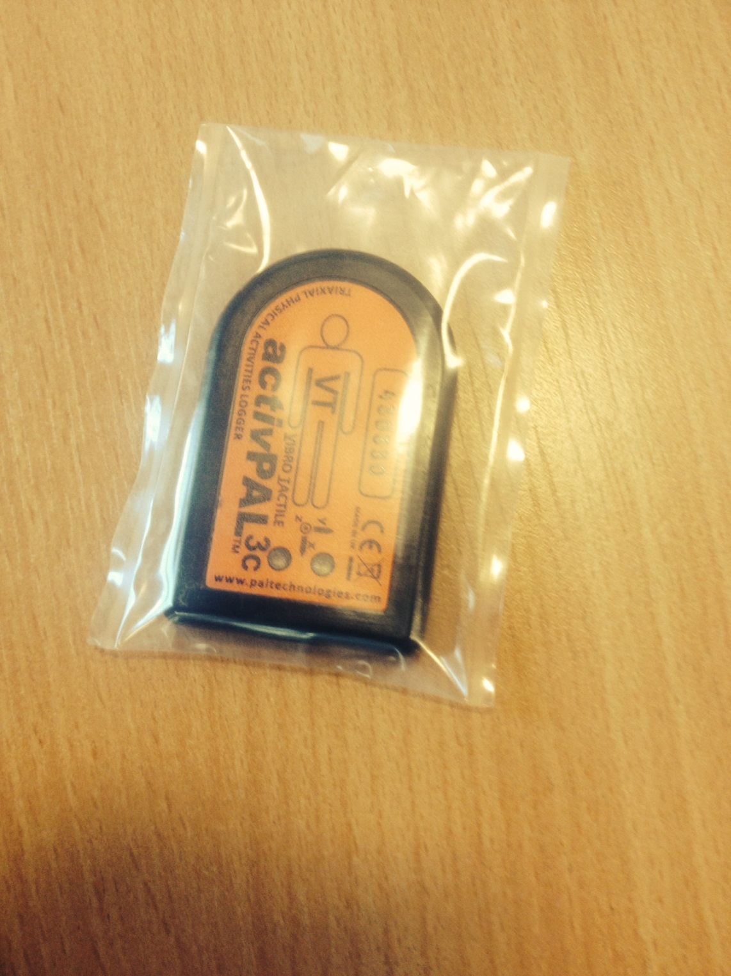

Figure 6. Remove the plastic cover from the PALstickie and attach to the plastic tubing with the activPAL enclosed.

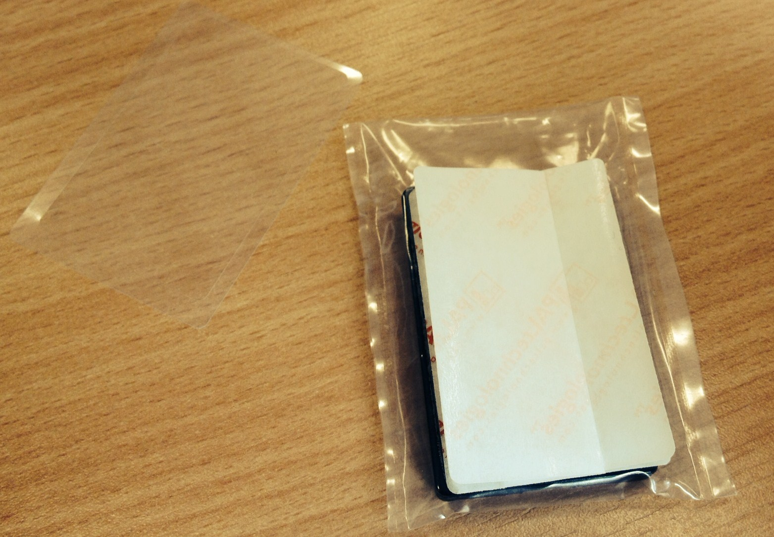

Figure 7. Serial number of the activPAL activity monitor.

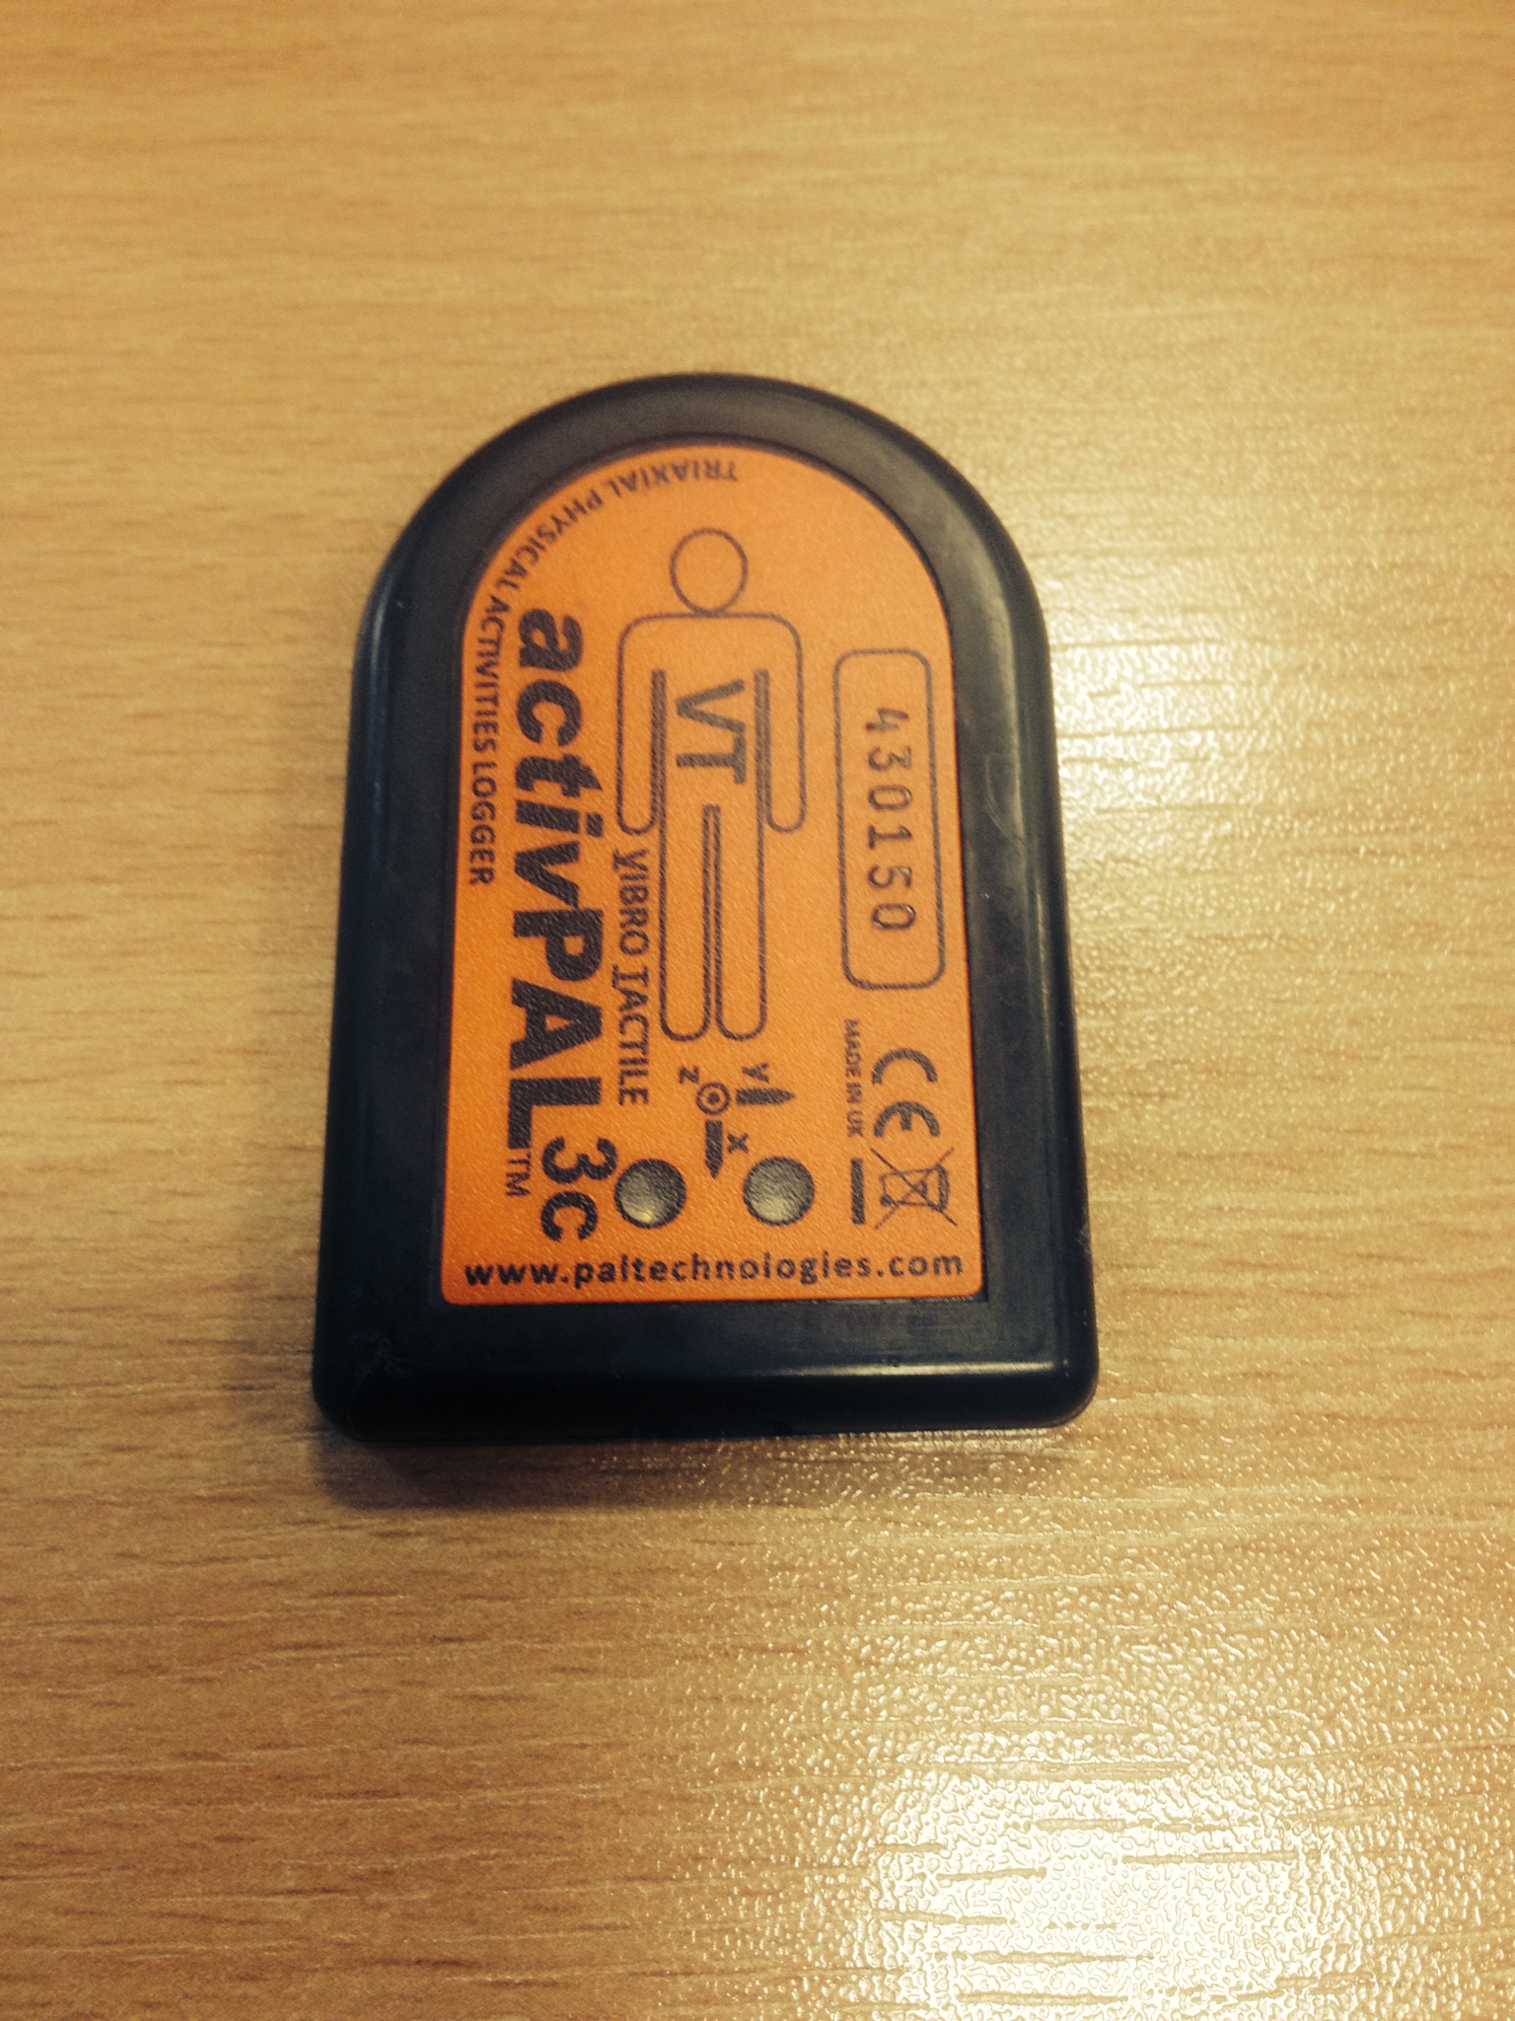
Serial number

Figure 8. Remove the butterfly wings from the PALstickie and attach to the mid thigh.

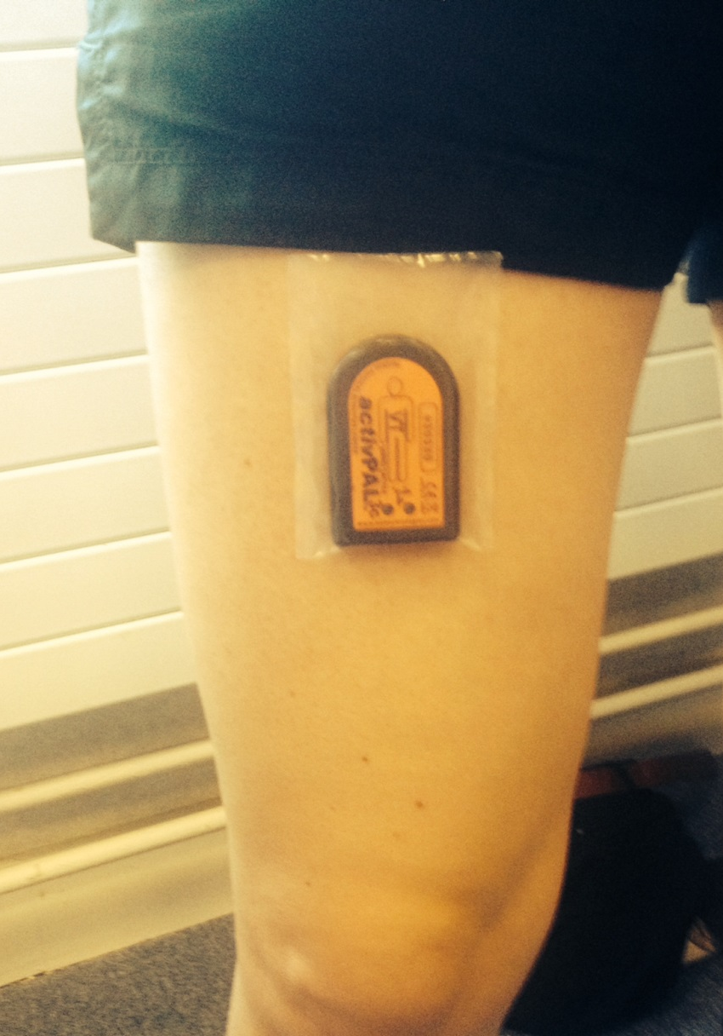

Figure 9. Remove the paper backing on the waterproof dressing.
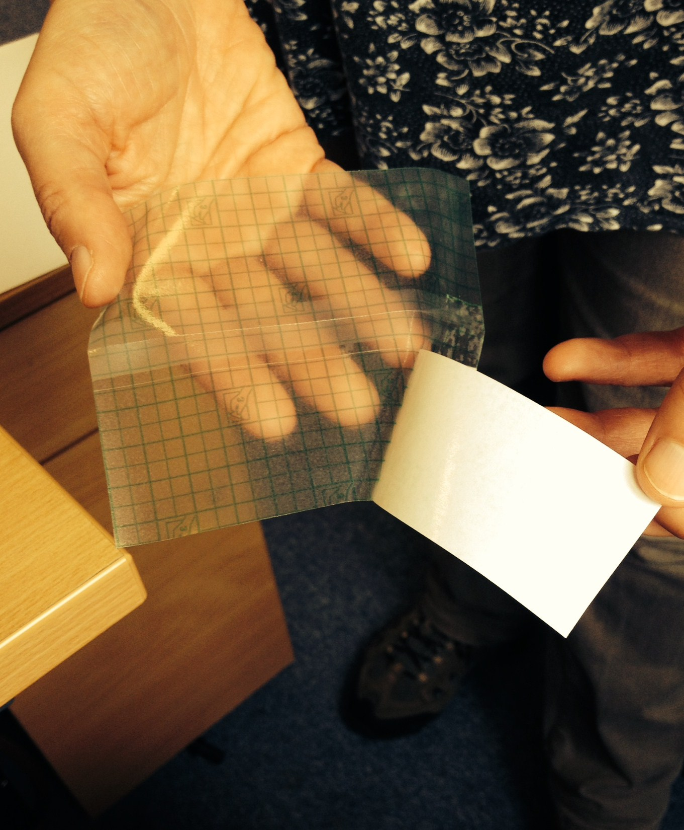
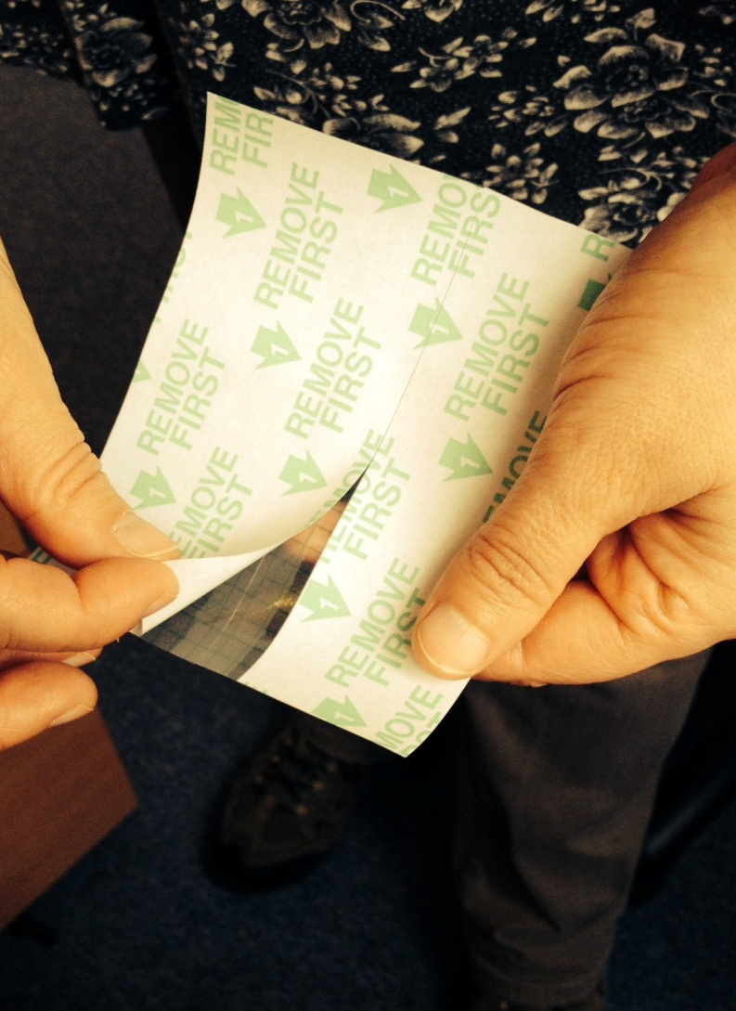

Figure 10. Place waterproof dressing over the activPAL3 on the thigh.

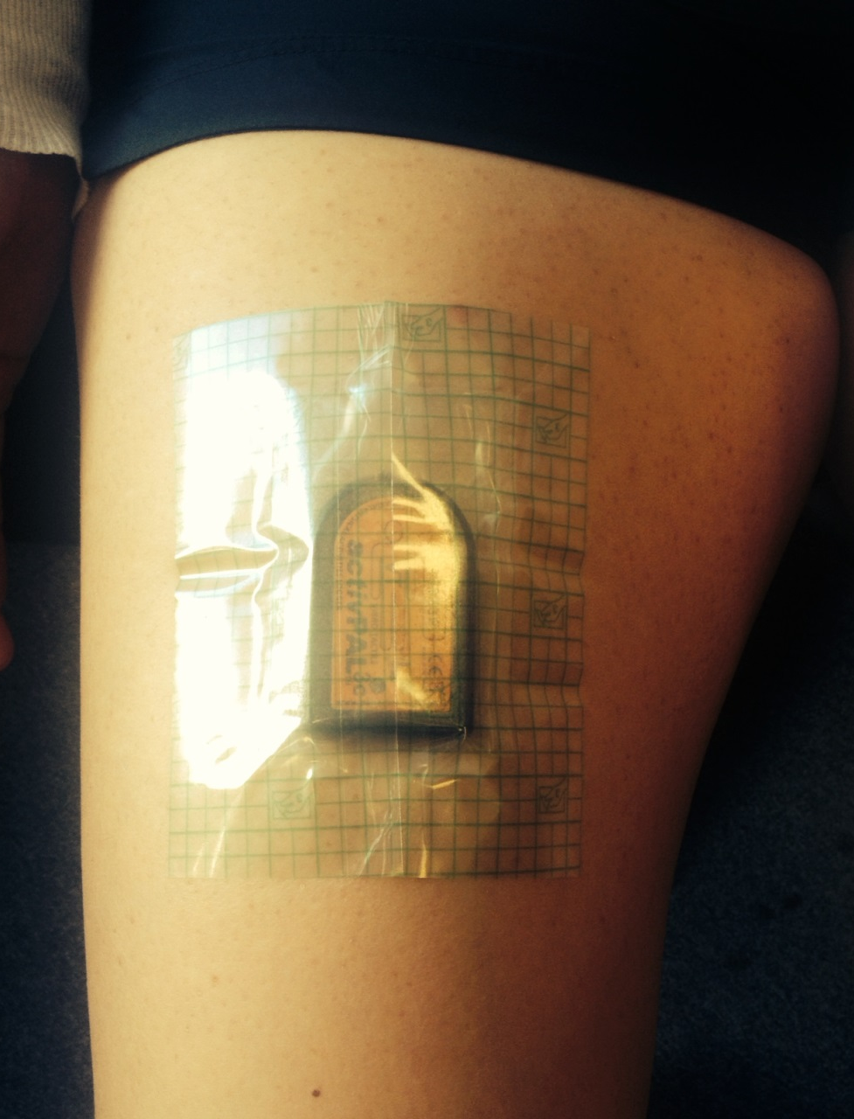

Figure 11. Remove the plastic cover from the waterproof dressing.
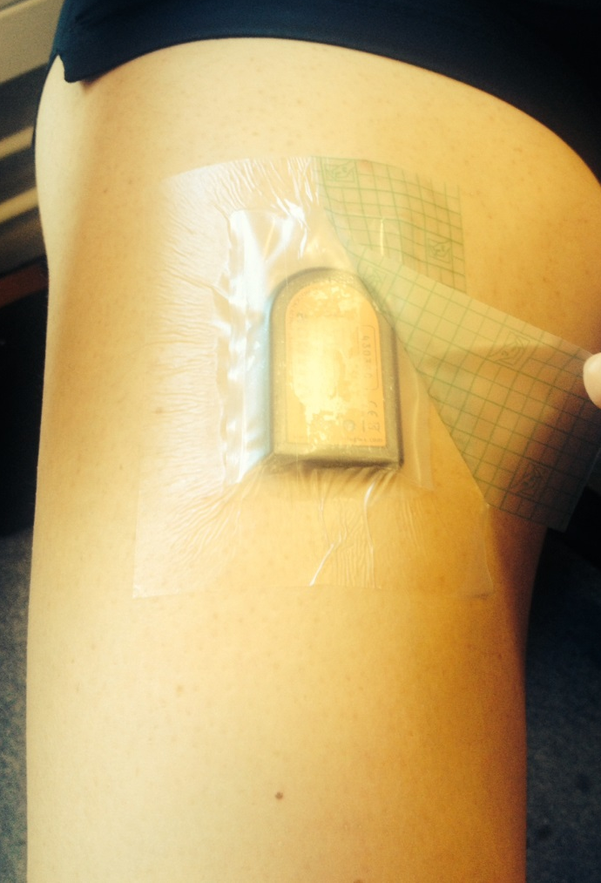
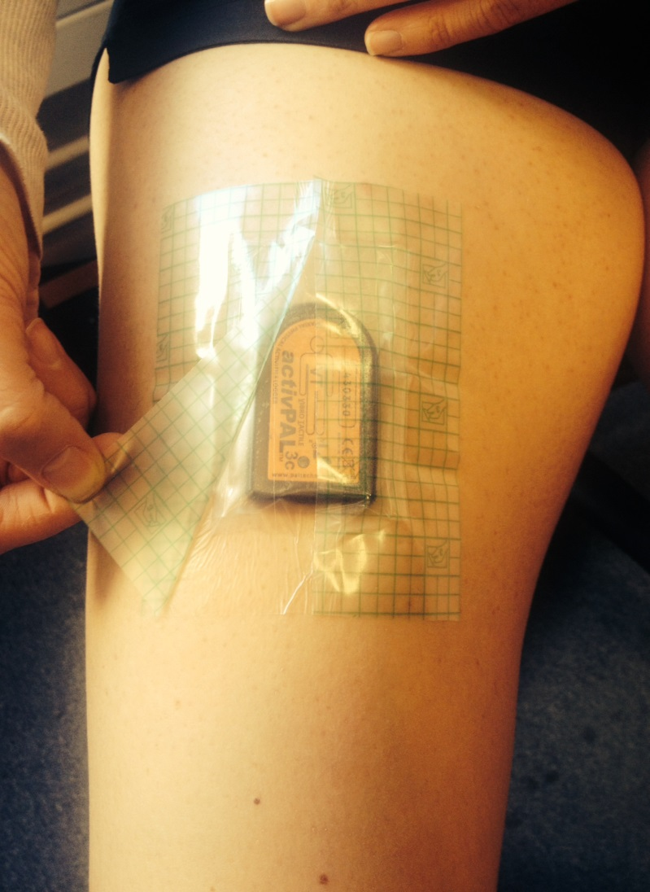

Figure 12. Press down the waterproof dressing onto the skin to finish.

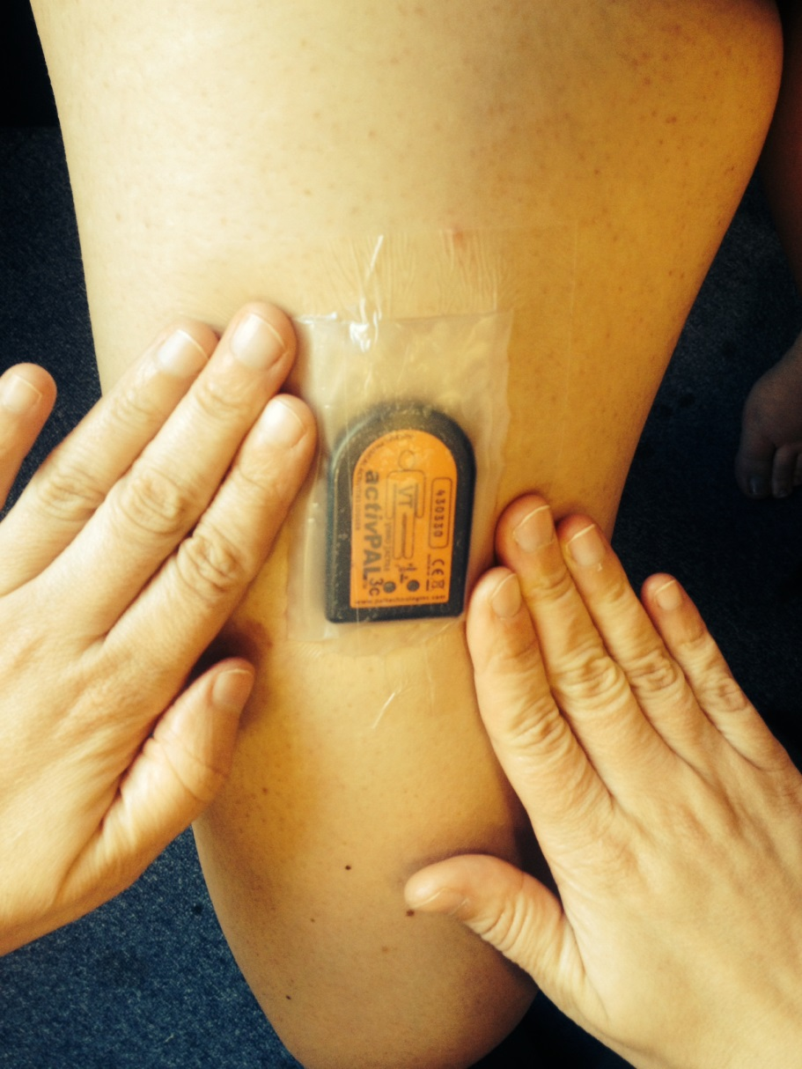

Figure 13. Remove the waterproof dressing and activPAL from leg.

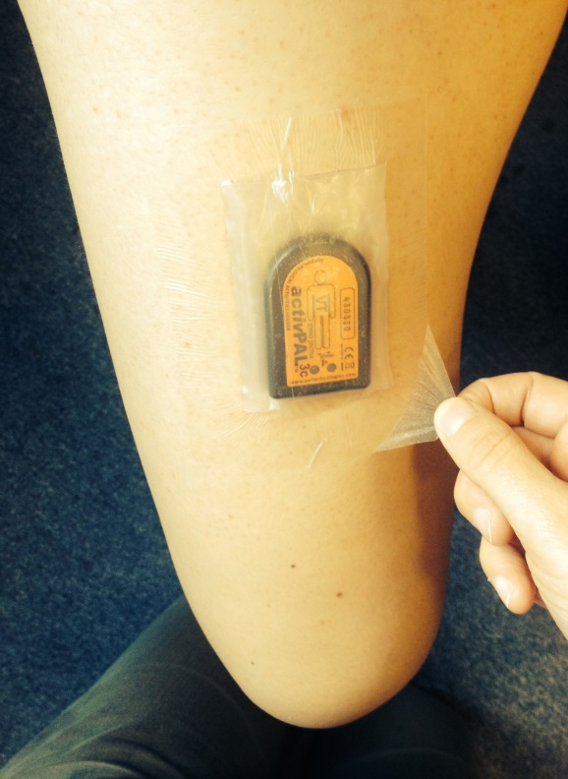
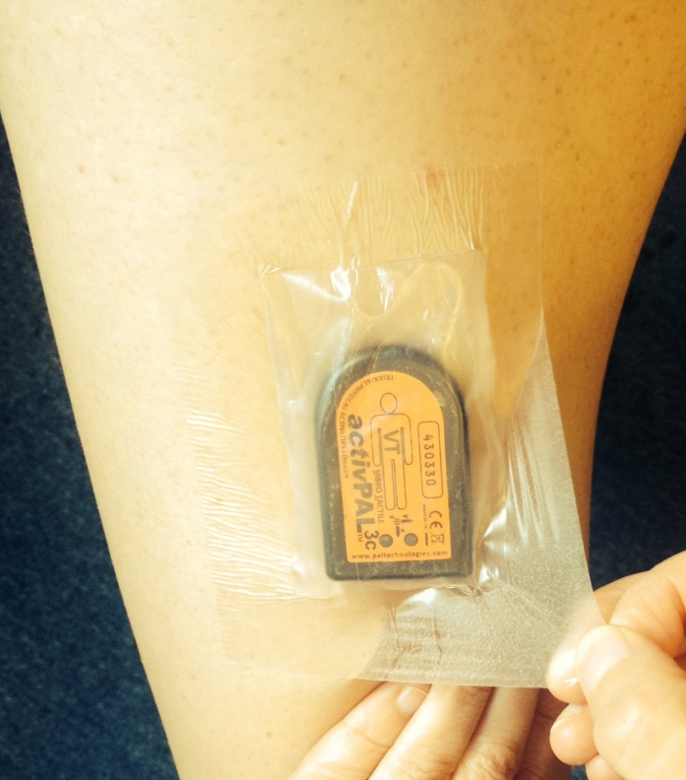
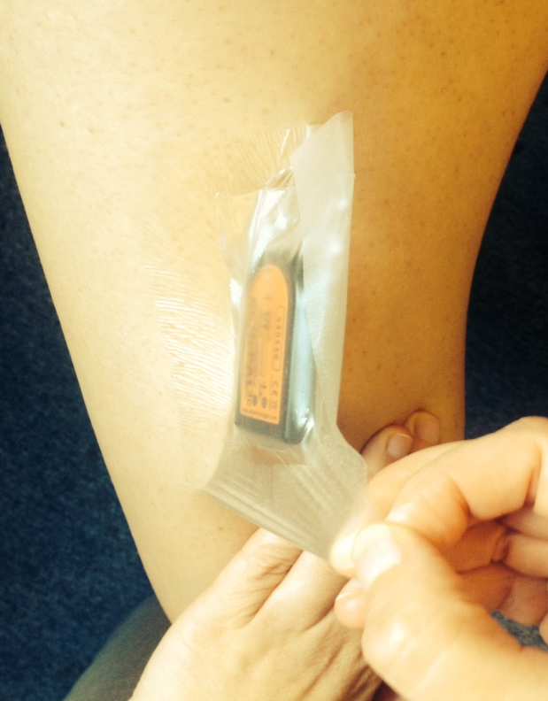

Figure 14. Roll back the PALstickie from the activPAL.



