Visual Inspection of activPAL data by Fieldworkers

SOP Reference: SeniorsUSP/SOP/E05a
Version Number: 3  Date: 10.02.15 | Previous Version Number: 2  Date: 13.11.14
Author: Dr Elaine Coulter, Dr Philippa Dall
Cohort Approval: PD [v2 10.02.15] SC [v2 10.02.15] KL [v2 10.02.15]
Approved by: Professor Dawn Skelton, PI, Signature:
Effective date: February 2015
Review by: August 2015

ASSOCIATED DOCUMENTS:

ActivPAL3 Program and Download Record
SeniorsUSP/SOP/E05b – Visual inspection of WP2 activPAL data-GCU

SCOPE:
The activPAL3 activity monitor will be used to measure physical activity levels and sedentary behaviour of 750 participants from both the Lothian Birth Cohort 1936 (n=300) and West of Scotland Twenty-07 cohorts (n=450).

This Standard Operating Procedure (SOP) describes how Fieldworkers should visually inspect the downloaded data from the activPAL3 activity monitor. This SOP is mainly aimed at fieldworkers in the Twenty-07 study, and represents a brief visual inspection, which will be supplemented by a more extensive quality assurance by researchers at [University]. Researchers for the LBC1936 should also use this SOP, if they conduct Visit 2, and remove monitors from participants. Again, a more extensive quality assurance will subsequently be performed by researchers at [University].

DEFINITIONS:

- WP2: Work Package 2
- PA: Physical Activity

PROCEDURE:

- Opening the activPAL weekly output for inspection

  - After the activPAL data has been downloaded, fieldworkers should inspect the weekly output of the data.
  - If visual inspection is being conducted at the time of download, then the graphical output should automatically appear on screen. If done later, the following steps should be followed.
  - Open the activPAL3 software (version 7.2.32).
  - Click on ‘view’ and click ‘by week’ (Figure 1). Note if you do not change it, the setting will remain on ‘by week’, and this stage can be omitted.
  - Click the ‘open’ icon (second icon in the left upper corner) or click ‘File’ and select ‘open’ to open the file you would like to check (screenshots 1 to 5). You will need to browse to select the folder on [Online Cloud Storage Folder] following the pathway:

LBC cohort only:
[Online Cloud Storage Folder File Path]

Twenty 07 cohort only:
[Online Cloud Storage Folder File Path]

(illustrated in screenshots 1 to 5 below).

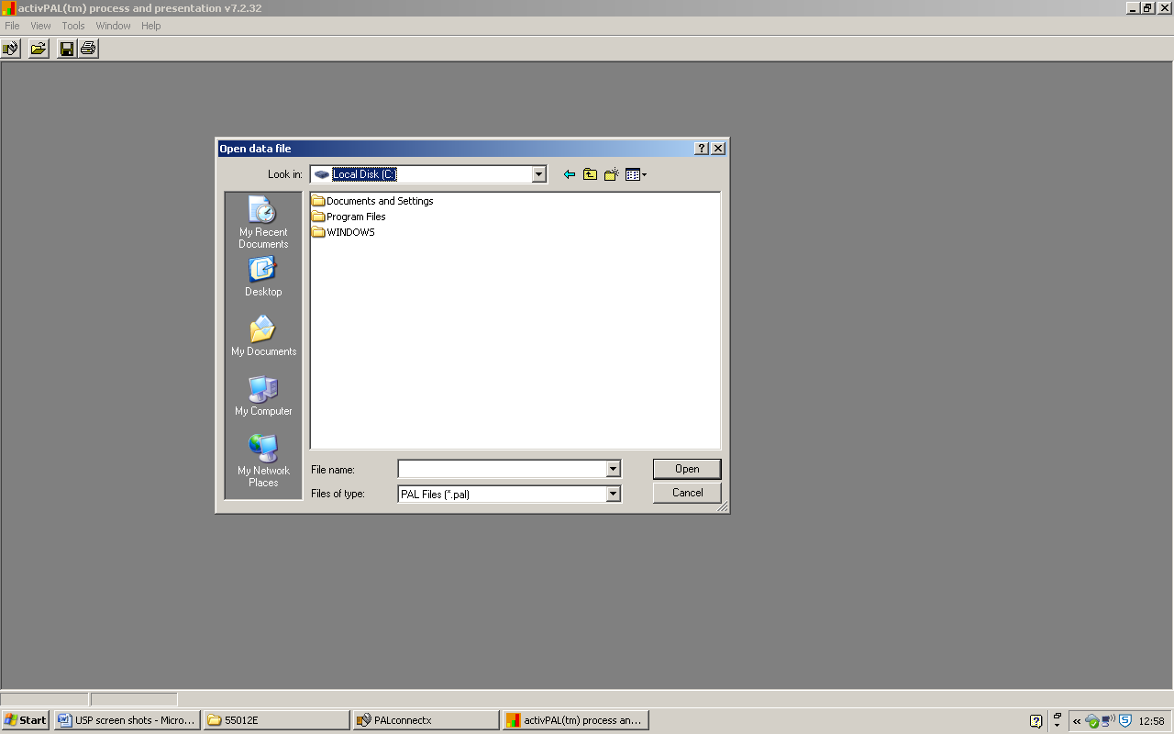Screenshot 1
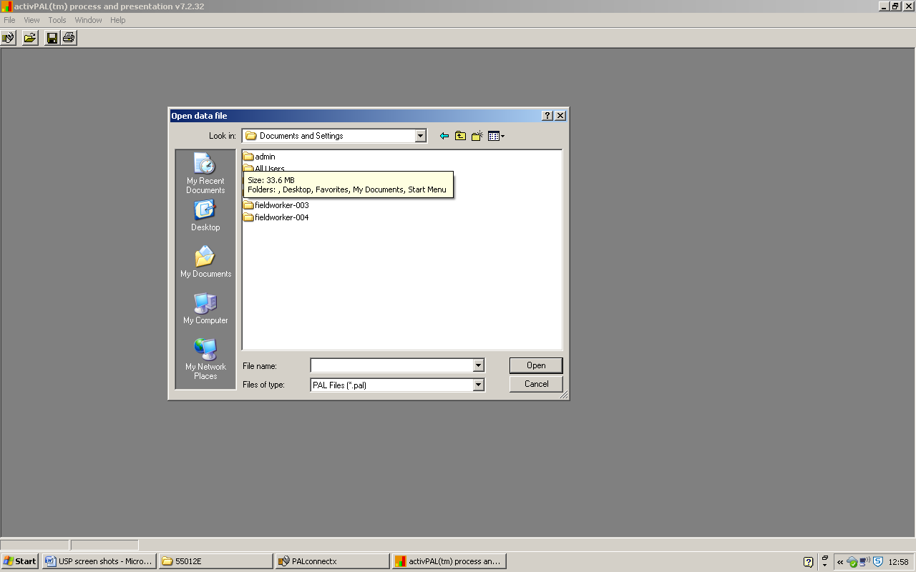
Screenshot 2

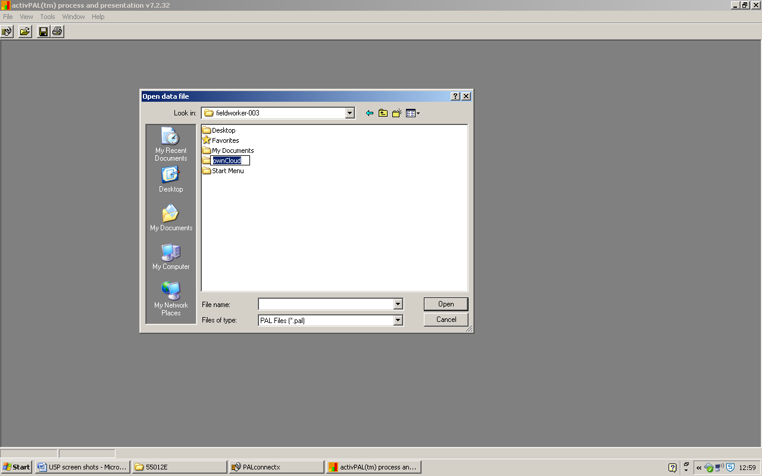
Screenshot 3
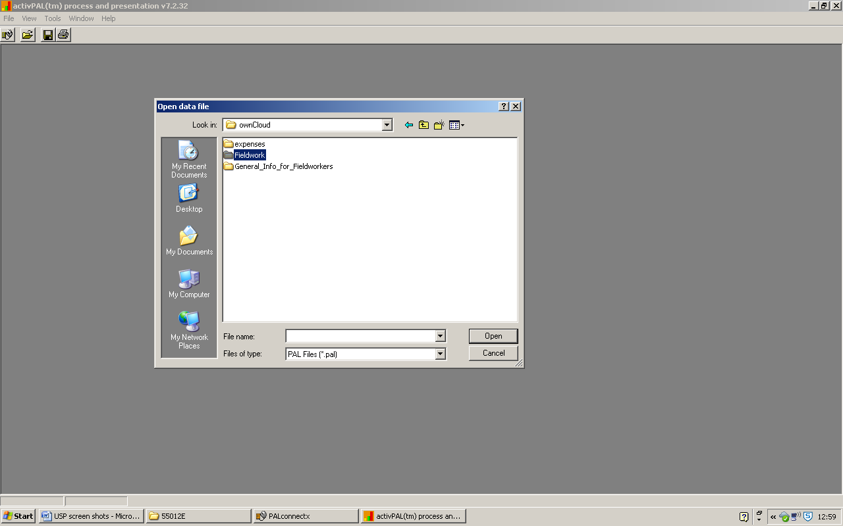
Screenshot 4

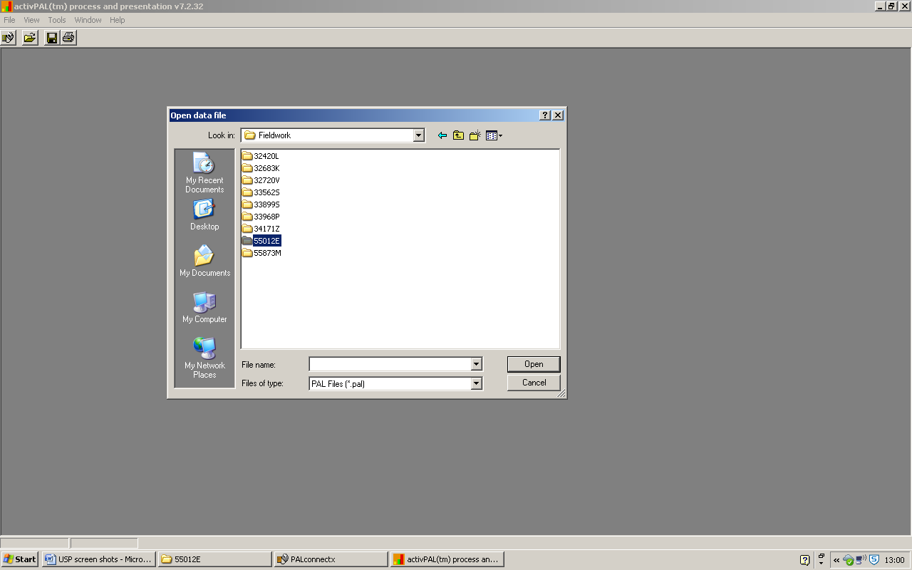
Screenshot 5
  - Select the file within the folder (there should only be one option), and select Open (screenshots 6 and 7).

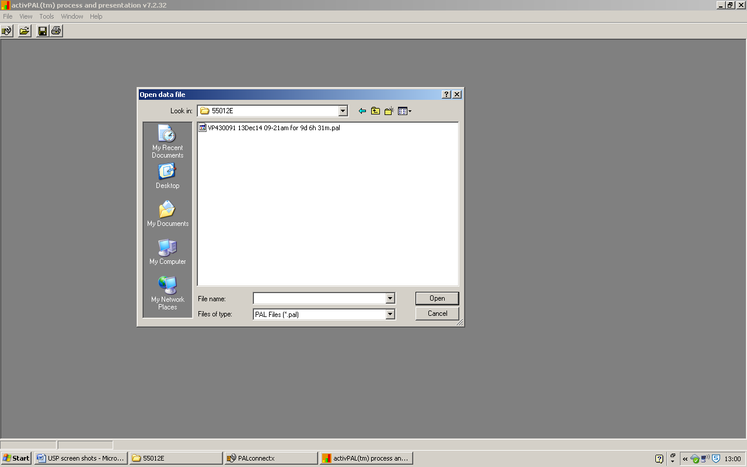
Screenshot 6

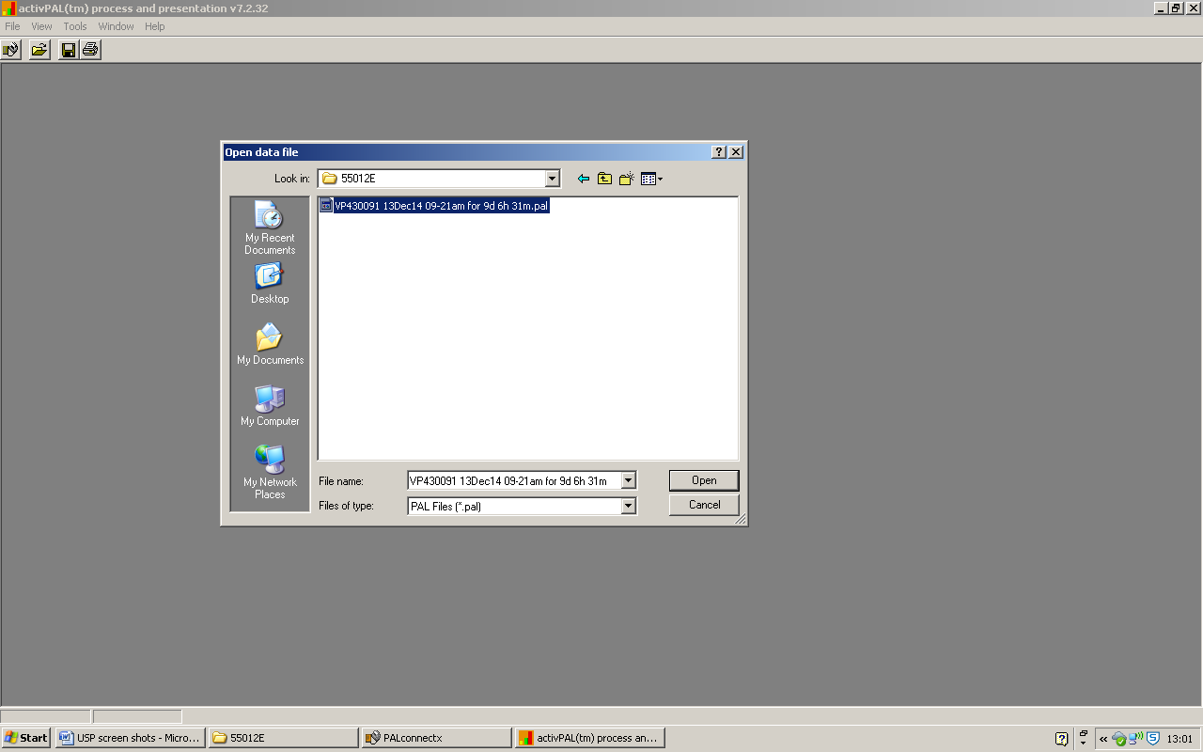
Screenshot 7

This will open a weekly summary of the participant’s data over the week and a daily summary for each day (Figure 3)

  - If you have selected ‘by day’ by mistake, when the file opens a prompt will ask you to select which day you would like to view. Close this window, change to weekly view (step 1.4), and open the file (step 1.6).

- Format of the activPAL weekly output

  - The activPAL weekly output consists of two sections of graphs.
  - At the top of the page there will be a graph with each row representing a week, and each column representing a day (figure 2). For the Seniors USP study, this will usually contain two rows.
  - Beneath this are a series of graphs, one for each day with data, where each row represents a day, and each column represents an hour (figure 2).
  - In each graph:
- time spent sitting (or lying) is represented by yellow
- time spent standing is represented by green
- and time spent walking is represented by red.
  - Time spent sitting (or lying) is shown by the size of the column underneath the axis (in yellow).
  - Time spent standing and walking are shown by the size of the column above the axis (in green and red).
  - Data from the first (partial) day of monitoring is not displayed in this graph – this will be the day the monitored was programmed. Note, if the monitor was programmed at exactly midnight then the first day may be displayed on the graph, however, this will be a rare occurrence.

- Generic advice on “normal” output
  - This brief visual inspection will ask you to look at the data presented in the weekly and daily graphs, and make a decision on whether it looks like a reasonable pattern of human movement. This judgment is generally easier to make visually that it is to describe in words.
  - Normal human movement will vary greatly in quantity between participants. Some participants may stand or walk for several hours a day (figure 2), while others may do so for less than an hour (figure 3).
  - Some slow or shuffling walking may not be picked up by the monitor, so it is acceptable for a participant to have no walking (red) in the graphs (figures 3 & 4).
  - It is normal for participants to vary what they are doing. While there may be prolonged periods of sitting/lying without change (for example when asleep overnight) – prolonged periods of standing or walking are far less likely.
  - The pattern of standing/walking across the day tends to vary hour by hour, with noticeable periods of low movement while a person is asleep (usually overnight), and variable quantities of standing/walking each hour (figures 4 & 5).

- Purpose of the brief visual inspection
  - The purpose of this brief visual inspection is to provide a rapid inspection of the data at the time the data is downloaded.
  - All data will undergo additional in-depth quality control, undertaken by researchers at [University].
  - Items flagged up by this brief visual inspection will be used to rapidly identify problems with activity monitors, data collection or procedures. This will allow issues to be resolved in an appropriate and timely manner.
  - Additionally, the record of the first day of monitoring made during the inspection will be used to produce the participant feedback report.

- Inspecting the activPAL weekly output – first day of monitoring and the number of days monitored

  - Check which day is the first day of monitoring/with data.
  - Use the top “weekly” graphs, and to identify the first column (day) that has meaningful data in it. You can supplement this check by looking at the “daily” graphs to check that there is data across the whole day.
  - Check which day (according to the activPAL monitor) has the first data. Use figure 6 as an example. The first partial day (= the day the monitor was programmed) does not show on the weekly graphs – the first column (named ‘Wed’ in figure 6) as displayed on the weekly graph is actually day 2 according to the activPAL (e.g. figure 2), the second column (named ‘Thu’ in figure 6) is day 3, etc.
Working out which day is the first complete day of data depends on when you programmed the monitor, and when visit 1 was. The day when the monitor was programmed (activPAL day 1) will not be shown on the weekly graph. The day of visit 1 is not a complete day of data, as the participant was not wearing the monitor the whole day. The first day of complete data should be the day after visit 1.This will usually be activPAL day 2 (the first column in the graph), but might be activPAL day 3 (the second columns in the graph) e.g. if you programme the ActivPAL and have Visit 1 on the same day this will be ActivPAL Day 2, but if you programme the ActivPAL and Visit 1 is the next day this will be ActivPAL Day3.
  - Record this day in the download sheet of the “activPAL program and download record”
  - Quickly check that the first full day with data matches the record of the date that the participants will have worn the monitor. This should be the date of the day after visit 1. The day of the week is displayed above each column in the “weekly” graph, and the date can be found on the left of each “daily” graph.
  - Record the date of this day in the download sheet of the “activPAL program and download record”.
  - Look along the “weekly” graphs – to count how many days have data in them. Example figures, with 5 days of data (figure 6), 7 days of data (figures 2 &3), and 8 days of data (figure 7) are shown below. Remember, the day the monitor is removed from the participants’ leg is not a complete day.
  - Record the number of days with complete data in the download sheet of the “activPAL program and download record”
  - If there are fewer than 7 days of data in the record, then please record a brief description of why (if known). For example, if you know that the participant removed the monitor early due to skin irritation, report “skin irritation”.

- Inspecting the activPAL weekly output – checking for consistency and unusual days

  - Look across the “daily” graphs to check whether the pattern of daily physical activity is consistent within each participant. Every participant is different, so do not compare this data with other participants. Bear in mind that for some days, for example Saturday or Sunday, it might be reasonable for the physical activity pattern to be different. Figures 4 & 5 show examples of reasonable similar patterns for the days, while figure 8 shows an example of unreasonable differences.
  - Check whether there is any walking recorded by the activPAL monitor. Figures 2 & 3 show someone with only a small amount of walking recorded, but it is possible to see no walking.
  - Check whether there are unusually large or constant postures of sitting, standing or walking activity that you would not normally expect. Figures 7 (weekly graph), 9 & 10 (daily graphs) show examples of unusual constant postures. These are often standing, and are likely to represent time spent propped on a desk or in a bag.
  - If you know the monitor was removed before Visit2, check whether the last day of data looks “normal” all the way to the end. This needs to be done in conjunction with checking for a consistent pattern across days. So, for example, if a person usually had some standing or walking in the evening until 10pm, but on the last day of data there was constant sitting (without any standing/walking) from 6pm, this might indicate that the monitor was removed before the person went to bed (e.g. Figure 11). Figures 12 & 13 show an example where the last day is not a full day of recording, due to the monitor stopping short.
  - Record any issues in the download sheet of the “activPAL program and download record”.

- Flagging up unusual data for

  - As well as completing the “activPAL program and download record” please send an e-mail to [University Contact Name & E-mail Address] to alert her to the fact that there was unusual data to report.
  - Please include your own details, the date of download and the activPAL3 serial number in the e-mail, so we can locate the file.

Review Acknowledgements
I acknowledge that I have read and reviewed this SOP and that no changes are required.
Name | Job Title | Signature | Date | Next Review due

Figure 1. Selecting to view the activPAL3 data “by week”.

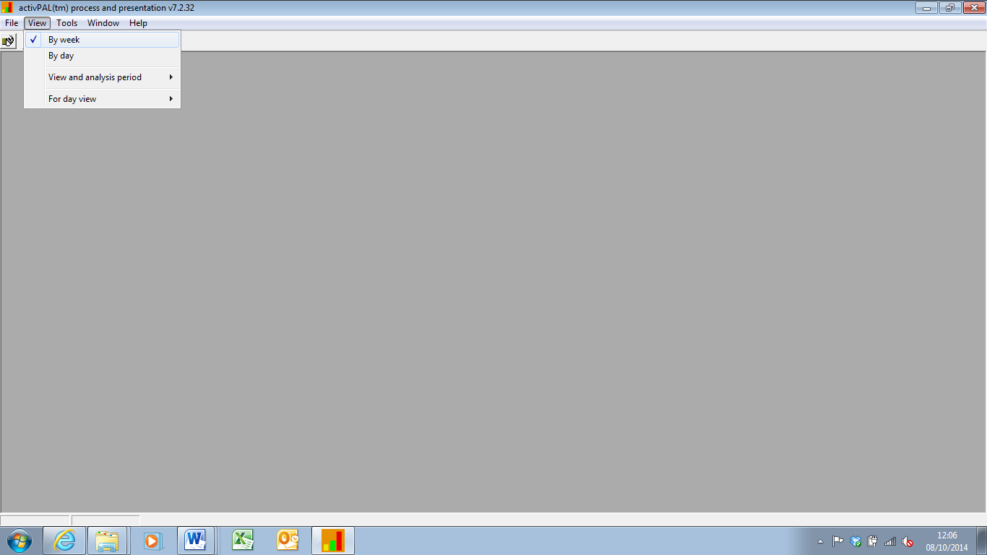

Figure 2. Example of week view of participant’s physical activity data [ref: 2004].

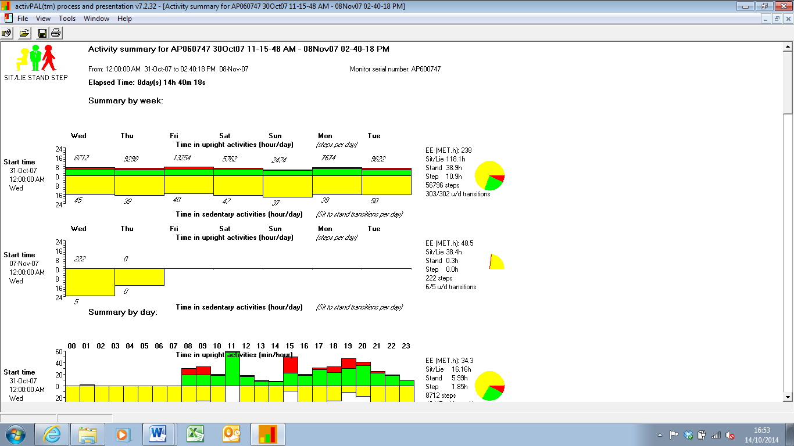
“weekly” graphs
First “daily” graph (scroll down for other days)
Figure 3. Example of a “weekly” graph of a low active person [ref: 3000]

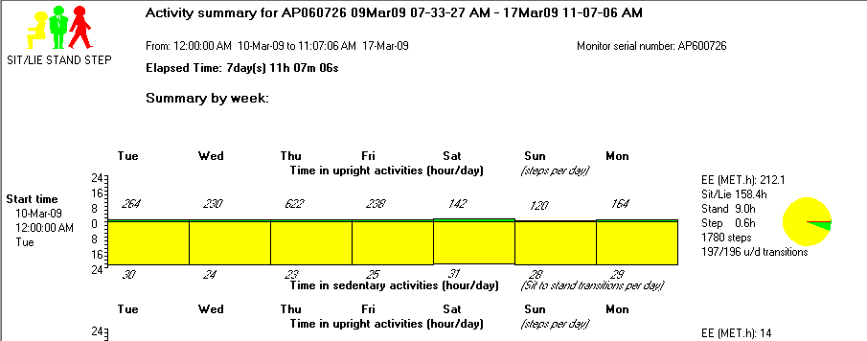

Figure 4. Example of a “daily” graphs of a low active person [ref: 30xx]

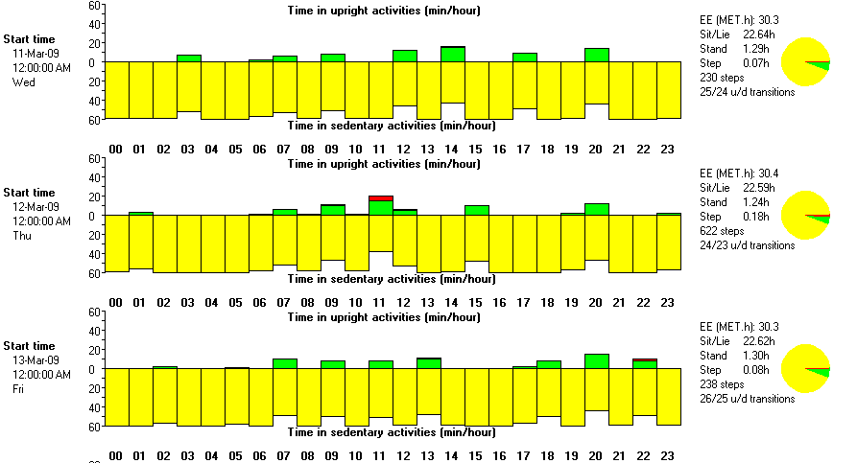
Figure 5. Examples of “daily” graphs showing natural variation [ref: 2015].

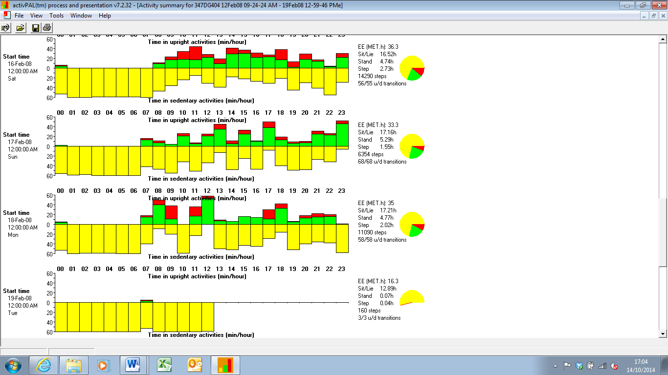

Figure 6. Example where the first day of data collection is day 3 [ref: 2015]

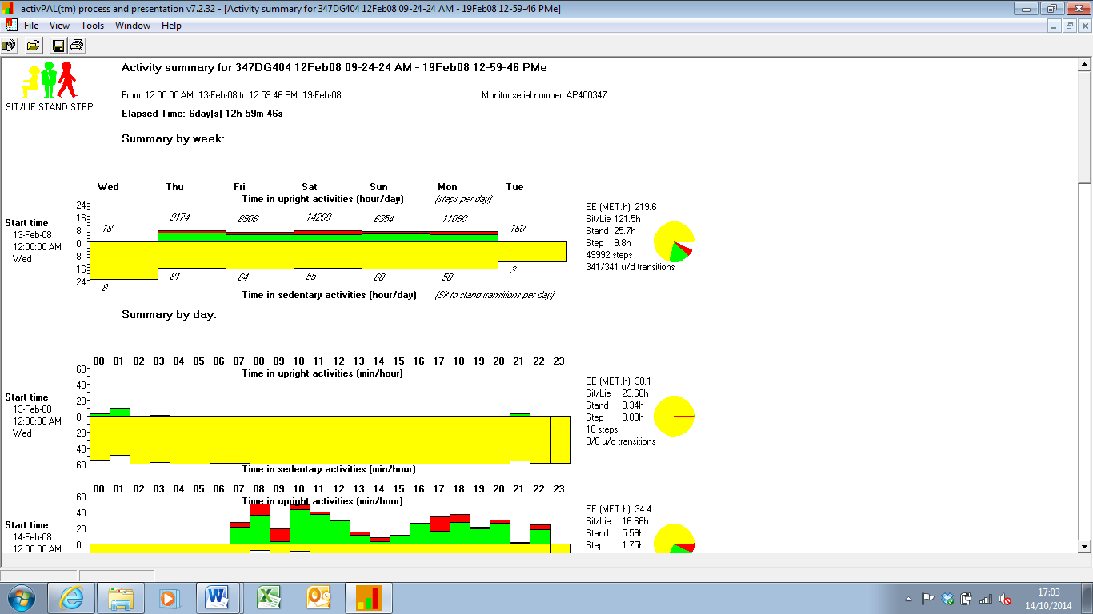
In this case: Thursday is Day 3. This is the first complete ActivPAL day.

Figure 7. Example showing 8 days for data, and constant standing posture on Wednesday [ref: 2043]

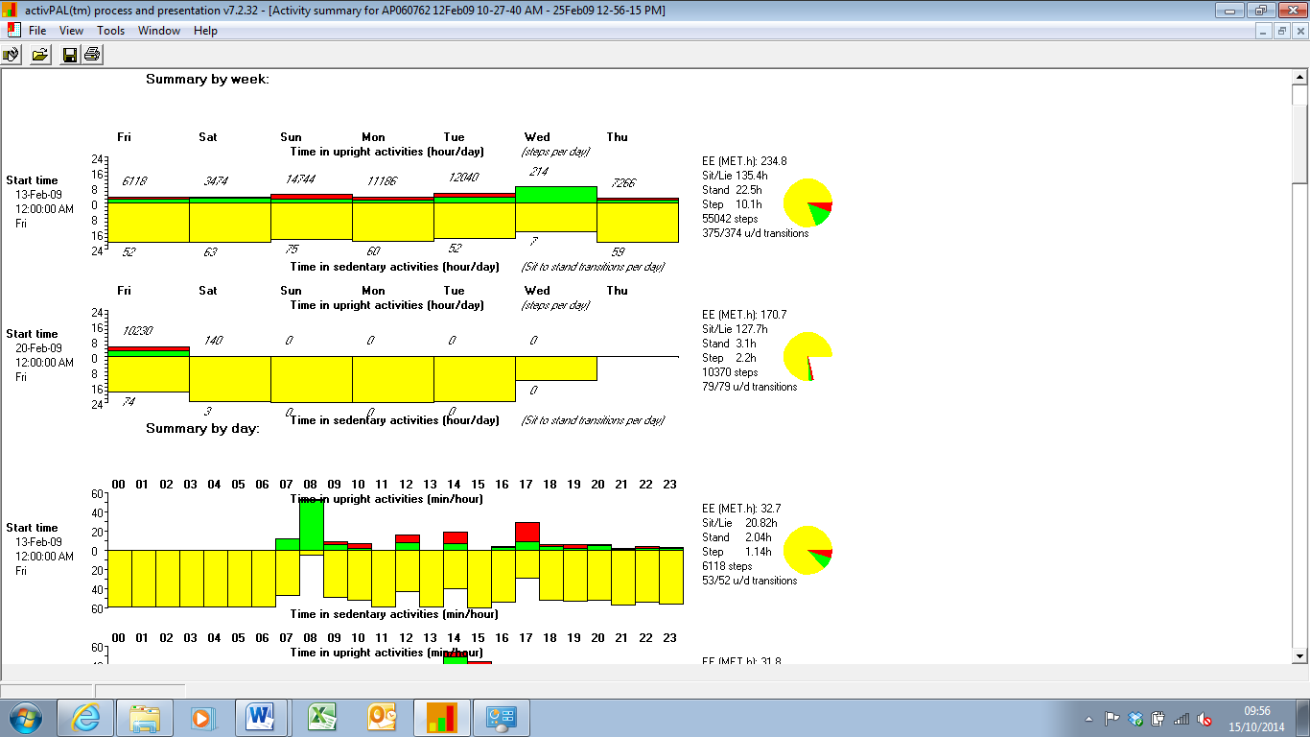

Figure 8. Examples of daily graph with a daily variation which does not look normal. Friday and Saturday look very different to Sunday and Monday. [ref: 2019]

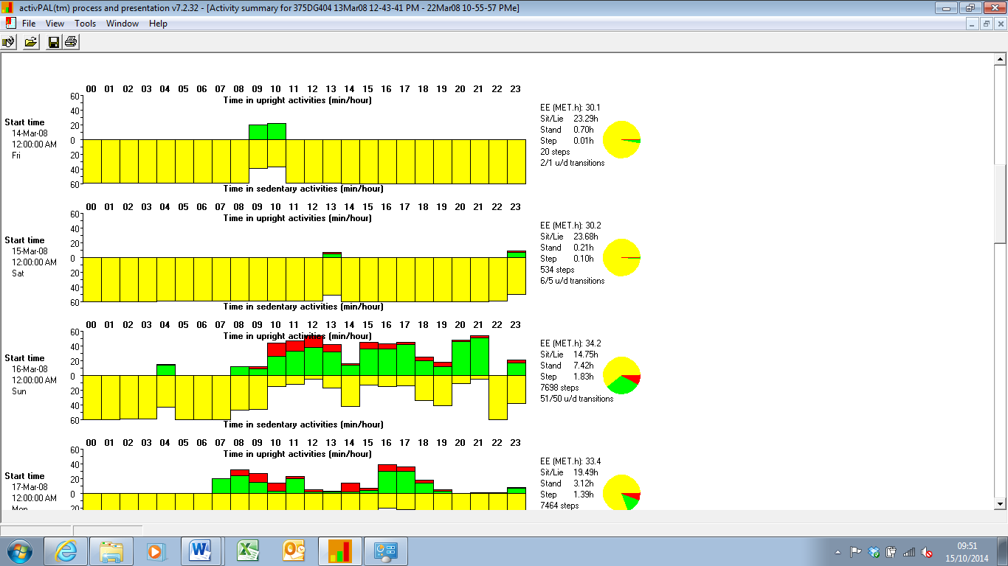

Figure 9. Example showing constant standing posture on the Wednesday [ref: 2043]

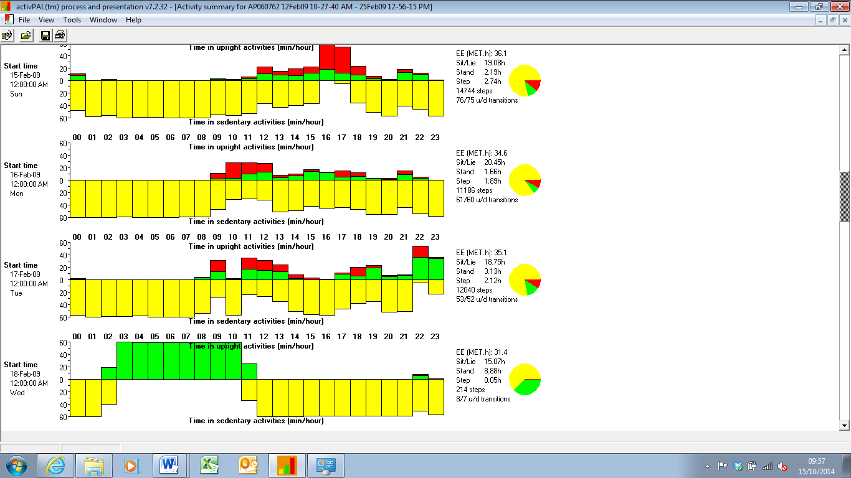

Figure 10. Example showing constant standing posture on the Friday [ref: 2014]

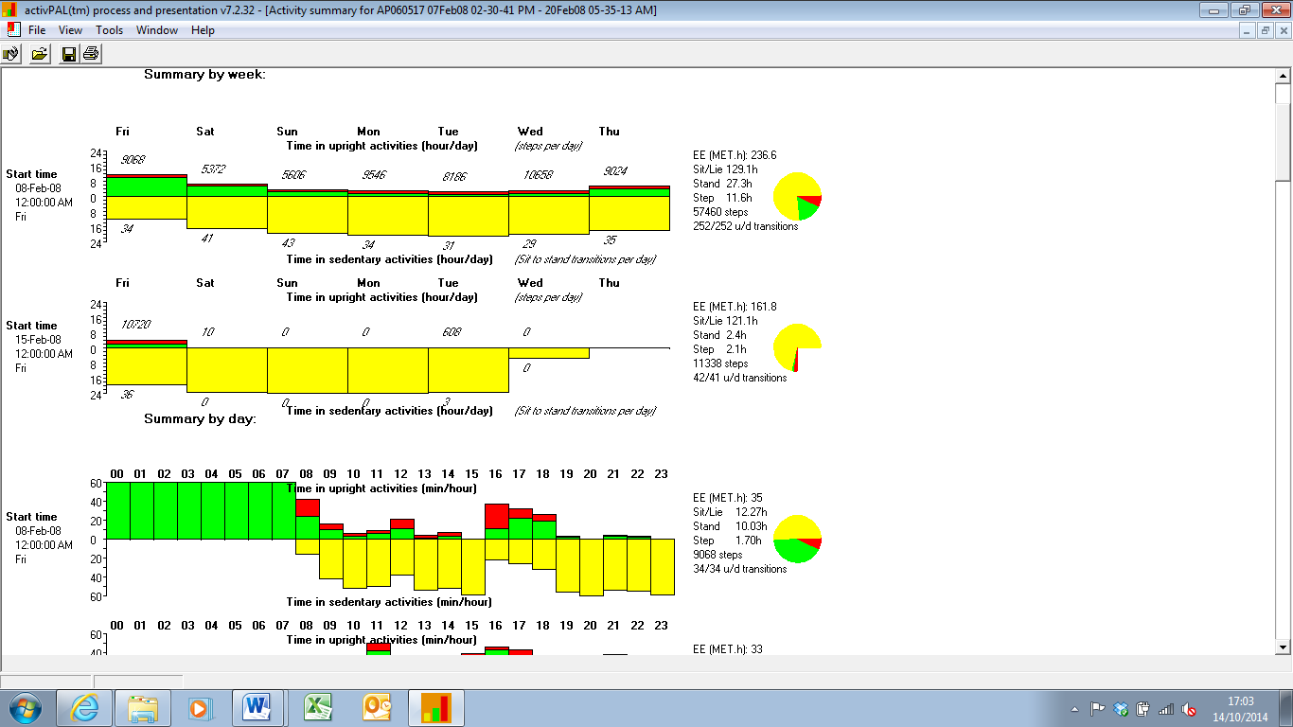

Figure 11. Example of monitor potentially being removed early on Wednesday [ref: 2050]

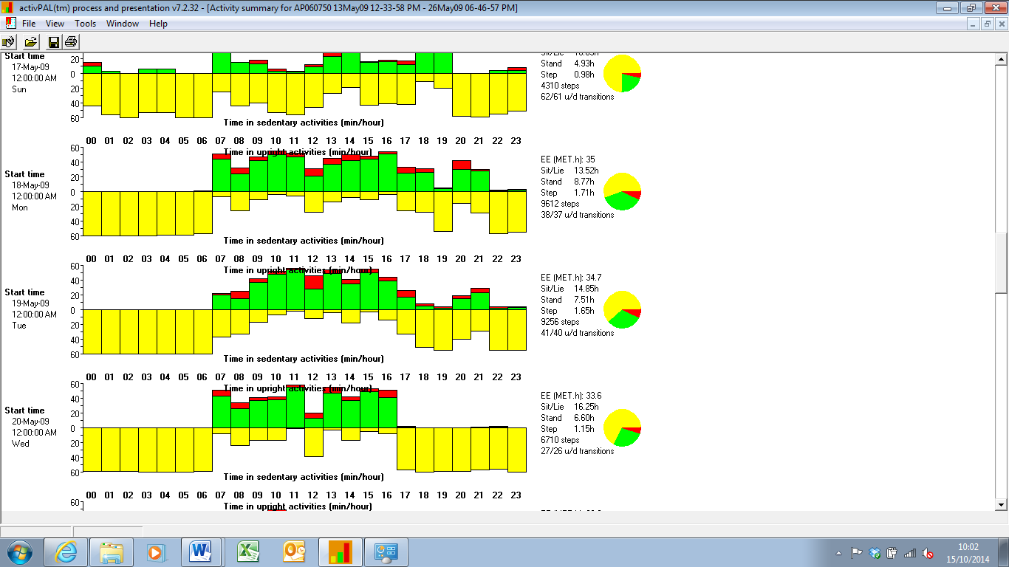

Figure 12. Example of the last day of monitoring cutting short, from the “weekly” graph [ref: 2034]

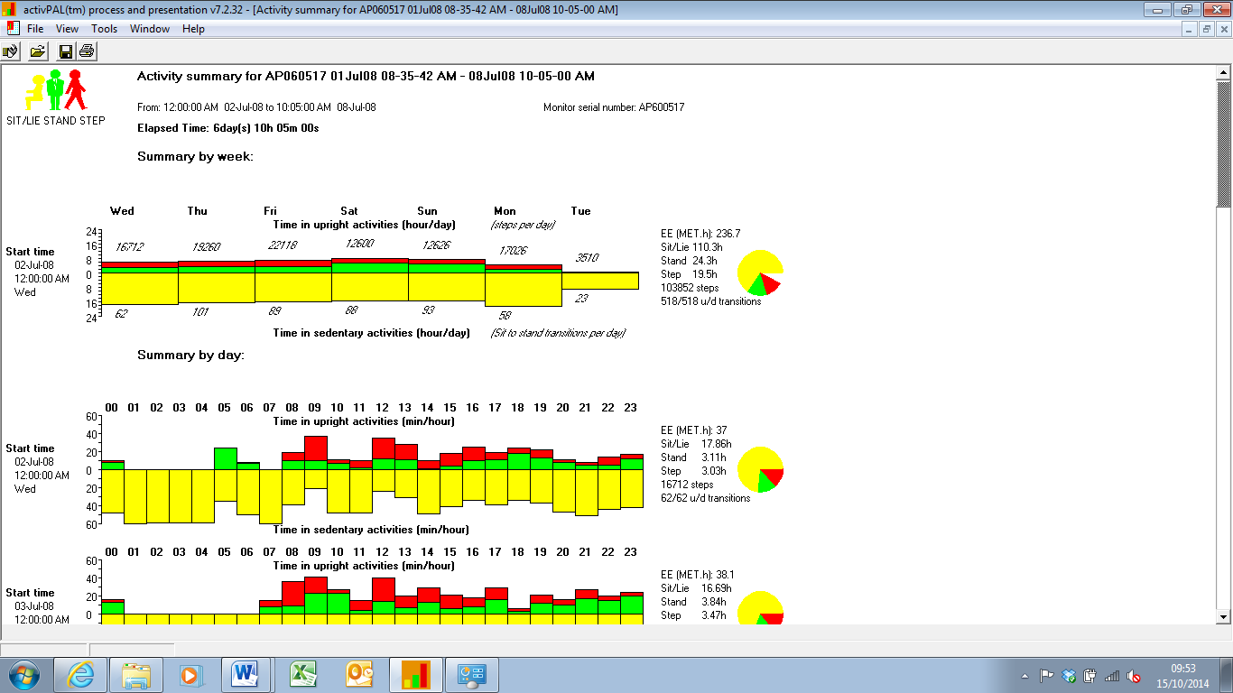

Figure 13. Example of the last day of monitoring cutting short, from the “daily” graph [ref: 2034]

