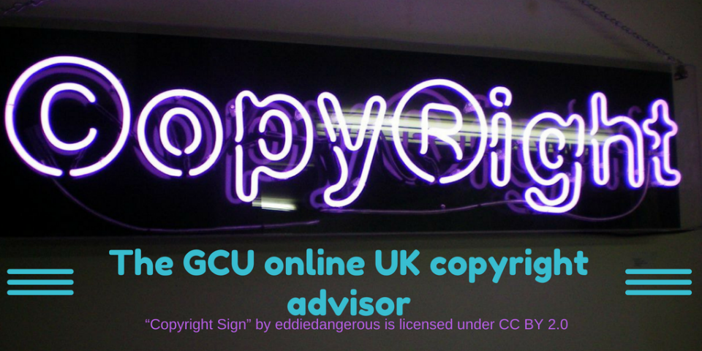
The GCU Copyright advisor - road testing sheet
We need your help! We would like you to try out the GCU Copyright advisor and let us know what we could improve about it.
Follow this link to display the copyright advisor on screen: https://edshare.gcu.ac.uk/3608/2/index.html
Question | Your feedback
Was the advisor easy to navigate through? | Yes / No
If not, why?

Did it cover all the items you needed? | Yes / No
If not, what should we add?

Was it easy to restart your session? | Yes / No
We have shared to advisor as an OER (Open Educational Resource) under CC license….
Would you download a copy? | Yes / No
If yes, would you edit it further, and if so, how?

If no, is this because of the file format?

We hope to upgrade the advisor to an HTML5 web resource. Would you find this format more useful?
If yes, do you have any suggestions?

What item type(s) did you test?

Was the information given accurate? | Yes / No
If not, can you specify where we went wrong?

Were there any broken links?

Any other suggestions or faults?

If the team have any further questions, can we contact you?
If yes, please let us know your email address:

Didn’t get a chance to hand this in? Don’t worry, you can scan and send it to copyright@gcu.ac.uk or snailmail to:
Copyright Advisor
Saltire Centre
Glasgow Caledonian University
Cowcaddens Road
Glasgow, G4 0BA

