The library blog is built using WordPress which is a popular free system for blogging and website creation.
First you will need your team login and password to the blog.
Then have a quick read of the Blog style guide. It is short and will keep you right. It is designed to be used alongside the website style guide with regard to language and terminology used.
Go to the library web site and drop in to the blog by clicking the blue Library News header in the blog window. As you roll your mouse over it, you will see it is a link.
This will take you in to the blog itself.
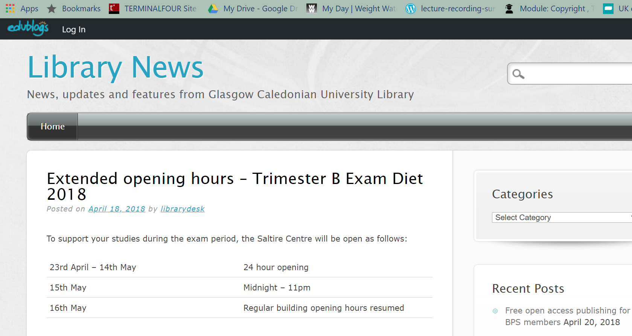
Now log in using your team login and password.
The fastest way to add content is to us the toolbar at the top of the screen.
Select Post from the drop down menu.
The drops you in to the edit screen
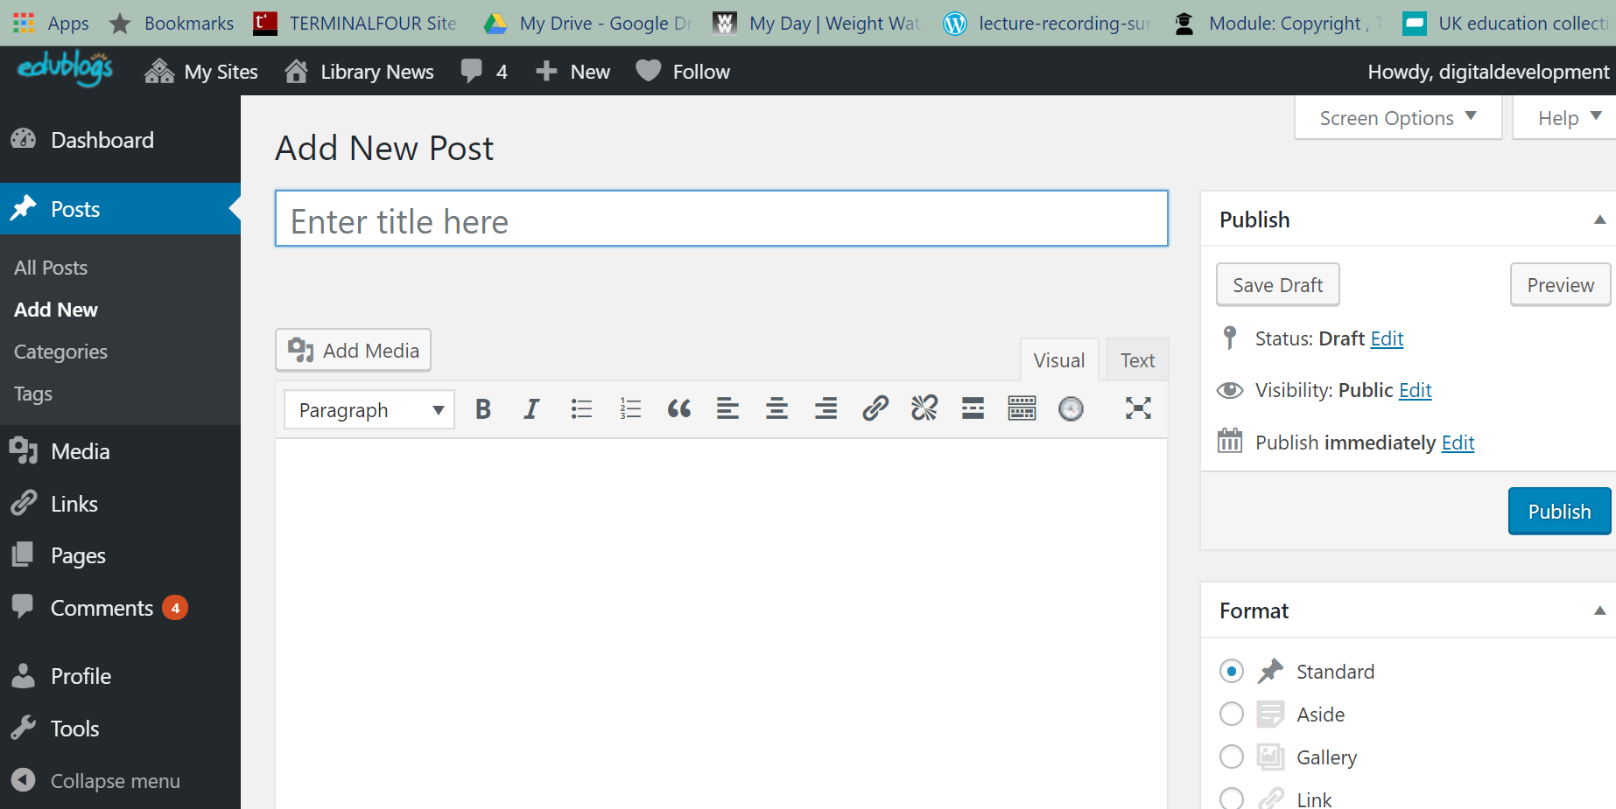
At this point you can paste in your content, if you have already written it using another programme, or type it in directly.
The preview button is really handy to give you an idea of what your finished post will look like, especially with regard to font and layout.
When you are finished, click the blue publish button to publish your post. The post will not pull through immediately to the twitter feed on the library home page. It will be live, but the feed only refreshes a few times a day, so you may not see it for a while.
The system will display a direct link which you can use to link directly to the post. This is handy for emails and tweets.
You can add images and other media files to your blog post.
First create your image (or find it using our finding images links!). Then save it to your PC ready for upload.
Now click the add media button.
Select your media file using the most appropriate method, then insert it using the blue insert into post button
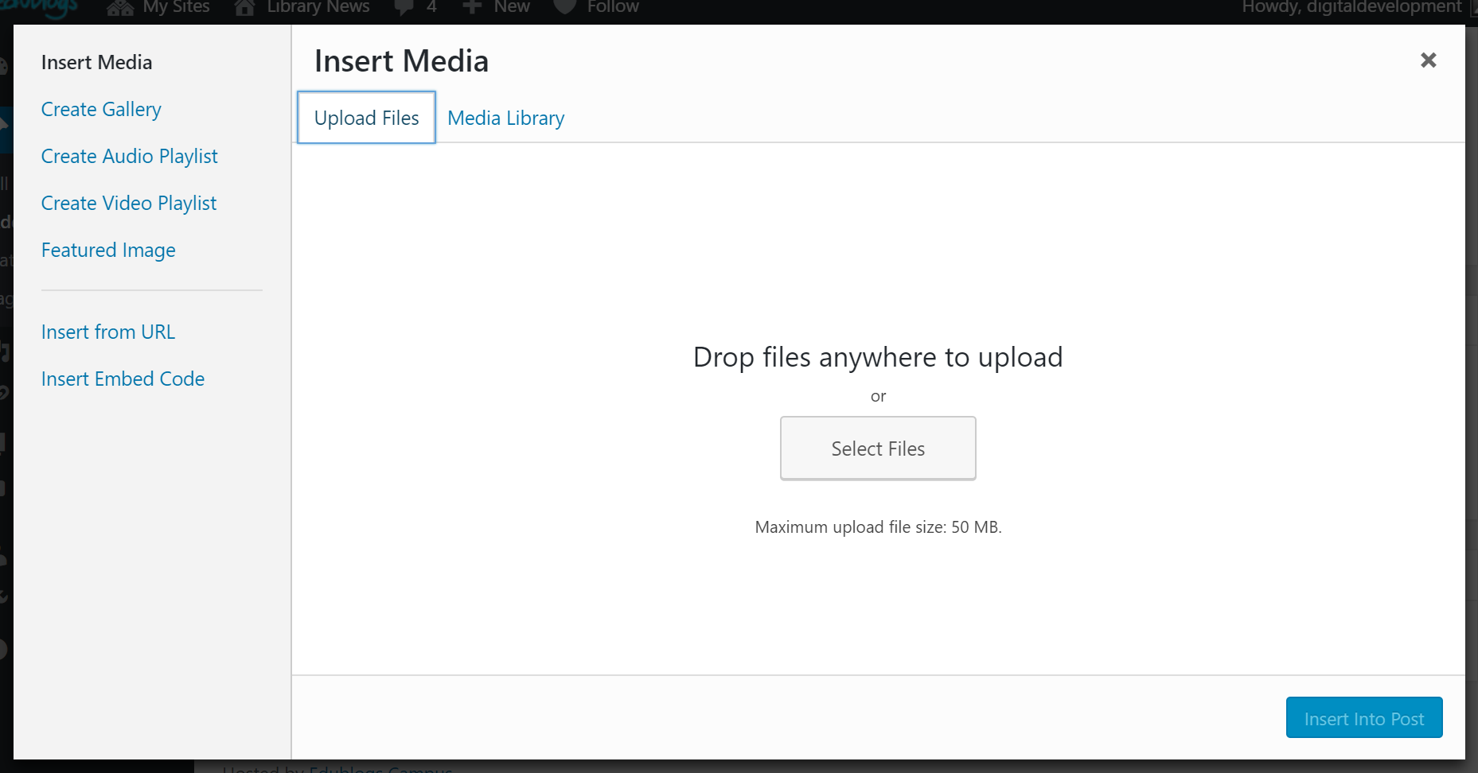
Once you have inserted your media, you may need to preview it to see if it works or renders properly, and whether it is an appropriate size. You may need to amend it slightly. When it is displaying the way you want, remember to publish the blog post.
All blog posts should have a category assigned to them. You can assign more than one category. This is important as it allows items to be accurately streamed from the blog into other web pages, such as Archives. It also shows other blog editors how to treat older posts.
The number of categories is limited, but you can also assign any number of tags to make items easy to retrieve.
If your post is short term, such as 24 hour opening, put a note in your diary to go back in to the blog and move the post to the Trash folder. This will stop the blog becoming clogged up with out of date information.
If you have any problems, email us on ddil@gcu.ac.uk We will be happy to help!

