Instruction for Hamish Wood entrance screens
The vertical screens
Even though these vertical screens are made up of 4 screens, the content is displayed in 3 parts (think of the 2 middle screens as one big one).
The content
Content must be created at the aspect ratios as below, otherwise your content may result in being stretched and look weird.
The screens can display videos (MP4) and/or images (JPG). You can only have up to two videos, so the third content will need to be an image.
The layout
You can have the videos or images in any layout on any screen, but just remember to make sure that the aspect ratio is correct for that piece of content (i.e. if you plan on having an image or video for the two middle screens make sure that it is 1920px x 2160px otherwise it will become stretched).
In the example below I have a video for the top screen (1920x1080), a video for the two middle screens (1920x2160), and a still image for the bottom screen (1920x1080).
Who to contact:
It used to be Joe Logan J.Logan@gcu.ac.uk to contact for putting content up on the screens, but now Nicole Cooke from Caledonian Connected is in charge of them Nicole.Cooke@gcu.ac.uk. However as of December 2017 Nicole is away on maternity leave, so I’ve been just emailing Caledonian Connected for putting stuff up on the screens cal-connected@gcu.ac.uk
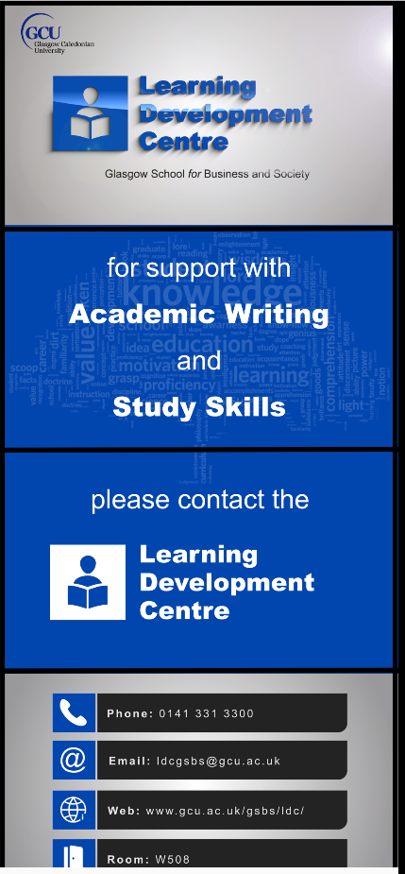
1920px x 1080px
1920px x 2160px
1920px x 1080px

