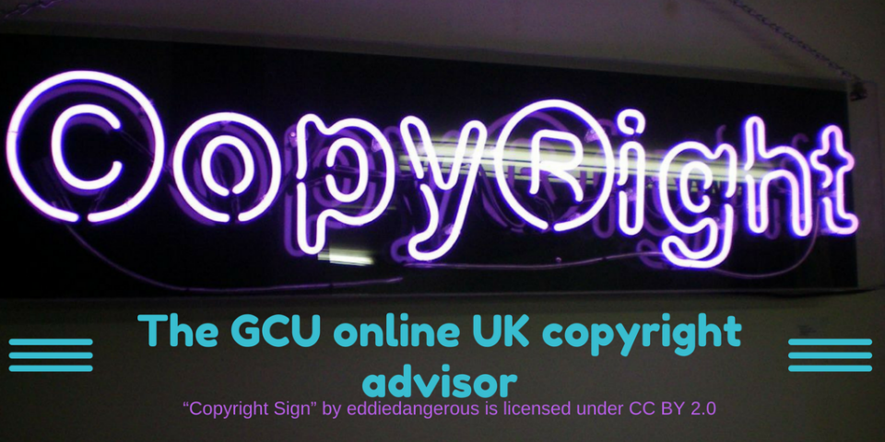
The GCU Copyright advisor - road testing sheet
We need your help! We would like you to try out the GCU Online Copyright advisor and let us know what we could improve about it.
Follow this link to display the copyright advisor on screen: https://edshare.gcu.ac.uk/4481/13/CARP/index.html
Question | Your feedback
Was the advisor easy to navigate through? | Yes / No
If not, why?

Did it cover all the item types you needed? | Yes / No
If not, what should we add?

Was it easy to restart your session? | Yes / No
We have shared to advisor as an OER (Open Educational Resource) under CC-BY license….
Would you download a copy? | Yes / No
If yes, would you edit it further, and if so, how?

Edits are made using Markdown language. Would you like to see a short guide to help users get started in customising the resource?
If no, is this because you are happy to use it “as is”?

We have upgraded the advisor to an HTML5 web resource. Do you find this format more useful?
If yes, do you have any further suggestions?

What item type(s) did you test?

Was the information given accurate? | Yes / No
If not, can you specify where we went wrong?

Were there any broken links?

Any other suggestions or faults?

Any other feedback or suggestions?

Was the guidance given clear and jargon free?
If the team have any further questions, can we contact you?
If yes, please let us know your email address:

Didn’t get a chance to hand this in? Don’t worry, you can scan and send it to copyright@gcu.ac.uk or snailmail to:
Copyright Advisor
Saltire Centre
Glasgow Caledonian University
Cowcaddens Road
Glasgow, G4 0BA
You can download a zip archive of the files here: https://edshare.gcu.ac.uk/id/document/32573
The original workflows and text files are available here: https://edshare.gcu.ac.uk/4237/

