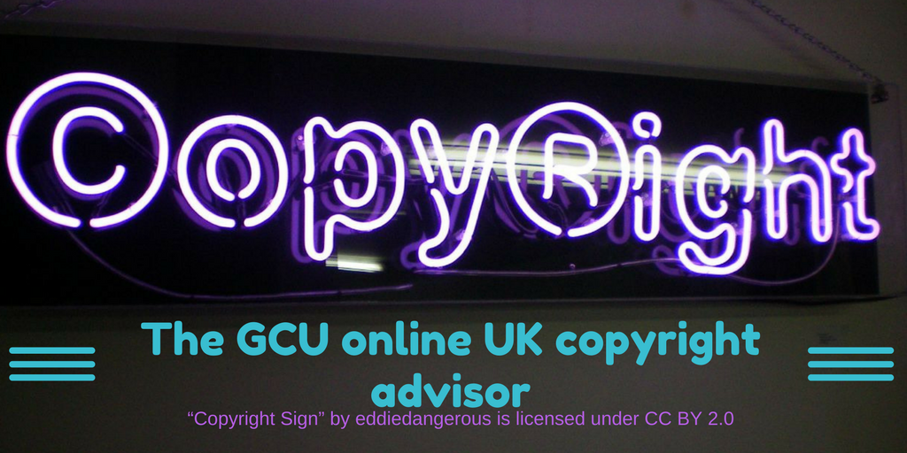

A simple guide to customising the GCU UK Copyright Advisor

Contents:
- Introduction
  - What is the Copyright Advisor? 2
  - The history 2
  - General information 2
- Using Markdown
  - A brief description of Markdown 3
  - Links to useful information 3
- Preparing to customise the GCU Copyright Advisor
  - Understanding the GCU Copyright Advisor site structure 4
- Customising the GCU Copyright Advisor
  - Editing text 5
  - Formatting text 7
- Customising the look and feel of the GCU Copyright Advisor 9
- A note about browser versions 10

Introduction
What is the Copyright Advisor?
GCU library operates a copyright advisory service for staff and students at the university. Users can email their enquiries to an inbox where they are picked up and answered. Recognising that many of the questions posed by users are the same and that users often wish for an immediate response to their enquiry, we identified an opportunity to develop an online copyright advisor tool that could provide quick and easy answers to frequently asked questions. In order to share the benefit of our creation, we also wanted the finished tool to be an OER, developed in line with GCU’s OER policy https://edshare.gcu.ac.uk/id/document/11345, available for use on our website and for download and adaptation from our educational resources repository edShare under a Creative Commons licence.
The history
We developed and launched the first version of our online copyright advisor tool in 2017. Along with the tool itself we made available the workflows and text files from the advisor on edShare at https://edshare.gcu.ac.uk/id/eprint/2706
This first version of the tool was designed using iSpring software. iSpring software is intended for the design of quizzes and surveys, so is not the most suitable for building a tool of this kind. To improve the user experience, we decided to apply for a SLIC innovation grant which would allow us to get professional help to upgrade the resource.
General information
The copyright advisor is built on HTML5 in a file format editable using the Markdown language.
The format of the Copyright Advisor makes it easy for you to update the links, text and general design to suit your institutional needs.
The Advisor is compatible with screen reading software.
The advisor is licensed CC-BY which means that you can adapt it freely, but you should credit us as the original author of the product.
The structure, navigation and look of the site was created by Worth Knowing Ltd. If you are planning extensive revisions, you may wish to contact them for a quote on your project https://worthknowing.org/.
You can view the Copyright Advisor at https://edshare.gcu.ac.uk/4481/13/CARP/index.html
You can download the zip archive at https://edshare.gcu.ac.uk/id/document/32573

Using Markdown
A brief description of Markdown
Markdown is a lightweight markup language with plain text formatting syntax. Its design allows it to be converted to many output formats, but the original tool by the same name only supports HTML. Markdown allows you to use a basic text editing program to easily style text on the web. You control the display of the document; formatting words as bold or italic, adding images, and creating lists. Mostly, Markdown is just ordinary text with a few non-alphabetic characters thrown in, like # or *.
Links to useful information
You can find out more on Wikipedia https://en.wikipedia.org/wiki/Markdown and GitHub have a nice beginners’ guide https://guides.github.com/features/mastering-markdown/.
I made extensive use of the Markdown cheat sheet from www.makeuseof.com It is a single sheet of A4 with everything you need in one place!

Preparing to customise the GCU Copyright Advisor
Understanding the GCU Copyright Advisor site structure
The question and answer files are contained in the /quiz folder and follow the structure below:
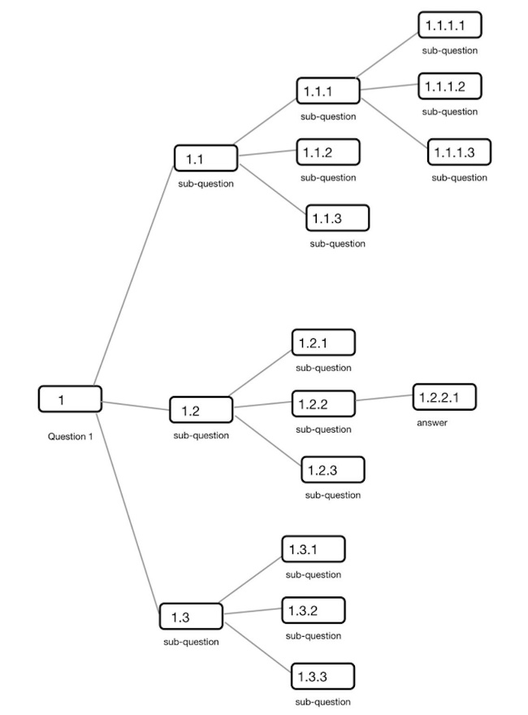

Question 1 is the top level. In the Copyright Advisor, this would match to the first question in a main section. For instance, if we look at the Audio file section, this would relate to file 1.md which contains the question “Did you create it?” This file also contains bullet points with yes and no options. These two words are internal links to the next level files 1.1.md and 1.2.md

In turn file 1.1.md contains the next question “Has it been used as part of any published or released work such as included in an educational resource?” with bullet points and internal links for the answers yes and no (1.1.1.md and 1.1.2.xml).

At this point you will notice that file 1.1.2 is in xml format, not md format. This is because 1.1.2 is an answer file and has a “Restart” button at the foot of the page. When editing, it is important that all answer files are in xml format, or you restart button will not work.

This only follows a very short branch of the main decision tree, but I hope it is enough to give you an overview of how the structure and naming convention works. You can see that this structure has a lot of scope for both extended and simple questions and answers.

Customising the GCU Copyright Advisor

First download the Copyright Advisor files from edShare. These download in a zipped format, so unzip the files and save them onto your hard drive. Remember, you will need to have a place where you can upload the files to make them available online. We used our educational resource repository edShare@GCU, so you will need to find out what is available for your institution.

The easiest way to edit markdown files is to use a really basic text editor. You can also use Git Hub, but to be honest, I found a really simple text editor works best (don’t use Word, it will not end well!).

Editing text
The first thing you will probably want to change is the text, the question and answer files are all in the /quiz folder.
To find your feet, I would practice on an “answer” page first. Step one is to find the file you want to edit, you will now see why I included a tree structure diagram in the first section! I found that it really helps….
Let’s look “behind the scenes” of file 1.1.2.xml as an example. The published page looks like this:

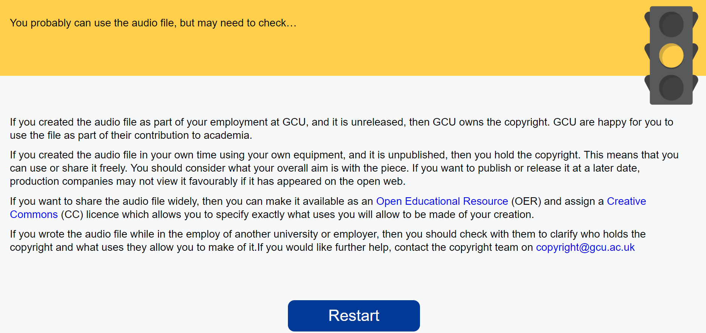

If we look at the corresponding file in the text editor, we get this:
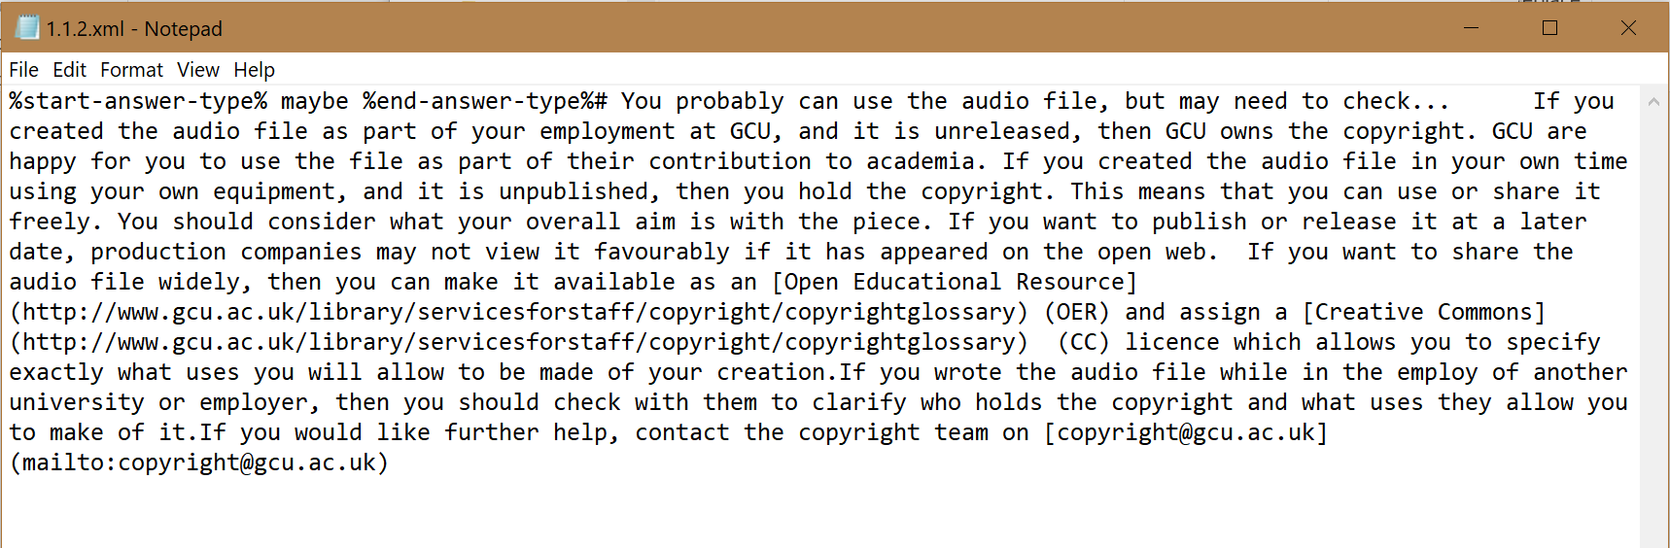
Lovely! I’ll copy and paste the text in here so we can see it more clearly:
%start-answer-type% maybe %end-answer-type%
# You probably can use the audio file, but may need to check...
If you created the audio file as part of your employment at GCU, and it is unreleased, then GCU owns the copyright. GCU are happy for you to use the file as part of their contribution to academia.
If you created the audio file in your own time using your own equipment, and it is unpublished, then you hold the copyright. This means that you can use or share it freely. You should consider what your overall aim is with the piece. If you want to publish or release it at a later date, production companies may not view it favourably if it has appeared on the open web.
If you want to share the audio file widely, then you can make it available as an [Open Educational Resource] (http://www.gcu.ac.uk/library/servicesforstaff/copyright/copyrightglossary) (OER) and assign a [Creative Commons] (http://www.gcu.ac.uk/library/servicesforstaff/copyright/copyrightglossary) (CC) licence which allows you to specify exactly what uses you will allow to be made of your creation.
If you wrote the audio file while in the employ of another university or employer, then you should check with them to clarify who holds the copyright and what uses they allow you to make of it. If you would like further help, contact the copyright team on
[copyright@gcu.ac.uk](mailto:copyright@gcu.ac.uk)
As you can see, the formatting and traffic light illustration are pulled in from different sections (we’ll get to that later!). At the moment, we are looking at the text.
The first changes you will want to make are to the basic wording - probably to change the institution name to your own as a start. As this is a pretty common one, I would just use a find and replace. Once you have made these changes, remember to save them. Basic text editors tend not to have autosave!

Formatting text
Now let’s look at some basic formatting as it appears in this file. I have highlighted the relevant sections.
- Headings: These are indicated by using # at the beginning of your heading, for example # You probably can use the audio file, but may need to check…
- External links: The nice thing about this framework is that we can link out to external sites (very useful for more detailed explanations) or to internal institutional sites. The format for this is [Name of link](//www.blahblahblah.com) Here’s an example from our page an [Open Educational Resource] (http://www.gcu.ac.uk/library/servicesforstaff/copyright/copyrightglossary) It is pretty straightforward, just remember, square brackets round the name of the link, round brackets round the URL.
- Institutional links: Just treat these in the same way as an external link.
- Mailto links: these work in exactly the same way, just add in mailto: at the front of the destination email. Here’s an example [copyright@gcu.ac.uk](mailto:copyright@gcu.ac.uk)

Got it? Nice work! Don’t forget to save!
Now we are on a roll, let’s look at some more formatting. Here’s an answer page from our maps section:
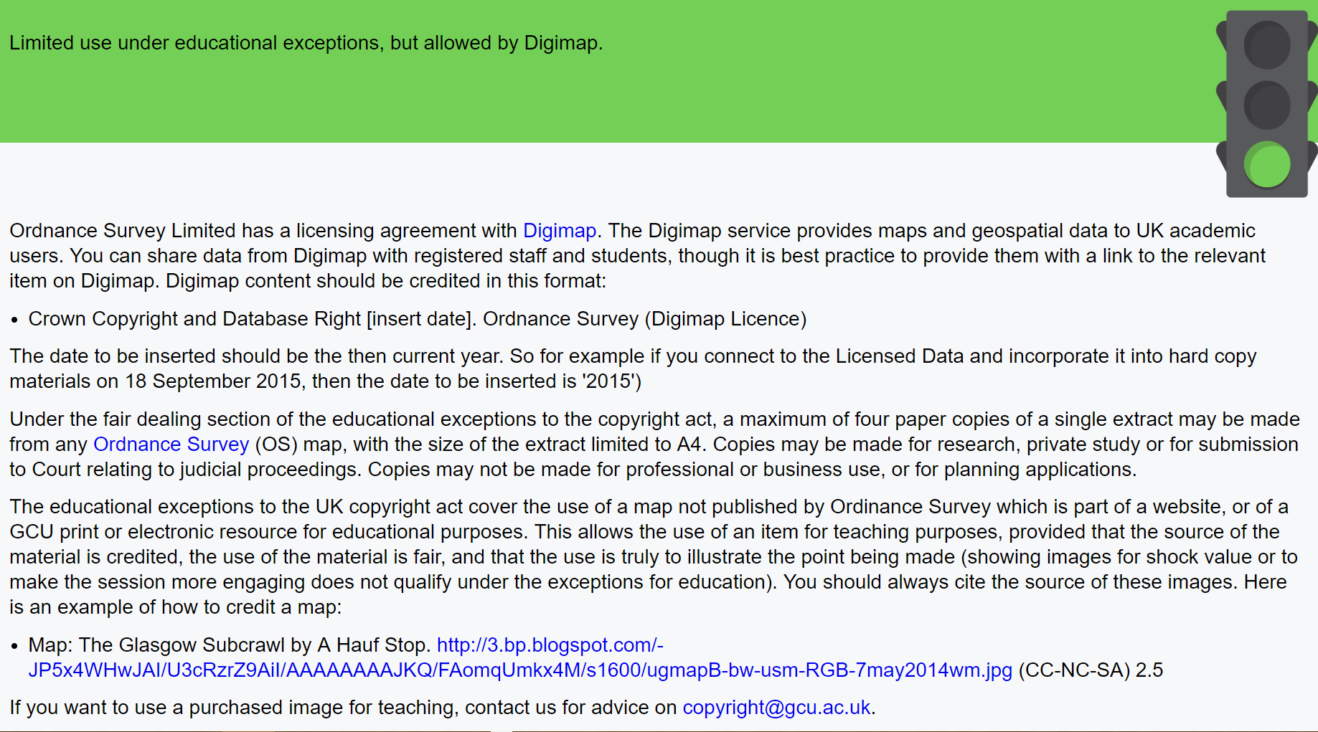
%start-answer-type% pass %end-answer-type%
# Limited use under educational exceptions, but allowed by Digimap.
Ordnance Survey Limited has a licensing agreement with [Digimap] (http://www.gcu.ac.uk/library/servicesforstaff/copyright/copyrightglossary/). The Digimap service provides maps and geospatial data to UK academic users. You can share data from Digimap with registered staff and students, though it is best practice to provide them with a link to the relevant item on Digimap. Digimap content should be credited in this format:
- Crown Copyright and Database Right [insert date]. Ordnance Survey (Digimap Licence)
The date to be inserted should be the then current year. So for example if you connect to the Licensed Data and incorporate it into hard copy materials on 18 September 2015, then the date to be inserted is '2015')
Under the fair dealing section of the educational exceptions to the copyright act, a maximum of four paper copies of a single extract may be made from any [Ordnance Survey] (http://www.gcu.ac.uk/library/servicesforstaff/copyright/copyrightglossary/) (OS) map, with the size of the extract limited to A4. Copies may be made for research, private study or for submission to Court relating to judicial proceedings. Copies may not be made for professional or business use, or for planning applications.
The educational exceptions to the UK copyright act cover the use of a map not published by Ordinance Survey which is part of a website, or of a GCU print or electronic resource for educational purposes. This allows the use of an item for teaching purposes, provided that the source of the material is credited, the use of the material is fair, and that the use is truly to illustrate the point being made (showing images for shock value or to make the session more engaging does not qualify under the exceptions for education).
You should always cite the source of these images. Here is an example of how to credit a map:
- Map: The Glasgow Subcrawl by A Hauf Stop. [http://3.bp.blogspot.com/-JP5x4WHwJAI/U3cRzrZ9AiI/AAAAAAAAJKQ/FAomqUmkx4M/s1600/ug_mapB-bw-usm-RGB-7may2014_wm.jpg] (http://3.bp.blogspot.com/-JP5x4WHwJAI/U3cRzrZ9AiI/AAAAAAAAJKQ/FAomqUmkx4M/s1600/ug_mapB-bw-usm-RGB-7may2014_wm.jpg) (CC-NC-SA) 2.5
If you want to use a purchased image for teaching, contact us for advice on [copyright@gcu.ac.uk](mailto:copyright@gcu.ac.uk).

The highlighted sections show how to add bullet points to your content. All you do is add a dash at the start of the section.

Customising the look and feel of the Copyright Advisor
Now we have covered the basics of updating the content of the advisor, let’s look at how you can customise it to your institution.
Changing the logo and credits
First you’ll need to upload the image file for the logo. Look in the /library folder, then select the images folder. Make sure your logo is saved in png format and is the right size for your needs. You can use Pixlr online editor (free!!) to make quick changes at this stage. Rename your logo to logo-op.png. Then upload your image file to the folder. It is best to delete the GCU logo to avoid confusion.
Now open the index.html folder. This sits at the top level of the advisor, so it is the first file you will see when you open up the main directory. This page controls the look and feel of the main index page. Here is a snapshot of the code of this page:
<!DOCTYPE html>
<html lang="en">
<head>
<meta charset="utf-8">
<meta http-equiv="x-ua-compatible" content="ie=edge">
<meta name="viewport" content="width=device-width, initial-scale=1, shrink-to-fit=no">
<title>Copyright Advisor</title>
<link rel="stylesheet" href="library/css/style.css?v=99400">
</head>
<body id="home">
<div class="page-wrapper">
<div class="page-wrapper-inner">
<header id="page-header" class="cf">
<a href="index.html" title="Return to the homepage" id="logo"> <img src="library/images/logo-op.png" alt="GCU logo" /> </a>
<p class="header-description">The GCU UK Copyright Advisor</p> </header>
<main id="quiz" class="page-content">
<div id="start"></div>
</main>
</div>
</div>
<footer class="page-footer">
<div class="page-footer-inner cf">
<div class="credits">
<strong>Content created by GCU Copyright Team. Site developed by Worth Knowing Ltd.</strong> </div>
<div class="license cf">
<div class="license-image"> <img src="library/images/cc-by.jpg" alt="AKQA logo" />
</div>
<div class="license-text">
<p>This work is licensed under a Creative Commons<br/> Attribution 4.0 InternationalLicense</p>
</div>
</div>
</div>
</footer>
<script type="text/javascript" src="library/js/scripts.min.js?v=99400"></script>
</body>
</html>

The line of code highlighted in yellow tells the index file to pull in the logo. You should also update the ALT text to say “Youruni logo”.
Changing the name of the advisor.
You may want to rename the advisor from The GCU UK Copyright Advisor by dropping in the name or initials of your institution. Just edit the name in the green highlighted text and save the file.
Changing the credits.
Again, this is a simple text edit of the section highlighted in blue. As the Advisor is license CC-BY, you should leave the GCU and Worth Knowing Credits in as original authors, but you can add in text like new version edited by XXXX. Don’t forget to save!
Changing the style of the Advisor
Site wide styles such as the font, type size, colours and layouts are controlled by the CSS files. These are in the CSS subfolder of the main library folder. This file controls the background, text and rollover colours. You may want to edit these to match your institution’s colour palette.

A note about browser versions
The browser used will affect the rendering of some of the text formatting and colours. We have made every effort to ensure that the Advisor runs on all common browsers. However, introducing a new resource is always a very good chance to steer users away from ancient versions of Explorer.
That’s it! If it all seems a bit like hard work, don’t worry, we are happy for you to use the GCU version on our website! However, if you do go ahead and produce your own version, we would love to hear about it! You can contact us at ddil@gcu.ac.uk
Good luck!

