10 Steps to Creating a Resource List
1. Add the Cite it! bookmark 2
2. Update an existing list 3
3. Create a new list 4
4. Structure the list 6
5. Add resources from the library 7
6. Add resources from the web 9
8. Import resources from a bibliography 12
9. Edit and annotate a resource 13
10. Complete list and send to library for processing 16
1. Adding resources to My Collection 17
2. Adding the bookmarks toolbar to your browser 19
3. Additional help and support 20

Attribution: Library Learning Services, University of Edinburgh. http://www.docs.is.ed.ac.uk/docs/library/ResourceLists/Get_Started_with_RL_Guidev2.pdf Available under a CC-BY 4.0 License.

Add the Cite it! bookmark

You can use the Cite it! bookmark to add resources to your list. In order to install it:
- Make sure the Bookmarks toolbar is showing at the top of your screen. If it is not there, please add it using the instructions at the end of this guide.
- Click through the welcome screen and follow the instructions to drag the Cite it! button into your bookmarks toolbar.
- Cite it! will now be visible in your browser’s Bookmarks toolbar.
- The Cite it! button can also be installed by:
  - Clicking on User Menu (in the top right-hand corner).
  - Selecting Cite it! from the drop-down menu and follow the instructions.

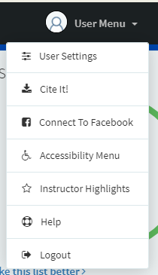

Note: Turn off any pop-up blockers on your browser to ensure the Cite it! tool will function correctly.

Update an existing list

Before creating a new list you can check if one already exists for your course by:
- Select Find Lists from the menu on the right of the screen.
- You can search for lists by title or course code.
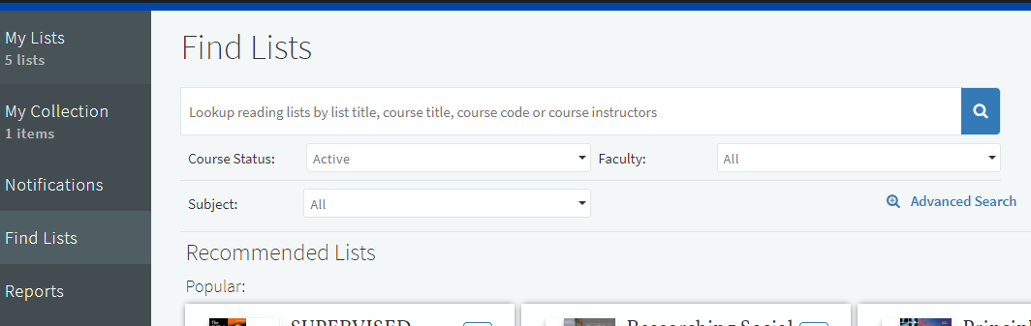

- If your course appears you can select it from the results and start to edit the list as described in section “4. Structure the list”.
- If you are unable to edit a list as expected please contact the Reading List team (readinglists@gcu.ac.uk).
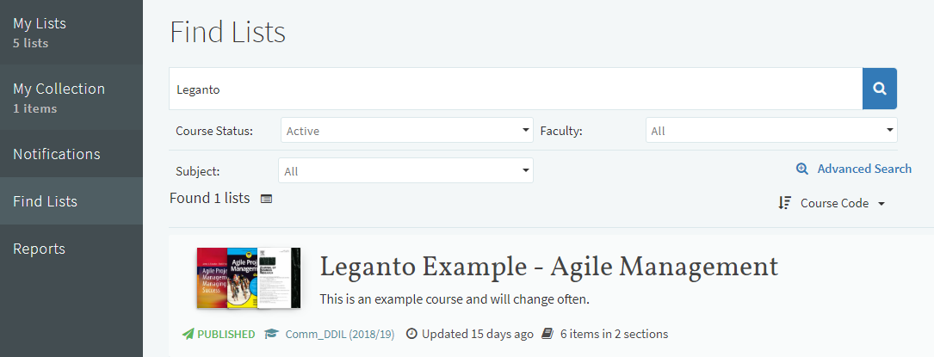

Create a new list
Lists are saved as you work, once created you can choose the list again by selecting it from the “My List” option from the menu on the left of the screen.

- Click on the new list button on the top-right of the screen.

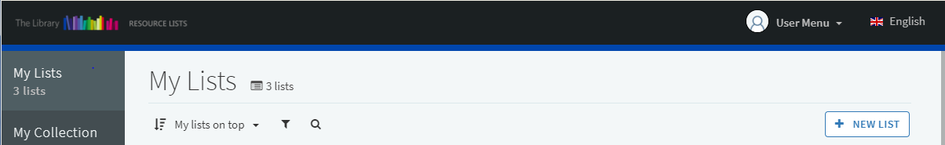

- Enter the Title and Description of your module.
- Click the create button.
- Choose one of the available templates (“Blank”, “Library Trimester”, or “Library Standard”).
- Connect your reading list with a course by clicking associate list, and then:
  - Look up course by typing a course code or name into the search box.
  - Do not alter the course dates as these are set automatically.
  - If you wish to associate the resource list with a number of modules click Associate and follow steps a-c to add the next course.
  - When completed click Associate & Close.

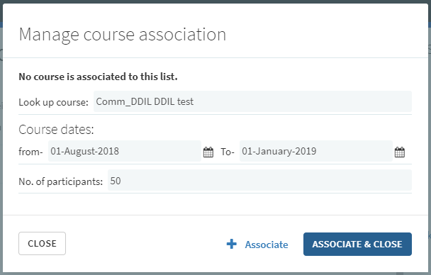
- Click on the Collaborators option on the right of the screen.
  - Click Manage collaborators.
  - Under Invite new collaborators.
  - Click Send Invitation.
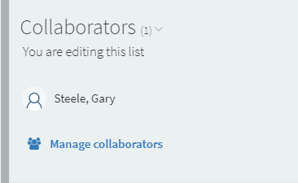

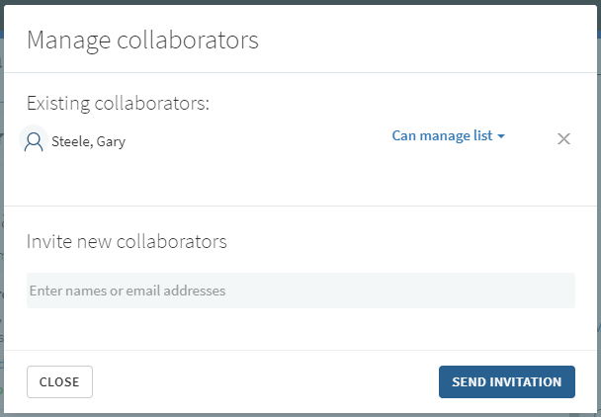

Structure the list

- If you have selected the blank template, you can add sections by:
  - Click new section.
  - Give the section a Title and Description.
  - More sections can be added using steps a-b.
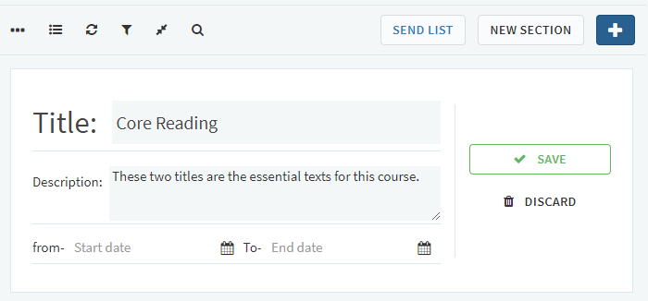
- If you have selected the “Library Trimester” or “Library Standard” template.
  - Click the three dots to the left of section title.
  - Select Edit Section.
  - Give the section a Description.
  - More sections can be added using the instructions above, from step 1. a-b.
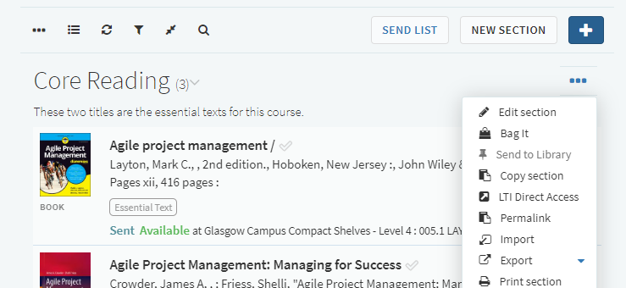

Add resources from the library

- Click on the + icon at the top of the list.
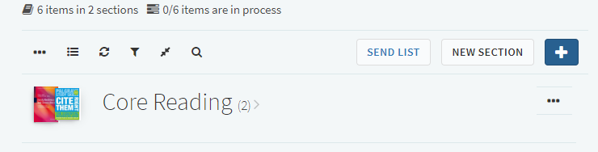
- To add a print or electronic book held by the library to the resource list:
  - Under Search tab on the panel on the right of the screen enter the title of the book.
  - The results can be filtered using the facet options Book.
  - Click on the item you would like to add. Now you can:
    - Drag and drop the item directly into your list, or
    - Pick a section from the drop-down menu and click on add.
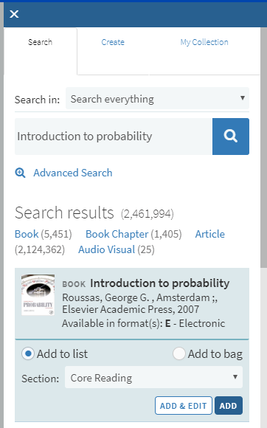

- To add a journal article held by the library to the resource list:
  - Under Search tab on the panel on the right of the screen enter the article title.
  - The results can be filtered using the facet options Article.
  - Click the item you would like to add. Now you can:
    - Drag and drop the item directly into your list, or
    - Pick a section from the drop-down menu and click add.
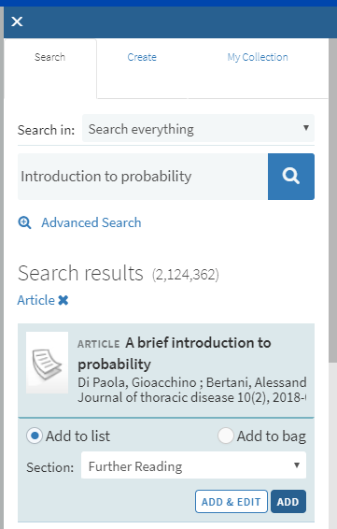
- Once you have added all required items please move on to step 9 “Edit and annotate a resource”.

Add resources from the web

- You can add resources that are not held by the Library to your list by using the Cite it! button.
- We have provided three examples below but any resource from the web can be added to a resource lists.
- Navigate to the website that contains the resource you require.
- To add a book not held by the library to the resource list:
  - Go to the item page and click the Cite It! Button on your bookmark toolbar.
  - The pop-up window will open with the book details already filled in.
  - Make sure the Type is set to Book.
  - Select Add to: List.
  - Select your resource list from the drop-down menu that appears.
  - Select the appropriate section from the drop-down menu that appears.
  - Click Add & Close.
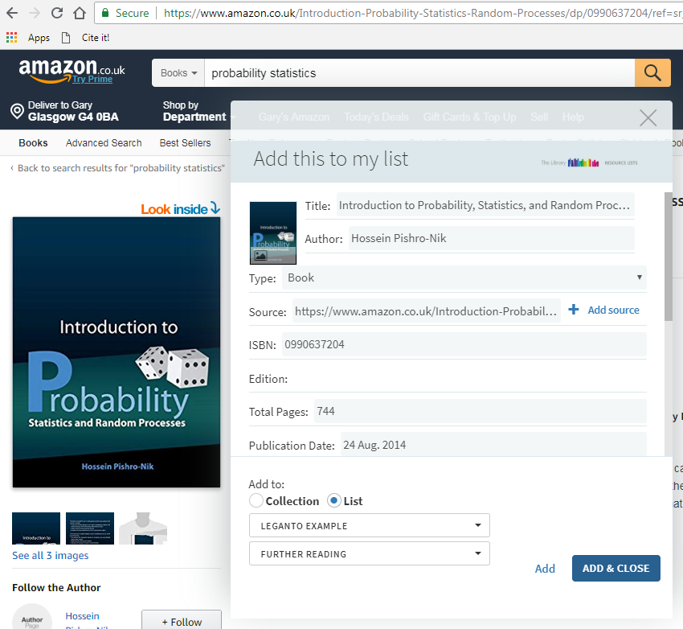

- To add an online newspaper to the resource list:
  - Go to the item page and click the Cite It! Button on your bookmark toolbar.
  - The pop-up window will open with the article details already filled in.
  - Make sure the Type is set to Newspaper Article.
  - Select Add to: List.
  - Select your resource list from the drop-down menu that appears.
  - Select the appropriate section from the drop-down menu that appears.
  - Click Add & Close.
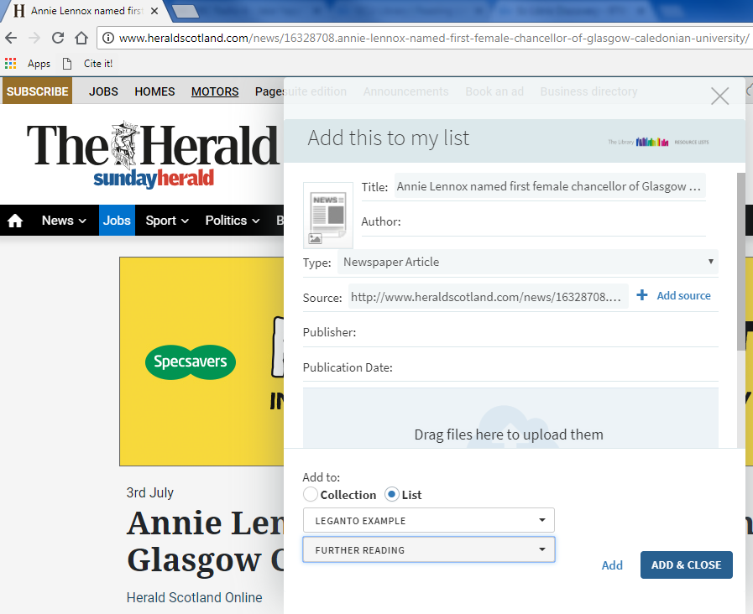

- To add a YouTube video to the resource list:
- Go to the item page and click the Cite It! Button on your bookmark toolbar.
- The pop-up window will open with the video details already filled in.
- Make sure the Type is set to Video.
- Select Add to: List.
- Select your resource list from the drop-down menu that appears.
- Select the appropriate section from the drop-down menu that appears.
- Click Add & Close.
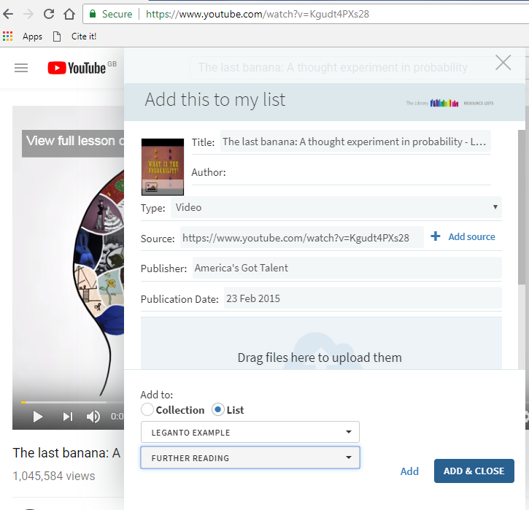

- Once you have added all required items please move on to step 9 “Edit and annotate a resource”.

Import resources from a bibliography

- To import a bibliography created by referencing software (like RefWorks):
  - Click the three dots at the top right of the list.
  - Select Import.
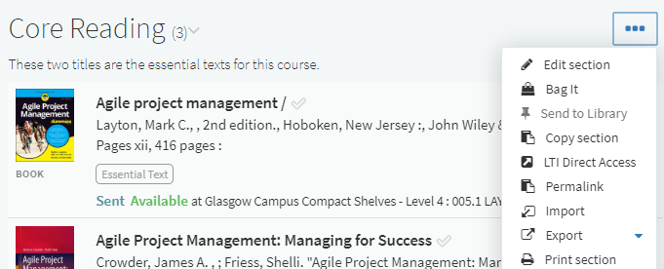

- Drag the bibliography in RIS file format into the pop-up window.
- Click confirm to upload.
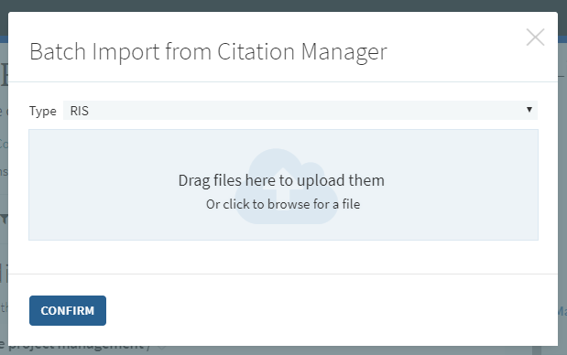

Edit and annotate a resource
This is a required step
- To mark a text as an essential text:
  - Click Add tags to item.
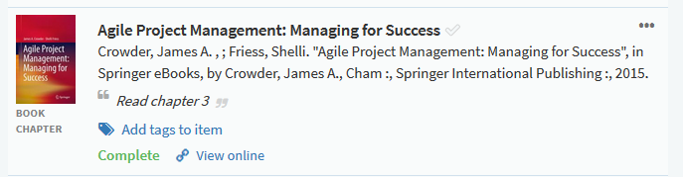
  - Select Essential text from the drop-down menu.
  - Click Save.
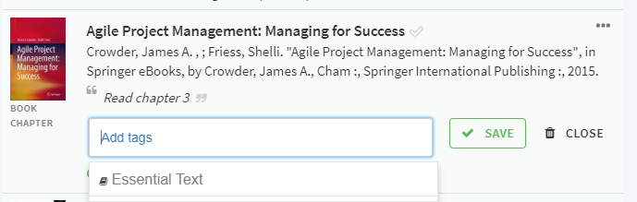

  - Items marked as Essential Text should only be resources that the students are directed to read

- To edit the details of an item on the resource list:
  - Click the three dots to the right of the title.
  - Select Edit Item. The Iitem details will appear in the panel on the right and can be edited as required.
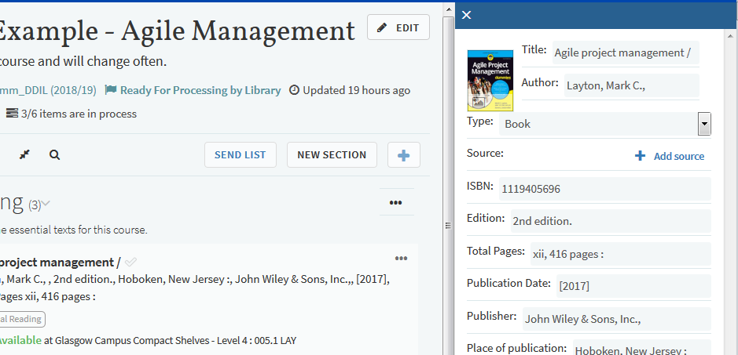

- To add notes to a title:
  - Click the title to open the details screen.
  - Click Add note under Public note to add text as required (For example “Please read chapter 2”).

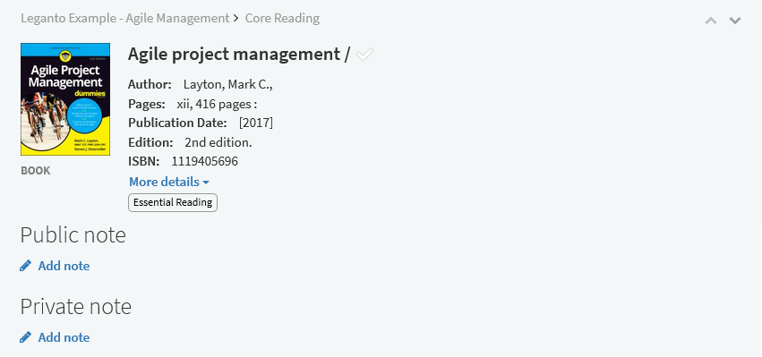

- To reorder or rearrange titles on a list:
  - Hover over the right of the title until the blue bar and Drag Citation option appears.
  - The title can then be dragged to the required position.
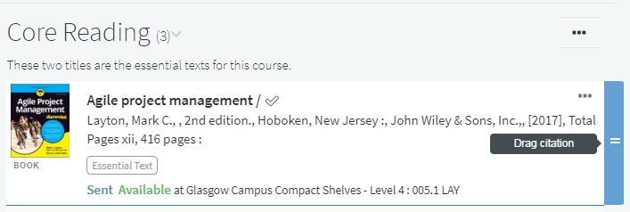
- To reorder all titles in the list alphabetically by author or title:
  - Click the three dots in the top left of the list.
  - Expand Order Citations in All Sections and select required sort order.
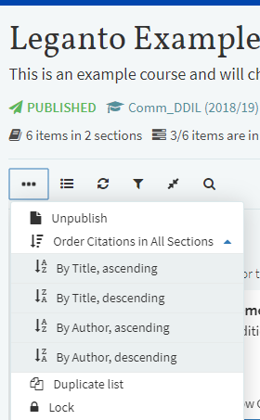

10. Complete list and send to library for processing

- After you have finished adding and editing all items on your list, please ensure:
  - The number of participants on the course has been entered.
  - The essential text on the list has been marked.
  - The List Advisor shows 100% complete (click on Make this list better to see steps required).
- You can review the list as student will see it by:
  - Click the three dots in the top left of the list.
  - Select View list as a student option.
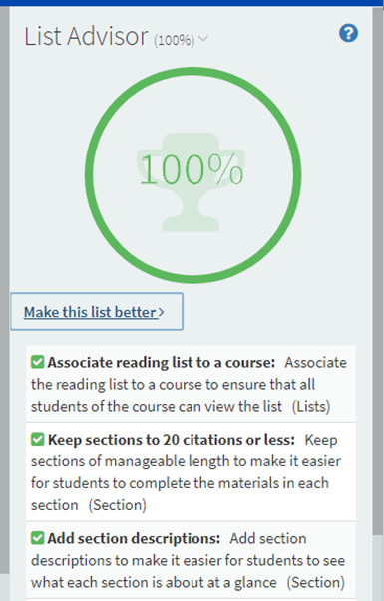 | 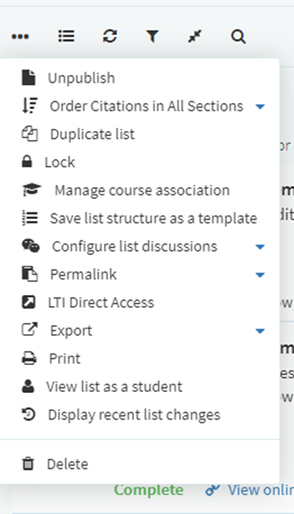

- Once you have completed the steps above your list is ready to be sent to the library for processing. To do this:
This is a required step
  - Click the Send List button in the menu bar.
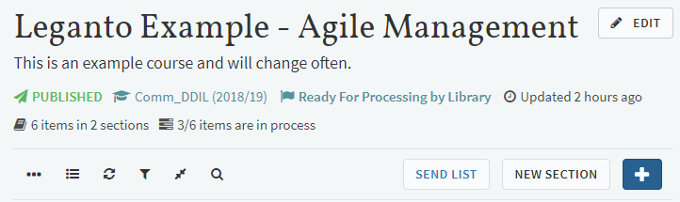

- After the list has been processed by the library you will receive an email to confirm the list is live.

Adding resources to My Collection

You can save resources at any time and add them to your resource list later on. This can be done by adding items to My Collection rather than directly to a list.
- To add an item to My Collection:
  - Go to the item page and click the Cite It! Button on your bookmark toolbar.
  - The pop-up window will open with the item details already filled in.
  - Select Add to: Collection.
  - Click Add & Close.
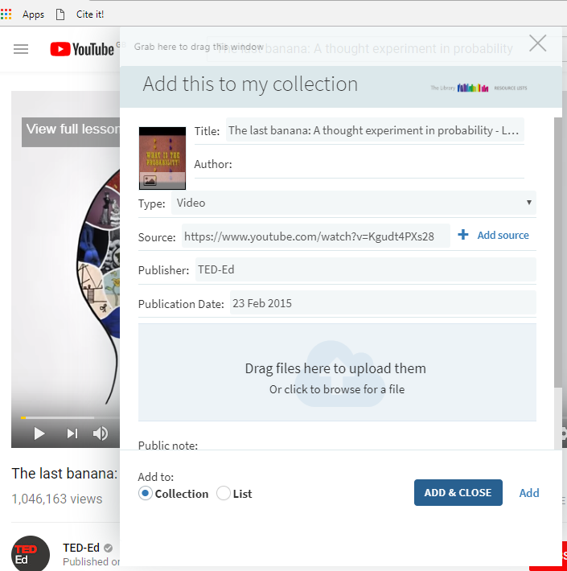

- Go to your resource List.
- Click the + button and select the My Collection tab on the right of the screen.
- Drag and drop the items you collected into the sections of your list.
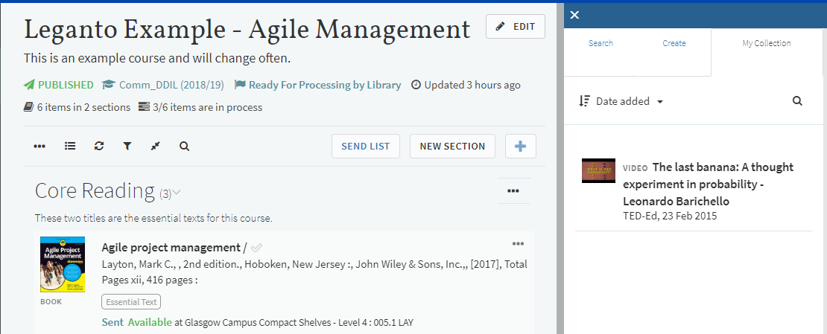
You can also add notes and tags to items in My Collection. These are private and won’t be visible if the item is added to a resource list.
- To add a note or tag:
  - Open the My Collection tab from the left-hand panel.
  - Click the item you wish to add the note or tag to.
  - Click Add note or Add tags to collection.
  - Type your note or tag and click on save.
  - A tag containing more than one word will need to be joined by a hyphen or underscore.
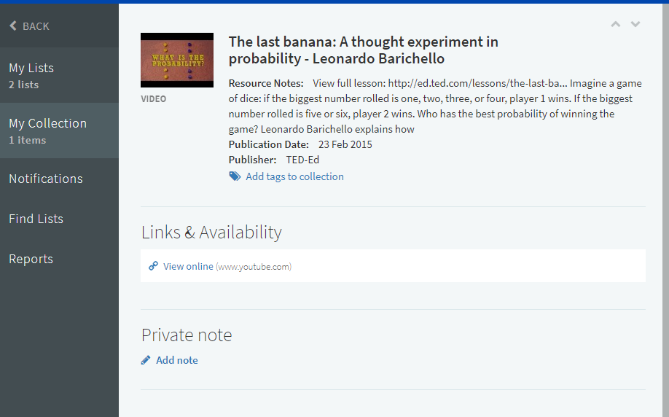

Adding the bookmarks toolbar to your browser

- In Chrome:
  - Select Ctrl+Shift+B or click on the Tools icon in the top-right corner.
  - Select Show bookmarks bar. 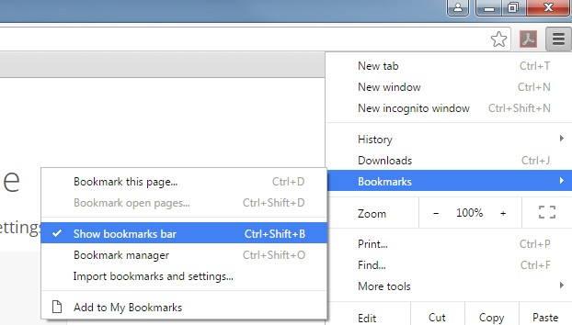

- In Internet Explorer:
  - Right click the Tools (cog-wheel) icon.
  - Select Favourites bar.
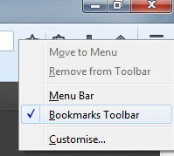
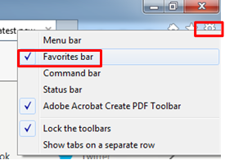
- In Firefox:
  - Right-click the Tools icon.
  - Select Bookmarks Toolbar.
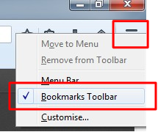

Additional help and support

- For further help and support see our website:
  - https://www.gcu.ac.uk/library/servicesforstaff/readinglists/

- Or alternatively, email the team at readinglists@gcu.ac.uk

