The Graduate School

RESEARCH STUDENT PERSONAL DEVELOPMENT PLAN (PDP)

Date of Submission | Student Signature | Director of Studies Signature

Part A: RESEARCH STUDENT SUMMARY INFORMATION

- The Student

1.1 Name:

1.2 Student No:

1.3 Sch/Division:

1.4 Email:

1.5 Tel:

1.6 Research location: (address where normally based for research study)

- The Supervisory Team

2.1 Director of Studies | Address:
Name: | Tel: | Email:
2.2 2nd Supervisor | Address:
Name: | Tel: | Email:
2.3 3rd Supervisor | Address:
Name: | Tel: | Email:
2.4 Advisor (s) | Address:
Name: | Tel: | Email:
2.5 Research Administrator | Address:
Name: | Tel: | Email:
2.6 Changes to supervisory team:

- The Research Degree Programme

3.1 Research degree type: | MPhil, PhD, Prof D
3.2 Mode of Study: | Full-time, Part-time
3.3 Give any details of any change to mode of study:

3.4 Funding Category: | (choose: University funded, School funded, externally funded, self-funded, Staff, UK/EU, International)
3.5 Proposed Title of Research project:

- Any Special Needs

Part B: PERSONAL DEVELOPMENT PLAN

For Research Student Journey progression, please refer to this webpage https://www.gcu.ac.uk/graduateschool/postgraduatestudy/phdstudyatgcu/theresearchstudentjourney/

Use the following template to focus on your personal and professional development. As a researcher you are responsible for your own development and should be looking for ways to enhance your research experience as you progress through your PhD. Take the time to reflect on progress with your supervisory team and plan for further development. Information on the Graduate School Researcher Development opportunities can be found here https://www.gcu.ac.uk/graduateschool/researcherdevelopment/

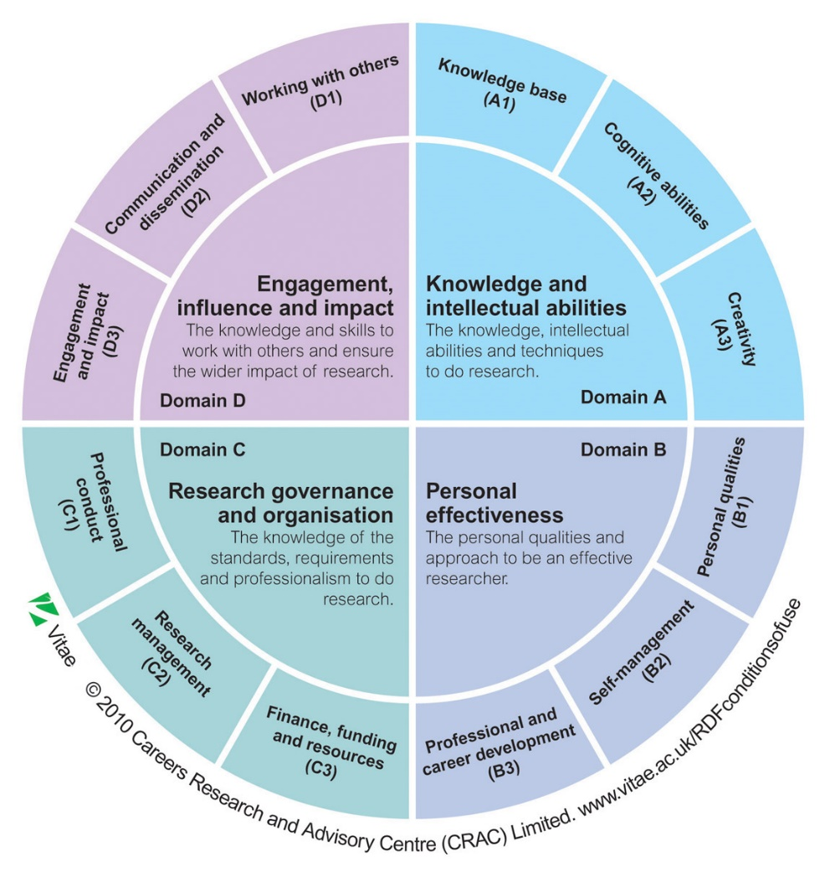
Researcher Development

The Researcher Development Framework
( www.vitae.ac.uk/rdf ) describes the knowledge,
behaviours and attributes of successful researchers.

Using this tool can be helpful in considering areas
for development and reflecting on progress.

RDF sub-domains | Areas for development | Activity to address development (specify details & dates) | Review meeting date | Examples of activity
Domain A – Knowledge and Intellectual Abilities
A1 – Knowledge Base |  |  |  | Attend relevant research methods workshop
A2 – Cognitive Abilities

A3 – Creativity

Domain B – Personal Effectiveness
B1 – Personal Qualities

B2 – Self management

B3 – Professional and Career development |  |  |  | Maintain up to date academic CV
Domain C – Research Governance and Organisation
C1 – Professional conduct |  |  |  | https://ukrio.org/ - find possible activities here
C2 – Research Management

C3 – Finance, Funding and Recourses |  |  |  | Submit Grant applications
Domain D – Engagement, Influence and impact
D1 – Working with others

D2 – Communication and Dissemination |  |  |  | Present conference paper
D3 – Engagement and Impact |  |  |  | Deliver public engagement activities

