edShare@GCU user guide

Toby Hanning, Glasgow Caledonian University

Email: edshare@gcu.ac.uk
Website: https://edshare.gcu.ac.uk

Contents

1. Introduction
2. Logging In
3. Managing Your Profile
4. Uploading Resources
4.1 Files
4.2 Resource Information
4.3 Divisions
4.4 Courses
4.5 Tags
4.6 Related URLs
4.7 Viewing Permissions
4.8 Editing Permissions
5. Uploading E-Learning Resources
6. Embedding Resources in GCULearn
6.1 Documents
6.2 Multimedia
6.3 E-Learning Resources
7. Additional Features
7.1 Templates
7.2 Version Control
7.3 Removal Requests
8. Statistics
9. Appendices
9.1 Subtitles and Closed Captions

1. Introduction

This guide provides detailed guidance on using edShare@GCU (hereafter referred to as edShare), including information on uploading resources, managing your profile and troubleshooting problems.
edShare is an educational resources repository for the GCU community. It allows staff to store, share and preserve a wide variety of learning and teaching materials in one central location. Staff can upload and manage their own resources and have the option to share them openly on the internet, with all members of the University, or with a select group of students or staff. You can upload any resource to edShare, with the following exceptions:
- Research – should be uploaded to the University’s PURE Portal;
- Digitised published resources (e.g. a scanned book chapter or article) – published resources must be digitised by the library’s scanning service, as specified in the University’s CLA Licence;
- Temporary resources – edShare is a repository, not a content management system, therefore temporary resources (e.g. student assessments) should be uploaded directly to GCULearn. edShare only accepts permanent resources and has built-in version control to manage edited or new versions.
It is also important that you consider whether or not a resource contains 3rd party copyright before uploading it to edShare. This is likely to be the case if you have included materials found on the web. Please use our Keeping it Legal Guide to ensure your resources are compliant with copyright law. We also provide advice on our copyright pages, or you can contact us with any questions relating to copyright, licensing or IPR.
Finally Government regulations place a duty on public-sector bodies, including the University, to make all digital content and platforms accessible to everyone, including those with disabilities. You can access support and guidance in creating accessible digital educational resources at the Delivering Digital Accessibility SharePoint site.

2. Logging In

To log in click on the Login button at the top right of the edShare homepage and, when prompted, enter your domain username and password. All GCU students and staff can log in to edShare, although only staff can upload resources. If you experience any problems logging in please contact edShare@gcu.ac.uk.

3. Managing Your Profile

All staff have a profile in edShare. Your profile provides an overview of activity around your items in the repository, including your latest additions and most downloaded items, and also provides a space to list your teaching interests and biography. Similar to a research profile, an edShare profile is your opportunity to market your educational expertise. The more information you add, the more people can find out about you and the work you do. Whilst we strongly recommend that you complete your edShare profile, there is no requirement to do so. You are welcome to add as much or as little information as you like.
To access your profile information click My Homepage when logged in. Here you will find a number of widgets which you can display on your page. You can add or remove widgets using the buttons at the bottom of the screen.
To edit your profile click the Edit Profile button. Each field in your profile has its own help section which provides advice on the type of information which should be added. To access this click the button to the right of each field.
In the Account Details section you will find a pre-populated email address. Please do not edit or remove this email address. However you can select whether or not your email address displays on your public profile page using the Hide Email field.
In the Personal Details section you can add Department, Organisation, Address and the URL of a personal homepage, should you have one. You can add as little or as much information as you like in this section, but remember that any information entered will be visible on your public profile page. Once you are happy with this information click Next.
In the next section you can add your Job Title, Educational Expertise, Biography and Qualifications. Again you can add as little or as much information as you like, but remember that information entered will be visible on your public profile page. Once finished click the Save button. You can now view your public profile by clicking on the link at the top of the screen, or edit the information you have just entered.
You can also upload a photograph to your profile. Click My Homepage and then Profile Picture. Select your photo for upload and click Upload. edShare will automatically resize your photograph to fit your profile; for best results upload a portrait photo at 120x160 pixels. You can view your public profile at any time by going to your homepage and clicking on your hyperlinked name at the top of the screen.
You can embed a summary of your user profile in any web page. Go to My Homepage and click the button at the top of the screen. Copy and paste the code from the Embeddable Profile section into the <head> tag of a page. Please contact us if require assistance with this.

4. Uploading Resources

To upload a resource to edShare click on Resource Manager and select New Resource. You will be presented with a form where you can add information about your resource. You need only upload a file, add a title and set viewing permissions, but the more information you add the more discoverable your resource will be. If you are unsure what information to add in a particular field, click the button for guidance or follow the step-by-step instructions below. When you have finished adding information click Deposit to submit your resource. Remember you can edit any of the information entered at a later date, although you will be unable to delete your resources once they are live. See the Removal Requests section of this guide for information on how to request a deletion.
4.1 Files
The first section allows you to upload your file(s) to your resource. You can upload a single file or you can upload multiple files. Click the Browse button (Chrome users will see a Choose button) to select the file and the Upload button to upload it to the repository. This may take a minute depending on the size of your file. You may then repeat this process if you need to upload more files to your resource.
Once uploaded you will see a variety of options for each of your files.
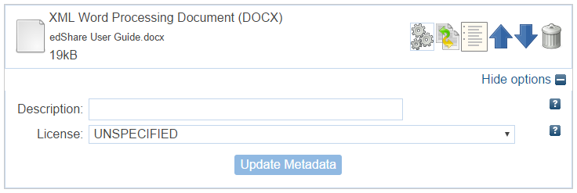
- Arrow buttons - If you have uploaded multiple files you can use the arrow buttons to arrange the order of the files in your resource.
- Bin button - If you have uploaded a file in error you can use the bin button to remove it.
- Description field – Use this field to add a brief description of your file e.g. Video, Slides, Transcript. This can help users identify at a glance what each file is and can be very helpful when uploading multiple files to the same record.
- Licence – Use this field to specify a licence for each file. You should not assign a licence unless you intend to make your resource open access. edShare only allows Creative Commons licences. More information on licensing is available from our Keeping it Legal Guide.

4.2 Resource Information
This section allows you to add information about your resource.
- Title (mandatory) – Assign a title to your resource. Try to make the title concise, but also helpful and explanatory to users. Avoid being too vague or too general. Instead of Lecture 1 try Comparative Forensic Sciences, Lecture 1, 2015.
- Summary – This field allows you to add a brief description of your resource.
- Creators – Here you can list the person or people who made your resource. Type a family name and use the autocomplete function to enter the details of GCU staff members. Alternatively you can manually enter the details of any external collaborators. Use the button to add additional creators. Email addresses in this field will always autocomplete with a staff member’s alias address and are used to build the browse menus. Please do not alter these email addresses.
- Additional information – This field allows you to add information about your resource that can't be entered anywhere else in the record. For example this may include suggestions for how another user might reuse your resource, or provide information regarding when or how your resource was created.
- Copyright holder – By default copyright is held by GCU and this field is auto-populated with the set statement Copyright © Glasgow Caledonian University. If this does not apply to your resource then you can update this statement with the actual copyright holder e.g. Copyright © The Author.
- Staff notes – This field can be used for admin purposes or personal notes regarding your resource. These notes are private and will not appear on the public resource page.
4.3 Divisions
The divisions section allows you to select the school(s) or department(s) with which your resource should be associated. Where possible you should select your specific department or institute, rather than the top-level school.
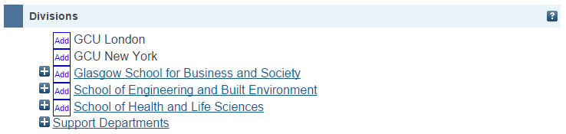
Use the button to navigate to your department or institute. Use the button to select your department or institute. You can select multiple divisions and should add all divisions affiliated to the creators of the resource.

4.4 Courses
You can assign your resource to the course or module it was created for. Begin typing a course name or course code and use the autocomplete function to enter the full details of the course. Data in this field is pulled from the module catalogue and should not be entered manually.
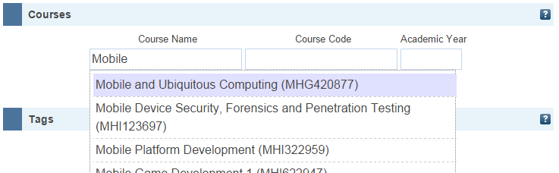
4.5 Tags

Locating an Alias Email Address Using Outlook
Alias email addresses are used throughout edShare. The system utilises them as a unique identifier for GCU staff and uses them to populate staff profile pages and the Browse by Creator view.
If you want to allow selected members of staff to view or edit a resource then you will need to know their alias email address. The alias email address is usually in the format abc1@gcu.ac.uk and can be located in Outlook.
The following instructions relate to Microsoft Office 2010.
- Open a new email message.
- Click on the To… button.
- Enter the surname of the staff member whose alias email address you are looking for.
- Locate the relevant staff member in the list, right click on the staff member’s name and select Properties.
- Select the E-mail Addresses tab – the alias email address is usually at the end of the list.
You can use the alias email address to assign viewing and editing permissions in edShare. Begin typing the alias email address in the email address field (under the Selected Users tab) and select the relevant user from the drop-down list.
The tags section allows you to enter individual words or phrases which describe the content of your resource. These help users understand what your resource is about and make your resource more discoverable via search engines such as Google.
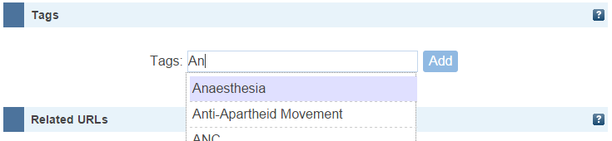
Begin typing a word or phrase and, if it has been previously entered as a tag on another resource, select it from the autocomplete function. If the system finds no existing matches, type the whole word or phrase and click the button.
4.6 Related URLs
This field allows you to add a link to a website or web page related to your resource. Enter the URL ensuring that you prefix it with http:// and select the type of URL from the drop-down menu. Use the button to add multiple URLs.
4.7 Viewing Permissions
Use this field to choose who can view your resource. By default viewing permissions are set to World, which means your resource will be openly available on the web and can be viewed by anyone in the world. If you are selecting this option remember to assign a licence to your resource in the Files section. This will ensure your resource is legally protected and will make it clear to users what they can and cannot do with your resource.
Alternatively you can choose from three other levels of viewing permissions:
- University – Selecting this option means that only registered students and staff at GCU can view your resource. The details of your resource will be openly available on the web and can be viewed by GCU users after they have logged in. If you wish to restrict access to just GCU staff, select the Staff Only box.
- Selected Users – This option allows you to specify a group of students or staff who are allowed to view your resource. The details of your resource will be openly available on the web and can be viewed by the users listed in this section after they have logged in. To add users search by name or email address and select the user from the drop-down list. The most efficient search is by email address. For staff use the alias email address found in Outlook, e.g. abc1@gcu.ac.uk. The side panel on page 7 explains how to locate a user’s alias email address using Outlook.
- Just Me – Selecting this option means that only you will be able to view your resource. The details of your resource will not be available on the web and your resource will not appear in search results until you change the viewing permissions to one of the other options.
4.8 Editing Permissions
Use this field to choose who can edit your resource. By default viewing permissions are set to Just Me, which means only you as the depositing users may edit the resource.
Alternatively you can choose from two other levels of editing permissions:
- Selected Users – This option allows you to specify a group of students or staff who are allowed to edit your resource. To add users search by name or email address and select the user from the drop-down list. The most efficient search is by email address. For staff use the alias email address found in Outlook, e.g. abc1@gcu.ac.uk. The side panel on page 7 explains how to locate a user’s alias email address using Outlook.
- University – Selecting this option means that any registered student or staff member at GCU can edit your resource. You can restrict editing permissions to just GCU staff by selecting the Staff Only box.

5. Uploading E-Learning Resources

E-learning resources created using software such as iSpring, Captivate, and Articulate can be uploaded to edShare. These are usually interactive resources which can incorporate a variety of file types including text, video, audio and images. Once uploaded you can normally view the resource through edShare or embed it into GCULearn.
Follow the instructions below to upload an e-learning resource to edShare:
- Export your resource as a zip file. Most e-learning software will allow you to do this.
- Go to your Resource Manager and click New Resource.
- In the Files section upload your zip file.
- Once uploaded click on the Box Icon (unpack).
- A screen will pop-up asking if you want to unpack into a single or multiple resource. Always select single. A second file will now display on your record.
- Next to this second file click the Files Icon. edShare will display a list of all the files in your zip package.
- Select the index.html as your main file and click Apply at the bottom of the screen.
- Use the Bin Icon to delete the original zip file.
- Complete the other fields in the record and click Deposit. Remember the more information you add the more discoverable your resource will be.
Due to the interactive nature of e-learning resources edShare is unable to create previews of these packages. However you can still view the resource in edShare; just navigate to the record and click the View button.

6. Embedding Resources in GCULearn

Resources stored in edShare can be easily linked to, or embedded, in GCULearn. The student experience will vary depending on whether you embed or link to your resource.
Embedding – Students see a snapshot of your resource in GCULearn. They can use the resource as normal without needing to leave GCULearn.
Linking – Students click on a hyperlink in GCULearn. edShare opens in a new window where they can use the resource as normal.

6.1 Documents
Documents include most Microsoft Office files e.g. Word, PowerPoint, Excel. Follow the instructions below to link to a document stored in edShare:
- On the edShare resource page right click on the Download button and select Copy Link Address. The link will usually take the form: https://edshare.gcu.ac.uk/id/document/xxxx
- In GCULearn open the Build Content menu and select Web Link.
- Enter a name for your link. This is the text users will see.
- Paste the link address from edShare into the URL field. Ensure the link begins https.
- Click Submit.
6.2 Multimedia
Multimedia includes video and audio. After uploading a multimedia file edShare will generate a number of derivative files and generate an embed code. Using this embed code ensures that the resource can be accessed on all types of devices and all browsers. If an embed code does not generate within two hours please contact us. Please note embed codes will not generate for HTML resources.
You can embed your multimedia file within GCULearn by copying the desired file’s embed code and pasting the code in GCULearn.
Follow the instructions below to embed a multimedia resource stored in edShare:
- Copy the embed code provided on the edShare resource page. The embed code will usually take the form:
<iframe width="auto" height="auto" src="LINK" frameborder="1" allowfullscreen></iframe>
- In GCULearn open the Build Content menu and select Item.
- Enter a name for your multimedia resource.
- In the Text field click the HTML icon. A pop-up window will open. Paste the embed code from edShare into the pop-up window.
If you wish you can resize video resources by specifying a width and height in the embed code e.g. width="100%" height="540". The width and height you specify will depend on the aspect ratio of your video. We also recommend that the width is specified in percent to ensure the resource is responsive i.e. it resizes to fit a user’s browser and device.
Click Update in the pop-up window and then Submit.

6.3 E-Learning Resources
Embedding e-learning resources from edShare within GCULearn requires manual creation of some HTML code with an iframe tag.
Open the HTML file within your resource in edShare by clicking View on the preview page. Copy the link from your browser. This should take the format: https://edshare.gcu.ac.uk/xxx/x/file_title.html. The link should always end .html.
- In GCULearn open the Build Content menu and select Item.
- Enter a name for your multimedia resource.
- In the Text field click the HTML icon. A pop-up window will open.
- Add the following and insert your edShare link as the “LINK”:
<p><iframe width="auto" height="auto" src="LINK" allowfullscreen=""></iframe></p>​
  - Here another example of the above with an edShare link inserted:
<p><iframe width="auto" height="auto" src="https://edshare.gcu.ac.uk/1136/8/index.html" allowfullscreen=""></iframe></p>​
If necessary you can resize the resource by specifying a width and height in the embed code e.g. width="100%" height="540". The width and height you specify will depend on the aspect ratio of your resource. We also recommend that the width is specified in percent to ensure the resource is responsive i.e. it resizes to fit a user’s browser and device.
Click Update in the pop-up window and then Submit.

7. Additional Features

edShare includes a number of additional features which can be accessed once a resource has been uploaded to the system. These features help you manage your resources and save time when uploading new resources.
7.1 Templates
If you need to upload a number of similar resources you can use the template feature to avoid having to repeatedly enter the same metadata. This feature creates an exact copy of a resource which you can edit and upload. There is no link between the two resources.
To use this feature navigate to the resource you want to use as a template. You can do this using the search function on the edShare homepage or by navigating to the resource via your Resource Manager. On the resource page click on the 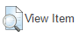button situated at the bottom of the metadata panel. Here you will see four tabs:
Select the Actions tab and click the Use As Template button. A new resource is created which you can edit. Upload your new resource, edit any metadata as required e.g. Title, Creators or Divisions and click the Deposit button to submit your new resource.
7.2 Version Control
We understand that teaching materials, policies and documentation are frequently reviewed within the University and that new versions of these resources are created on a regular basis. edShare is a repository intended for permanent resources only, with the core aim of enabling the long-term preservation of the University’s educational output; as such there is no functionality for staff to delete resources from edShare. Instead we request that staff upload new versions of their resources using the system’s in-build version control functionality. This ensures that all versions of a resource are retained in their original state.
When a new version of a resource is uploaded to edShare the following actions are undertaken by the system:
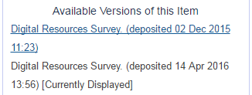
- The new version is linked to any older versions already stored in edShare.
- The metadata associated with the new version is updated to include links to any older versions already stored in edShare.
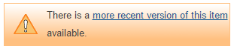
- The metadata associated with any older versions is updated to direct users to the latest version available.
- The metadata associated with any older versions is hidden from edShare search function to ensure that only the latest version is discoverable.
To create a new version of a resource navigate to the most recent version already stored in edShare. You can do this using the search function on the edShare homepage or by navigating to the resource via your Resource Manager. On the resource page click on the button situated at the bottom of the metadata panel. Here you will see four tabs; select the Actions tab and click the New Version button. A new version of your resource is created which you can now edit. Select the Details tab and click the Edit Item button. Remove the old file(s) from your resource using the Bin Icon and upload the new version. Update any metadata as required e.g. Title, Creators or Divisions and click the Deposit button to submit your new resource.

7.3 Removal Requests
Internal Requests
Occasionally there may be justification to permanently remove a resource from edShare rather than upload a new version. If this is the case you can request a deletion from the edShare team.
To do this navigate to the resource you want to remove. You can do this using the search function on the edShare homepage or by navigating to the resource via your Resource Manager. On the resource page click on the button situated at the bottom of the metadata panel. Here you will see four tabs; select the Actions tab and click the Request Deletion button. A template removal request is displayed. Select Click To Edit to add a reason for requesting the removal; without this the edShare team will be unable to fulfil your request. To submit your request click Send. The edShare team will consider your request and may ask for more information before making a decision. If your resource is removed the metadata will usually be retained and URLs will continue to point to 'tombstone' citations, to avoid broken links and to retain item histories.
External Requests
When uploading a resource to edShare you should consider whether or not your resource includes any third party content. Third party content refers to any copyright work created by someone other than you. It is up to you to check carefully if you have permission to reuse such content in your resource. The edShare team have created a Keeping it Legal Guide which provides information on how to stay legal when uploading resources, or when using or adapting resources created by others. If you have questions which are not covered by this guide then please contact us before uploading your resources to edShare.
Due to the nature of online content we recognise that from time to time material published in edShare may be in breach of copyright law or include personal or sensitive data. The edShare team have created a robust Takedown Policy which deals with such instances and aims to resolve any complaints swiftly and amicably to the satisfaction of all parties concerned.

8. Statistics

The Most Viewed Items widget is available from your homepage and lists your top 10 most viewed resources. To view these statistics click My Homepage when logged in and scroll down until you see a section entitled Most Viewed Items. If you cannot see this widget on your homepage you may need to add it using the buttons at the bottom of the screen.
The edShare team can also provide download statistics and a variety of information from Google analytics. Please contact us for further information.

9. Appendices

9.1 Subtitles and Closed Captions
When creating resources please check to see if the software you have used has the capability to create subtitles and closed captions for video or e-learning resources. If software capability is present, it is advisable to utilise this functionality prior to uploading your resource to edShare. For example, you can add closed captions if creating resources using Camtastia. The GCU Training Team provides detailed guidance and training on the use of Camtasia, and how to add closed captions.
Where the software used to create your resource does not support closed captioning it is possible to add closed captions to your resource retrospectively. To add closed captions you must create a Web Video Text Tracks (WebVTT) file which contains the text track for your video and associated timings. You can then reference this file using a track tag.
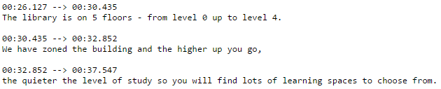
- Create your WebVTT file. You can either convert an existing transcript to WebVTT format or create a new file and manually add captions. The following site provides tools which can make this processes quick and easy: http://www.vttcaptions.com/the-caption-generator.html

- Upload your WebVTT file alongside your video in edShare. We recommend giving your file a simple name e.g. Video.vtt.

- Obtain the document URL for your WebVTT file in edShare. This is the link you will reference. To obtain this link select the WebVTT file, right click on the Download button and select Copy Link Address. The link will usually take the form: https://edshare.gcu.ac.uk/id/document/xxxx

- Add a track tag. The track tag is contained within the video tag and takes the form:

<track kind="captions" src="" label="English"></track>

Add the document URL for your WebVTT file to the src attribute of the track tag e.g.

<track kind="captions" src="http://edshare.gcu.ac.uk/id/document/5332" label="English"></track>

- Upload your video and WebVTT file in edShare. When viewing the player you will now see a button which can be used to switch your closed captions on and off.

