Getting Started with Resource Lists at GCU
This quick guide is for students and will show you how to:
- Find your Resource List
- View your list, search for items on a list and manage your reading
- Export your Resource List as a bibliography
More information on Resource Lists at GCU including a video tutorial is available on the Library website: www.gcu.ac.uk/library/onlineresources/resourcelistsstudents/

Finding your Resource List
There are two ways to find your Resource List, either through your module in GCULearn or by searching on the Resource Lists homepage.

GCULearn
- In your module in GCULearn, click on the Resource List link on the menu on the left hand side of the screen.
- If your lecturer has sent your list to the library, you will be taken directly to it. If they have not, you will be taken to the main Resource Lists homepage.

Resource Lists at GCU homepage
- Go to https://gcu.alma.exlibrisgroup.com/leganto/readinglist/searchlists
- You may be prompted to log in with your university domain username and password.
- In the search box, type in your module title, module code, or lecturers name, and click search

Why can’t I find a Resource List for my module?
Not all modules have had a Resource List submitted to the library yet. If there is not a Resource List available for your module, please consider asking your lecturer to use the Library’s Resource Lists service.

Using Resource Lists
The icons at the top of your Resource List will help you change the list view, search for items and filter the list by importance level or by resource type.
Toggle Section View allows you to change the list view. It will switch the view from just the section headings to the full expanded list. Click on a heading to view citations in a section.

Filter allows you to view the list by either sections, tags, or resource type.
Compact View allows you to switch between the compact view and the full view, which displays all the citation information for items on your list.
Search allows you to look for specific items on your list.

Resource List Citations
Resource citations on your list will look like this:
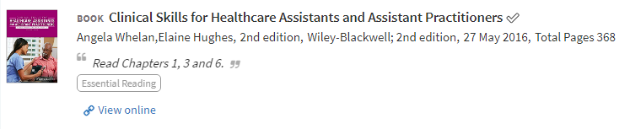
You will see:
- The importance level of the item as set by your lecturer (either Essential, Recommended or Further Reading)
- If it is a print item, you will see what campus they are available at and where in the library they are located.
- If the item is an online resource, you will see a View Online link which will take you directly to the resource.
- You may also see a note from your lecturer about the resource (e.g. “Read Chapters 1, 3 and 6”)

When you click on a citation, you will see:
- Links to any online version(s) if the citation is an ebook, journal article or other online resource.
- For online resources, you will see the Mark as broken function. You can use this to report any broken links to the library.
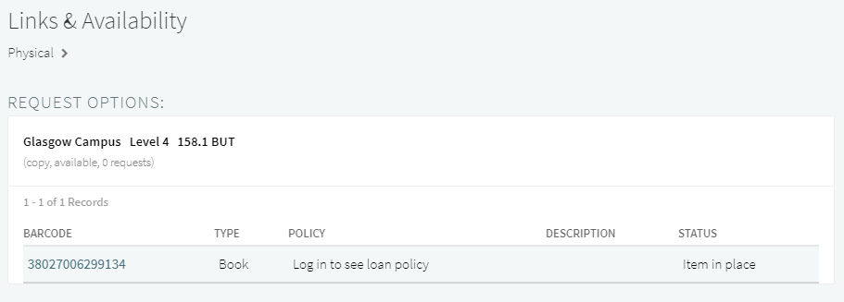
- If the citation is for a print book, you will see information about how many copies there are available and where in the library it is located.

Exporting your Bibliography
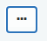
You can export your Resource List as a bibliography in a number of formats. If you export your list to Word, you can also choose which citation style to use. To export your list:
- Click on the Resource List options button (three dots) which is located to the right of the Resource List title.
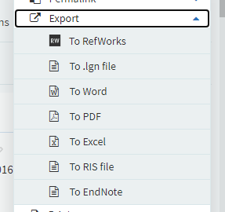
- Click Export then click on your desired export format. If you wish to export to RefWorks or other reference management systems, use the RIS file option.
- If you are exporting to Word, you will then be asked to choose a bibliography style. Pick your style from the dropdown menu and then click Export.

It is worth noting that if you are exporting the Harvard reference style, you will need to review this as it is not British Standard Harvard.
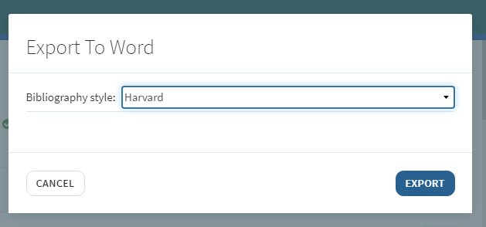

Linking to your RefWorks account
You can also link your RefWorks account to the Resource List system; you may wish to do this if you would like to export your Resource Lists straight to RefWorks. To link your account you must first know your individual log in details for RefWorks.
To find that out:
- Log into your RefWorks account
- Click on your name which is at the top right hand of screen which will reveal the drop down menu
- Choose settings from the drop down menu.
- A pop up window should appear prompting you to create an alternate password
- If a pop up window doesn’t appear, scroll down to that section and create the password

You can then go to your Resource List and link accounts as follows:
- Go to your Resource List and log in if prompted
- Once you are logged in you should see your initials in the top right hand corner, click on this and select User Settings in the dropdown menu
- Under Citation Managers, select RefWorks and then New RefWorks
- Enter your individual login details for RefWorks and click Save
You can now export your resource list directly to your RefWorks account using the instructions above, and choosing Export – To RefWorks.

Attribution: Library Learning Services, University of Edinburgh. http://www.docs.is.ed.ac.uk/docs/Library/ResourceLists/Quick_guide_for_students.pdf
Available under a CC-BY 4.0 License.

