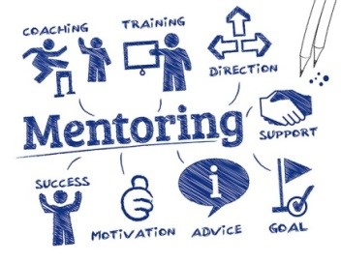
Understanding your Mentoring Needs
Before you start reading the next part of this guide ask yourself these two key questions:
Do you want a mentor?
Do you need a mentor?
If you have answered ‘yes’ to both these questions, then here are some topics to consider and some key questions to reflect upon:

Understanding your mentoring needs
If you have never had a mentor before two key questions you need to be able to answer for yourself, before you proceed are as follows:

What do you hope to gain from a mentoring relationship?
Clarifying for yourself your expectations, goals and objectives will make the process of finding the right mentor much easier. For example, do you need to find a mentor who will support you to gain more experience in a particular field?
Do you want to grow and develop yourself?
Have you reached a road block in your career?
Do you want to benefit from an open and trusted relationship?
What type of mentor do you want or need?
This might be a less obvious question to someone that hasn’t mentored before because this question poses another question – what type of mentors are there? Simply put it perhaps is more about the qualities of the mentor e.g. are you looking for someone to robustly challenge you? Gently probe?
Do you want someone like you or the exact opposite in terms of personality?
Do you want someone to guide you through new territory?
Perhaps you might want to think outside your comfort zone and not be too restrictive when considering your options of who to choose?
Also, is gender important to you when selecting your mentor?
Whatever your choices about what you need or want from a mentoring relationship be prepared to look outside your current areas of knowledge and location.

