- Log on to PURE using your domain user name and password.
- Click the Personal overview tab and then click Edit profile

- Three areas in your Research Profile can be updated at this time, (1) Profile photo, (2) Research interests, and (3) Visibility of profile.
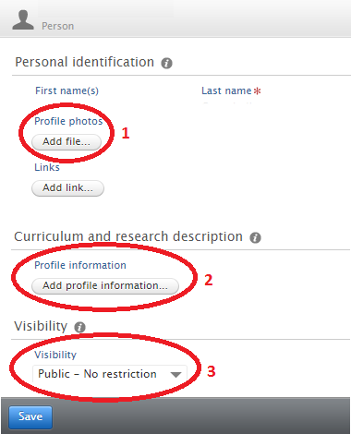

- To upload a photograph click on the Add file button under the Profile photos section.
- Upload your photograph using the “drag file of browse your computer” option.
- The Type option should be left as Portrait.
- Click Create once your file has been uploaded.
- It is recommended to crop any photograph to a 1:1 or square aspect ratio before uploading.

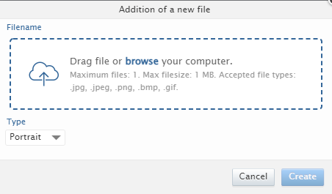

You can also add images to an image gallery within Pure. Images added using this feature are visible on the Research Profile on ResearchOnline.

To add an image to the image gallery within Pure:
- Follow the above outlined process, however set the Type option to Gallery
- Click Create

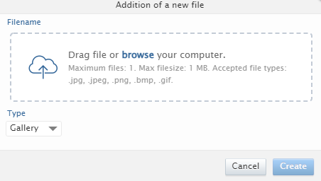

- To update your research interest and personal description click on the Add profile information button under the Curriculum and research description section.
- Click Create once you have added the text for your research interest and personal description.

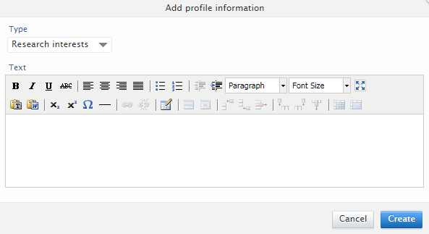

- Ensure Visibility is set to “Public – No restrictions” under the Visibility section.
- Click Save in your research profile to save all of these updates.

