Steps to access and update your researcher profile in Pure:

- Log on to PURE using your domain user name and password.
- Click the Personal overview tab and then click Edit profile

- Once the Edit profile area has been accessed, scroll to the Person Expertise section
- Click Add Person Expertise

- Add free text keywords to Area of Expertise text box. If adding multiple keywords, these should be entered in individual text boxes (see Area of Expertise field in image at 6).
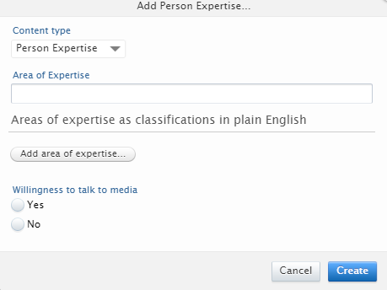

- Select Willingness to talk to media (Yes or No)

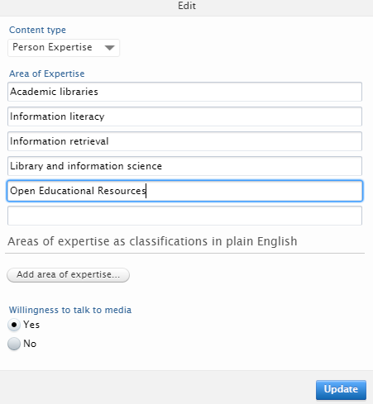

- Click Update
- Click Save in person profile area
- Area of Expertise is now added in Pure and your data will be submitted for approval by an administrator. Once approved it will be added to the expertise database which can be used to identify subject matter experts at GCU.

