Curriculum Design Overview for Online Delivery

GCU LEAD Digital Learning Team
Glasgow Caledonian University
October 2015

Contents
Developing online learning at GCU: Curriculum Design Overview for Staff 3
Introduction and overview 3
The GCU Online Learning Experience 4
Getting Started: The Design Process 5
Stage 1: Planning 6
Stage 2: Storyboarding 7
Stage 3: Prototyping 10
Stage 4: Delivery; evaluation, reflection, modification 11
Acknowledgements 12

Developing online learning at GCU: Curriculum Design Overview for Staff
_____________________________________________

Introduction and overview
This guide provides an overview and a suggested curriculum design process for developing fully online learning programmes and modules.

It has been designed as an open, flexible resource to provide guidance to individuals and/or programme teams who are designing new or existing modules for fully online delivery. It links to existing policy and strategy as well as newly developed resources.

Much of the guidance is equally applicable to campus based, blended learning and all relates to our core learning, teaching and feedback design principles.

- GCU Strategy for Learning
- GCU Feedback Principles
- GCU Student Experience Framework

When designing for fully online delivery, the need for a FAIR (flexible,accessible, inclusive, relevant) curriculum is crucial, as your potential students will be coming from increasingly culturally and educationally diverse cultures.

The GCU Online Learning Experience

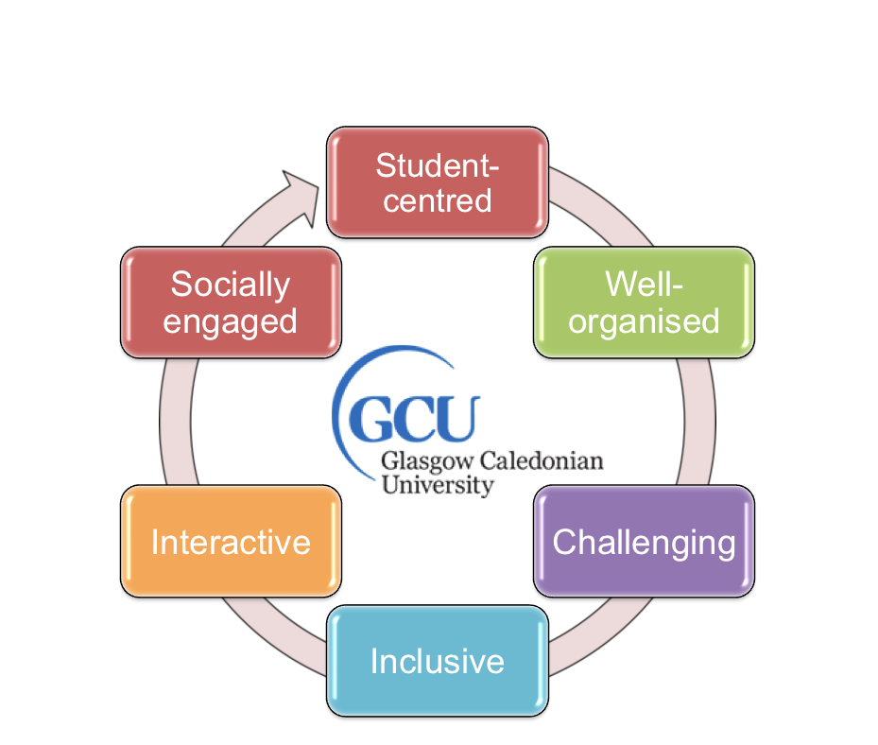

Figure 1: GCU Online Learning Characteristics

All online learning activities should be based on the design principles in the GCU Strategy for Learning. However there are a number of considerations that must be taken into account when developing and running fully online courses. The GCU online learning experience will be distinctive in its approach to engaging students, valuing them as individual learners and encouraging them to advance the common good mission in a relevant context. The following characteristics confirm this intention.
- Student-centred, stimulating and engaging, with opportunities for students to contribute and collaborate online, enhanced by constructive tutor and peer feedback
- Well-organised, within an online learning environment that makes effective use of innovative learning technologies and a range of relevant digital resources.
- Challenging, encouraging the development of academic excellence and independent learning within a responsive online framework.
- Inclusive, offering a vibrant and welcoming online learning community.
- Interactive, deepening knowledge and understanding through a variety of online activities, coursework, discussion topics and assignments.
- Socially engaged, reflecting GCU’s Common Good mission, core values and global outlook through real-world learning activities and community engagement.

Getting Started: The Design Process

Working with a number of module teams, we have developed a learning design workflow model.

Our model has been adapted from established learning design processes and tools into a simple linear model. In reality the process is more overlapping, iterative and circular.

This model also provides staff with another way to engage with GCU’s Peer Support development process. More information on Peer Support in GCU is available from the Learning and Teaching Community in GCU Learn.

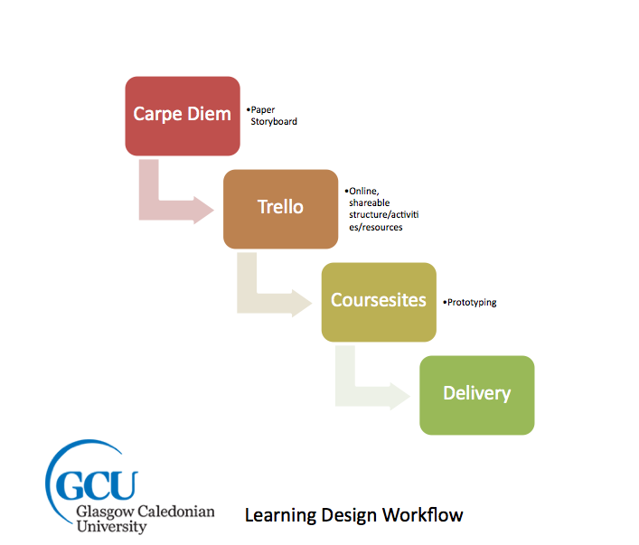

Figure 2: GCU Learning Design Workflow

Stage 1: Planning

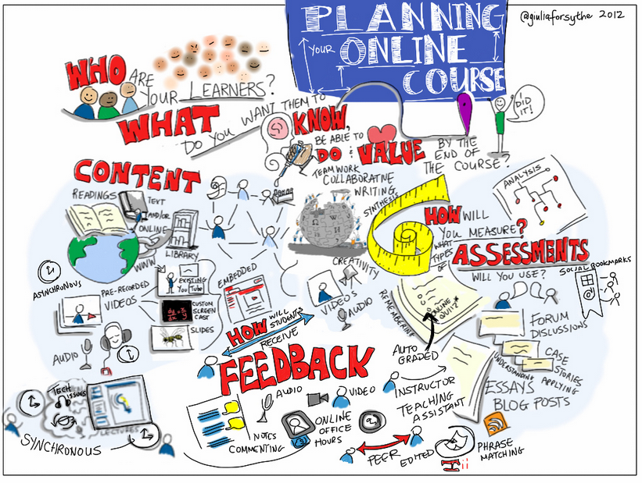
(Image: Giulia Forsyth https://www.flickr.com/photos/gforsythe/8186356402)

If you are developing a completely new module/programme, then you may need to spend more time on developing a blueprint (overview) which should form a central part of your programme/module approval process. If you are adapting an existing programme/module then your module descriptors will in effect be your blueprint and provide a skeleton storyboard. Learning outcomes should lead the design process, not tools or technologies.

Planning any type of learning activity is crucial. Most lecturers are constantly updating and modifying their teaching. Most are very familiar and comfortable with the traditional face to face classroom setting and can adapt their input easily. With online learning, the student-teacher dynamic is different. Distance and technology lie between the student and the teacher. The balance and frequency of formal and informal interactions, assessment and feedback opportunities change in fully online delivery. Interactions, both student -teacher and student-student need more choreography and planning. This can be challenging but also exciting. Online learning can allow you, and your students, to engage with and use technology in new and different ways to meet module learning outcomes.

The Carpe Diem Learning Design Process is an established and proven team based methodology for developing online learning activities.

We have condensed and adapted the methodology from a 2 day workshop to a 2 hour one. We strongly recommend that programme or module teams spend at least half a day collaboratively creating a programme/module blueprint and timeline.

Taking time to come to consensus and consistency of approaches (particularly for assessment, feedback and interactions) not only helps to improve the final learning experience for students, but also saves development time and prevents potential confusion for staff and students alike.

- Overview presentation
- Carpe Diem Activity Booklet

Stage 2: Storyboarding
Creating a programme/module storyboard is an effective way to start planning activities, assessments and feedback.

One of the most important aspects of developing a storyboard as team exercise is the discussion the process creates and the shared understanding of how a module descriptor translates into actual learning, teaching, assessment and feedback activities.

The structure of a storyboard is flexible. you can use themes, topics, assessments or time. Whatever way you structure a storyboard, it provides a means to start listing, describing and detailing the types of activities, resources, interactions, collaboration, assessments and feedback across a module/programme.

These examples show storyboards using a week by week approach that were developed in two hour sessions.

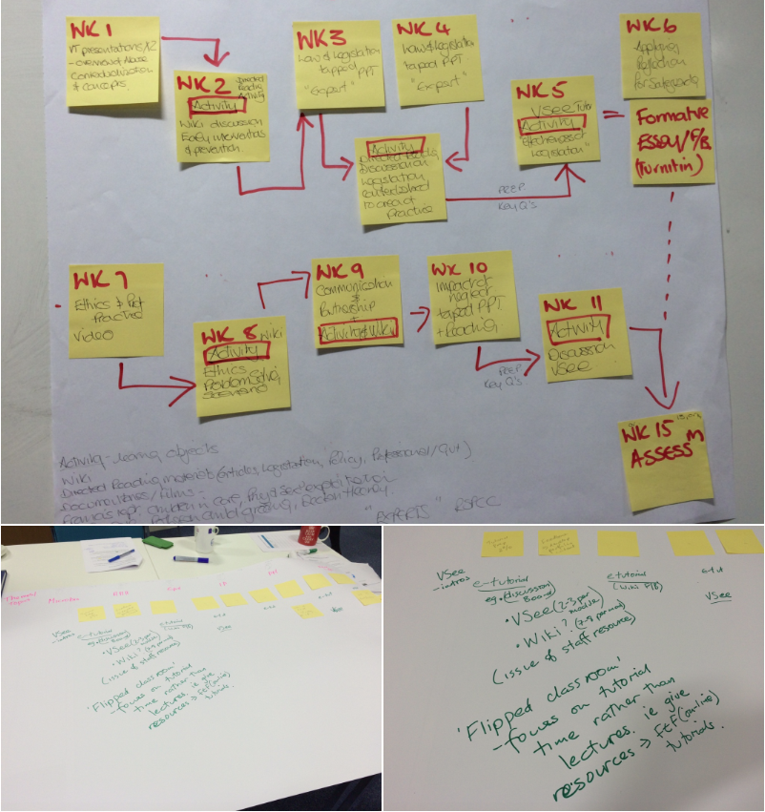

Mapping assessments, formative and summative, can provide a good starting point for a storyboard. This should allow you to think about for example, the load of assessment activities for students; where and when there are feedback-feedforward opportunities. Alternatively you may want to use topics or themes as your starting point.

The storyboarding process is as much about the discussion it engenders for team members as the actual storyboard itself. Think of your storyboard as a discussion starter for team members to come to consensus about the balance and timing of activities, sources of content/resources to be used, and more. This discursive process can help to improve consistency of the student experience. For example a team can agree a common structure and set of terminology for activities as well as a common set of technologies to be used across a programme/module.

This process also provides the opportunity to critically reflect on your current practice. Moving to online delivery does not mean simply recreating what you do in face-to-face setting. Do you really need to follow for example a traditional lecture format? Moving online could provide the perfect opportunity to break free from the 1 hour lecture.

However a paper based timeline isn’t particularly robust. The next stage is to transform the initial storyboard to a more accessible and shareable resource.

Trello is an freely available tool to “manage anything” that is increasingly being used as a collaborative project management tool. We have found that its features are useful for creating and sharing detailed module storyboards as this example illustrates.

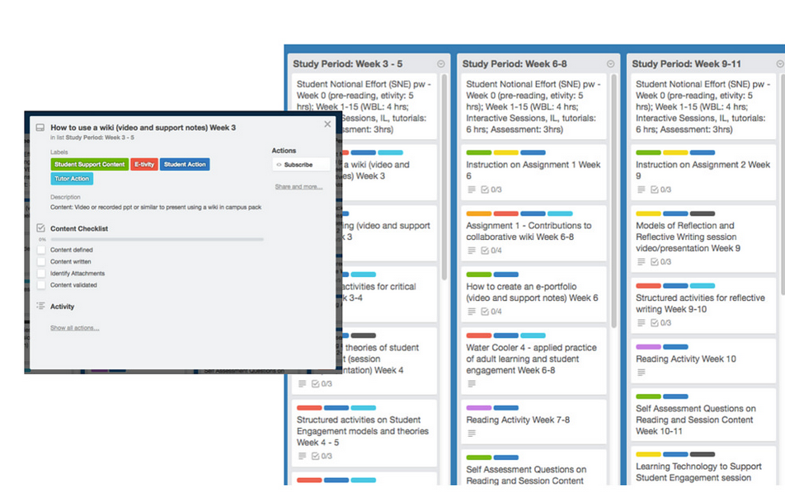
https://flic.kr/p/qQTYBu

Trello’s communication features such as emails, reminders, task allocation and completion allow a paper based storyboard to come alive and start turning into an actual set of activities. Colour coding types of activities, resources, interactions and build a rich picture of a module.

Trello can also cut down the need for face-to-face meetings and allow distributed teams to share their progress and see the rest of team’s progress at any time.

“it was so straightforward to use. I think it’s got a lot of scope in terms of how you use it, I think it is really really useful for seeing what is going on across a programme” (Lecturer, GSBS)

This visual overview of a module could be used for re-approval purposes as well as sharing with programme/module teams and potentially students.

“if you want people to work collaboratively on a new programme or just in review current module content, it gives you a platform to do that that’s nice and easy and you don’t need to all get together and sit round a table and have big meetings”
(Lecturer, GSBS)

The GCU Guide to Developing Online Modules provides more detailed guidance on how you might want to structure your module and activities. It is strongly recommended that you read this before undertaking any storyboarding activities.

Stage 3: Prototyping
Once you have your storyboard you can start to develop your activities. The storyboarding process should have identified existing and yet to be created activities and content. As stated earlier, learning outcomes not technology should be driving the design process. Knowing what you want to do is more important than knowing what technology you can use.

As with our campus based programmes, online learning at GCU will be delivered through GCU Learn, our virtual learning environment.

The storyboard should provide a guide to activities and resources and allow you to identify what activities/ resources/content you already have access to and what needs to be created. This is the point where you can have meaningful discussions with your school Learning Technologists about what are the most appropriate technologies to use to meet your intended learning outcomes.

Use Coursesites, the openly available version of Blackboard, or a community area within GCULearn to create a demo area (or sandpit) and build up a prototype of your module. In this way you can (peer) review and test out your learning design and module structure. As you build your activities remember accessibility issues and ensure that resources are available in accessible formats.

Use this space to experiment and play with ideas and tools. Encourage yourself and colleagues to review and try activities from both learner and staff perspectives. Consider having a colleague (internal or external) and/or student(s) act as a critical friend to your developments. An outside, objective perspective can be a really helpful way to help ensure the clarity and consistency of your overall design. It can also be a useful way to test your design on a range of devices and operating systems, as well as sharing effective and innovative practice.

The checklist in our Developing Online Modules Guide is a good starting point for reviewing what you have done. Our module design rubric is a more detailed resource and can be useful to use with critical friends/and or external reviewers.

Using Coursesites gives you more control over access to any potential external reviewers and it provides a clear delineation between developing and existing modules. Using a community keeps your development within the GCU environment. There is no right or wrong option, and the choice is largely down to personal preferences and you own context.

Once you are happy with with your prototype you can export your module from Coursesites directly into Blackboard, or move your content, activities and structure from a community into your module in GCU Learn.

Stage 4: Delivery; evaluation, reflection, modification
If you have followed this design process you should be well prepared for your module going live. As with all of the best laid plans, sometimes things can go wrong. So be prepared for glitches, both human and technology driven. However, if you have clear lines of communication with your students, you should be able to adapt and keep things on track.

Tracking, reporting and learning analytics become more important in online delivery mode. A simple way to get a feel for student engagement is to use the built in reporting features in GCULearn in particular the Performance Dashboard and the Retention Centre. These are both found in the Evaluation link in every module menu. These will help you to track student interactions and if necessary make appropriate interventions with students. Remember when you are creating your module pages within GCULearn to select the tracking features.

As with face to face teaching, you will find that some activities will work better than others. You may also find that your own preferences for interactions with students change as the module progresses. You could also try to get some peer feedback as the module runs too.

Try not to make any radical changes when a module is running. Instead, go back to your storyboard/prototype and update it as the module progresses. That way when you update your module you can make the majority of changes at one time.

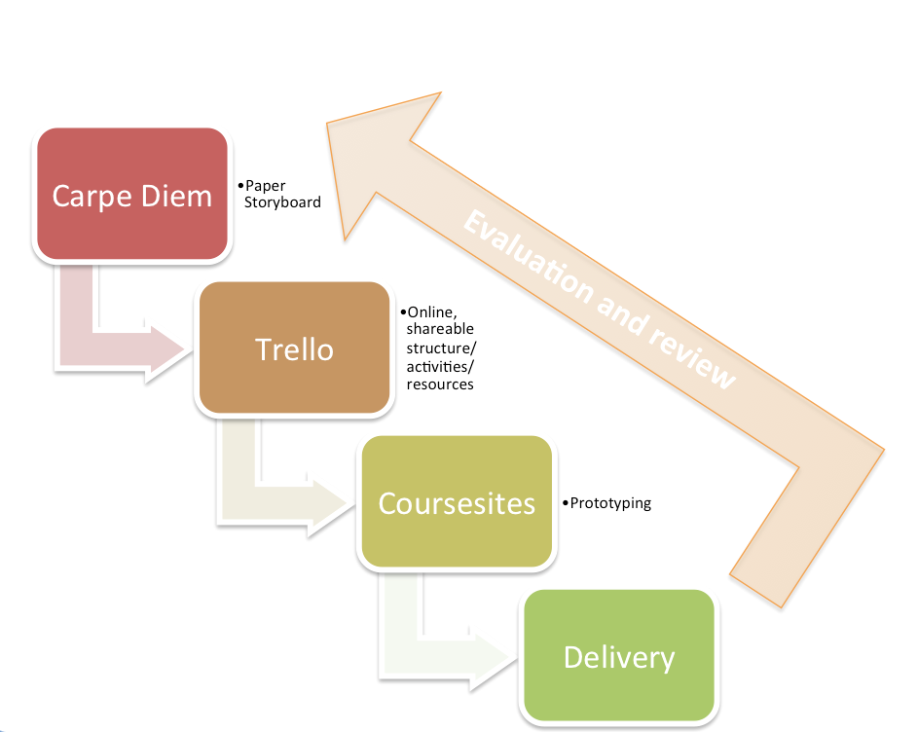
Figure 3: Learning Design Cycle

Our GCU Guide to Developing Online Modules provides detailed information and guidance on creating modules within GCU Learn.

Acknowledgements

The GCU Blended Learning Team would like to acknowledge Professor Gilly Salmon (PVC, University of Western Australia) for her support and guidance over the years in developing and openly sharing the Carpe Diem design process.

The GCU Guide to Developing Fully Online Modules by the GCU LEAD Digital Learning Team is licensed under a Creative Commons Attribution-Non-Commercial-ShareAlike 4.0 International Licence

Using Trello for Learning Design Case Study: http://bit.ly/1LS9QbA

