PLOS Open Access Agreement: Guide for GCU Authors

Summary of the agreement

GCU has an open access publishing agreement with PLOS which runs from January 2022 until December 2023. This agreement allows corresponding authors who are current staff or students at GCU to publish at no cost in 6 PLOS journals: PLOS ONE, PLOS Genetics, PLOS Pathogens, PLOS Computational Biology, PLOS Neglected Tropical Diseases and PLOS Digital Health.

Eligibility checklist for authors

1. The corresponding author must be a current student or member of staff at GCU
2. The article must have been accepted for publication from 3 January 2022 onwards
3. The journal title must be one of: PLOS ONE, PLOS Genetics, PLOS Pathogens, PLOS Computational Biology, PLOS Neglected Tropical Diseases and PLOS Digital Health

How to complete the fee waiver option

If the eligibility checklist has been met authors should follow the steps below to ensure that the open access fee is covered by the agreement.
1. Within the article submission system go to 'Additional Information'
2. Scroll to the 'Publication fees' section
3. Select the option 'My institution will fully or partially pay the fee...' shown below:
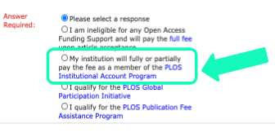
4. This displays a drop-down and authors must choose 'Glasgow Caledonian University' from this list shown below:
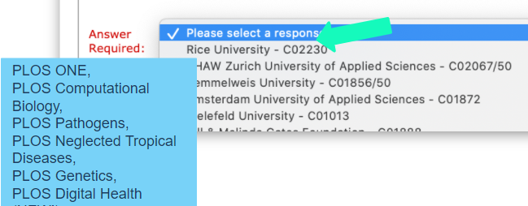
5. Once these steps are complete, authors can continue with the rest of the article submission process.

The screenshot images in this guide are reproduced with permission from PLOS.

