Guide overview
This guide explains how to register with ORCID and obtain your unique identifier, how to add your ORCID to your Pure profile, and how to authorise the export of data from Pure to ORCID.
- If you do not already have an ORCID follow this guide from Part 1: Register with ORCID
- If you have an ORCID but it does not yet display on your Pure profile, follow this guide from Part 2: Add your ORCID to your Pure profile
- If you have an ORCID and it already displays on your Pure profile, follow this guide from Part 3: Authorise the export of data from Pure to ORCID.

Part 1: Register with ORCID
- Go to the ORCID website
- Click Sign in/Register
- Click Access Through your Institution
- Enter Glasgow Caledonian University
- Click Register Now at the bottom of the screen
- Enter requested details to create an ORCID:
  - Name and email address. We recommend you use a personal email address as your primary email so you can continue to access your ORCID account, even if you leave GCU
  - Create a password
  - Set ORCID visibility (see Appendix: ORCID visibility settings). We recommend that you set your ORCID record visibility to ‘Everyone’ as this offers the greatest visibility of your research
- Click Register. As part of the ORCID registration process you will be sent a verification email
- When prompted, verify your primary email account by clicking on the verification button/link in the email.

Add information to your ORCID record
There are several editable areas within your ORCID record. You can add information relating to the following:
- Names (given and family name, publishing name and other names)
- Biography
- Activities
  - Education and qualifications
  - Invited positions and distinctions
  - Membership and services
  - Funding
- Emails
- Websites and social links
- Keywords (words or phrases which describe your research activities)
- Countries (highlight where you conduct your research or where your research is focused)
You do not need to add the following fields within ORCID as this data will be passed from Pure, once you have completed Parts 2 and 3 of this guide:
- Employment
- Works

Part 2: Add your ORCID to your Pure profile
- Navigate to Caledonian Connected
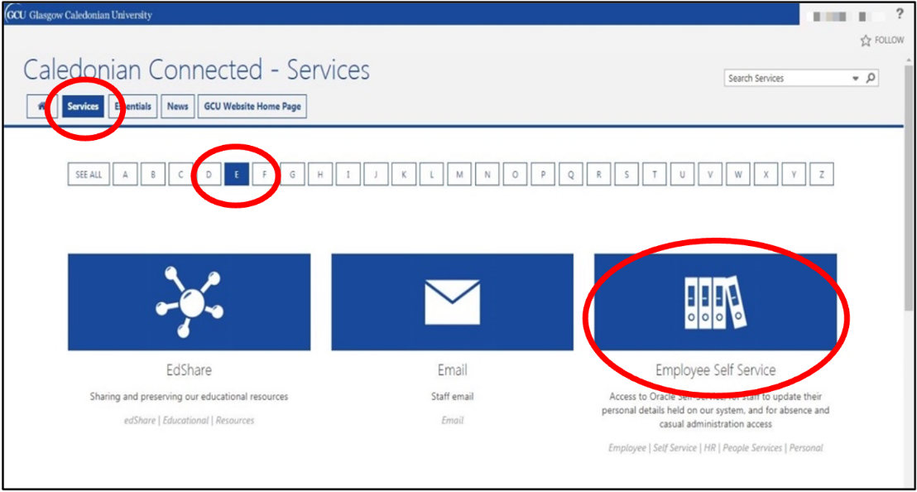
- Click Services
- Click E
- Click Employee Self Service
- Sign-in to Employee Self Service (you will need to connect to VPN if not on campus)
- Navigate to the ORCID section of Employee Self Service
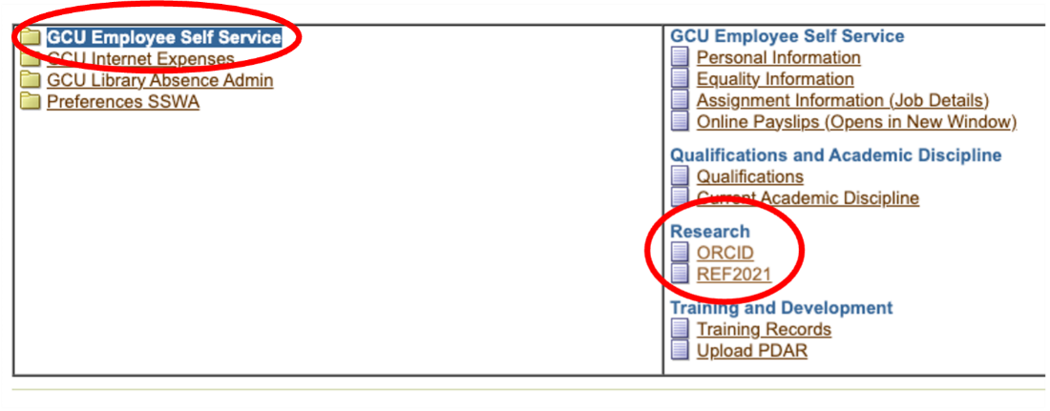
- Click GCU Employee Self Service
- In the Research section click ORCID
- Click Update
- Enter you ORCID including dashes (16 digits), for example: 0001-0002-0003-0004. Enter only the number part of the identifier and dashes.
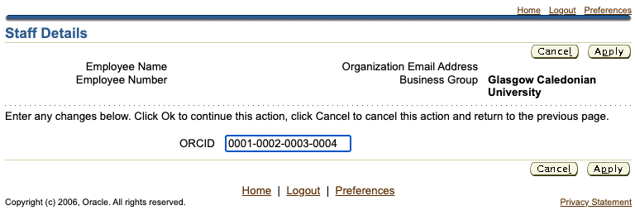
- Click Apply
- Click Next
- Click Submit
- Your ORCID will be saved to GCU Employee Self Service.
An automated process will pass your ORCID from the GCU Employee Self Service system to Pure and complete a series of validation checks. If your ORCID passes validation it will be visible on your Pure profile within 24 hours. If your ORCID fails validation a system administrator will resolve the issue but it will take longer for it to appear on your Pure profile.

Getting help
If you are unable to log in to Employee Self Service please contact workforcesystems@gcu.ac.uk.
If you have successfully added your ORCID to Employee Self Service but it does not appear on your Pure profile after a week, please contact Library Research Services repository@gcu.ac.uk.

Part 3: Authorise the export of data from Pure to ORCID
To authorise the export of content from Pure to ORCID please follow these steps:
- Log in to Pure
- Click on Personal tab on the Pure menu bar
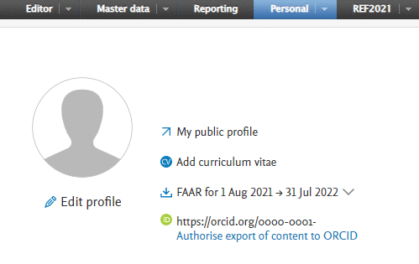
- Click Authorise export of content to ORCID
- A message will appear titled Connect with your ORCID ID. This message states that upon setup, Pure will export the following content immediately, and then subsequently automatically update it (at a frequency determined by the Pure administrator):
  - Institutional organisational affiliation
  - Other personal identifiers (e.g. Scopus ID, Researcher ID)
  - Your Pure Portal URL
  - Your research outputs, where:
    - The publication status is ‘Published, E-pub ahead of print’
    - The visibility of the record is ‘Public – No restriction’
    - The workflow step is ‘Validated’
- Click Proceed
- ORCID will then ask you to authorise access
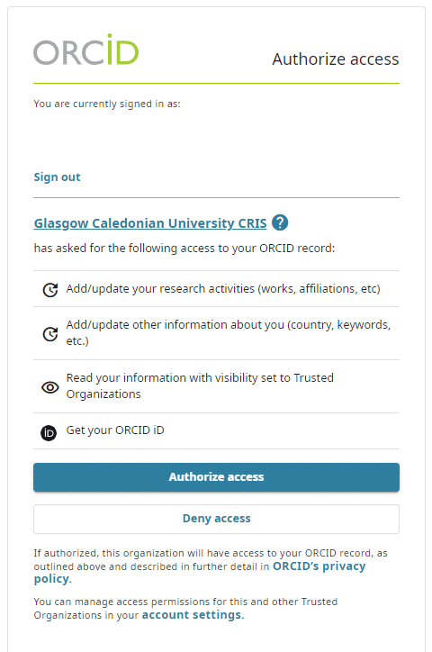
- Click Authorize access
- A message will appear stating ‘ORCID for [Name] applied. Remember to save.’
- Click Save
Details of your research outputs will be exported from Pure to ORCID each night. This includes all outputs deposited in Pure which have been validated by the library and have a publication status of epub ahead of print or published.

Getting help
If you have any questions about ORCID, including authorising the export of data from Pure to ORCID, please contact the Library Research Services team: repository@gcu.ac.uk.

Appendix: ORCID visibility settings
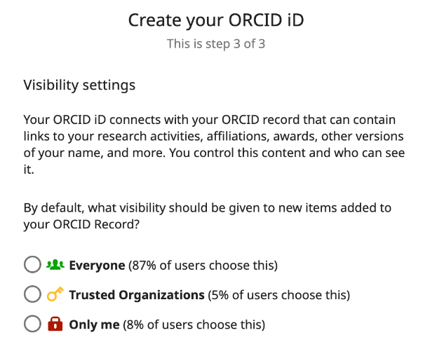
Your ORCID is always publicly visible, and you control the visibility settings for all other content in your ORCID record. Any information added by a trusted organization will always be visible to them regardless of the visibility setting that you choose; if you have given them permission to do so, they will also be able to update the information they've added.
There are three visibility settings: everyone, trusted parties, or only me.
- Everyone: Information marked as everyone can be viewed by anyone who comes to the orcid.org website or consumed by anyone using the ORCID public API. This information is also included in the public data file posted annually by ORCID.
- Trusted parties: Limited-access information that can be seen by any trusted parties whom you have granted access to your ORCID record. These connections require explicit action on your part.
  - Trusted organizations: The organization will ask you to grant them specific permission to read limited-access information at the same time that you give them permission to get your ORCID. Once you have granted permission, the trusted organization will be able to see information that you have set as visible to trusted parties in addition to the information set as visible to everyone.
  - Trusted individuals: You can grant any ORCID holder account delegate access as a trusted individual to help administer your account on your behalf. Once you have granted them delegate access, the individual will be able to see information that you have set as visible to trusted parties access in addition to information set as visible to everyone.
- Only me: Private information can only be seen by you and trusted individuals you have granted access to help administer your ORCID record on your behalf. It is also used by ORCID algorithms to help distinguish your identity from another person who may have a similar name, be in a similar field, or may be confused with you for other reasons. This information is not shared with others.

Source: ORCID Support, n.d. Visibility settings. [Online]. [Accessed 4 November 2022]. Available from: https://support.orcid.org/hc/en-us/articles/360006897614

