RESEARCH STUDENT PERSONAL DEVELOPMENT PLAN (PDP)

Date of Submission | Student’s Signature | Director of Studies’ Signature
Click or tap to enter a date. | Click or tap here to enter text. | Click or tap here to enter text.

Part A: RESEARCH STUDENT SUMMARY INFORMATION

- The Student

Full name | Click or tap here to enter text.
Student ID Number | Click or tap here to enter text.
School/Department | Click or tap here to enter text.
GCU email address | Click or tap here to enter text.
Research location (address where normally based for research study) | Click or tap here to enter text.

- The Supervisory Team

Director of Studies
Name | Click or tap here to enter text.
Tel./Mob. Number | Click or tap here to enter text.
Email | Click or tap here to enter text.
Address | Click or tap here to enter text.
Second Supervisor
Name | Click or tap here to enter text.
Tel./Mob. Number | Click or tap here to enter text.
Email | Click or tap here to enter text.
Address | Click or tap here to enter text.
Third Supervisor
Name | Click or tap here to enter text.
Tel./Mob. Number | Click or tap here to enter text.
Email | Click or tap here to enter text.
Address | Click or tap here to enter text.
Advisor(s)
Name(s) | Click or tap here to enter text.
Tel./Mob. Number(s) | Click or tap here to enter text.
Email(s) | Click or tap here to enter text.
Address(es) | Click or tap here to enter text.
School Programme Coordinator
Name | Click or tap here to enter text.
Tel./Mob. Number | Click or tap here to enter text.
Email | Click or tap here to enter text.
Address | Click or tap here to enter text.

Have there been any changes to the supervisory team? If yes, please provide more details.
Click or tap here to enter text.

- The Research Degree Programme

Research degree type | Choose an item.
Mode of Study | Choose an item.
Funding Category | ☐ University Funded ☐ School Funded  ☐ Externally Funded  ☐ Self-Funded ☐ Staff ☐ UK/EU ☐ International
Give any details of any change to mode of study | Click or tap here to enter text.
Proposed Title of research | Click or tap here to enter text.

- Any adjustments/support requirements/Reasonable Adjustment Plans (RAP)?

Click or tap here to enter text.

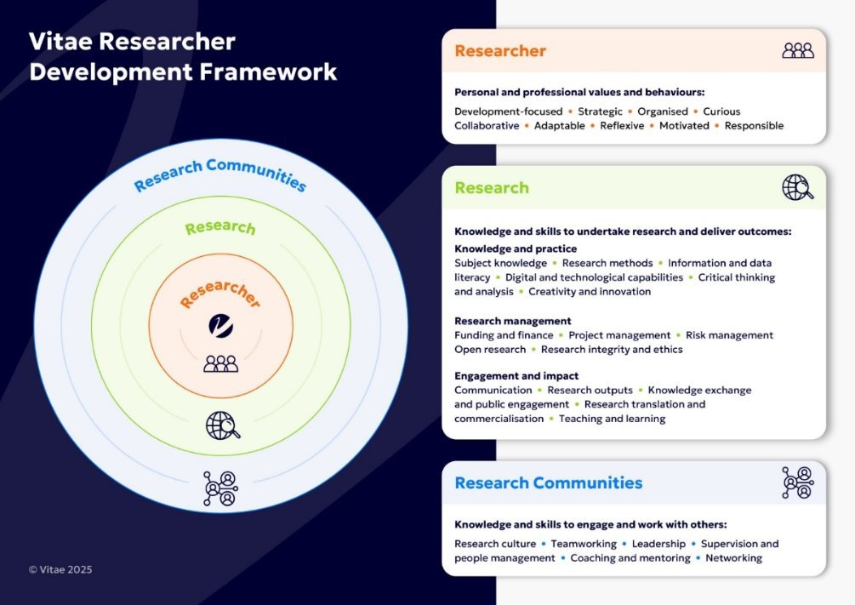
Part B: PERSONAL DEVELOPMENT PLAN

More information about the Research Student Journey progression can be viewed on the Doctoral Hub webpages.

Use the following template to focus on your personal and professional development. As a researcher, you are responsible for your own development and should be looking for ways to enhance your research experience as you progress through your PhD. Take the time to reflect on progress with your supervisory team and plan for further development. Information on the Graduate School Researcher Development opportunities can be found on the Researcher Development page.

The Vitae Researcher Development Framework - Vitae describes the knowledge, behaviours and attributes of successful researchers. Using this tool can be helpful in considering areas for development and reflecting on progress.

RDF sub-domains | Areas for development | Activity to address development (specify details & dates) | Review meeting date | Examples of activity
Domain A – Knowledge and Intellectual Abilities
A1 – Knowledge Base | Click or tap here to enter text. | Click or tap here to enter text. | Click or tap here to enter text. | Example: Attend relevant research methods workshop
A2 – Cognitive Abilities | Click or tap here to enter text. | Click or tap here to enter text. | Click or tap here to enter text.
A3 – Creativity | Click or tap here to enter text. | Click or tap here to enter text. | Click or tap here to enter text.
Domain B – Personal Effectiveness
B1 – Personal Qualities | Click or tap here to enter text. | Click or tap here to enter text. | Click or tap here to enter text.
B2 – Self management | Click or tap here to enter text. | Click or tap here to enter text. | Click or tap here to enter text.
B3 – Professional and Career development | Click or tap here to enter text. | Click or tap here to enter text. | Click or tap here to enter text. | Example: Maintain up to date academic CV
Domain C – Research Governance and Organisation
C1 – Professional conduct | Click or tap here to enter text. | Click or tap here to enter text. | Click or tap here to enter text. | Example: https://ukrio.org/ - find possible activities here
C2 – Research Management | Click or tap here to enter text. | Click or tap here to enter text. | Click or tap here to enter text.
C3 – Finance, Funding and Recourses | Click or tap here to enter text. | Click or tap here to enter text. | Click or tap here to enter text. | Example: Submit Grant applications
Domain D – Engagement, Influence and impact
D1 – Working with others | Click or tap here to enter text. | Click or tap here to enter text. | Click or tap here to enter text.
D2 – Communication and Dissemination | Click or tap here to enter text. | Click or tap here to enter text. | Click or tap here to enter text. | Example: Present conference paper
D3 – Engagement and Impact | Click or tap here to enter text. | Click or tap here to enter text. | Click or tap here to enter text. | Example: Deliver public engagement activities

